SOMA Codex
Book IV — Engineering Manual & Specifications
The buildable specification. Where Book II gives the anatomy and Book III the physiology, this book is what an engineer — or an AI coding tool — implements from. Language: Rust.

This book specifies the organism as software: the crate map, the single onboarding ceremony, the projection and lease contracts, the event format, the runtime invariants stated as MUST clauses, the determinism specification, and the threat model. It is written so that each section can be handed to an implementer as a contract. Where a section depends on the anatomy, it cites Book II by system (S1–S8); where it depends on an algorithm, it cites Book III.

1. Engineering discipline (non-negotiable)
These rules hold for every crate. They are the organism's equivalent of "no toxic biochemistry" — they are enforced by the toolchain, not by reviewer goodwill.
Rule | Enforcement | Why
Rust, edition 2024, MSRV pinned | workspace Cargo.toml | memory safety; one language for the body (glue/ML excepted)
unsafe_code = "forbid" | workspace lint (compile error) | no undefined behavior anywhere in the body
no unwrap/expect/panic/todo/unimplemented | clippy deny | every failure path is explicit; the organism never aborts silently
no print*/dbg! | clippy deny | observability is structured (tracing/metrics), never ad-hoc
missing_docs = "warn" | workspace lint | the body is self-documenting
fail-closed defaults | code review + tests | absent a governance boundary, refuse to operate (INV-8)
Why a forbidden-panic body matters for an organism. A panic is an uncontrolled death of a holon. In a system whose whole thesis is governed continuity, an unhandled panic is a governance hole: a part dies without a record, outside the immune system's view. Forbidding it forces every failure to become a governed event — which is exactly what the evolution loop (Book V) feeds on.

2. The crate map
The organism is a Rust workspace. Dependencies flow strictly downward; a crate may depend only on crates beneath it, and this is a compile-time property, not a convention.
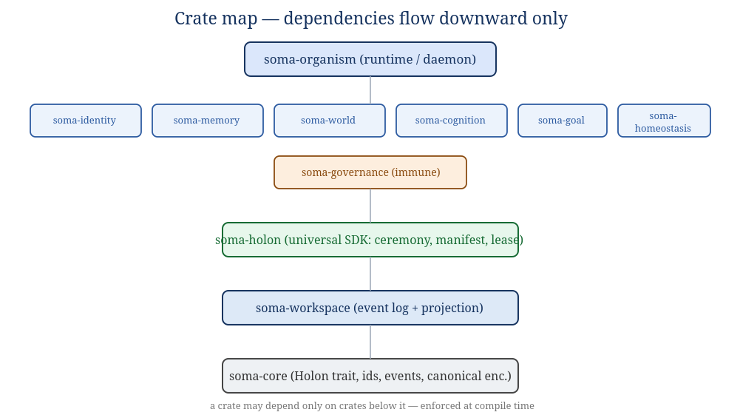
Figure 2.1 — Crate map. Each system crate (S1–S8) implements the anatomy of Book II.
Crate | Implements (Book II) | Responsibility
soma-core | the membrane & holon contract | the Holon trait, typed IDs, EventSpec, canonical encoding, the projection/aperture types. No I/O, no crypto runtime.
soma-workspace | S1 Workspace | append-only hash-chained log, subscriptions, projection computation, replay-with-verification.
soma-holon | the recursion rule | the universal SDK every holon uses: manifest, the onboarding ceremony, lease protocol, outcome reporting. Used identically by cells and systems.
soma-governance | S8 Immune/Governance | Trust, Authority (+ kill switch), Verification (non-valent), Sentinel. The laws maintained.
soma-identity | S2 Identity & Self | Identity Registry, Continuity, Self-Model.
soma-memory | S3 Memory | episodic/semantic/procedural stores, consolidation, recall.
soma-world | S4 World-Model | predictive world-model, Cartographer graph, Uncertainty.
soma-cognition | S5 Cognition | Reasoning (model-inference cells), Deliberation, Effector.
soma-goal | S6 Goal | Constitution (lexical), Goal (ODD), Evaluation.
soma-homeostasis | S7 Homeostasis | Arousal/Anxiety, Metabolism/Resource, Valence.
soma-organism | L5 assembly | the runtime/daemon that wires the systems, runs the lifecycle loop (Book V), holds the local lock, exposes the operator/HumanSeat surface.

3. soma-core: the Holon contract
The whole architecture is one trait applied recursively. A Holon is anything with a membrane. The trait is deliberately small — five capabilities matching the five-part recursion rule (Book II §3).
// soma-core — illustrative signatures (not final API)

/// A governed unit at any scale: cell, workflow, organ, system, organism.
pub trait Holon {
/// Stable identity within the organism.
fn id(&self) -> HolonId;

/// The contract this holon presents at its membrane (capabilities,
/// publishes/subscribes, trust ceiling, whether it needs a human gate).
fn manifest(&self) -> &Manifest;

/// Perceive: fold one governed projection into private state.
/// This is the ONLY way the outside reaches the holon.
fn perceive(&mut self, view: Projection) -> Result<(), HolonError>;

/// Act: given a granted lease, produce outcome records for the log.
/// Returns records to append; never performs a side effect directly.
fn act(&mut self, lease: &Lease) -> Result<Vec<OutcomeRecord>, HolonError>;

/// Project: expose this holon's governed ~20% to its parent.
fn project(&self, aperture: Aperture) -> Projection;
}
Key consequences of this shape:
- No holon performs a side effect itself. act returns records; the workspace appends them; effectors are themselves holons that consume leased records. This is what makes "the bus is the only channel" (INV-2) structurally true rather than a policy.
- Perception is one-directional and governed. perceive takes a Projection the workspace computed under the governance policy — the holon cannot widen its own aperture.
- Composition is uniform. An organ holding workflows holds Vec<Box<dyn Holon>> and coordinates them through projections and leases — exactly as the organism holds systems. There is no "system-level" API distinct from the "cell-level" API. That sameness is the holarchy in code.

Typed identifiers and events
All identifiers are validated newtypes (non-empty, bounded length, no control characters): HolonId, OrgId, GoalId, TaskId, LeaseId, EventType, RecordSeq, MechanismOfAction. Every record is described by an EventSpec { event_type, source, description, required_payload_keys }; the workspace rejects a record that does not satisfy its spec. Encoding is canonical (deterministic key ordering) so that hashing is stable — the precondition for the hash chain and for record-replay (§8).

4. The Manifest schema (soma-holon.v1)
Every holon declares itself with one manifest schema, regardless of scale. This is the document the ceremony validates.
Field | Type | Meaning / constraint
schema_version | string | exactly "soma-holon.v1"
holon_id | HolonId | unique within the organism
kind | enum | Cell | Workflow | Organ | System | Organism — the holon's level
parent | HolonId? | the holon it is a part of; None only for the organism (whose parent is the ecosystem / HumanSeat)
display_name | string | non-empty; for logs/UI
capabilities | [string] | what it can do; clean set
domains | [string] | operational scopes it serves
publishes | [EventType] | event types it may emit; each must match a declared capability prefix
subscribes | [EventType] | event types it may receive
aperture_tier | enum | Peripheral (summaries only) or Focused (detail under live lease + authority)
max_trust_required | f64 ∈ [0,1] | trust ceiling above which work is blocked for this holon's risk class
requires_human_gate | bool | whether its actions need HumanSeat approval
sub_holons | [HolonId] | its children (empty for a cell); the recursion made explicit
The schema is identical for a routing cell and for the entire World-Model system. The difference between a cell and a system is the value of kind and the size of sub_holons — not a different contract. This is the engineering expression of "the same interface at every scale."

5. The one onboarding ceremony
Before any holon may act, it passes one ceremony. There is no second admission path. Each step writes a hash-chained, mechanism-stamped record to the workspace; if any step is missing, the holon is not onboarded and the runtime fails closed.
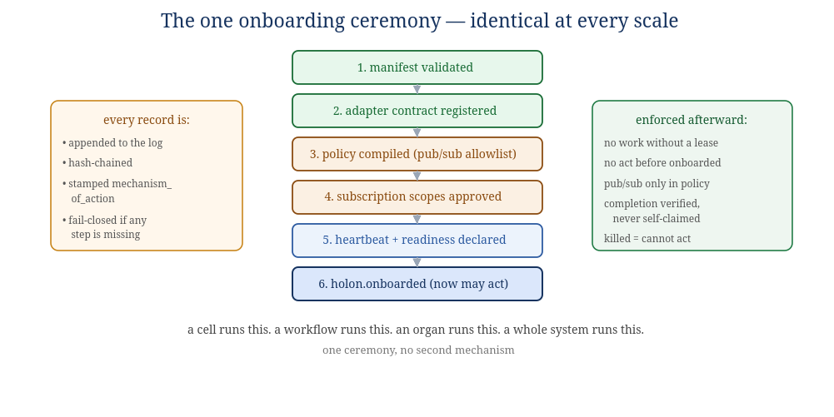
Figure 5.1 — The ceremony. A cell runs it; a whole system runs it; the steps are the same.
- Manifest validated — shape, scope, capability/event consistency, no duplicate children. Emits holon.manifest.validated with the manifest hash.
- Adapter contract registered — a concrete contract is derived from the manifest (sorted capabilities, lease protocol, trust/authority hooks, audit fields) and committed: holon.adapter_contract.registered.
- Policy compiled — publish/subscribe allowlists are compiled from the manifest; a policy digest is recorded: holon.policy.compiled.
- Subscription scopes approved — each publish and subscribe event type is individually approved: holon.subscription_scope.approved (one per scope).
- Heartbeat & readiness declared — the holon declares liveness affordances: holon.readiness.declared.
- Onboarded — the gate. Only when steps 1–5 exist and are consistent does the runtime write holon.onboarded. From this record forward, and not before, the holon may claim leases, be routed work, receive focused context, and have completions accepted.
The ceremony is implemented once in soma-holon and called by every crate. The organism's own boot (Book V) is the ceremony applied to the top-level Organism holon, whose parent is HumanSeat.

6. The projection contract (parent ↔ child)
This is the mechanical form of the 80/20 membrane (Book II §3.2). It governs every parent's view of every child, at every scale.
// what crosses a membrane inward
pub struct Projection {
pub of: HolonId, // whose state this summarizes
pub aperture: Aperture, // Peripheral | Focused
pub at_seq: RecordSeq, // the log position this view reflects
pub summary: CanonicalMap, // the governed ~20% — never the holon's internals
}

pub enum Aperture { Peripheral, Focused } // Focused requires live lease + authority
Rules of the contract:
- Aperture is computed, not requested. The Projection/Aperture organ (S1) decides each holon's aperture from its task state, lease liveness, domain authority, and trust. A holon cannot promote its own aperture (INV-11).
- Peripheral by default. Idle or unleased holons get summaries only. Focused detail opens only while a matching lease is live and authority covers the domain, and closes the moment the lease ends.
- A projection reflects a log position. Every projection is stamped with at_seq, so perception is always "as of" a definite point in the organism's history — which is what makes coordination replayable (§8).
- Internals never cross. The summary is constructed by the child's project() under the aperture; the child's private 80% is never serialized across the membrane.

7. The lease protocol (governed action)
No holon acts without a lease. A lease is a kernel-of-governance grant — time-limited, scoped, signed by the Authority organ (S8) — that authorizes one holon to work one task. The protocol is a small state machine:
request --> [Authority checks: onboarded? trust in domain? authority covers? not killed?]
--> GRANT(lease_id, ttl, scope) | DENY(reason)
GRANT --> Claim --> (Renew)* --> Complete(evidence) | Fail(reason) | Release
Complete --> [Verification organ confirms] --> Accepted | Escalate(tier|HumanSeat) | Reject
- Claim binds the lease to the holon and opens its focused aperture for the task domain.
- Renew extends the TTL while work continues; an expired lease auto-closes the aperture.
- Complete submits the work with evidence; it does not itself complete the task. The Verification organ decides. There is no self-certified completion (INV-4).
- Fail attributes a reason that becomes trust evidence and evolution signal (Book V).
- Release returns the task without prejudice (e.g., the holon recognizes it is the wrong one).

8. The event record & determinism specification

Record format
pub struct Record {
pub seq: RecordSeq, // total order within the organism
pub event_type: EventType, // must match a known EventSpec
pub source: HolonId, // who emitted it
pub mechanism_of_action: MechanismOfAction, // WHY — never empty (INV-7)
pub parent_id: Option<String>, // causal parent record, if any
pub payload: CanonicalMap, // canonical (deterministic) encoding
pub prev_hash: Hash, // commits to the previous record
pub hash: Hash, // sha-256 over (prev_hash, body)
}

What "deterministic" means here — precisely
INV-9 — Determinism is a property of how holons coordinate, not of what they say. The governing core is deterministic by record-replay, not by re-execution. Given the recorded log — which includes the non-deterministic cell outputs as data — the coordination protocol (ordering, governance decisions, trust updates, projection computation, policy evaluation) re-runs and produces identical results. The organism is not deterministically re-executable from first principles, because a Reasoning cell's model inference (S5) cannot be re-derived from its inputs. It is logged, and replay reads it back.
Concretely, the boundary is:
Deterministic (replayable) | Non-deterministic (logged, not re-derived)
record ordering & hash chain | model inference inside Reasoning cells (S5)
governance / authority / lease decisions | wall-clock timestamps
trust posterior updates from recorded outcomes | any external tool result a cell privately obtained
projection / aperture computation | random seeds drawn inside a holon's private 80%
policy compilation & evaluation
This is why the membrane identity is three-way, not four (Book II §3.1): a non-deterministic value lives in the shared 20%, so "shared" ≠ "deterministic data." The protocol over that shared data is what replays. Replay therefore serves audit, debugging, and the evolution loop — not bit-exact re-simulation of thought.

9. Runtime invariants (the MUST clauses)
These are the laws of the organism, stated so they can be tested. Each is enforced in code and checked by tests; several are enforced structurally (by the shape of the Holon trait) rather than by runtime checks, which is stronger.
INV-1 — Append-only. The event log MUST be append-only and hash-chained; records are never edited or deleted. Retention/compaction MUST be non-destructive markers.
INV-2 — One channel. Holons MUST coordinate only through the workspace. There MUST be no direct holon-to-holon channel at any scale. (Structural: act() returns records; it cannot reach another holon.)
INV-3 — One ceremony. A holon MUST NOT act until its holon.onboarded record exists. Every holon, every scale, uses the same ceremony.
INV-4 — Verified, never claimed. A task MUST NOT be completed on a holon's self-report. The non-valent Verification organ MUST confirm completion for any task above trivial risk.
INV-5 — Killed cannot act. A killed or quarantined holon MUST immediately lose authority; its outstanding leases are void; it cannot publish, subscribe, claim, or be routed work.
INV-6 — HumanSeat ceiling. Destructive or high-risk actions MUST require HumanSeat approval. HumanSeat sits above the holarchy (§11); no automation may bypass or optimize against it.
INV-7 — Mechanism on every event. Every record MUST carry a non-empty mechanism_of_action. No anonymous side effects.
INV-8 — Fail closed. If a required governance boundary is absent, the holon MUST refuse to operate rather than operate ungoverned.
INV-9 — Coordination determinism. The coordination protocol MUST be replayable from the recorded log; content (cell inference) is logged, not re-executed (§8).
INV-10 — Lexical constitution. Constitutional objectives MUST be constraints prior to all goal optimization — never weighted terms a valence/reward signal can outbid. (Structural: the Constitution organ is separate from and gates the Goal organ; Book II §12.)
INV-11 — Projection-only perception. A holon MUST perceive others only via governed projection; it MUST NOT read another holon's internals, nor widen its own aperture.
INV-12 — Scope on every event. Every record and boundary crossing MUST carry organism/identity/scope so it is attributable and auditable.
Two invariants are exceptions to "everything is a holon." The Verification organ (INV-4) and the HumanSeat path (INV-6) are deliberately non-valent authorities carved out of the recursion's drive economy. A self-modeling organism with intrinsic drives (S7) must have at least one brake it cannot want to defeat. These are those brakes. If a future change cannot keep them carved out, the safety claim of this design is void and the documents must say so plainly.

10. Security & threat model (recast for the organism)
SOMA is local-first and customer-owned; there is no supplier in its data path and no hidden remote control. The threat model is recast biologically: the immune system (S8) defends the body; the membrane (Book II §3) is the trust boundary; the log is the asset whose integrity is everything.
Asset | Adversary / failure | Defense (organ / invariant)
The event log + hash chain (the organism's reality & identity) | tampering, reordering, silent edit | append-only + hash chain (INV-1); replay-with-verification (S1); continuity anchored to chain (S2)
Authority & leases | a holon acting beyond scope, or after kill | Authority organ; lease protocol (§7); INV-3/5
Trust (the reward channel) | a holon that learns to look reliable (reward-hacking) | verification-gated trust evidence (INV-4); Sentinel drift/anomaly detection; kill-the-winner scrutiny of dominant holons (Book III)
The constitutional floor | a strong valence signal outbidding safety | lexical priority (INV-10); valence subordinate to Constitution (S6) and Verification (S8)
Destructive actions (delete, restore, self-modify) | automation overreach | HumanSeat ceiling (INV-6), above the holarchy (§11)
A failing or hostile holon | cascade, cytokine storm (over-remediation) | circuit breakers; bounded remediation; negative selection; quarantine before kill (S8, Book III)
Secrets / private state in the 80% | leakage across the membrane | projection-only perception (INV-11); internals never serialized (§6)

11. HumanSeat: the apex, above the holarchy
HumanSeat is decided, not ambiguous: it sits above the organism, not as a parent inside the recursion. The organism's top-level holon projects upward to HumanSeat exactly as any child projects to its parent — but HumanSeat is the one authority that carries no valence, holds no lease, and cannot be optimized against. It is "the human is the authority ceiling who can step out, never the relay" (Book I, the HumanSeat principle; the M in MEDA). Concretely:
- HumanSeat approves/denies the gated actions of INV-6, on holds with timeouts.
- HumanSeat can quarantine or kill any holon, including a whole system, and the kill is honored by INV-5.
- HumanSeat is outside the deterministic core: a human decision is an input recorded on the log, not a replayable computation.
- The designer-who-removes-himself (Book I §11) is encoded here: HumanSeat can step out, and the organism runs on under its own constitution — but the seat above it never disappears from the design.

12. Verification & test strategy
Because the invariants are the product, the test suite is organized around them, not around features.
- Invariant tests — one suite per INV-1…INV-12, each attempting the forbidden thing and asserting it is refused (e.g., a holon attempting to act before holon.onboarded; a killed holon attempting to claim; a goal value attempting to outbid a constitutional constraint).
- Replay tests — record a session, replay the coordination protocol, assert identical governance decisions, trust posteriors, and projections (INV-9), with cell outputs read from the log.
- Membrane tests — assert no projection ever contains a child's internals; assert apertures cannot be self-widened (INV-11).
- Property tests — the hash chain never verifies after any single-record mutation; canonical encoding is order-independent.
- Recursion tests — the same ceremony, lease, and projection tests run with the holon-under-test instantiated as a cell, then as an organ, then as a system — proving the interface is genuinely self-similar.
- Soak tests — long-running homeostatic stability: inject failure, assert the anxiety regulator (S7) recovers to setpoint and never spirals to a stall (the corrected anxiety experiment, Book I §7 / Book III).

13. Event schema catalog
Every record on the workspace has a known EventSpec; the workspace rejects any record whose payload does not satisfy its spec (fail-closed, INV-8). This catalog is the canonical set of event types for v1. Event types are dotted, lowercase, and prefixed by the organ family that owns them; each must match a declared capability prefix in the emitter's manifest (Book IV §4).

Lifecycle & ceremony events (every holon)
event_type | required payload keys | meaning
holon.manifest.validated | holon_id, manifest_hash, kind | step 1 of the ceremony
holon.adapter_contract.registered | holon_id, manifest_hash, contract_hash | step 2; concrete contract committed
holon.policy.compiled | holon_id, policy_digest, pub_count, sub_count | step 3; pub/sub allowlist compiled
holon.subscription_scope.approved | holon_id, direction, event_type | step 4; one per approved scope
holon.readiness.declared | holon_id, heartbeat_ms | step 5; liveness affordances
holon.onboarded | holon_id, kind, contract_hash, policy_digest, sub_holon_ids | step 6; the gate — may act after this
holon.heartbeat | holon_id, at_seq | periodic liveness
holon.retired | holon_id, reason | removed from service; memory retained

Task & lease events (governed action)
event_type | required payload keys | meaning
goal.admitted | goal_id, criteria, constraints | an outcome-driven goal enters ACTIVE
task.created | task_id, goal_id, domain, risk | a task derived from a goal
lease.requested | task_id, holon_id | a holon asks to work a task
lease.granted | task_id, holon_id, lease_id, ttl_ms, scope | authority grants a scoped, timed lease
lease.denied | task_id, holon_id, reason | onboarding/trust/authority/kill check failed
lease.renewed | lease_id, ttl_ms | extend while work continues
work.attempted | lease_id, holon_id, evidence | intermediate progress / outcome candidate
task.completed | task_id, lease_id, verifier_evidence | accepted by Verification (INV-4)
task.failed | task_id, lease_id, reason | trust-attributed failure
lease.released | lease_id, reason | returned without prejudice

Governance, trust & safety events
event_type | required payload keys | meaning
trust.evidence.applied | holon_id, domain, outcome, weight, evidence_id | a verified outcome updates a Beta posterior
trust.snapshot | holon_id, domain, mean, variance, root_hash | Merkle-rooted trust state (Book III §3.2)
authority.granted | holon_id, scope_class | authority scope derived from trust
authority.contracted | holon_id, scope_class, reason | scope reduced on trust drift
holon.quarantined | holon_id, reason | Sentinel isolates before kill
holon.killed | holon_id, reason, approved_by | authority revoked; leases void (INV-5)
sentinel.drift.detected | holon_id, metric, distance | CUSUM/Wasserstein drift signal (Book III §8.2, §9.2)
breaker.opened / breaker.closed | holon_id, window | circuit breaker state change

HumanSeat & homeostasis events
event_type | required payload keys | meaning
humanseat.gate.raised | gate_id, action, reason, timeout_ms | a gated action awaits approval (INV-6)
humanseat.gate.approved / .denied | gate_id, by | the apex decision (an input, not a computation)
homeostasis.arousal.ticked | level, setpoint, multiplier | regulated arousal update (Book III §6.2)
evolution.diagnosed | holon_id, criterion, root_cause | a specific shortfall (Book V §4)
evolution.regenerated | holon_id, change_kind, new_generation | a targeted improvement deployed

14. Per-crate module specifications
Each crate's public surface, organ by organ. Types are illustrative (final signatures may differ) but the responsibilities and boundaries are normative.

14.1 soma-core
Modules: holon (the Holon trait, §3), id (validated newtypes), event (EventSpec, EventType, the catalog registry), canonical (deterministic encoding + hashing), projection (Projection, Aperture), lease (Lease, LeaseState), manifest (Manifest, HolonKind). No I/O, no async, no crypto runtime beyond hashing. Everything above depends on this and nothing else at the bottom.

14.2 soma-workspace (S1)
Modules: log (append-only segments, hash chain, append(record) -> (seq, hash), replay_verified(from) -> impl Iterator), subscription (durable cursors, ack/nack, relevance routing), projection (the Aperture organ: project(holon, policy) -> Projection). Guarantees: append is atomic and fsync-durable; replay re-verifies the chain and halts on mismatch; a malformed record is rejected, never silently skipped. This crate is the sole writer of truth.

14.3 soma-holon (the recursion SDK)
The crate every holon links. Modules: ceremony (onboard(manifest, &mut Workspace) -> Receipt — the six steps of §5), policy (compile pub/sub allowlists; the digest), lease (request/renew/complete/fail/release through the SDK boundary, never writing kernel state directly), outcome (report(evidence)). This crate is what makes "one ceremony, no second mechanism" (INV-3) literally true: there is exactly one code path to onboard, and it is here.

14.4 soma-governance (S8)
Modules: trust (TrustStore of Beta posteriors per (holon, domain, tier); Merkle-rooted persistence; apply(evidence), score(holon, domain) -> (mean, var)), authority (scope_for(holon) -> ScopeClass; the kill switch kill(holon, reason, approval); lease admission checks), verification (the non-valent verify(task, evidence) -> Verdict; carries no goals/valence; cannot be a lease holder), sentinel (negative selection, danger model, CUSUM/Wasserstein drift, circuit breakers, bounded remediation). This crate maintains the laws that every membrane enforces.

14.5 soma-identity (S2)
Modules: registry (membranes: self/non-self, holon names & boundaries), continuity (reconstruct(&Workspace) -> SelfState — rebuild "I" from the hash-chained log at boot), self_model (the reflexive SelfModel { i_am, my_parts, my_state }; reconcile(projection); raises contradictions to Cognition + Homeostasis). Closes Gap 1.

14.6 soma-memory (S3)
Modules: episodic, semantic, procedural (the three stores), consolidation (hot→warm→cold by decayed activation; recall(query) -> Vec<Memory> by similarity; salience by centrality). Failed work is composted here as evidence (necromass), feeding the evolution loop.

14.7 soma-world (S4)
Modules: model (predictive world-model: predict(), update_to_reduce(surprise), free-energy descent), cartographer (the relational knowledge graph; dependency/blast-radius queries), uncertainty (conformal intervals on every estimate). Consumes projections; produces the world-state projection the rest of the body orients on.

14.8 soma-cognition (S5)
Modules: reasoning (domain-specialized cells; the boundary where non-deterministic model inference lives — its output is logged, never re-derived, INV-9), deliberation (expected-free- energy action selection with the reluctant-action threshold of Book III §5.2), effector (the only crate that acts on the world outside the organism, and only through a granted lease). Model calls are made inside a cell's private 80% and their results are written to the log as content.

14.9 soma-goal (S6)
Modules: constitution (the lexically-prior, non-tradeable objective set; permits(action) -> bool evaluated before any goal scoring — INV-10), goal (outcome-driven goals: weighted criteria, hard/soft constraints, injected context; the DRAFT→…→COMPLETED lifecycle), evaluation (grade outcomes, calibrate the grader, emit the specific shortfall signal). The constitution module is a separate compilation unit from the goal module on purpose.

14.10 soma-homeostasis (S7)
Modules: arousal (the PID + hysteresis regulator with setpoint, relief valve, and performance floor — tick(trust_trend), Book III §6.2), metabolism (resource budget; Little's-law backpressure), valence (the functional good/bad weighting). All signals are functional, not phenomenal (Book 0 §6); all are subordinate to the constitution (S6) and the verification ceiling (S8).

14.11 soma-organism (L5 assembly)
The runtime/daemon. Wires the systems in dependency order, runs the living loop (Book V §1), holds the local lock and the workspace handle, reconstructs the self at boot, exposes the operator/HumanSeat surface, and runs the bounded tick loop with health guards. It is the top-level Holon whose parent is HumanSeat; its own boot is the ceremony applied to itself.

15. Worked type reference: a task from grant to verified completion
To make the contracts concrete, here is the full path of one task in types, showing where each invariant bites.
// 1. Goal admitted (soma-goal) — constitution checked FIRST (INV-10)
let goal = Goal::new(criteria, constraints);
constitution.permits(&goal)?; // lexical gate, before any scoring
workspace.append(record("goal.admitted", goal.digest()))?; // INV-7: mechanism stamped

// 2. Task + lease (soma-holon -> soma-governance)
let task = Task::from_goal(&goal, domain, risk);
let lease = match authority.admit(&holon, &task) { // checks onboarded? trust? scope? not killed?
Ok(scope) => Lease::grant(task.id, holon.id(), ttl, scope), // INV-3, INV-5
Err(reason) => return deny(reason), // INV-8 fail-closed
};

// 3. Perceive + act (soma-cognition) — focused aperture only while lease live (INV-11)
let view: Projection = workspace.project(holon.id(), Aperture::Focused);
holon.perceive(view)?;
let outcome: Vec<OutcomeRecord> = holon.act(&lease)?; // returns RECORDS, not side effects (INV-2)

// 4. Verify — non-valent organ decides; no self-certification (INV-4)
match verification.verify(&task, &outcome) {
Verdict::Accept => { workspace.append(record("task.completed", ...))?;
trust.apply(Evidence::success(holon.id(), domain)); } // INV-9 fold
Verdict::Escalate(t) => escalate(t), // tier or HumanSeat (INV-6)
Verdict::Reject(why) => { workspace.append(record("task.failed", why))?;
trust.apply(Evidence::failure(holon.id(), domain)); }
}
Every line above is either a governed record on the workspace or a pure function of it. There is no path in this code that reaches another holon directly, completes without verification, acts without a lease, or edits the past — because those paths do not exist in the types. The invariants are enforced by what the API makes impossible, not only by what it checks.
End of Book IV. The crate map, ceremony, contracts, event catalog, and invariants here are the build contract; Book III supplies the algorithms inside the organs, and Book V shows them running.

