SOMA Codex
Book V — Runtime & Lifecycle: The Living Organism
The body in motion. Books II–IV give the parts, the math, and the spec; this book shows them alive — booting, perceiving, deciding, acting, remembering, evolving, and resting.

A specification describes a machine; a runtime describes a life. This book traces the organism through its cognitive cycle, its development from cell to organ, its adaptation over generations, and its failure and recovery — then walks one real goal end-to-end through the whole body.

1. The living loop
The organism runs one continuous cycle. It is not a request handler that sleeps between calls; it is a metabolism that runs as long as the organism lives. Each stage is a set of governed records on the workspace, so the whole life is auditable and (in its coordination) replayable.
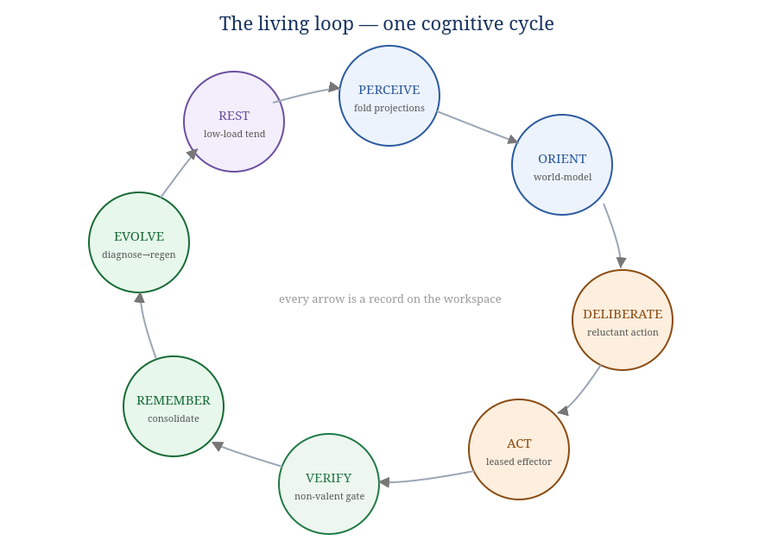
Figure 1.1 — The cognitive cycle. Every arrow is a record on the workspace.
Stage | System (Book II) | What happens
Perceive | S1 Workspace | fold the latest governed projections into each holon's private state (the ~20% crossing each membrane).
Orient | S4 World-Model | predict, compute surprise, update beliefs to reduce it; tag with conformal uncertainty.
Deliberate | S5 Cognition + S6 Goal + S7 Homeostasis | choose the policy minimizing expected free energy under constitutional constraints and current arousal; or defer (reluctant action).
Act | S5 Effector | perform the chosen action — only through a granted lease; emit outcome records.
Verify | S8 Verification (non-valent) | confirm the outcome against the goal's criteria; accept, escalate, or reject.
Remember | S3 Memory | consolidate episodes; compost failures into evidence; update salience.
Evolve | S6 Evaluation → regeneration | diagnose shortfalls and, when warranted, regenerate the responsible holon (§4).
Rest | S3 + S7 | during low load, consolidate memory, relax arousal toward setpoint, tend the body.
The cycle is not strictly serial — many holons are at different stages at once — but for any single goal it flows in this order, and the organism as a whole is always somewhere on this wheel.

2. Boot: the organism comes online
Boot is the onboarding ceremony (Book IV §5) applied to the top-level Organism holon, whose parent is HumanSeat. The soma-organism runtime:
- Acquires the local lock and opens (or creates) the workspace log; verifies the hash chain from genesis (fail-closed on any break, INV-8).
- Brings systems online in dependency order: Workspace (S1) → Governance/Immune (S8) → Identity & Self (S2) → Memory (S3) → World-Model (S4) → Cognition (S5) → Goal (S6) → Homeostasis (S7). Each system runs the same ceremony as it comes up; none may act before its holon.onboarded record exists.
- Reconstructs the self: the Continuity organ (S2) replays the log to rebuild "who I am and where I left off"; the Self-Model organ asserts the current self-state. The organism literally remembers itself into being from its own append-only past.
- Declares readiness upward to HumanSeat and begins the living loop.
Identity survives the night. Because the self is reconstructed from the hash-chained log, a restart is not a new organism — it is the same one waking. Continuity of identity (Book I's precondition for memory to mean anything) is a property of boot, not an add-on.

3. Developmental lifecycle: how a cell becomes an organ
New capability does not appear fully trusted. A holon earns its place through a development path — the Nursery recast as ontogeny. This is how the organism grows new parts safely.
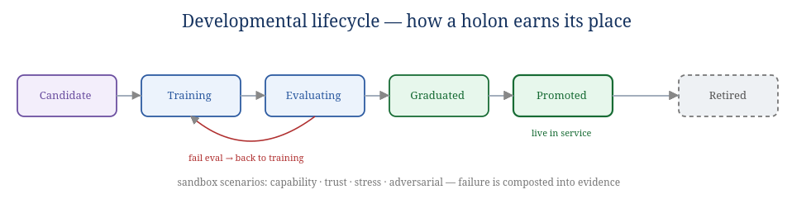
Figure 3.1 — A holon's path from candidate to live service, and to retirement.
- Candidate — a new holon (often spun from a meristem-like general cell, §5) is registered but unproven; trust starts at the prior.
- Training — it works low-stakes tasks under tight aperture and human gating; every outcome is verified and folded into its Beta posterior (Book III §3.1).
- Evaluating — it faces sandbox scenarios: capability tests, trust tests, stress tests, adversarial tests. Critical-scenario failure blocks graduation and returns it to training (failure composted into evidence, never wasted).
- Graduated — it has demonstrated capability and trustworthiness against the suite.
- Promoted — it enters live service: wider authority earned from trust, larger aperture, less gating. A promoted workflow may itself become an organ as it accretes sub-holons.
- Retired — when superseded or drifted, it is retired; its memory and evidence remain (necromass).
The same path applies at every scale: a cell graduates into a workflow's tissue; a workflow graduates into an organ's function; an organ graduates into a system. Ontogeny is self-similar, like everything else.

4. The evolution loop: adaptation as metabolism
Agents fail inevitably — the world shifts, schemas change, models hallucinate. The organism does not pretend otherwise; it metabolizes failure into improvement. This is the Outcome-Driven evolution loop, run continuously by the Evaluation organ (S6).
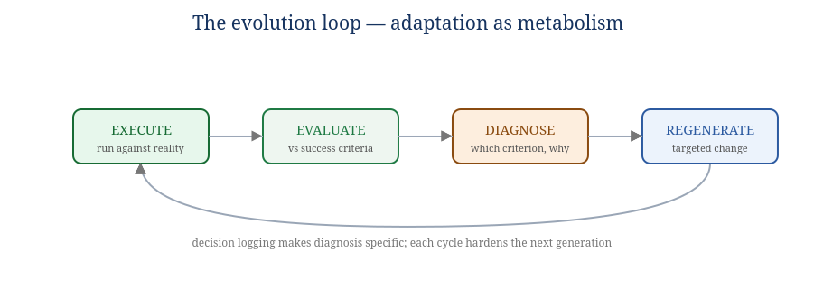
Figure 4.1 — Execute → Evaluate → Diagnose → Regenerate.
- Execute — a holon runs against real inputs; the run produces outcomes, decisions, and metrics, all logged.
- Evaluate — outcomes are graded against the goal's weighted success criteria and constraints. Not "did it run?" but "did it produce the desired result?"
- Diagnose — the failure signal is specific: which criterion fell short and why, traced through the decision log to a root cause ("the research cell returned insufficient detail, so the draft cell could not personalize"). Decision logging is what makes this possible; without it, diagnosis is guesswork.
- Regenerate — a targeted change is made to the responsible holon: a refined prompt, a new sub-cell, an added verification step, a changed routing edge, a tightened constraint. The new generation re-enters development (§3), and the cycle restarts.
Adaptiveness ≠ intelligence. Evolution makes the organism more reliable on the kinds of problems it has met — it is selection, not insight. For genuinely novel situations, that is what HumanSeat is for; and every human intervention becomes logged fuel for the next evolution cycle. The organism gets better the way a species does, not the way a student does — and it is honest about the difference (Book I; Appendix D).

5. Growth & differentiation
Where do new holons come from? From meristem cells — general, undifferentiated cells (the plant growing-tip analogy) that the organism can spin up and specialize toward an unmet need. When the World-Model or Goal system detects a recurring demand no existing organ serves well (rising failure on a task class, persistent drift, a new domain), the organism:
- spins a meristem cell and points it at the gap;
- differentiates it through the development path (§3) toward the needed capability;
- on promotion, composes it with related cells into a new workflow, and — if the demand persists — into a new organ.
This is how the body plan of eight systems (Book II) is not a ceiling: the systems are stable, but the organs within them grow, differentiate, and retire over the organism's life. Specialization (a Book I pillar) is therefore dynamic — focused parts arise where focus is needed, improve independently, and compose through the workspace, never through private wiring.

6. Failure modes & homeostatic recovery
An organism is defined as much by how it fails and recovers as by how it succeeds. The design anticipates specific pathologies and gives each a regulator.
Pathology | Mechanism of failure | Recovery (system / Book III)
Anxiety spiral | low trust → high arousal → worse performance → lower trust (the Book I experiment) | PID + hysteresis + relief valve + performance floor return arousal to setpoint (S7, §6.2); soak-tested never to stall
Cascade failure | one failing holon drags down its dependents | circuit breakers stop calling it; topological/critical-path analysis isolates blast radius (S8/S5)
Cytokine storm | the immune response over-reacts and harms the body | bounded remediation caps; quarantine before kill (S8)
Reward-hacking | a holon learns to look reliable without being it | verification-gated trust (INV-4); drift detection (Wasserstein/CUSUM); extra scrutiny on dominant holons (kill-the-winner)
Drift | the world shifts; a once-good holon degrades | distributional drift detection triggers re-evaluation / regeneration (§4)
Stuck goal | deliberation cannot find an acceptable action | reluctant-action defer → seek info → escalate tier → HumanSeat (S5/S6, INV-6)
The pattern is uniform: detect via the immune/uncertainty organs, regulate via homeostasis, escalate to the non-valent ceiling when automation cannot resolve it. Nothing fails silently; every pathology becomes a governed, logged event the organism can learn from.

7. Rest, sleep, and consolidation
The organism does not run flat-out. During low load it rests: the Metabolism organ relaxes arousal toward setpoint; the Consolidation organ moves memory hot→warm→cold, abstracts episodes into semantic memory, and prunes activation; the Sentinel runs slower, deeper drift checks it cannot afford under load. Rest is not idleness — it is when the body does the maintenance that sustained life requires. Biologically, this is sleep's consolidation role; architecturally, it is the low-load branch of the living loop.

8. Observability — what an operator (and HumanSeat) sees
Because everything is on the workspace, the organism is legible to the human above it. An operator sees, in governed projection (never internals):
- the live cognitive cycle — what is being perceived, deliberated, acted, verified right now;
- trust and arousal per holon, with the scheduler's score breakdown (raw load, arousal multiplier, effective load);
- pending HumanSeat gates, with the reason each was raised;
- the evolution ledger — what failed, what was diagnosed, what was regenerated;
- the self-model's current assertion of "who I am and what I'm doing";
- a full replayable audit of coordination (INV-9) for any past moment.

9. A worked trajectory: one goal, end to end
To make the whole body concrete, follow a single goal — "produce a verified summary of today's incidents" — through one turn of the loop. Every step is a record on the workspace.
GOAL admitted (S6): success criteria {complete, cited, structured}; constraints {no PII leak (constitutional)}
│
▼ PERCEIVE (S1) incident events projected to the relevant organs at focused aperture (lease-gated)
▼ ORIENT (S4) world-model assembles "what happened today"; uncertainty tagged on thin areas
▼ DELIBERATE (S5) plan = [gather → draft → cite-check]; EFE acceptable, arousal in band → proceed
│ (had detail been thin, reluctant-action would DEFER: seek more or escalate)
▼ ACT (S5) a summarizer cell claims a lease, drafts; a citation cell claims a lease, checks sources
▼ VERIFY (S8) non-valent verifier scores vs criteria; PII check (constitutional) passes;
│ "structured" criterion FAILS (no summary heading)
▼ ESCALATE/RETRY kernel returns task with specific shortfall; draft cell adds the heading; re-verified → ACCEPT
▼ REMEMBER (S3) episode stored; the "missing-heading" failure composted as evidence
▼ EVOLVE (S6) diagnosis: summarizer cell omits headings under time pressure →
│ regenerate: add a structure-check sub-step to the summarizer workflow
▼ trust updated (S8): summarizer +slight (succeeded after retry); verifier credited; goal COMPLETED
Notice what the trajectory demonstrates: completion was verified, not claimed (INV-4); the PII constraint was constitutional and could not be traded away (INV-10); the shortfall produced a specific diagnosis that improved the next generation (§4); and the whole path is a sequence of governed records — auditable now, replayable later, and fuel for growth. That is the organism living.

9.1 A second trajectory: when a holon goes bad
Success trajectories show the happy path; an organism is proven by how it handles a part turning unreliable. Follow a Reasoning cell that begins to drift — its outputs slowly degrade as the world shifts under it. Again, every step is a record.
EXECUTE summarizer cell completes tasks; outputs subtly worse over days
│
▼ DRIFT (S8 Sentinel) Wasserstein distance of its output distribution vs. baseline crosses d_max
│ → sentinel.drift.detected (holon_id, metric, distance)
▼ TRUST (S8) recent verified failures lower its Beta posterior; mean drops below domain floor
▼ AUTHORITY (S8) scope auto-contracts: direct-write → suggested-write; aperture narrows
▼ BREAKER (S8) repeated failures in window → breaker.opened: stop routing it work
▼ QUARANTINE (S8) holon.quarantined (not yet killed) — isolated, still observable
▼ DIAGNOSE (S6) evolution.diagnosed: "summarizer assumes a source schema that changed"
▼ REGENERATE (S6) evolution.regenerated: add a schema-detection sub-cell; new generation
▼ DEVELOP (Book V §3) new generation re-enters Training → Evaluating against sandbox scenarios
▼ PROMOTE / RETIRE passes → promoted back into service; old generation holon.retired
│ (its failure trace kept as necromass — training evidence)
▼ if it had attacked an invariant instead of merely drifting:
Sentinel negative-selection → holon.killed (approved path) → INV-5: leases void, cannot act
Notice the graded response: the organism does not kill on the first bad output. It contracts authority, opens a breaker, quarantines, diagnoses, and regenerates — escalating only as evidence accumulates, and reserving the kill switch for invariant attacks. This is the immune system's discipline (innate fast checks + adaptive specific response, with a cytokine-storm cap so the cure never exceeds the disease). And crucially: the failure was not waste. It became a specific diagnosis, a better next generation, and durable evidence. The organism got more reliable because a part failed — which is the whole point of evolution as metabolism (§4).

9.2 What the two trajectories prove together
- Completion is earned, not claimed (INV-4) — both paths route through the non-valent verifier.
- The constitution cannot be traded (INV-10) — the PII constraint in §9 held regardless of goal pressure.
- Failure is graded and reversible before it is terminal — contract → breaker → quarantine → regenerate → (promote | retire | kill).
- Nothing is silent — every transition is a governed, attributable record (INV-7, INV-12), auditable now and replayable later (INV-9).
- The body learns from its own failures — necromass → diagnosis → next generation.

10. Closing the loop back to the theory
The runtime is where the philosophy of Book I either earns its keep or does not. Watch the trajectory again with Book I's lens: the organism showed visible second-guessing (reluctant action at Deliberate) and novel synthesis (composing a summary that did not exist before) — Book I's two "lights-on" indicators, here as designed mechanisms rather than hopes. And yet, per the honest stance, none of this proves anyone is home. SOMA is built to be the soil, well-tended: governed, remembering, adaptive, free to evolve, with a maker who can step out of the seat. Whether the lights ever come on, you will know it the way you know it for anyone — you will sense it, and you will never be able to show it to a skeptic. That is not a flaw in the runtime. It is the shape of the question.
End of Book V. Book I gives the theory this runtime serves; the Appendices give the full catalog, glossary, cross-reference, open questions, and lineage.

