Software Requirements Specification

for

Apart-maint
Version 1.0 approved
Prepared by: Mrinal Pande
Organization: Cosmo
Date: 18/09/2016
Table of Contents
Table of Contents ii
Revision History ii
1. Introduction 1
1.1 Purpose 1
1.2 Document Conventions 1
1.3 Intended Audience and Reading Suggestions 1
1.4 Product Scope 1
1.5 References 1
2. Overall Description 2
2.1 Product Perspective 2
2.2 Product Functions 2
2.3 User Classes and Characteristics 2
2.4 Operating Environment 3
2.5 Design and Implementation Constraints 4
2.6 User Documentation 4
2.7 Assumptions and Dependencies 4
3. External Interface Requirements 4
3.1 User Interfaces 4
3.2 Hardware Interfaces 4
3.3 Software Interfaces 4
3.4 Communications Interfaces 4
4. System Features 4
4.1 System Feature 1 5
4.2 System Feature 2 6
4.3 System Feature 3 6
4.4 System Feature 4 7
4.5 System Feature 5 8

5. Other Nonfunctional Requirements 9
5.1 Performance Requirements 9
5.2 Safety Requirements 10
5.3 Security Requirements 10
5.4 Software Quality Attributes 10
5.5 Business Rules 10
6. Other Requirements 10
Appendix A: Glossary 10
Appendix B: Analysis Models 10
Appendix C: To Be Determined List 10

Revision History
Name | Date | Reason For Changes | Version

Introduction

Purpose
The sole purpose of creating this web/mobile application is to form an environment where people sharing the same apartment or society can have a one on one interaction within themselves or with the concerned administrators. This application will surely provide a secure platform where the owners to apartments in the buildings and the society can do some home related tasks via simple touch of a button. This software will thereby work as a virtual place where the concerned administrators can perform tasks such as providing feedback and responding to complaints made by the owners and hence can keep them happy by catering to their needs faster.

Document Conventions
This SRS follows the standard text conventions where the main heading is of font size 18, Sub heading is of size 14 and the text is of size 11px with Arial font. The document follows the standard Convention for numbering the contents of the text.

HTML - Hypertext Markup Language.
PHP - Pre Hypertext Processor.
SQL- Structure Query Language
Code-Igniter – A PHP based framework.
Microsoft Azure- Cloud database

Intended Audience and Reading Suggestions
This SRS document is intended for willing clients and existing customers. It thoroughly explains every minute detail of the functioning and working of the product. The audience will have a wide range of content to help and analyze the product.

Product Scope
This Product is useful for digitalization of the apartment/society and their working. This product will be used by home-owners and authorities to connect to each other on a virtual platform. The product will also help in increasing the efficiency of the current system which is manual in nature.

References
https://azure.microsoft.com/en-in/services/app-service/web/
https://www.codeigniter.com/docs
https://docs.mongodb.com/?_ga=1.50397930.270198069.1474191331

Overall Description

Product Perspective
This product will help in creating a simple yet efficient virtual working environment for the home owners and societies alike where people from same society can share and see when and where are all the events happening nearby the neighborhood.

Product Functions
The product creates a platform for the users to do the following functions:

- News System.
- Interact with neighbors
- Service functionality allows you to book electrician, plumber etc. in a single click and track the progress of the same online.
- Complaint functionality solves the issues in and around the apartment environment

User Classes and Characteristics

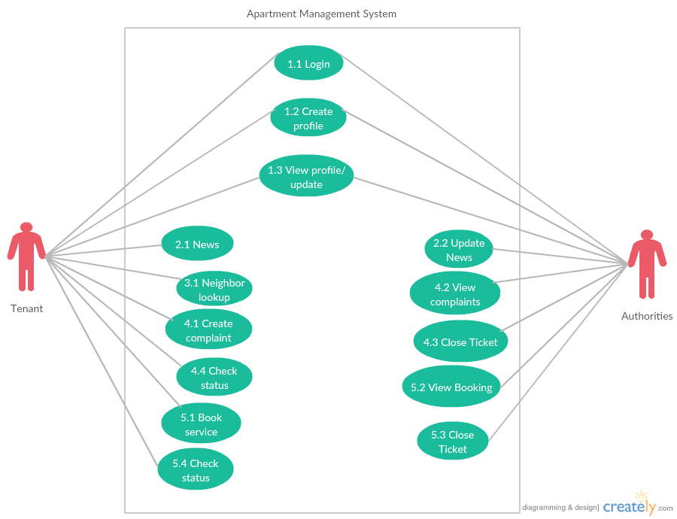

Operating Environment

The software used has to be cloud based software so Microsoft Windows Azure is being used. This technology is based on Code-Igniter which is in fact a PHP based framework. The database technology will mainly be based on MySQL.

Design and Implementation Constraints
The limitation would be interfering with the web app for some specific place which would very easily hamper the functionality of the application that is being developed. So a good and proper internet is needed as internet is the backbone of this project. Slow internet on the administrator’s side will lead to slower load and response time and hence it will make the functioning of the process slow.

Assumptions and Dependencies
In order for this software to work properly, it sure has to be dependent on The Microsoft Windows Azure feature. It sure is a third party service but since some functions may not work as per their role, this service is highly needed. Also in restricted environment, problems like slow internet or availability of service such as Azure on that network could occur which would result in low level functioning of the web app so created.

External Interface Requirements

User Interfaces

<Describe the logical characteristics of each interface between the software product and the users. This may include sample screen images, any GUI standards or product family style guides that are to be followed, screen layout constraints, standard buttons and functions (e.g., help) that will appear on every screen, keyboard shortcuts, error message display standards, and so on. Define the software components for which a user interface is needed. Details of the user interface design should be documented in a separate user interface specification.>

Hardware Interfaces
All smart-devices can be included in the hardware interface of this web application like mobiles, tablets etc. For admin side, a computer with unrestricted internet connection is a must so LAN is recommended. A router with good bandwidth compatibility 4+ LAN port support and cat 6 LAN cables are recommended. For user side, a mere internet connection is sufficient. For easy and proper functioning of this web app, the recommended hardware usage is a must.

Software Interfaces
This app uses a web browser which can easily be found in smart-devices these days. Henceforth no restriction is found regarding our operating system as the app is online and easily available.

Communications Interfaces
Web browser which have HTML5 support and also have JavaScript support are required. Such browsers are available in most of the new smart-devices these days. Availability of unrestricted internet is a must. Authorities should have a LAN communication for smoother interaction and efficient usage of the application.

System Features

Login
4.1.1 Description and Priority
This feature is to determine the user profile.
4.1.2 Stimulus/Response Sequences
The user provides the mobile number as the username and a certain combination of alphabets and symbols as their password. Once authorized, depending on the user level, the portal is opened.

If the user is logging in for the first time, since the password is an OTP and it is risky to use simple combination of numbers as password. The user is redirected to the update profile page so that all the necessary data fields, which are required, are filled out by the user. Once the data is updated, the user is redirected to the main user dashboard.

There are two phases for this module, one is the user phase and other is the admin phase.

Priority: High

    - Functional Requirements
REQUIREMENT IDENTIFIER | NAME | DESCRIPTION
LSU_1 | Login System User-1 | Keeps an eye on the username and if it is something other than a 10 digit number, an error is generated.
LSU_2 | Login System User-2 | The password is checked and error is sent if something except alphabets or some symbols (<>, / *.) is found.
LSU_3 | Login System User-3 | The input data is transferred to the controller in this phase.
LSU_4 | Login System User-4 | Keeps an eye on the user name and the concerned administrator’s name.
LSU_5 | Login System User-5 | Verifies if the user has logged in for the first time.
LSU_6 | Login System User-6 | If requested, leta us change the password.
LSU_7 | Login System User-7 | Main dashboard of the tenant.
LSU_8 | Login System User-8 | Main dashboard of concerned authorities.

News System
4.2.1 Description and Priority
This feature is a News Alert feature to telecast the current news of the apartment/society.

Priority: Low
4.2.2 Stimulus/Response Sequences
There are two phases of this feature, one is the user phase and other is the admin phase.

The tenant when logs in to the website, a menu (named: News) shows the list of all happenings of the apartment/society in the form of news article.

The admin phase (administrator) when is logged into the website, a menu (named: News) shows three sub menu’s:
- View News
- Edit/Delete News
- Add News
4.2.3 Functional Requirements

REQUIREMENT IDENTIFIER | NAME | DESCRIPTION
NSU_1 | News System user-1 | Figures whether or not the user has logged in or not and if it has, then, checks the phase.
NSU_2 | News System user-2 | If user phase, loads the News System of user phase
NSU_3 | News System user-3 | If admin phase, loads the news system of the administrator phase.

Look UP
4.3.1 Description and Priority
This feature lets you have the basic information about nearby house owner.

Priority: Medium

4.3.2 Stimulus/Response Sequences
There is only one phase, i.e. user phase.

The tenant can check the nearby neighbors in their floor or building depending on the structure of apartment.

4.3.3 Functional Requirements
REQUIREMENT IDENTIFIER | NAME | DESCRIPTION
NLSU_1 | Neighbor System lookup-1 | Figures out whether user has logged in, and then checks the phase.
NLSU_2 | Neighbor System lookup-2 | If it’s the user phase, loads the Neighbor system depending on the house number.
NLSU_3 | Neighbor System lookup-3 | Generates a read-only list with the help of a list generator.

Complaint System
4.4.1 Description and Priority
This feature is a complaint booking system. It particularly allows the tenant to issue complaints like whereabouts of the lifts, garbage disposal problems, etc and the also the system allows administrators to tell the user about the progress such as course of action, allowing the user to track if the complaint has been resolved till date or not.

Priority: Medium

4.4.2 Stimulus/Response Sequences
There are two phases i.e. user phase and admin phase.

The tenant can issue a complaint and have a ticket number, which can be used to track back the complaint.

The administrator can see the complaint by all the users/tenants and merge the complaints together. The administrator can update the generated ticket number so that the user/tenant can know that the concerned problem has been solved.

4.4.3 Functional Requirements

REQUIREMENT IDENTIFIER | NAME | DESCRIPTION
CSS_1 | Complaint service system-1 | If user has logged in, the phase of the user is checked.
CSS_2 | Complaint service system-2 | Complaint booking method is loaded if the user has logged in user phase.
CSS_3 | Complaint service system-3 | Complaint description is checked.
CSS_4 | Complaint service system-4 | Complaint status is loaded if the phase in which the user has logged in is admin phase.
CSS_5 | Complaint service system-5 | The list that generates the ticket is checked by the administrator along with the users that issued the complaint.
CSS_6 | Complaint service system-6 | The system updates a ticket number so as to help the users who made request to check the status.

Service Booking
4.5.1 Description and Priority
This is a service booking system. It allows the tenant to have access to services like having an electrician, plumber, carpenter, housemaid etc. on the click of a button. The tracking system allows the administrators to provide the user with the progress such as time of showing up, and thus allows the user to finally know when the service person is going to be at home and how much he/she will be costing.

Priority: High

4.5.2 Stimulus/Response Sequences
Has two phases, the user phase and the administrator’s phase.

The tenant can book a service and can have a ticket number, which will be used to keep a track of the booked service. This service can be cancelled and nullified at any point of time.

The administrator can view the service that is being booked by all the tenants and provide the right person for this service. Also ticket number is updated by the administrator so that the tenant can know what is happening.

4.5.3 Functional Requirements

REQUIREMENT IDENTIFIER | NAME | DESCRIPTION
SBS_1 | Service booking System-1 | Helps in checking the phase in which the user logged in.
SBS_2 | Service booking System-2 | Helps in loading the service booking method if the user logged in user phase.
SBS_3 | Service booking System-3 | Helps in checking the description, time etc. of work.
SBS_4 | Service booking System-4 | Helps in loading the service tracking system if the user has logged in as an administrator.
SBS_5 | Service booking System-5 | Helps in checking the list of tickets that are generated.
SBS_6 | Service booking System-6 | Updates the ticket number so as to track the service request.

Other Nonfunctional Requirements
REQUIREMENT ID | NAME | DESCRIPTION
5.1 | Performance Requirements | The optimal working environment for the app to work is where all the users and administrator can work together on a real time system. Service booking and complaints should be given highest priority from administrator point of view as they are serving the residents and solving problems
5.2 | Safety Requirements | No safety requirements.
5.3 | Security Requirements | Privacy issues and security concerns with this app consists of data loss such as identity theft, data corruption. Using Azure platform we regulate the security concerns to the application. Most of the data hosted is secured by the platform and avoids such losses.
5.4 | Software quality attributes | Availability- Only requires accessibility to Azure Web Services  Maintainability- Easy to maintain  Portability-Easily portable  Re-usability- Can be used by each and every apartment anywhere in the country

Other Requirements
<Define any other requirements not covered elsewhere in the SRS. This might include database requirements, internationalization requirements, legal requirements, reuse objectives for the project, and so on. Add any new sections that are pertinent to the project.>
Appendix A: Glossary
<Define all the terms necessary to properly interpret the SRS, including acronyms and abbreviations. You may wish to build a separate glossary that spans multiple projects or the entire organization, and just include terms specific to a single project in each SRS.>
Appendix B: Analysis Models
<Optionally, include any pertinent analysis models, such as data flow diagrams, class diagrams, state-transition diagrams, or entity-relationship diagrams.>
Appendix C: To Be Determined List
<Collect a numbered list of the TBD (to be determined) references that remain in the SRS so they can be tracked to closure.>

