Software Requirements Specification

for

Apart-maint
Version 1.0 approved
Prepared by: L. Sriram Arvind
Organization: Cosmo
Date: 18/09/2016
Table of Contents
Table of Contents ii
Revision History ii
1. Introduction 1
1.1 Purpose 1
1.2 Document Conventions 1
1.3 Intended Audience and Reading Suggestions 1
1.4 Product Scope 1
1.5 References 1
2. Overall Description 2
2.1 Product Perspective 2
2.2 Product Functions 2
2.3 User Classes and Characteristics 3
2.4 Operating Environment 4
2.5 Design and Implementation Constraints 4
2.6 User Documentation 4
2.7 Assumptions and Dependencies 4
3. External Interface Requirements 4
3.1 User Interfaces 4
3.2 Hardware Interfaces 4
3.3 Software Interfaces 5
3.4 Communications Interfaces 5
4. System Features 5
4.1 System Feature 1 5
4.2 System Feature 2 6
4.3 System Feature 3 7
4.4 System Feature 4 7
4.5 System Feature 5 8
4.6 System Feature 6 9

5. Other Nonfunctional Requirements 10
5.1 Performance Requirements 10
5.2 Safety Requirements 10
5.3 Security Requirements 10
5.4 Software Quality Attributes 10
5.5 Business Rules 11
6. Other Requirements 10
Appendix A: Glossary 11
Appendix B: Analysis Models 11
Appendix C: To Be Determined List 11

Revision History
Name | Date | Reason For Changes | Version

Introduction

Purpose
The purpose of the software being developed is to create an automated apartment maintenance system where people living in same apartment or society can interact with each other and also the authorities/management. This application provides a platform where the house owners can do all their apartment maintenance task via computer. It also allows the authorities to perform tasks like responding to the complaints by the tenants and provide feedback. This web application also provides a digital environment for the regular society procedures, work as a virtual place where people can get updates and alerts on what is going around in the society, news about the society and upcoming events.

Document Conventions
This SRS follows the text conventions where the main heading is font size 16 and the text is of size 11 with Arial font.

PHP - Pre Hypertext Processor.
HTML - Hypertext Markup Language.
Code-Igniter – A PHP based framework.
MongoDB- Database software
Microsoft Azure- Cloud database

Intended Audience and Reading Suggestions
This document is particularly intended for the potential clients and existing customers, remaining SRS document will explain every parameters of the product and the intended audience will have a wide range of content to dissect and analyze the product.

Product Scope
The Product is meant for the purpose of providing a digital environment to the apartment/society/community and its working. The product will be used by the tenants, administrators and authorities to connect to each other on a virtual platform to save time and increase the efficiency of the current existing system which is manual in nature and hence is time consuming.

References
https://azure.microsoft.com/en-in/services/app-service/web/
https://www.codeigniter.com/docs
https://docs.mongodb.com/?_ga=1.50397930.270198069.1474191331

Overall Description

Product Perspective
The Product is meant for the purpose of providing a digital environment to the apartment/society/community and its working. The product will be used by the tenants, administrators and authorities to connect to each other on a virtual platform to save time and increase the efficiency of the current existing system which is manual in nature and hence is time consuming.

Product Functions
The product creates a platform for the users to do the following functions:

- News system for entities such as maintenance, electricity etc.
- Interaction with neighbors.
- Service feature allows the user to book electrician, plumber etc. in a single click and track the progress by a booking number generated.
- Complaint feature solves the issues around the apartment/society.
- Visitor system to improvise general security

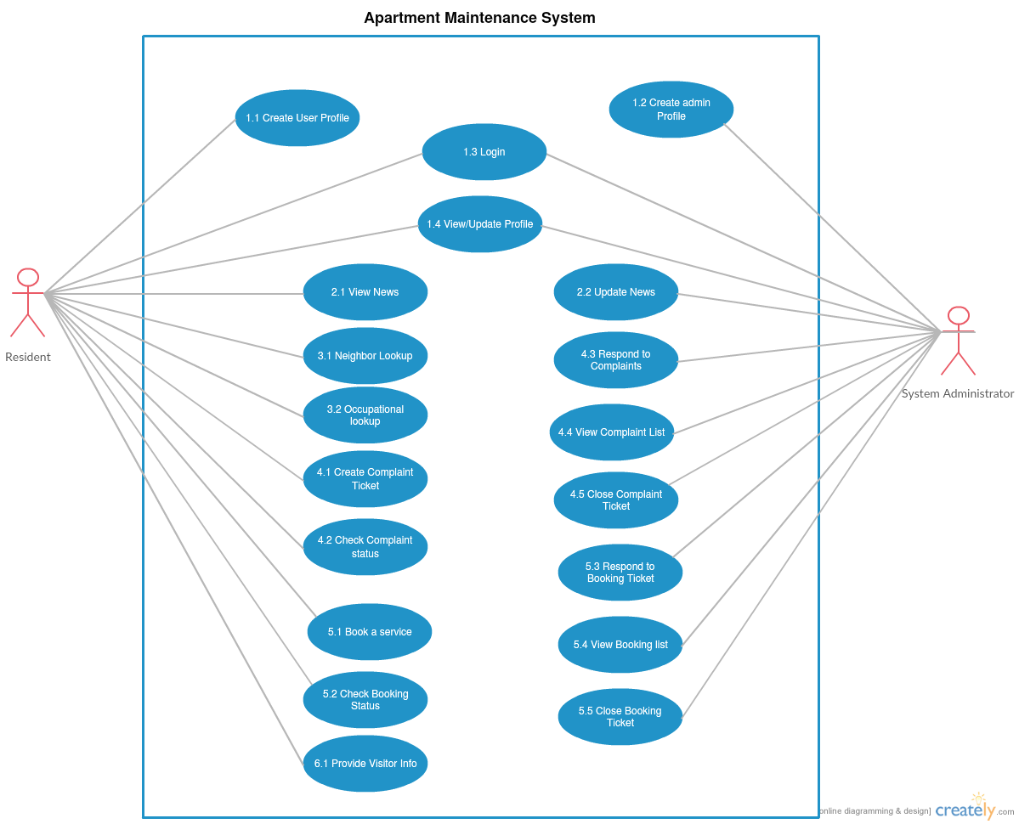
User Classes and Characteristics

Operating Environment

The software is web and mobile based, that makes it the sole reason of making the architect cloud based. Cloud system is Microsoft Windows Azure. Web technology is based on PHP (5.3.8 or 7.0.8) based framework Code-Igniter (3.1.0) and Slim 3 (for APIs). Database technology is based on MySQL and MongoDB.

Design and Implementation Constraints
Limitations would be the modification of the web app for some specific place which could lead to non-optimized functionality and hamper the functioning of the app. Internet being the backbone for this project availability to a good and decent internet is needed, slow internet on the admin side may lead to slower load and response time which could make the process slow. Maintainability can be obtained by onsite or offsite engineers so one can talk to management and work on a problem from other place without actually being present there.

Assumptions and Dependencies
This software depends on Azure cloud service by Microsoft which is a third-party service. Some functions may not work if this service is not available. For payment and access management it should be noted that third-party API's are used any bug in those API or any unstable update on those API's may damage the software and it working and may impair some of its functionality which could result in some down times. In some restricted environment there can be problems like slow internet or unavailability of service such as Azure on that network which could result in less optimal functioning to no functioning of the web app.

External Interface Requirements

User Interfaces

<Describe the logical characteristics of each interface between the software product and the users. This may include sample screen images, any GUI standards or product family style guides that are to be followed, screen layout constraints, standard buttons and functions (e.g., help) that will appear on every screen, keyboard shortcuts, error message display standards, and so on. Define the software components for which a user interface is needed. Details of the user interface design should be documented in a separate user interface specification.>

Hardware Interfaces
Supported device list for Apart-maint web application are any smart devices with a non-restricted internet connection this includes smart-phone, tablets etc. For Administrator side a Computer with a non-restricted internet connection and Good processing power and LAN is recommended. A Computer with Intel i5 or AMD A10+ processors and a basic graphic processor by NVIDIA or AMD is recommended. A router with good bandwidth compatibility 4+ LAN port support and cat 6 LAN cables are recommended. To access the web-app the internet is sufficient for Residents. However for easy working of the app on admin side, the recommended hardware should be used.

Software Interfaces
The web-app uses basic web browser which is available in any smart-device now a days. Also there is no restriction in the operating system as the app is online and readily available. Azure web service used for hosting the app is an open service which is available on any non-restricted internet. Interface Protocols for Azure service can be found at: Azure Web Service

Communications Interfaces
Web browser with HTML5 support and JavaScript support are needed which are there in most of the new smart-devices these days. Availability of internet with HTTP and HTTPS and without restrictions is a must. Administrator side should have a gigabit LAN communication for seamless communication.

System Features

Login
4.1.1 Description and Priority
A System feature to determine authenticate the user profile.
4.1.2 Stimulus/Response Sequences
The user i.e. the tenant will provide the username (mobile number) and password so that the credentials can be checked and be authenticated.

The user can then login to the system using these credentials and can also change the password. Once the update profile page is done update the data, then the user is redirected to the main user dashboard.

If the authentication fails, an error is displayed on the page stating “invalid details “ and if the user forgets their credentials they are given a chance to recover them.

The two phases for this module are the user phase and the admin phase.

Priority: High

4.1.3 Functional Requirements

Requirement Identifier | Name | Description
LP_1 | Login phase 1 | Check for username input box, Display error if input is anything other than 10 digit number (real time check)
LP_2 | Login phase 2 | Check for password input box
LP_3 | Login phase 3 | Input Data is transferred to controller in POST method.
LP_4 | Login phase 4 | User Phase and Admin Phase Check
LP_5 | Login phase 5 | Change password and Update Profile methods
LP_6 | Login phase 6 | Main User home page (if LPU_5 is user Phase)
LP_7 | Login phase 7 | Admin Home page

News System
4.2.1 Description and Priority
A feature to update about the current news of the apartment/society.

Priority: Low
4.2.2 Stimulus/Response Sequences
Two phases of this feature, one is the user phase and other is the admin phase.

The user phase (tenant) when is logged in to the website, a menu (named: News) shows the list of all happenings of the apartment/society/flat in form of news.

When the administrator is logged in the website, a menu is displayed (named: News) shows three sub menu’s:
- View News
- Edit/Delete News
- Add News
4.2.3 Functional Requirements
Requirement Identifier | Name | Description
NUP1 | News Phase 1 | First it is checked if the user is logged in, if yes then we check the phase.
NUP2 | News Phase 2 | If it is user phase, load the News System of user phase.
NUP3 | News Phase 3 | If it is the admin phase then we load the News System of admin phase.

Look UP
4.3.1 Description and Priority
A neighbor lookup feature, where the basic information about the respective neighbors nearby your house is known.

Priority: Medium

4.3.2 Stimulus/Response Sequences
There is only one phase the user phase.

The user or the tenant can check who are nearby neighbor in their floor or building depending on the structure of apartment, the number of houses.

This is auto generated and is the parameters for the function is just the house number. This system is only read only.

4.3.3 Functional Requirements
Requirement Identifier | Name | Description
LUP_1 | Look up phase 1 | Check if user is logged in or not, if yes then check the phase
LUP_2 | Look up phase 2 | If user phase, load the Neighbor system depending on the house number.
LUP_3 | Look up phase 3 | A List generator of nearby house which is only read-only.

Complaint System

4.4.1 Description and Priority
A complaint registering and tracking system. This feature allows the user (tenant) to book complaints such as lift breakdown, garbage collection problem, etc. And allows the user to track if the complaint has been resolved

Priority: Medium

4.4.2 Stimulus/Response Sequences
There are two phases the user phase and admin phase.

The user (tenant) can book a complaint and generate a complaint number, which can be used to track the complaint.

The admin (administrator) can view the complaint by all the tenants and can update the complaint number so that the tenant can know that the complaint has been resolved.

4.4.3 Functional Requirements
Requirement Identifier | Name | Description
CP_1 | Complaint phase 1 | Check if user is logged in or not, if yes then check the phase
CP_2 | Complaint phase 2 | If user phase, load the complaint booking method
CP_3 | Complaint phase 3 | Check the input from the user
CP_4 | Complaint phase 4 | If admin phase, load the complaint status method
CP_5 | Complaint phase 5 | Check the list of tickets generated for the moment and allot necessary employee for the requested tickets
CP_6 | Complaint phase 6 | Update the ticket number so that the user can track their complaint request

Service Booking
4.5.1 Description and Priority
A service booking feature which allows the tenant to book services such as electrician carpenter, housemaid etc. and also a tracking system allows administrators to update the tenant with the progress of the work and allows the user to track when the service person is going to be home.
Priority: High

4.5.2 Stimulus/Response Sequences
The two phases are user phase and admin phase.

The user can book a service and generate a booking number, which is used to track the booked service.

The administrator can view the booked service and allot the person for the service. He can update the booking number so that the tenant can know what is happening and can be updated about the same.

4.5.3 Functional Requirements
Requirement Identifier | Name | Description
SB_1 | System booking 1 | If the user is logged in check the phase.
SB_2 | System booking 2 | If user phase, load the booking method
SB_3 | System booking 3 | Take input from the user such as service type, work description etc.
SB_4 | System booking 4 | If it is the admin phase then we load the service tracking.
SB_5 | System booking 5 | Check the list of booking number generated for the moment and allot necessary employee for the requested tickets
SB_6 | System booking 6 | Update the booking number so that the user can track their service request

Visitor system
4.6.1 Description and Priority
A Visitor Alert feature to communicate the arrival of visitors of the apartment/society/flat residents to the security officials.

Priority: Low
4.6.2 Stimulus/Response Sequences
There are two phases of this feature, one is the user phase.

The user phase (tenant) when is logged in to the website, a menu (named: Visitor) will let them enter details of visitors including their expected time of arrival

4.6.3 Functional Requirements
Requirement Identifier | Name | Description
VSP_1 | Visitor phase system 1 | If user is logged in then we check the phase
VSP_2 | Visitor phase system 2 | if user phase is loaded then the visitor updated menu

Other Nonfunctional Requirements
Requirement Identifier | Name | Description
5.1 | Performance Requirements | The application is to work where all the tenants and administrator can work together on a real time system. Booking a service and complaining should be given highest priority from administrator point and hence solving problems.
5.2 | Safety Requirements | There are no safety requirements as such.
5.3 | Security requirements | Security concerns with this application consists of data loss such as data corruption and data manipulation.
5.4 | Software quality attributes | Availability- Only requires accessibility to Azure Web Services  Maintainability- Easy to maintain its services  Portability- Easily portable because of it being a web application.

Business Rules
<List any operating principles about the product, such as which individuals or roles can perform which functions under specific circumstances. These are not functional requirements in themselves, but they may imply certain functional requirements to enforce the rules.>

Other Requirements
<Define any other requirements not covered elsewhere in the SRS. This might include database requirements, internationalization requirements, legal requirements, reuse objectives for the project, and so on. Add any new sections that are pertinent to the project.>
Appendix A: Glossary
<Define all the terms necessary to properly interpret the SRS, including acronyms and abbreviations. You may wish to build a separate glossary that spans multiple projects or the entire organization, and just include terms specific to a single project in each SRS.>
Appendix B: Analysis Models
<Optionally, include any pertinent analysis models, such as data flow diagrams, class diagrams, state-transition diagrams, or entity-relationship diagrams.>
Appendix C: To Be Determined List
<Collect a numbered list of the TBD (to be determined) references that remain in the SRS so they can be tracked to closure.>

