Software Requirements Specification

for

Apart-maint
Version 1.0 approved
Prepared by: Nikhil Nair
Organization: Cosmo
Date: 18/09/2016
Table of Contents
Table of Contents ii
Revision History ii
1. Introduction 1
1.1 Purpose 1
1.2 Document Conventions 1
1.3 Intended Audience and Reading Suggestions 1
1.4 Product Scope 1
1.5 References 2
2. Overall Description 2
2.1 Product Perspective 2
2.2 Product Functions 2
2.3 User Classes and Characteristics 3
2.4 Operating Environment 4
2.5 Design and Implementation Constraints 4
2.6 User Documentation 4
2.7 Assumptions and Dependencies 4
3. External Interface Requirements 4
3.1 User Interfaces 4
3.2 Hardware Interfaces 5
3.3 Software Interfaces 5
3.4 Communications Interfaces 5
4. System Features 5
4.1 System Feature 1 5
4.2 System Feature 2 6
4.3 System Feature 3 7
4.4 System Feature 4 7
4.5 System Feature 5 9
4.6 System Feature 6 10

5. Other Non-functional Requirements 11
5.1 Performance Requirements 11
5.2 Safety Requirements 11
5.3 Security Requirements 11
5.4 Software Quality Attributes 11
5.5 Business Rules 11
6. Other Requirements 12
Appendix A: Glossary 12
Appendix B: Analysis Models 12
Appendix C: To Be Determined List 12

Revision History
Name | Date | Reason For Changes | Version

Introduction

Purpose
The purpose of the software is to create a digital environment where people living in same apartment/society/community can interact with each other and the authorities/management. This web/mobile application will provide a platform where the house owners can do home related task via computer. Inversely authorities can perform tasks like providing feedback and respond to complaints by the house owners. This web application also automatizes and digitize the function of a regular society procedures. This would also work as a virtual place where people can get updates and alerts on what is going around in the society, news about the society and upcoming events.

Document Conventions
This SRS follows the standard text conventions where the main heading is of font size 18, Sub heading is of size 14 and the text is of size 11px with Arial font. The document follows the standard Convention for numbering the contents of the text.

PHP - Pre Hypertext Processor.
HTML - Hypertext Markup Language.
Code-Igniter – A PHP based framework.
SQL- Structure Query Language
MongoDB- Database software
Microsoft Azure- Cloud database

Intended Audience and Reading Suggestions
This document is particularly intended for the potential clients and existing customers, remaining SRS document will explain every parameters of the product and the intended audience will have a wide range of content to dissect and analyze the product.

Product Scope
This Product is intended for the purpose of automation of the apartment/society/community and its working. The product will be used by home-owners and authorities to connect to each other on a virtual platform to save time and increase the efficiency of the current existing system which is manual in nature.

References
https://azure.microsoft.com/en-in/services/app-service/web/
https://www.codeigniter.com/docs
https://docs.mongodb.com/?_ga=1.50397930.270198069.1474191331

Overall Description

Product Perspective
This product is a self-contained project taking one objective in mind to create a simple yet efficient virtual working environment for the home owners and societies alike. Where people from same society can share and see who, what, when and where are all the things happening all around the neighborhood and be updated with their surroundings.

Product Functions
The product creates a platform for the users to do the following functions:

- Interact with neighbors via neighbor lookup and occupational lookup
- Service functionality allows you to book electrician, plumber etc. in a single click and track the progress of the same online.
- Complaint functionality solves the issues in and around the apartment environment
- Visitor system to improvise general security.
- News System allows you to remain updated about the society events

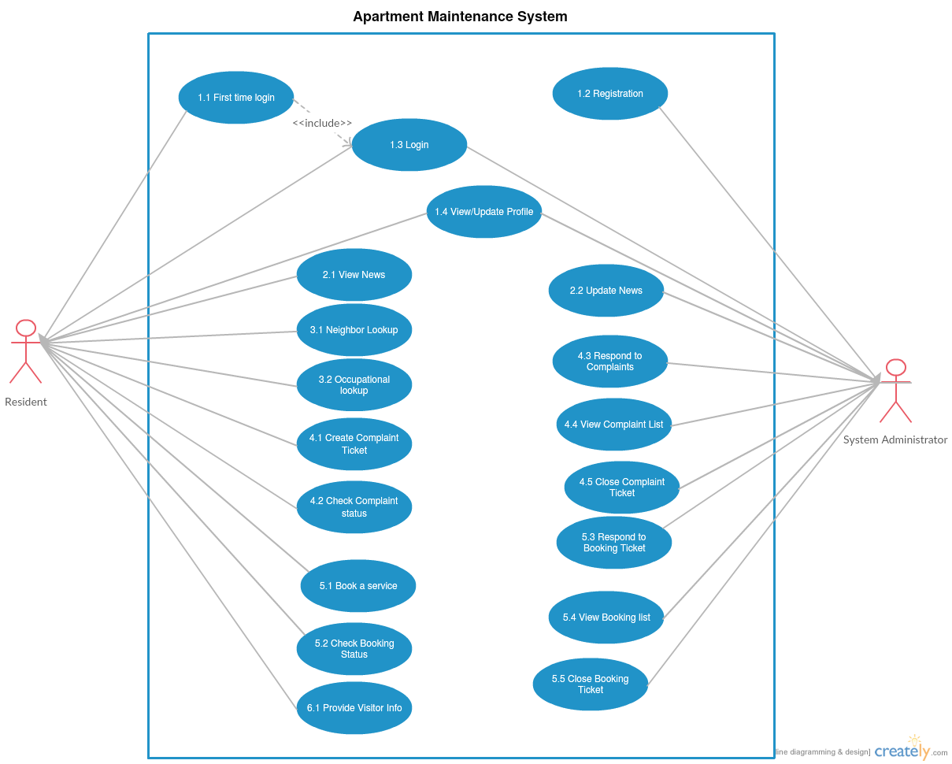
User Classes and Characteristics

Operating Environment

The software is web and mobile based, that makes it the sole reason of making the architect cloud based. Cloud system is Microsoft Windows Azure. Web technology is based on PHP (5.3.8 or 7.0.8) based framework Code-Igniter (3.1.0) and Slim 3 (for APIs). Database technology is based on MySQL and MongoDB.

Design and Implementation Constraints
Limitations would be the modification of the web app for some specific place which could lead to non-optimized functionality and hamper the functioning of the app. Internet being the backbone for this project availability to a good and decent internet is needed, slow internet on the admin side may lead to slower load and response time which could make the process slow. Maintainability can be obtained by onsite or offsite engineers so one can talk to management and work on a problem from other place without actually being present there.

Assumptions and Dependencies
This software depends on Azure cloud service by Microsoft which is a third-party service. Some functions may not work if this service is not available. For payment and access management it should be noted that third-party API's are used any bug in those API or any unstable update on those API's may damage the software and it working and may impair some of its functionality which could result in some down times. In some restricted environment there can be problems like slow internet or unavailability of service such as Azure on that network which could result in less optimal functioning to no functioning of the web app.

External Interface Requirements

User Interfaces

<Describe the logical characteristics of each interface between the software product and the users. This may include sample screen images, any GUI standards or product family style guides that are to be followed, screen layout constraints, standard buttons and functions (e.g., help) that will appear on every screen, keyboard shortcuts, error message display standards, and so on. Define the software components for which a user interface is needed. Details of the user interface design should be documented in a separate user interface specification.>

Hardware Interfaces
Supported device list for Apart-maint web application are any smart devices with a non-restricted internet connection this includes smart-phone, tablets etc. For Administrator side a Computer with a non-restricted internet connection and Good processing power and LAN is recommended. A Computer with Intel i5 or AMD A10+ processors and a basic graphic processor by NVIDIA or AMD is recommended. A router with good bandwidth compatibility 4+ LAN port support and cat 6 LAN cables are recommended. To access the web-app the internet is sufficient for Residents. However for easy working of the app on admin side, the recommended hardware should be used.

Software Interfaces
The web-app uses basic web browser which is available in any smart-device now a days. Also there is no restriction in the operating system as the app is online and readily available. Azure web service used for hosting the app is an open service which is available on any non-restricted internet. Interface Protocols for Azure service can be found at: Azure Web Service

Communications Interfaces
Web browser with HTML5 support and JavaScript support are needed which are there in most of the new smart-devices these days. Availability of internet with HTTP and HTTPS and without restrictions is a must. Administrator side should have a gigabit LAN communication for seamless communication.

System Features

Login
4.1.1 Description and Priority
Credential check function.
4.1.2 Stimulus/Response Sequences
End-User has been given credential to access to the portal and this function checks the credentials and if true, the End-user to re-directed to the main portal and if false the End-user is given error log message for the false trigger.

Priority: High

4.1.3 Functional Requirements
Requirement Identifier | Name | Description
LMUP_1 | Login Module User Phase_1 | Scan for username input box, Shoot error if input is anything other than 10 digit number.
LMUP_2 | Login Module User Phase_2 | Scan for password input box, Shoot error if input is anything other than alphabet.
LMUP_3 | Login Module User Phase_3 | Input Data is Switched to logic controller in POST method.
LMUP_4 | Login Module User Phase_4 | User Phase and Admin Phase Check
LMUP_5 | Login Module User Phase_5 | Initial Login Check
LMUP_6 | Login Module User Phase_6 | Change password and Update Profile methods (if LPU_5 is executed)
LMUP_7 | Login Module User Phase_7 | Main User Portal (if LPU_4 is user Phase)
LMUP_8 |  | Main Admin Portal (If LPU_4 is admin phase)

News System
4.2.1 Description and Priority
A news system feature to broadcast the news of the apartment/society/flat.

Priority: Low
4.2.2 Stimulus/Response Sequences
Two phases of this feature, one of them is user phase and the other is admin phase.

The End-User can view the news from the system, when logged in the portal.

The administrator when is logged into the website, can do the following

- View News
- Edit/Delete News
- Add News
4.2.3 Functional Requirements
Requirement Identifier | Name | Description
NSUP_1 | News System User Phase_1 | Check if user is logged in or not, if yes then check the phase
NSUP_2 | News System User Phase_2 | if user phase, load the News System of user phase
NSUP_3 | News System User Phase_3 | if admin phase, load the News System of admin phase

Look UP
4.3.1 Description and Priority
Information booth for the knowing the neighbors in the apartment for emergencies.

Priority: Medium

4.3.2 Stimulus/Response Sequences
One and only phase i.e. user

The End-user can use this information booth function to check who is living nearby, and this system is designed depending on the structure of the building.

Required parameter is house number of the user who is searching for neighbor.

4.3.3 Functional Requirements
Requirement Identifier | Name | Description
NLUP_1 | Neighbour Lookup User Phase_1 | Check if user is logged in or not, if yes then check the phase
NLUP_2 | Neighbour Lookup User Phase_2 | if user phase, load the Neighbor system depending on the house number
NLUP_3 | Neighbour Lookup User Phase_3 | A List generator of nearby house which is only read-only

Complaint System
4.4.1 Description and Priority
A Complaint booking system where the general common problems are logged, such as parking space issue, corridor cleanliness etc.

The End-user has to be logged in and required parameters are taken from the user profile automatically by the system, so only type of complaint and complaint string has to be submitted.

Priority: Medium

4.4.2 Stimulus/Response Sequences
Two phases i.e. user phase and admin phase.

In the user phase i.e. the End-user can complaint and generate 11 digit number, which is used to track the status

The admin phase i.e. the administrator can view the booked complaints by all the tenants. The administrator can update the ticket number and keep the tenant informed about the update through the portal and short message service.

4.4.3 Functional Requirements
Requirement Identifiers | Name | Description
CS_1 | Complaint Status_1 | Scan if user is logged in or not, if yes check the phase flag
CS_2 | Complaint Status_2 | If user phase flag is on, load the complaint booking method
CS_3 | Complaint Status_3 | Check the input string from the End-user such as complaint type and complaint string
CS_4 | Complaint Status_4 | If admin phase flag is on, load the complaint status method
CS_5 | Complaint Status_5 | Scan the list of tickets generated and allot necessary labors for the requested ticket
CS_6 | Complaint Status_6 | Update the ticket number so that the user can track their complaint request

Service Booking
4.5.1 Description and Priority

A Service booking system where the personal housing problems are logged, such as electrician, plumber, carpenter, housemaid etc.

The End-user has to be logged in and required parameters are taken from the user profile automatically by the system, so only type of service and service string has to be submitted.

Priority: High

4.5.2 Stimulus/Response Sequences
Two phases i.e. user phase and admin phase.

The user phase i.e. the tenant can book a service and generate a ticket number, which can be used to track the booked service. The booked service can be cancelled and nullified.

The admin phase i.e. the administrator can view the booked service by all the tenants and allot the right person for the service. The administrator can update the ticket number so that the tenant can know what is happening such as timing of arrival, estimated cost, hours of labor required etc.

Two phases i.e. user phase and admin phase.

In the user phase i.e. the End-user can book a service and generate 11 digit number, which is used to track the status of the service.

The admin phase i.e. the administrator can view the booked services by all the tenants. The administrator can update the ticket number and keep the tenant informed about the update through the portal and short message service.

4.5.3 Functional Requirements
Requirement Identifier | Name | Description
SB_1 | Service Booking_1 | Scan if user is logged in or not, if yes then check the phase
SB_2 | Service Booking_2 | If user phase flag is on, load the service booking method
SB_3 | Service Booking_3 | Check the input string from the End-user such as service type and service string
SB_4 | Service Booking_4 | If admin phase flag is on, load the service status method
SB_5 | Service Booking_5 | Scan the list of tickets generated and allot necessary labors for the requested ticket
SB_6 | Service Booking_6 | Update the ticket number so that the user can track their complaint request.

SS_1: Check if user is logged in or not, if yes then check the phase.
SS_2: If user phase, load the service booking method
SS_3: Check the input data from the user such as service type, work description and estimated amount of work and availability time.
SS_4: If admin phase, load the service tracking method
SS_5: Check the list of tickets generated for the moment and allot necessary employee for the requested tickets
SS_6: Update the ticket number so that the user can track their service request.

Visitor system
4.6.1 Description and Priority
A visitor notification feature to communicate the arrival of visitors of the apartment/society/flat residents to the security officials.

Priority: Low
4.6.2 Stimulus/Response Sequences
Two Phases i.e. user phase and admin phase.

User phase i.e. End-user when logged in the portal, a method called visitor allows users to enter details of their visitor who are going to visit them , so that no problems do not a rise at security check by the entry gate.

Admin Phase reads the data i.e. the list of visitors of the day can be viewed by the user.

4.6.3 Functional Requirements
Requirement Identifier | Name | Description
VUP_1 | Visitor User Phase_1 | Scan if user is logged in or not, if yes then check the phase.
VUP_2 | Visitor User Phase_2 | If user phase flag is on, load the visitor updated menu.
VUP_3 | Visitor User Phase_3 | If admin phase flag is on, load the visitor view menu.

Other Nonfunctional Requirements
Requirement ID | Name | Description
5.1 | Performance Requirements | The scenario where user and admin operations can flow smoothly is the best scenario. Complaint booking and service booking should be given the highest priority
5.2 | Safety Requirements | No safety requirements as such
5.3 | Security Requirements | Privacy issues include data corruption, data loss and identity theft. Most of the problems are solved by the usage of azure
5.4 | Software Requirements | Availability- Only requires accessibility to Azure Web Services  Maintainability- Easy to maintain its services  Portability- Easily portable because of it being a web application.  Re-usability- Can be used by each and every apartment anywhere in the country

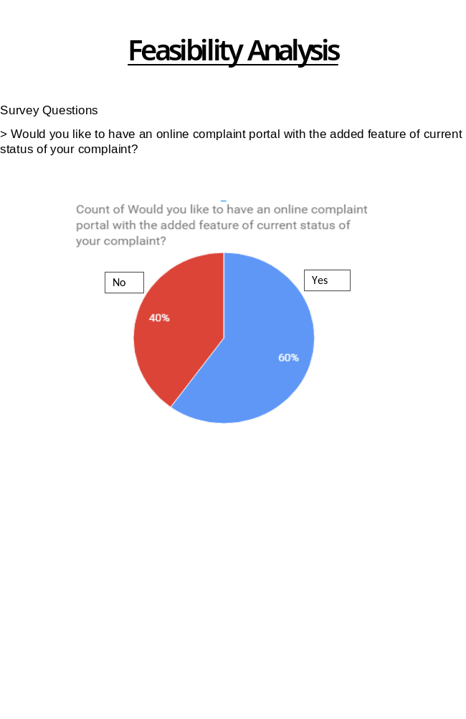

Other Requirements
<Define any other requirements not covered elsewhere in the SRS. This might include database requirements, internationalization requirements, legal requirements, reuse objectives for the project, and so on. Add any new sections that are pertinent to the project.>
Appendix A: Glossary
<Define all the terms necessary to properly interpret the SRS, including acronyms and abbreviations. You may wish to build a separate glossary that spans multiple projects or the entire organization, and just include terms specific to a single project in each SRS.>
Appendix B: Analysis Models
<Optionally, include any pertinent analysis models, such as data flow diagrams, class diagrams, state-transition diagrams, or entity-relationship diagrams.>
Appendix C: To Be Determined List
<Collect a numbered list of the TBD (to be determined) references that remain in the SRS so they can be tracked to closure.>

