Software Requirements Specification

for

Apart-maint
Version 1.0 approved
Prepared by: Mehak Bhatia
Organization: Cosmo
Date: 18/09/2016
Table of Contents
Table of Contents ii
Revision History ii
1. Introduction 1
1.1 Purpose 1
1.2 Document Conventions 1
1.3 Intended Audience and Reading Suggestions 1
1.4 Product Scope 1
1.5 References 2
2. Overall Description 2
2.1 Product Perspective 2
2.2 Product Functions 2
2.3 User Classes and Characteristics 3
2.4 Operating Environment 4
2.5 Design and Implementation Constraints 4
2.6 User Documentation 4
2.7 Assumptions and Dependencies 4
3. External Interface Requirements 4
3.1 User Interfaces 4
3.2 Hardware Interfaces 4
3.3 Software Interfaces 4
3.4 Communications Interfaces 4
4. System Features 4
4.1 System Feature 1 5
4.2 System Feature 2 6
4.3 System Feature 3 7
4.4 System Feature 4 7
4.5 System Feature 5 8
4.6 System Feature 6 9

5. Other Nonfunctional Requirements 10
5.1 Performance Requirements 10
5.2 Safety Requirements 10
5.3 Security Requirements 10
5.4 Software Quality Attributes 10
5.5 Business Rules 10
6. Other Requirements 10
Appendix A: Glossary 11
Appendix B: Analysis Models 11
Appendix C: To Be Determined List 11

Revision History
Name | Date | Reason For Changes | Version

Introduction

Purpose
We are developing a mobile as well as a web application that can provide a platform where the people owning an apartment can do home related task via computer. Also authorities can perform tasks like providing feedback and respond to complaints filed by their apartment’s owners. This could even work as a place where people can get updates and alerts on what is going around in the society and also news about the society and upcoming events.

Document Conventions
This SRS follows the standard text conventions where the main heading is of font size 18, Sub heading is of size 14 and the text is of size 11px with Arial font. The document follows the standard Convention for numbering the contents of the text.

PHP - Pre Hypertext Processor.
HTML - Hypertext Markup Language.
Code-Igniter – A PHP based framework.
SQL- Structure Query Language
MongoDB- Database software
Microsoft Azure- Cloud database

Intended Audience and Reading Suggestions
This document is particularly intended for the potential clients and existing customers. The following SRS document will give every insight of the product.

Product Scope
This Scope of the product is to provide a virtual ground to connect apartment-owners and the authorities. This Product will be able to save time and increase the efficiency of the current existing system which is manual in nature.

References
https://azure.microsoft.com/en-in/services/app-service/web/
https://www.codeigniter.com/docs

Overall Description

Product Perspective
This main objective of this product is to create a simple and efficient virtual working environment for the home owners and societies alike. Here people from same society can share and see what, when and where are all the things happening all around the neighborhood and be updated.

Product Functions
The product does the following functions:

- Interaction with the neighbors
- Book services online.
- File a complaint online.
- Information about incoming visitor if any.
- News system.

User Classes and Characteristics
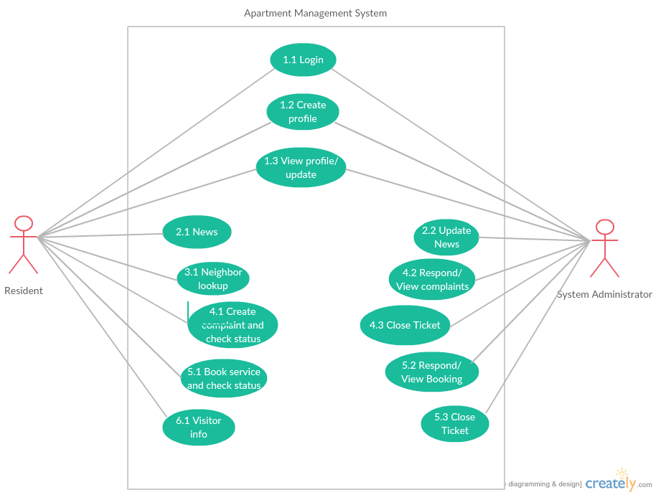

Operating Environment

This software is web and mobile based software which is why its architecture will be cloud based ie Microsoft Windows Azure. Web service is based on PHP based framework which will be Code-Igniter and Slim 3. Database services are based on MySQL and MongoDB.

Design and Implementation Constraints
In some restricted environment there can be problems like slow internet or unavailability of service such as Azure on that network which could result in less optimal functioning to no functioning of the web app.

Assumptions and Dependencies
Azure cloud service by Microsoft is what this software is dependent on. It is a third party software. Some functions embedded in our system may not work if this service is unavailable. There can also be problems like slow internet or unavailability of service such as Azure on that network which could result in improper functioning or no functioning of the web app.

External Interface Requirements

User Interfaces

<Describe the logical characteristics of each interface between the software product and the users. This may include sample screen images, any GUI standards or product family style guides that are to be followed, screen layout constraints, standard buttons and functions (e.g., help) that will appear on every screen, keyboard shortcuts, error message display standards, and so on. Define the software components for which a user interface is needed. Details of the user interface design should be documented in a separate user interface specification.>

Hardware Interfaces
Authorities are recommended to have a Computer with a smooth unrestricted internet. A Computer with Intel i5 or AMD A10+ processors and a basic graphic processor by NVIDIA or AMD is recommended. Internet is sufficient for users. For smooth working of the app at the admin side, the hardware mentioned above is recommended.

Software Interfaces
This app uses a web browser which can be found in any of the smart-devices that we own. In fact no restriction is found as far as the operating system is concerned as the app is online and easily available.

Communications Interfaces
Web browser which have HTML5 support and also have JavaScript support are required. Such browsers are available in most of the new smart-devices these days. Availability of unrestricted internet is a must. Authorities should have a LAN communication for seamless communication.

System Features

Login
4.1.1 Description and Priority
It is a feature to determine the user profile.
4.1.2 Stimulus/Response Sequences
The user provides the username (mobile number) and password so that he/she can be authenticated. Once authorized, depending on the user level, the portal is opened.

If the user is logging in for the first time, he/she is redirected to the update profile page so that all the necessary data fields which is required is filled by the user. Once the update profile page is done update the data, then the user is redirected to the main user dashboard.

If the authentication fails, an system error is thrown on the login page stating “invalid credentials “ and the user is given another chance to make a login account and fill the necessary details.

There are two phases for this module, one is the user phase and other is the admin phase.

Priority: High

4.1.3 Functional Requirements

REQUIREMENT IDENTIFIER | NAME | DESCRIPTION
LU_1 | Login User-1 | Will check the username and if it is anything other than a 10 digit number, sends error.
LU_2 | Login User-2 | Will check the password and sends error if anything other than alphabets or some symbols (<>, / *.) is found.
LU_3 | Login User-3 | It transfers the input data to the controller.
LU_4 | Login User-4 | Checks the user name and the administrator name.
LU_5 | Login User-5 | Checks whether the user is logging in for the first time.
LU_6 | Login User-6 | Helps in changing password if requested.
LU_7 | Login User-7 | User’s main dashboard.
LU_8 | Login User-8 | Admin’s main dashboard.

News System
4.2.1 Description and Priority
It is a News Alert feature to telecast the current news of the apartment/society/flat.

Priority: Low
4.2.2 Stimulus/Response Sequences
There are two phases of this feature, one is the user phase and other is the admin phase.

When the user logs in, a menu (named: News) shows the list of all happenings of the apartment in form of news.

When the admin is logged into the website, a menu (named: News) shows three sub menu’s:
- View News
- Edit/Delete News
- Add News

4.2.3 Functional Requirements

REQUIREMENT IDENTIFIER | NAME | DESCRIPTION
NU_1 | News user-1 | It figures out whether the user is logged in or not and if it is, then checks the phase.
NU_2 | News user-2 | If user phase is prevalent, loads the News System of user phase
NU_3 | News user-3 | If the phase is admin phase instead of user phase, loads the news system of the administrator phase.

Look UP
4.3.1 Description and Priority
It is a neighbor information system, where basic information about nearby house is known.

Priority: Medium

4.3.2 Stimulus/Response Sequences
This applies to only user phase.

The user can check who are nearby neighbor in their floor or building depending on the structure of apartment, the number of houses.

4.3.3 Functional Requirements

REQUIREMENT IDENTIFIER | NAME | DESCRIPTION
NLU_1 | Neighbor lookup-1 | If user is logged in, it checks the phase.
NLU_2 | Neighbor lookup-2 | Loads the Neighbor system depending on the house number if it’s the user phase
NLU_3 | Neighbor lookup-3 | A read-only list is generated by a list generator.

Complaint System
4.4.1 Description and Priority
It is a complaint booking system. This feature lets the tenants to file complaints such as breakdown of the lift, problems related to garbage, etc and the tracking system lets the authorities to update the user with the progress of action and also allows the user to track if the problem has been solved or not.

Priority: Medium

4.4.2 Stimulus/Response Sequences
There are two phases i.e. user phase and admin phase.

The user can make their complaint via generating a ticket number, which in fact is used to track the complaint.

The authorities can view the complaint by all the users and make a complaint portal. He/She can update the ticket number so as to let the user know that the problem is solved and that they can now relax.

4.4.3 Functional Requirements
REQUIREMENT IDENTIFIER | NAME | DESCRIPTION
CS_1 | Complaint service-1 | If the user is logged in, it checks the phase of in which he/she logged on.
CS_2 | Complaint service-2 | Loads the complaint booking method if the user logged in as user phase.
CS_3 | Complaint service-3 | Checks the complaint description and type from the user.
CS_4 | Complaint service-4 | It loads the status of the complaint if the phase is admin phase.
CS_5 | Complaint service-5 | The ticket generated list is checked along with allot necessary employee for the requested tickets.
CS_6 | Complaint service-6 | The ticket number is updated so that it can be tracked by the users who made request.

Service Booking
4.5.1 Description and Priority
It is a system for booking services. This allows the user to book services such as electrician, carpenter plumber etc. and the tracking system allows the authorities to provide the user with the progress such as time of reporting, allowing the user to track when is this service person reaching their home and how much they have to pay in order to get those services.

Priority: High

4.5.2 Stimulus/Response Sequences
There are two phases i.e. user phase and admin phase.

In the user phase the user can book a service thereby generating a ticket number, which in turn will be used to track the service booked. This service can also be cancelled within a certain time period.

In the admin phase the authorities can view the service booked by all the users and give the right person that service. The authorities can update the ticket number so that the user can know all about the timing of arrival, money they have to pay, hours of labor that person will be putting in, etc.

4.5.3 Functional Requirements
REQUIREMENT IDENTIFIER | NAME | DESCRIPTION
SB_1 | Service booking-1 | Checks the phase of the logged user.
SB_2 | Service booking-2 | Loads the service booking method if logged in as user phase.
SB_3 | Service booking-3 | Checks the description of work, and bounded time for work.
SB_4 | Service booking-4 | Loads the service tracking system if the user is logged in as an administrator.
SB_5 | Service booking-5 | Check list for tickets that are generated
SB_6 | Service booking-6 | The ticket number is updated so that service request can be tracked.

Visitor system
4.6.1 Description and Priority
It is a Visitor Alert feature to inform about the whereabouts of visitors of the apartment residents to the security officials/concerned authorities.

Priority: Low
4.6.2 Stimulus/Response Sequences
It only has the user phase.

When the user logs in to the website, a menu (named: Visitor) will let them enter details of visitors they are expecting including the time around which they are being expected.

4.6.3 Functional Requirements
REQUIREMENT IDENTIFIER | NAME | DESCRIPTION
VU_1 | Visitor user-1 | Checks the phase of the user which logs in.
VU_2 | Visitor user-2 | Loads the visitor updated menu if the phase is user phase.

Other Nonfunctional Requirements
REQUIREMENT ID | NAME | DESCRIPTION
5.1 | Performance Requirements | The suited environment for the app is where all the users and the authorities can work together on a real time system. Complaints and Service booking should be given highest priority from administrator point of view, as they are solving problems the tenant’s problems.
5.2 | Safety Requirements | No safety requirements.
5.3 | Security Requirements | Issues such as privacy and security of the users is concerned with this app as it can suffer problems such as data loss like identity theft, data corruption etc.  losses.
5.4 | Software quality attributes | Availability  Maintainability  Portability  Re-usability

Other Requirements
<Define any other requirements not covered elsewhere in the SRS. This might include database requirements, internationalization requirements, legal requirements, reuse objectives for the project, and so on. Add any new sections that are pertinent to the project.>
Appendix A: Glossary
<Define all the terms necessary to properly interpret the SRS, including acronyms and abbreviations. You may wish to build a separate glossary that spans multiple projects or the entire organization, and just include terms specific to a single project in each SRS.>
Appendix B: Analysis Models
<Optionally, include any pertinent analysis models, such as data flow diagrams, class diagrams, state-transition diagrams, or entity-relationship diagrams.>
Appendix C: To Be Determined List
<Collect a numbered list of the TBD (to be determined) references that remain in the SRS so they can be tracked to closure.>

