Software Requirements Specification

for

Apart-maint
Version 1.0 approved
Prepared by: Mehak Bhatia, Mrinal Pande, Nikhil Nair, Nikhita Agarwal, L. Sriram Aravind
Organization: Cosmo
Date: 18/09/2016
Table of Contents
Table of Contents ii
Revision History ii
1. Introduction 1
1.1 Purpose 1
1.2 Document Conventions 1
1.3 Intended Audience and Reading Suggestions 1
1.4 Product Scope 1
1.5 References 2
2. Overall Description 2
2.1 Product Perspective 2
2.2 Product Functions 2
2.3 User Classes and Characteristics 3
2.4 Operating Environment 4
2.5 Design and Implementation Constraints 4
2.6 User Documentation 4
2.7 Assumptions and Dependencies 4
3. External Interface Requirements 4
3.1 User Interfaces 4
3.2 Hardware Interfaces 4
3.3 Software Interfaces 5
3.4 Communications Interfaces 5
4. System Features 5
4.1 System Feature 1 5
4.2 System Feature 2 6
4.3 System Feature 3 7
4.4 System Feature 4 8
4.5 System Feature 5 9
4.6 System Feature 6 10

5. Other Non-functional Requirements 10
5.1 Performance Requirements 10
5.2 Safety Requirements 10
5.3 Security Requirements 11
5.4 Software Quality Attributes 11
5.5 Business Rules 11
6. Other Requirements 11
Appendix A: Glossary 11
Appendix B: Analysis Models 11
Appendix C: To Be Determined List 12

Revision History
Name | Date | Reason For Changes | Version

Introduction

Purpose
The purpose of the software is to create a digital environment where people living in same apartment/society/community can interact with each other and the authorities/management. This web/mobile application will provide a platform where the house owners can do home related task via computer. Inversely authorities can perform tasks like providing feedback and respond to complaints by the house owners. This web application also automatizes and digitize the function of a regular society procedures. This would also work as a virtual place where people can get updates and alerts on what is going around in the society, news about the society and upcoming events.

Document Conventions
This SRS follows the standard text conventions where the main heading is of font size 18, Sub heading is of size 14 and the text is of size 11px with Arial font. The document follows the standard Convention for numbering the contents of the text.

PHP - Pre Hypertext Processor.
HTML - Hypertext Markup Language.
Code-Igniter – A PHP based framework.
SQL- Structure Query Language
MongoDB- Database software
Microsoft Azure- Cloud database

Intended Audience and Reading Suggestions
This document is particularly intended for the potential clients and existing customers, remaining SRS document will explain every parameters of the product and the intended audience will have a wide range of content to dissect and analyze the product.

Product Scope
This Product is intended for the purpose of automation of the apartment/society/community and its working. The product will be used by home-owners and authorities to connect to each other on a virtual platform to save time and increase the efficiency of the current existing system which is manual in nature.

References
https://azure.microsoft.com/en-in/services/app-service/web/
https://www.codeigniter.com/docs
https://docs.mongodb.com/?_ga=1.50397930.270198069.1474191331

Overall Description

Product Perspective
This product is a self-contained project taking one objective in mind to create a simple yet efficient virtual working environment for the home owners and societies alike. Where people from same society can share and see who, what, when and where are all the things happening all around the neighborhood and be updated with their surroundings.

Product Functions
The product creates a platform for the users to do the following functions:

- Interact with neighbors via neighbor lookup and occupational lookup
- Service functionality allows you to book electrician, plumber etc. in a single click and track the progress of the same online.
- Complaint functionality solves the issues in and around the apartment environment
- Visitor system to improvise general security.
- News System allows you to remain updated about the society events

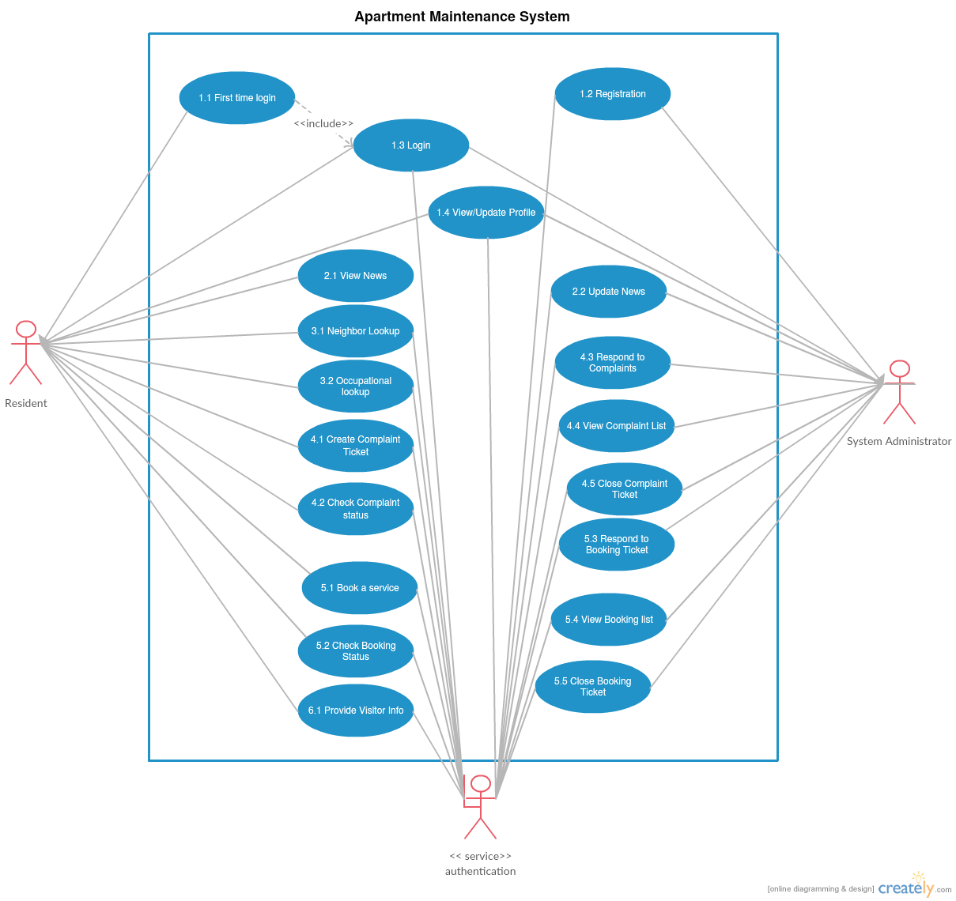
User Classes and Characteristics

Operating Environment

The software is web and mobile based, that makes it the sole reason of making the architect cloud based. Cloud system is Microsoft Windows Azure. Web technology is based on PHP (5.3.8 or 7.0.8) based framework Code-Igniter (3.1.0) and Slim 3 (for APIs). Database technology is based on MySQL and MongoDB.

Design and Implementation Constraints
Limitations would be the modification of the web app for some specific place which could lead to non-optimized functionality and hamper the functioning of the app. Internet being the backbone for this project availability to a good and decent internet is needed, slow internet on the admin side may lead to slower load and response time which could make the process slow. Maintainability can be obtained by onsite or offsite engineers so one can talk to management and work on a problem from other place without actually being present there.

Assumptions and Dependencies
This software depends on Azure cloud service by Microsoft which is a third-party service. Some functions may not work if this service is not available. For payment and access management it should be noted that third-party API's are used any bug in those API or any unstable update on those API's may damage the software and it working and may impair some of its functionality which could result in some down times. In some restricted environment there can be problems like slow internet or unavailability of service such as Azure on that network which could result in less optimal functioning to no functioning of the web app.

External Interface Requirements

User Interfaces

<Describe the logical characteristics of each interface between the software product and the users. This may include sample screen images, any GUI standards or product family style guides that are to be followed, screen layout constraints, standard buttons and functions (e.g., help) that will appear on every screen, keyboard shortcuts, error message display standards, and so on. Define the software components for which a user interface is needed. Details of the user interface design should be documented in a separate user interface specification.>

Hardware Interfaces
Supported device list for Apart-maint web application are any smart devices with a non-restricted internet connection this includes smart-phone, tablets etc. For Administrator side a Computer with a non-restricted internet connection and Good processing power and LAN is recommended. A Computer with Intel i5 or AMD A10+ processors and a basic graphic processor by NVIDIA or AMD is recommended. A router with good bandwidth compatibility 4+ LAN port support and cat 6 LAN cables are recommended. To access the web-app the internet is sufficient for Residents. However for easy working of the app on admin side, the recommended hardware should be used.

Software Interfaces
The web-app uses basic web browser which is available in any smart-device now a days. Also there is no restriction in the operating system as the app is online and readily available. Azure web service used for hosting the app is an open service which is available on any non-restricted internet. Interface Protocols for Azure service can be found at: Azure Web Service

Communications Interfaces
Web browser with HTML5 support and JavaScript support are needed which are there in most of the new smart-devices these days. Availability of internet with HTTP and HTTPS and without restrictions is a must. Administrator side should have a gigabit LAN communication for seamless communication.

System Features

Login
4.1.1 Description and Priority
An Authentication feature to determine the user profile.
4.1.2 Stimulus/Response Sequences
The user provides the username (mobile number) and password so that the credentials can be checked and be authenticated. Once authorized, depending on the user level, the portal is opened.

If the user is logging in for the first time, since the password is an OTP and it is risky to use simple combination of numbers as password. The user is request to change password with a certain combination of alphabets and symbols and then the user is redirected to the update profile page so that all the necessary data fields which is required is filled by the user. Once the update profile page is done update the data, then the user is redirected to the main user dashboard.

If the authentication fails, an system error is thrown on the login page stating “invalid credentials “ and the user by any chance forgets his credentials is given a chance to recover them.

There are two phases for this module, one is the user phase and other is the admin phase.

Priority: High

4.1.3 Functional Requirements

Requirement Identifier | Name | Description
LPU_1 | Login Phase User 1 | Check for username input box, Throw error if input is anything other than 10 digit number (real time check)
LPU_2 | Login Phase User 2 | Check for password input box, Throw error if input is anything other than alphabet, special symbol except → (<>,/*.)
LPU_3 | Login Phase User 3 | Input Data is transferred to controller in POST method.
LPU_4 | Login Phase User 4 | User Phase and Admin Phase Check
LPU_5 | Login Phase User 5 | First time Login Check
LPU_6 | Login Phase User 6 | Change password and Update Profile methods (if LPU_5 is executed)
LPU_7 | Login Phase User 7 | Main User Dashboard (if LPU_4 is user Phase)
LPU_8 | Login Phase User 8 | Main Admin Dashboard (If LPU_4 is admin phase)
LPU_9 | Login Phase User 9 | Register all the apartment users

News System
4.2.1 Description and Priority
A News Alert feature to telecast the current news of the apartment/society/flat.

Priority: Low
4.2.2 Stimulus/Response Sequences
There are two phases of this feature, one is the user phase and other is the admin phase.

The user phase (tenant) when is logged in to the website, a menu (named: News) shows the list of all happenings of the apartment/society/flat in form of news.

The admin phase (administrator) when is logged into the website, a menu (named: News) shows three sub menu’s:
- View News
- Edit/Delete News
- Add News
4.2.3 Functional Requirements

Requirement Identifier | Name | Description
NPU_1 | News Phase User 1 | Check if user is logged in or not, if yes then check the phase.
NPU_2 | News Phase User 2 | if user phase, load the News System of user phase.
NPU_3 | News Phase User 3 | if admin phase, load the News System of admin phase.

Look UP
4.3.1 Description and Priority
A neighbor information system, where basic information about nearby house is known.

Priority: Medium

4.3.2 Stimulus/Response Sequences
There is only one phase, i.e. user phase.

The user (tenant) can check who are nearby neighbor in their floor or building depending on the structure of apartment, the number of houses.

This is auto generated and is the parameters for the function is just the house number. This system is only read only.

4.3.3 Functional Requirements
Requirement Identifiers | Name | Description
NLPU_1 | Neighbor Lookup 1 | Check if user is logged in or not, if yes then check the phase
NLPU_2 | Neighbor Lookup 2 | If user phase, load the Neighbor system depending on the house number.
NLPU_3 | Neighbor Lookup 3 | A list generator of nearby house which is only read-only.

.

Complaint System
4.4.1 Description and Priority
A complaint booking system. This feature allows the user (tenant) to book complaints such as lift breakdown, garbage collection problem, etc and the tracking system allows administrators to update the user with the progress such as course of action, allows the user to track if the complaint has been resolved

Priority: Medium

4.4.2 Stimulus/Response Sequences
There are two phases i.e. user phase and admin phase.

The user phase i.e. the tenant can book a complaint and generate a ticket number, which can be used to track the complaint.

The admin phase i.e. the administrator can view the complaint by all the tenants and tunnel the complaints together. The administrator can update the ticket number so that the tenant can know that the complaint has been resolved

4.4.3 Functional Requirements
Requirement Identifiers | Name | Description
CS_1 | Complaint System 1 | Check if user is logged in or not, if yes then check the phase
CS_2 | Complaint System 2 | If user phase, load the complaint booking method
CS_3 | Complaint System 3 | Check the input data from the user such as complaint type and complaint description.
CS_4 | Complaint System 4 | If admin phase, load the complaint status method
CS_5 | Complaint System 5 | Check the list of tickets generated for the moment and allot necessary employee for the requested tickets
CS_6 | Complaint System 6 | Update the ticket number so that the user can track their complaint request

Service Booking
4.5.1 Description and Priority
A service booking system. This feature allows the user (tenant) to book services such as electrician, plumber, carpenter, housemaid etc. and the tracking system allows administrators to update the user with the progress such as time of reporting , allows the user to track when the service person is going to be at home and how much it is going to cost.

Priority: High

4.5.2 Stimulus/Response Sequences
There are two phases i.e. user phase and admin phase.

The user phase i.e. the tenant can book a service and generate a ticket number, which can be used to track the booked service. The booked service can be cancelled and nullified.

The admin phase i.e. the administrator can view the booked service by all the tenants and allot the right person for the service. The administrator can update the ticket number so that the tenant can know what is happening such as timing of arrival, estimated cost, hours of labor required etc.

4.5.3 Functional Requirements
Requirement ID | Name | Description
SS_1 | Service System_1 | Check if user is logged in or not, if yes then check the phase
SS_2 | Service System_2 | If user phase, load the service booking method
SS_3 | Service System_3 | Check the input data from the user such as service type, work description and estimated amount of work and availability time.
SS_4 | Service System_4 | If admin phase, load the service tracking method
SS_5 | Service System_5 | Check the list of tickets generated for the moment and allot necessary employee for the requested tickets
SS_6 | Service System_6 | Update the ticket number so that the user can track their service request.

Visitor system
4.6.1 Description and Priority
A Visitor Alert feature to communicate the arrival of visitors of the apartment/society/flat residents to the security officials.

Priority: Low
4.6.2 Stimulus/Response Sequences
There are two phases of this feature, one is the user phase.

The user phase (tenant) when is logged in to the website, a menu (named: Visitor) will let them enter details of visitors including their expected time of arrival

4.6.3 Functional Requirements
Requirement ID | Name | Description
VPU_1 | Visitor Phase User 1 | Check if user is logged in or not, if yes then check the phase.
VPU_2 | Visitor Phase User 2 | if user phase, load the visitor updated menu

Other Nonfunctional Requirements
Requirement ID | Name | Description
5.1 | Performance Requirements | The optimal working environment for the app to work is where all the users and administrator can work together on a real time system. Service booking and complaints should be given highest priority from administrator point of view as they are serving the residents and solving problems.
5.2 | Safety Requirements | There are no safety requirements as such
5.3 | Security Requirements | Privacy issues and security concerns with this app consists of data loss such as identity theft, data corruption. Using Azure platform we regulate the security concerns to the application. Most of the data hosted is secured by the platform and avoids such losses.
5.4 | Software Requirements | Availability- Only requires accessibility to Azure Web Services  Maintainability- Easy to maintain its services  Portability- Easily portable because of it being a web application.  Re-usability- Can be used by each and every apartment anywhere in the country

Other Requirements
<Define any other requirements not covered elsewhere in the SRS. This might include database requirements, internationalization requirements, legal requirements, reuse objectives for the project, and so on. Add any new sections that are pertinent to the project.>
Appendix A: Glossary
<Define all the terms necessary to properly interpret the SRS, including acronyms and abbreviations. You may wish to build a separate glossary that spans multiple projects or the entire organization, and just include terms specific to a single project in each SRS.>
Appendix B: Analysis Models
<Optionally, include any pertinent analysis models, such as data flow diagrams, class diagrams, state-transition diagrams, or entity-relationship diagrams.>
Appendix C: To Be Determined List
<Collect a numbered list of the TBD (to be determined) references that remain in the SRS so they can be tracked to closure.>

