Feasibility Analysis

Survey Questions
> Would you like to have an online complaint portal with the added feature of current status of your complaint?
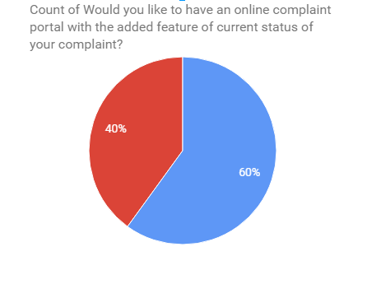

> Are you comfortable paying bills online?

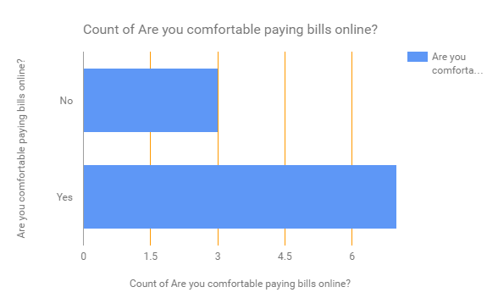

> Do you face difficulties when hiring an electrician, plumbers etc?

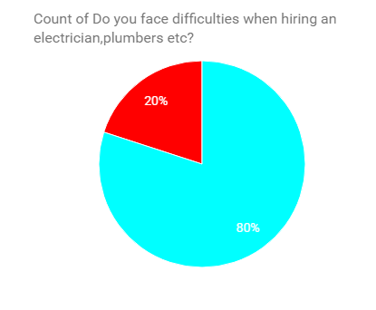

> Would you like a system which automatically updates you about all your society events?

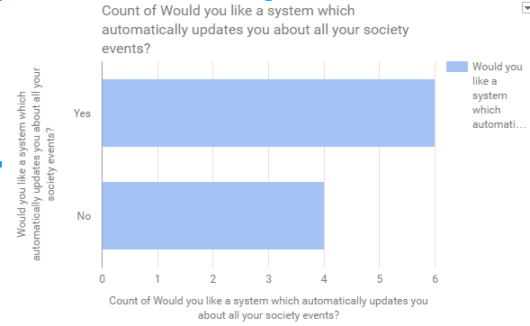

> Would you like to have an online system which will notify your security guard when you are expecting visitors?
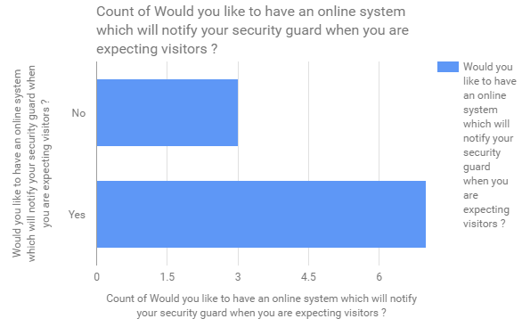

Feasibility Analysis of the above survey:

>What if the system isn’t implemented?
- As we know everything is digital these days since there is more and more demand for things to be automated it.

- Automation of house maintaining is a easy to maintain and easy accesss thing which can be useful as people are living on the go lives.
- Awareness is a major issue in the people as people these days don't know who live beside them.
- Paying the maintenance which is a manual task and takes time helps in many ways such as reducing labor, time and wastage of paper.

>What are the current process problems?
- Manual logs to keep records such as maintainence etc.
- Complaining is a manual task which require the resident to go and lodge it which takes time.
- Events happening in and around the society are not known.
- Requesting for a service like electrition, others requires resident to manually check if the thing has been done.
- Determining the financial cycle of the management is a long process.

>How will the proposed system help?
- The proposed system will help you automatize the apartment/society/community management for better communication and make the apartment life easier.
- It will automate all your monthly and annual bills and keep all the accounts online.
- The system will help us maintain a track of all the expenses and help in providing complete transparency.
- Ensure better safety and security in your apartment.
- Help you build better network with our neighbours.
- Update you on all the Events, news and services in and around your neighbourhood.
- Maintains an online record of all the visitors in the society as well as the domestic staff removing the manual regular register.

>What will be the integration problems?
- For payment and access management it should be noted that third-party API's are used. Any bug in those API or any unstable update on those API's may damage the software and its working and may impair some of its functionality which could result in some down times.
- Internet being the backbone for this project, availability of a good and decent internet is needed both on user and admin side.
- Slow internet on the admin side may lead slow response times.

> Is new technology needed? What skills?
Basic Computer skills are needed which are mostly in all people these days. No new technology as such is needed.

> What facilities must be supported by the proposed system?
- This product is a self-contained project for the home owners and societies where people from same society can share and see what, when and where are all the things happening all around the neighborhood and be updated with their surroundings.
- The product creates platform for the user to:
a) Pay bills for entities such as maintenance, electricity, taxes (home, water).
- Interact with neighbors
- Service functionality allows you to book electrician, plumber etc. in a single click and track the progress of the same online.
- Complaint functionality solves the issues in and around the apartment environment
- Visitor system to improvise general security

