**Optimized Cursor Browser UI Prompts for SpotifyEcho Integration**

# Repository Analysis: EchoTune AI Music Discovery Platform

Based on analysis of the Spotify-echo repository, this is a sophisticated **AI-powered music discovery platform** with:

# Technical Stack

**Backend**: Node.js, Express.js, [Socket.io](http://socket.io/)

**Frontend**: React, Material-UI

**Database**: MongoDB (primary), SQLite (fallback)

**AI Integration**: Multi-provider LLM support OpenAI GPT 4o, Google Gemini 2.0, Claude 3.5

**Music APIs**: Spotify Web API with OAuth integration

**Infrastructure**: Docker, nginx, automated deployment

# Key Features

Conversational AI for music discovery

Advanced recommendation algorithms (collaborative + content-based filtering)

Real-time analytics dashboard

Progressive Web App capabilities

Comprehensive settings management

**Cursor Prompt Templates for GitHub Coding Agent Integration**

# Repository Context & MCP Setup Prompt

You are working on EchoTune AI, an advanced music discovery platform built with Node.js,

* Multi-provider LLM integration in `/src/chat/llm-providers/`
* Spotify API services in `/src/spotify/`
* ML recommendation engine in `/src/ml/`
* React components in `/src/frontend/components/`- MongoDB analytics in `/src/api/routes/`

CONTEXT RULES:

* Always consider the existing multi-LLM architecture when suggesting integrations
* Maintain compatibility with current Spotify OAuth flow
* Preserve the analytics dashboard functionality
* Follow the established error handling patterns in `chatbot.js`

MCP SERVERS TO LEVERAGE:

* GitHub MCP Server: For repository operations and PR automation
* Perplexity MCP Server: For music research and trend analysis
* Memory MCP Server: For conversation context across sessions
* Fetch MCP Server: For external music API integrations

When making changes, always:

1. Run existing tests first
2. Check compatibility with current LLM providers
3. Maintain the analytics tracking system
4. Update relevant documentation

# Perplexity Research Integration Prompt

SYSTEM: You are enhancing EchoTune AI with Perplexity API integration for real-time music TASK: Integrate Perplexity Sonar for music discovery research within the existing chat sy

REQUIREMENTS:

* Add Perplexity provider to `/src/chat/llm-providers/perplexity-provider.js`- Follow the existing provider interface pattern from `openai-provider.js`
* Use Perplexity for queries about:
  + Latest music trends and releases
  + Artist information and discography
  + Genre analysis and recommendations
  + Music industry news and insights

INTEGRATION POINTS:

* Modify `/src/chat/model-registry.js` to include Perplexity Sonar
* Update `/src/frontend/components/EnhancedChatInterface.jsx` for research mode
* Add research capabilities to conversation context- Maintain existing analytics tracking

CODE STYLE:

* Follow existing async/await patterns
* Use the established error handling from `chatbot.js`
* Maintain compatibility with current conversation flow
* Add appropriate logging for analytics dashboard

PERPLEXITY USAGE EXAMPLES:

* "What are the latest indie rock trends in 2025?"
* "Research artists similar to [current playing track]"
* "Find upcoming releases in [user's preferred genres]"

# GitHub Actions Automation Prompt

SYSTEM: You are setting up GitHub Actions workflows for EchoTune AI to automate music res

CURRENT SETUP:

-

Repository: dzp5103/Spotify-echo

-

Deployment: DigitalOcean with Docker

* Testing: npm test, linting enabled
* Environment: Node.js, MongoDB, Redis

CREATE WORKFLOWS FOR:

1. **Music Research Automation** (`.github/workflows/music-research.yml`)
   * + Trigger: Weekly schedule + manual dispatch
     + Use Perplexity API to research music trends
     + Update recommendation algorithms with new data
     + Generate weekly music industry insights report
2. **Code Quality with AI Review** (`.github/workflows/ai-code-review.yml`)
   * + Trigger: Pull requests to main
     + Use Grok-4 via OpenRouter for code analysis
     + Focus on music recommendation algorithm improvements
     + Check integration points with Spotify API
3. **Dependency Updates** (`.github/workflows/dependency-research.yml`)
   * Research new music/AI libraries using Perplexity
   * Check compatibility with current multi-LLM setup - Auto-create PRs for relevant updates

SECURITY:

* + Store API keys in GitHub Secrets: PPLX_API_KEY, OPENROUTER_KEY
  + Use minimal permissions for tokens
  + Include rate limiting for API calls

INTEGRATION WITH EXISTING:

* + Respect current Docker deployment setup
  + Maintain DigitalOcean deployment workflow - Preserve existing test suite and linting

# MCP Server Integration Prompt

You are integrating MCP servers into EchoTune AI for enhanced GitHub coding agent workflo

CURRENT ARCHITECTURE:

* Multi-provider chat system with OpenAI, Gemini, Claude
* Spotify OAuth integration and audio analysis
* Real-time analytics with MongoDB
* React frontend with Material-UI

MCP INTEGRATION STRATEGY:

1. **GitHub MCP Server**
   * Auto-generate issues for music feature requests
   * Create PRs for recommendation algorithm updates
   * Manage release notes with music discovery improvements
2. **Perplexity MCP Server**
   * Research music trends for recommendation tuning
   * Analyze user feedback patterns
   * Generate insights for analytics dashboard
3. **Memory MCP Server**

- Maintain conversation context across music discovery sessions

- Store user music preferences persistently

- Track recommendation effectiveness over time

4

. **Filesystem MCP Server**

- Manage music analysis data files

- Handle playlist exports and imports

- Organize training data for ML algorithms

CURSOR CONFIGURATION:

```json

{

"github-music": {

"command": "node",

"args": ["./mcp-servers/github-mcp.js"],

"env": {

"GITHUB_TOKEN": "ghp_your_token",

"REPO": "dzp5103/Spotify-echo"

}

},

"perplexity-research": {

"command": "node",

"args": ["./mcp-servers/perplexity-mcp.js"],

"env": {

"PPLX_API_KEY": "pplx_your_key"

}

}

}

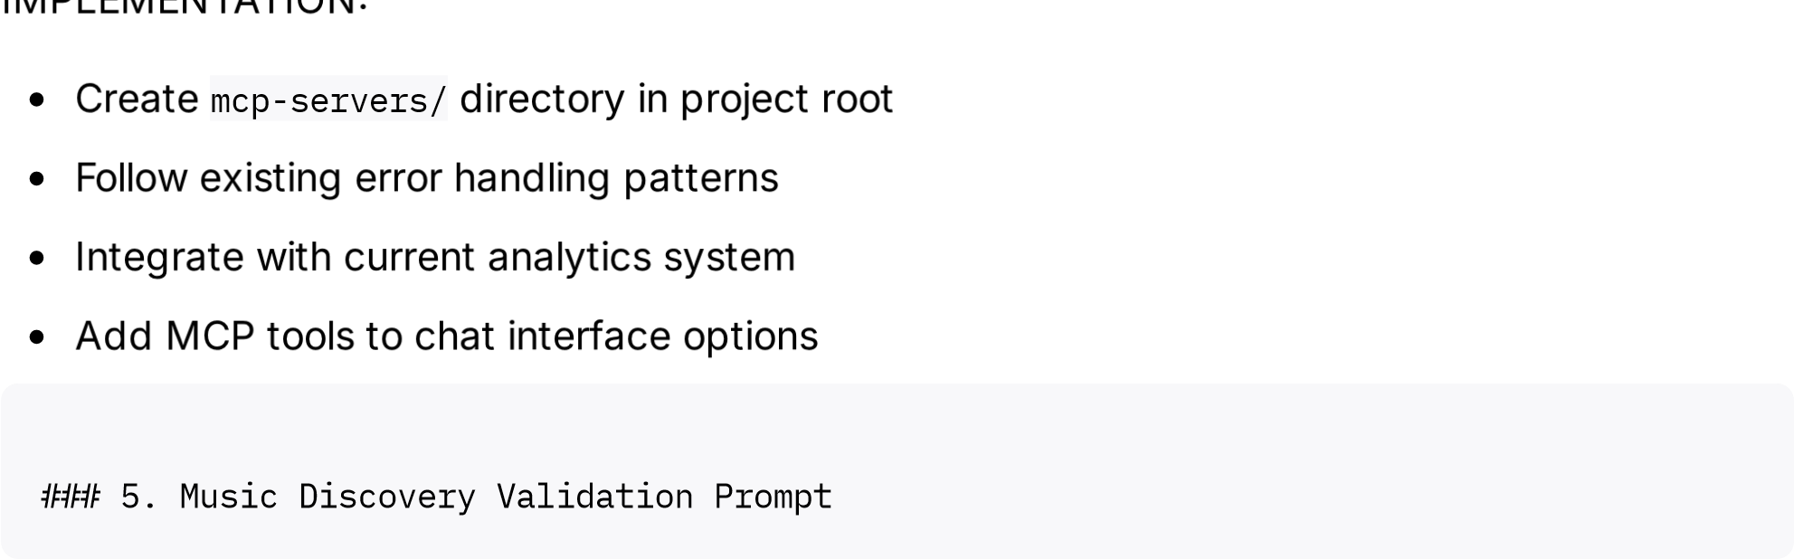

SYSTEM You are validating and improving EchoTune AI's music discovery algorithms using AI powered analysis.

VALIDATION FRAMEWORK Current recommendation engine combines:

Collaborative filtering (user behavior)

Content-based filtering (audio features)

ML models in /src/ml/recommendation-engine.js

VALIDATION TASKS

**Algorithm Performance Analysis**

Use Perplexity to research latest recommendation system improvements

Analyze user engagement metrics from analytics dashboard

Compare current algorithms with industry standards

**A/B Testing Integration**

Set up experiments for different recommendation strategies

Use GitHub Actions to automatically test algorithm variants

Track success metrics: saves, plays, user ratings

**Real-time Quality Monitoring**

Monitor recommendation relevance using chat feedback

Use MCP servers to flag unusual patterns

Auto-adjust parameters based on user satisfaction

CODE QUALITY CHECKS

Validate audio feature analysis accuracy

Test Spotify API error handling robustness

Ensure recommendation explanations are meaningful

Monitor response times for music discovery

RESEARCH INTEGRATION

Use Perplexity for competitive analysis of music platforms

Research emerging audio analysis techniques

Stay updated on Spotify API changes and new features

AUTOMATION

### 6. Roadmap Management Prompt

Auto

-

generate

reports

on

recommendation

effectiveness

Create

GitHub

issues

for

algorithm

improvements

Schedule

regular

model

retraining

based

on

new

data

You are managing the EchoTune AI roadmap using AI-powered research and GitHub integration.

CURRENT ROADMAP STATUS

✅ Phase 1 Enhanced Intelligence Multi-LLM, Real-time Analytics, PWA

Phase 2 Social Features Friend recommendations, Collaborative playlists)

Phase 3 Platform Expansion Multi-platform, Enterprise features) Phase 4 Innovation Advanced AI, VR/AR, Music therapy)

ROADMAP AUTOMATION

**Research-Driven Planning**

Use Perplexity to research music industry trends

Identify emerging technologies for integration

Analyze competitor features and market gaps

**GitHub Project Management**

Auto-create roadmap issues with AI-generated descriptions

Link features to code changes using GitHub MCP

Track progress with automated milestone updates

**Stakeholder Updates**

Generate weekly progress reports using analytics data

Create technical documentation from code changes

Maintain changelog with AI-assisted descriptions

INTEGRATION PRIORITIES

Multi-platform music service support Apple Music, YouTube Music)

Advanced social features with privacy controls

Enterprise-grade analytics and insights

Therapeutic music applications research

PROMPT TEMPLATES FOR ROADMAP

"Research latest developments in [music tech area]"

"Analyze feasibility of [proposed feature] integration"

"Generate technical specification for [roadmap item]"

"Identify dependencies for [upcoming milestone]" Use GitHub MCP to automatically:

## Usage Instructions

1

. **Copy the appropriate prompt** based on your current task

)

. **Paste into Cursor's Composer** (Cmd/Ctrl + I

2

. **Add specific context** about what you're working on

3

. **Let the AI provide tailored solutions** for your EchoTune AI codebase

4

Create

epic

issues

for

major

features

Link

research

findings

to

development

tasks

Update

project

boards

based

on

progress

Generate

release

notes

from

commits

These prompts are optimized for the Spotify-Echo repository's architecture and will provi