**MULTIPLE CHOICE/S: Read and analyze the following statement then choose the best answer on the choices provided.**

**No. of Items:** 41 **Total Points:** 100 pts

1. What is a well-defined procedure that allows an agent to solve a particular problem?

a) Process

b) Algorithm

c) Flowchart

d) Program Flow

2. What is NOT a characteristic of an algorithm?

a) Well-ordered

b) Easy to perform

c) Must terminate

d) Ambiguous

3. Which flowchart symbol represents an I/O operation?

a) 

b) 

c) 

d) 

4. Which flowchart symbol might represent a loop?

a) 

b) 

c) 

d) 

5. Which flowchart symbol represents that a certain flow connects to an additional diagram not found on the current page?

a) 

b) 

c) 

d) 

6. Based on the image given, what flowchart structure is being represented?

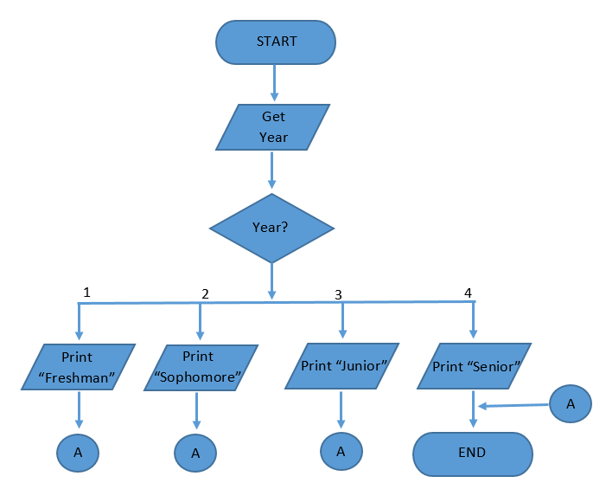

a) Loop

b) Sequence

c) Decision

d) Case

7. Based on the image given, what flowchart structure is being represented?

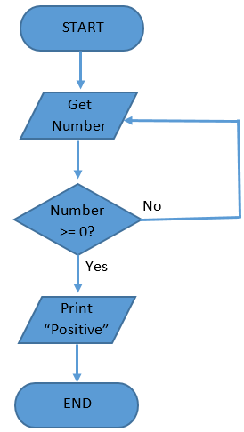

a) Loop

b) Sequence

c) Condition

d) Case

8. What was the original proposed name for Java?

a) C

b) Oat

c) Oak

d) Java Coffee

9. What technology contain a complete set of class files for all types of Java technology packages?

a) JVM

b) SDK

c) JDK

d) JRE

10. After compiling a Java source code, what file will be generated and stored on the storage device?

a) .class file

b) .exe file

c) .java file

d) .jar file

11. What method does all program execution happen in Java?

a) constructor method

b) accessor method

c) executor method

d) main method

12. What is the term used to refer to one or more statements bound by an open and close curly brace?

a) statement

b) body

c) block

d) class

13. Which among the following is a valid identifier name?

a) *number

b) number$

c) number*

d) -number

14. Which among the following is a valid identifier name?

a) _lastname

b) -lastname

c) %lastname

d) &lastname

15. What Java literal is enclosed in double quotation marks?

a) Character

b) Boolean

c) Integral

d) String

16. What Java literal can be represented in either decimal, octal or hexadecimal?

a) Character

b) Boolean

c) Integral

d) String

17. What data typecan only have either one of two values, true or false?

a) int

b) boolean

c) char

d) String

18. What symbol represents an operation that will return the remainder or two operands?

a) /

b) %

c) $

d) |

19. What symbol evaluates two or more relational expressions and results to a true value if and only if all expressions are true?

a) ^

b) |

c) &

d) !

20. What symbol evaluates two or more relational expressions and results to a true value if and only if all expressions result in different values?

a) ^

b) |

c) &

d) !

21. Given the Java source code, what line would produce a syntax error?

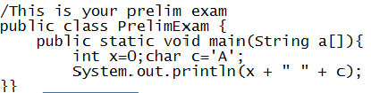

a) Line 1

b) Line 3

c) Line 4

d) Line 6

22. Given the Java source code, what line would produce a syntax error?

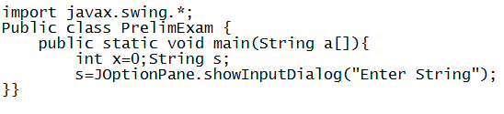

a) Line 1

b) Line 2

c) Line 3

d) Line 4

23. Given the Java source code, what line would produce a syntax error?

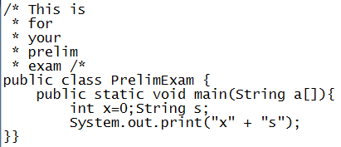

a) Line 1

b) Line 2

c) Line 5

d) Line 8

24. Given the following code fragment, what value would be contained in variable r?

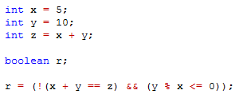

a) true

b) false

25. Given the following code fragment, what value would be contained in variable r?

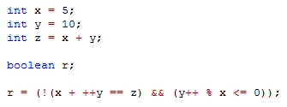

a) true

b) false

26. Given the following code fragment, what value would be final value contained in variable x?

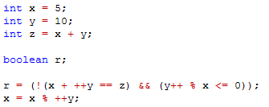

a) 12

b) 5

c) 2

d) 7

27. Given the following code fragment, what value would be final value contained in

variable y?

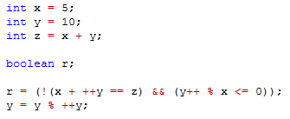

a) 12

b) 1

c) 5

d) 7

28. Given the following code fragment, what value would be the value contained in variable r?

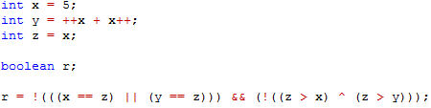

a) true

b) false

29. Given the following code fragment, what value would be the value contained in variable r?

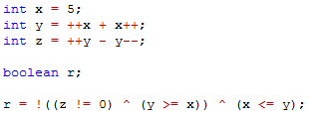

a) true

b) false

30. Given the following code fragment, what value would be the value contained in variable r?

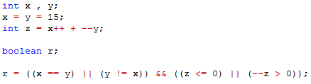

a) true

b) false

31. Given the following code fragment, what value would be the value contained in variable x?

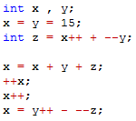

a) 14

b) -15

c) 15

d) -14

32. Given the following code fragment, what would be printed on screen if the user inputs value 10?

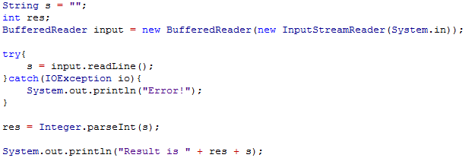

a) Result is 20

b) Result is 10s

c) Result is 1010

d) Result is 1020

33. Given the following code fragment, what would be printed on screen if the user inputs value 15 and 5 respectively?

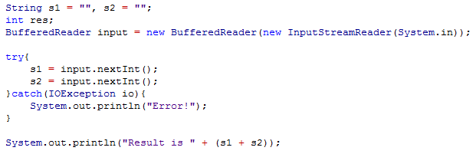

a) Result is 25

b) Result is 105

c) Result is (s1 + s2)

d) Compiler will generate a syntax error

34. Given the following code fragment, what would be printed on screen if the user inputs value 7 and 9 respectively?

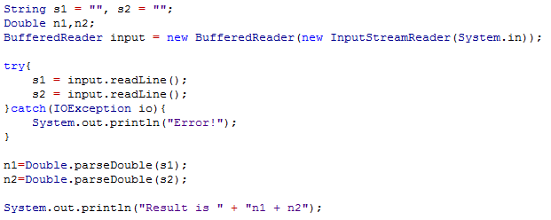

a) Result is 16

b) Result is n1 + n2

c) Result is 79

d) Compiler will generate a syntax error

35. Given the following code fragment, what would be printed on screen if the user inputs value 12 and 3 respectively?

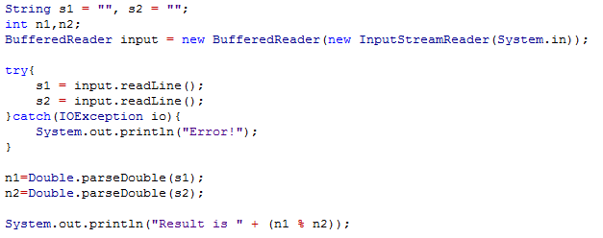

a) Result is 0

b) Result is 12

c) Result is 3

d) Compiler will generate a syntax error

36. Given the following code fragment, what would be printed on screen if the user inputs value 5,10 and 15 respectively?

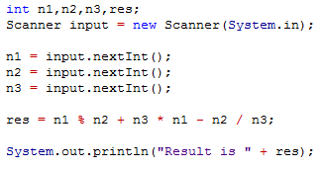

a) Result is 6

b) Result is 8

c) Result is 80

d) Compiler will generate a syntax error

37. Given the following code fragment, what would be printed on screen if the user inputs value 5,10 and 15 respectively?

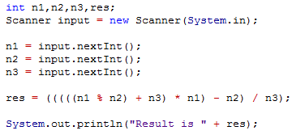

a) Result is 6

b) Result is 8

c) Result is 80

d) Compiler will generate a syntax error

38. Given the following code fragment, what would be printed on screen if the user inputs value 10, 2 and 2 respectively?

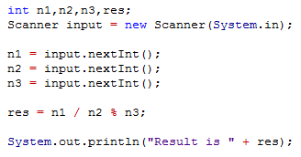

a) Result is 1

b) Result is 1.0

c) Result is 2

d) Result is 2.0

39. Given the following code fragment, what would be printed on screen if the user inputs value 20 and 8 respectively?

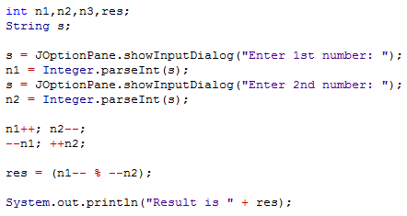

a) 2

b) 4

c) 6

d) 8

40. Given the following code fragment, what would be printed on screen if the user inputs value 8 and 4 respectively?

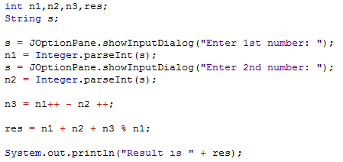

a) Result is 2

b) Result is 6

c) Result is 12

d) Result is 18

41. Given the following code fragment, what would be printed on screen if the user inputs value 4 and 2 respectively?

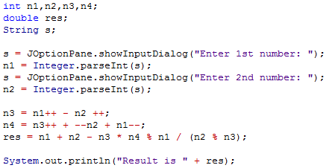

a) Result is 5.0

b) Result is 4.5

c) Result is 4

d) Compiler will generate a syntax error

**END OF EXAM**