## About the Project/Project Title

Grazioso Salavate assigned a project to develop a web based application for improve management of animal’s databases. The project is intended to let the Austin Animal Center utilize and manipulate animal databases. Software application should be able to work with existing data from animal shelters to identify and categorize available dogs. The project will contain multiple layers. MongoDB is a base layer for a raw data. The second layer will use Pymongo interaction to add CRUD functionality for the database: Create, Read, Update, and Delete documents to specific MongoDB database. The last layer uses Plotly Dash to develop the dashboard interface. The code for the project should be open source.

## Motivation

Grazioso Salvare is an innovative international rescue-animal training company, that works with non-profit agency. The company recognizes dogs who will be able to participate in search and rescue training. Potentially, these dogs will work with law enforcement, first responders and rescue teams. Only certain breed will be suitable for the position. The project should provide automated solution for maintaining the database for animal shelters. The software will help to safe the time, optimize the search, and organize existing data. The main goal is to provide the ability to perform quick search through the entire database and recognize the best candidates.

## Getting Started

First, we need to create the environment for the database. It will be done by uploading a file to load the dataset. MongoDB documents can be modified by connecting to a server, inquiring the needed document, and then changing the document’s properties.

The second step is to create admin and user account for the database.

The next step will be testing the script to ensure CRUD functionality for the database. CRUD stands for Create, Read,Update and Delete. These methods are will help us to manage the data in the database. The Create method allows us to insert new document in the database, two different operations can be used : *db.collection.insertOne()* and *db.collection.insertMany().* The Read method let us inquiry about specific document using special filters and criteria. Two operations that can be used are *db.collection.find()* and *db.collection.findOne().* The Update method will let us update the required document based on specific filters. There are three different operations: *db.collection.updateOne(), db.collection.updateMany(),db.collection.replaceOne().* The Delete method will remove a document from the specific database.

**Installation**

Required tools that we will be using Linux terminal to access a Mongo shell. Once the connection to a local server is made, PyMongo is needed to interact with MongoDB by using Python applications. Jupiter notebooks is used to create a library and test scripts.

* MongoDB -source-available cross-platform document-oriented database program. The installation and use will be don through the terminal, using the command line.
* PyMongo - a Python (script language) distribution containing tools for working with MongoDB.
* Jupyter notebook - a web-based interactive computing platform, great for data science projects.

**Usage**

1. Import the Austin Animal Center Outcomes file.

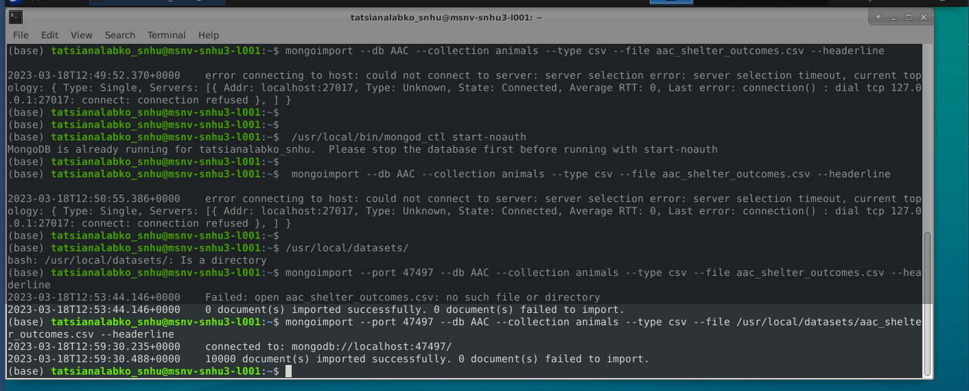

Import file

**2.** Create an administrator and user account in the mongo shell.

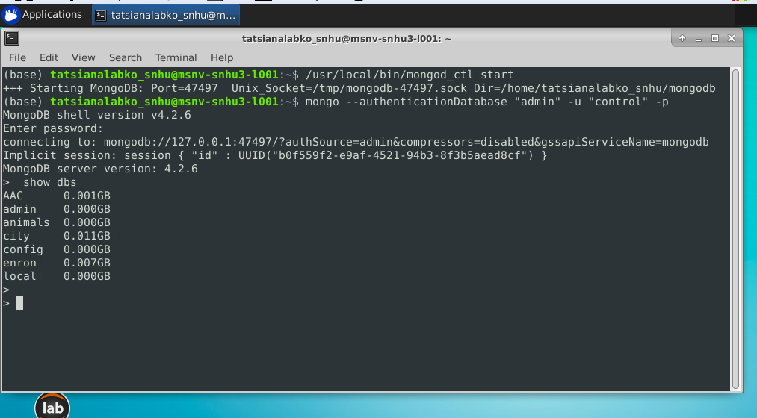

Type to enter a caption.

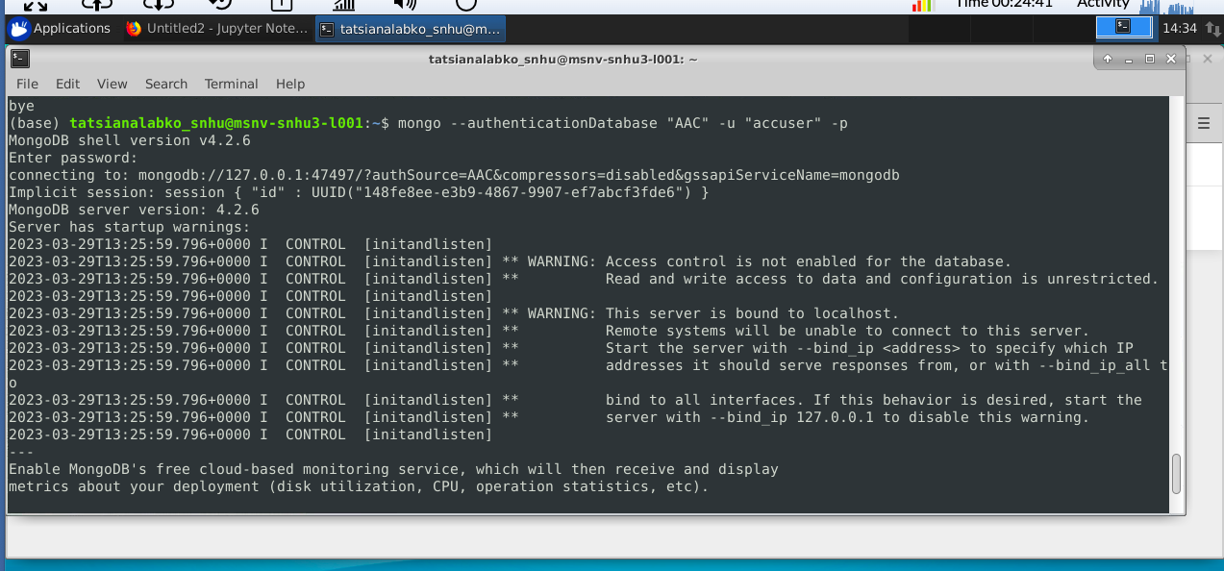

Type to enter a caption.

3.Develop a Python module in a PY file:

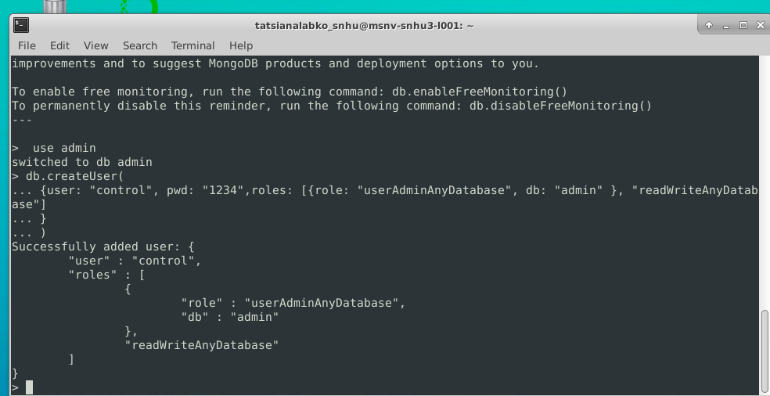

Type to enter a caption.

Tests:

Test Python module to make sure it works:

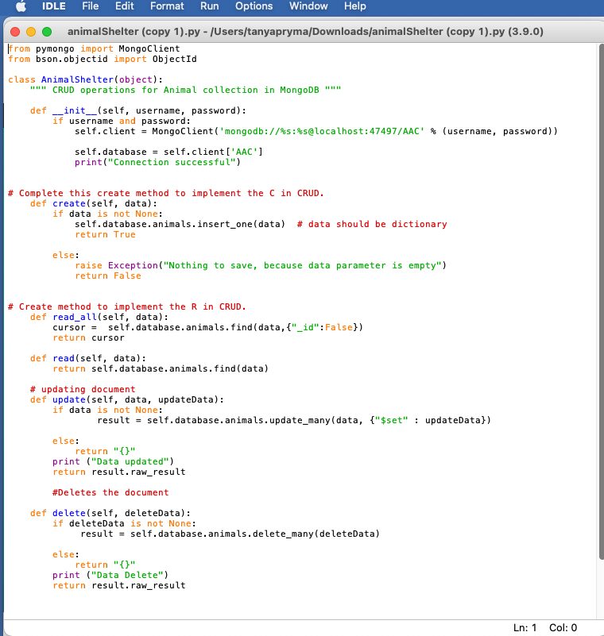

CRUD

1.Create the ned object:

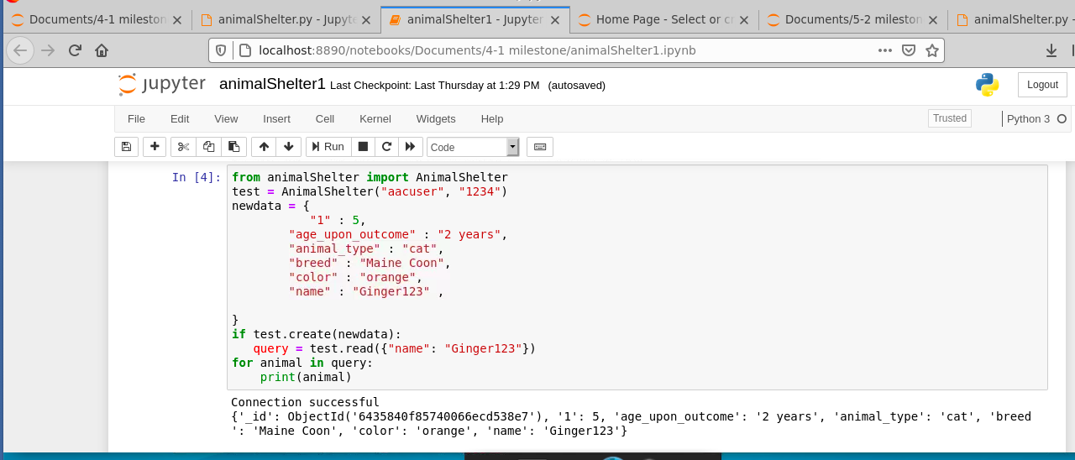

Type to enter a caption.

2.Read the object that we created :



Type to enter a caption.

3. Update the object created:

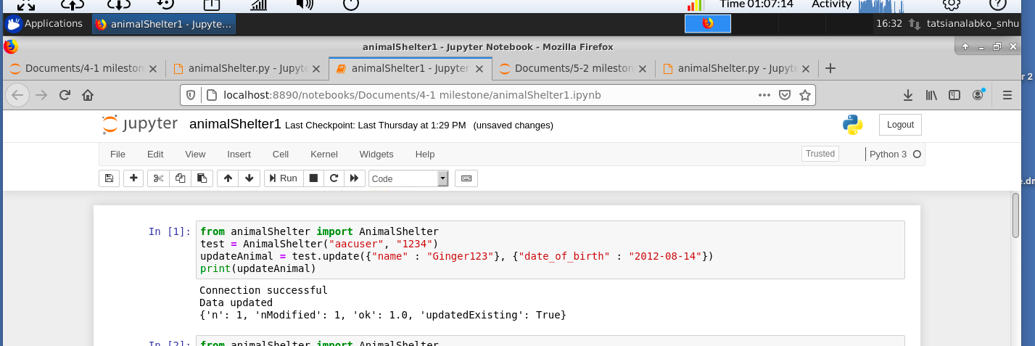

Type to enter a caption.

4. Delete the object created

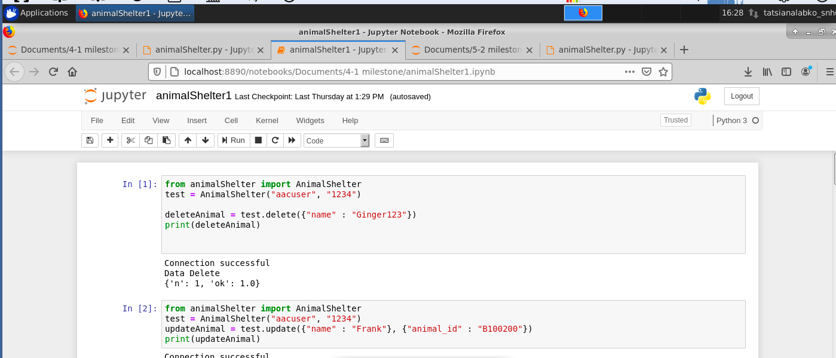

Type to enter a caption.

**Creating Dashboard:**

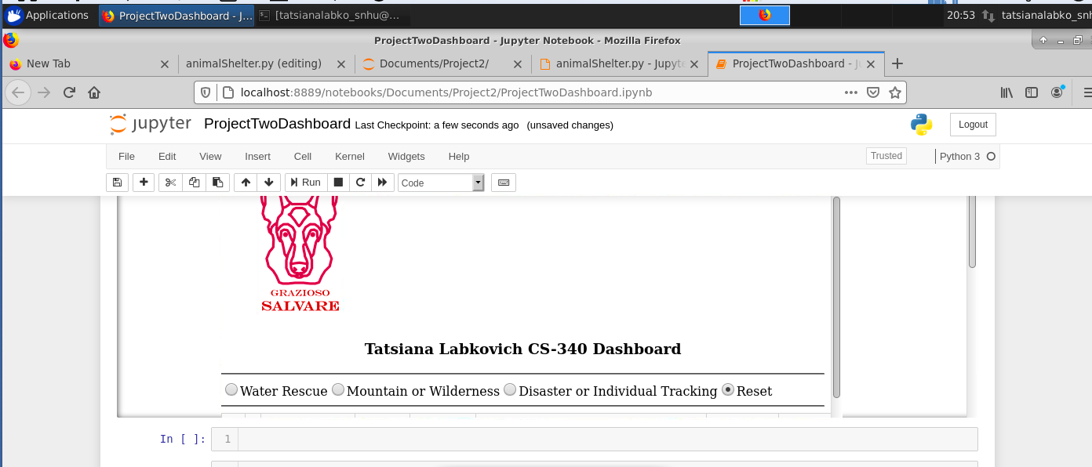

Type to enter a caption.

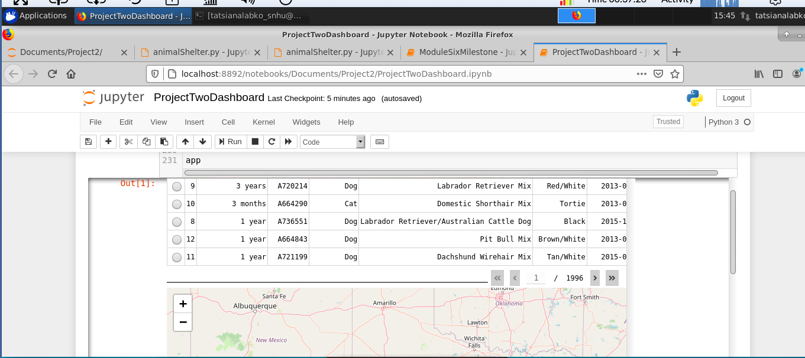

Type to enter a caption.

Project Challenges:

I have problems with developing dashboard. I am unable to display the charts, and interactivity of my dashboard is not working properly. I think my map is too big and blocking the chart.