# CLIMATE CHANGE INFOGRAPHIC

## INTRODUCTION

The climate change infographic are the pictorial representation of the Earth’s climate. The data on the climate change infographics is collected through satellite and weather predicting stations. These climate-changing diagrams vary in forms. In this project we use API for the data visualization. The Climate Change Infographic shows the global temperature rise, sea level rise and impact on ecosystem.

After searching the uploading the data user can see the details about climate change infographics. Many people aren’t know about the climate change infographics. So to minimize this problem I am going to make this climate change infographic web page. The main purpose of this web page is show the basic knowledge to the users or viewers. In this project used HTML, CSS and JS.

I am developing a web page (Climate Change Infographic) to know more about the climate change, cause and effects. In this page show the short description about the

* What is climate change?
* Cause of climate change?
* Effects of climate change?

**OBJECTIVES**

* To show the Sea Level Rise
* To show impact on ecosystems.
* To show the hourly weather changes

**Code:**

**Index.html**

<!DOCTYPE html>

<html lang="en">

<head>

  <meta charset="UTF-8">

  <meta name="viewport" content="width=device-width, initial-scale=1.0">

  <title>Climate Change Infographic</title>

  <link rel="stylesheet" href="styles.css">

  <script src="https://cdn.jsdelivr.net/npm/chart.js"></script>

  <script src="script.js"></script>

</head>

<body>

  <header class="header">

    <h1>Climate Change Infographic</h1>

    <div class="infographic">

        <!-- <h1>Understanding Climate Change</h1> -->

        <p>Climate change is one of the most pressing challenges of our time...</p>

        <button class="section-button" data-section="what">What is Climate Change?</button>

        <button class="section-button" data-section="causes">Causes of Climate Change</button>

        <button class="section-button" data-section="effects">Effects of Climate Change</button>

        <div class="section what">

            <h2>What is Climate Change?</h2>

            <p>Climate change refers to the long-term alteration of Earth's average weather patterns and global temperatures. It is primarily driven by the increase in greenhouse gases, such as carbon dioxide (CO2), methane (CH4), and nitrous oxide (N2O), in the atmosphere. These gases trap heat from the sun, creating a "greenhouse effect" that leads to a warming of the planet.</p>

        </div>

        <div class="section causes">

            <h2>Causes of Climate Change</h2>

            <p>Burning of fossil fuels, deforestation, industrial processes, and agriculture are among the main factors contributing to climate change. These activities release greenhouse gases into the atmosphere, enhancing the natural greenhouse effect and leading to global warming.</p>

        </div>

        <div class="section effects">

            <h2>Effects of Climate Change</h2>

            <p>Climate change has wide-ranging effects, including rising temperatures, sea level rise, extreme weather events, impact on ecosystems, health risks, agricultural challenges, and more. These effects highlight the urgency of addressing climate change through mitigation and adaptation strategies.</p>

        </div>

    </div>

    <p>Visualizing Temperature Rise</p>

  </header>

  <!-- <div class="container">

    <canvas id="temperatureChart"></canvas>

  </div> -->

  <div class="container">

    <a href="graph.html" class="graph-link">View Temperature Graph</a>

  </div>

</body>

</html>

**Graph.html**

<!DOCTYPE html>

<html lang="en">

<head>

  <meta charset="UTF-8">

  <meta name="viewport" content="width=device-width, initial-scale=1.0">

  <title>Temperature Graph</title>

  <link rel="stylesheet" href="styles.css">

  <script src="https://cdn.jsdelivr.net/npm/chart.js"></script>

  <script src="graph-script.js"></script>

  <script src="js.js"></script>

</head>

<body>

  <div class="container">

    <canvas id="temperatureChart"></canvas>

  </div>

</body>

</html>

**Styles.css**

body {

    margin: 0;

    font-family: 'Open Sans', sans-serif;

    font-size: 16px;

    background: url('https://source.unsplash.com/1600x900/?landscape') center/cover no-repeat;

  }

  .header {

    background-color: none;

    color: black;

    text-align: center;

    padding: 20px;

  }

  .infographic {

    background-color: none;

    padding: 20px;

    border-radius: 5px;

    margin: 20px auto;

    max-width: 800px;

    box-shadow: 0px 0px 10px rgba(0, 0, 0, 0.1);

  }

  .infographic h1 {

    margin-top: 0;

  }

  .infographic p {

    margin: 10px 0;

  }

  .infographic button {

    margin: 5px;

    padding: 5px 10px;

    background-color:none;

    color: rgb(14, 13, 13);

    border: none;

    border-radius: 3px;

    cursor: pointer;

  }

  .container {

    max-width: 800px;

    margin: 0 auto;

    padding: 20px;

    background-color: rgba(255, 255, 255, 0.9);

    border-radius: 5px;

    box-shadow: 0px 0px 10px rgba(0, 0, 0, 0.1);

  }

  .section {

    display: none;

  }

  .section.active {

    display: block;

  }

**Script.js**

document.addEventListener("DOMContentLoaded", function () {

    const buttons = document.querySelectorAll(".section-button");

    const sections = document.querySelectorAll(".section");

    buttons.forEach(button => {

      button.addEventListener("click", function () {

        const sectionName = button.getAttribute("data-section");

        sections.forEach(section => {

          section.classList.remove("active");

        });

        const activeSection = document.querySelector(`.section.${sectionName}`);

        activeSection.classList.add("active");

      });

    });

    // Dummy temperature data (replace with actual API data)

    const years = [2000, 2005, 2010, 2015, 2020];

    const temperatures = [0.8, 1.2, 1.6, 2.0, 2.4];

    const ctx = document.getElementById("temperatureChart").getContext("2d");

    const temperatureChart = new Chart(ctx, {

      type: "line",

      data: {

        labels: years,

        datasets: [{

          label: "Global Temperature Rise",

          data: temperatures,

          borderColor: "rgba(75, 192, 192, 1)",

          fill: false

        }]

      },

      options: {

        scales: {

          y: {

            beginAtZero: false,

            title: {

              display: true,

              text: "Temperature Rise (°C)"

            }

          },

          x: {

            title: {

              display: true,

              text: "Year"

            }

          }

        }

      }

    });

  });

**Script for graph**

document.addEventListener("DOMContentLoaded", function () {

    // Dummy temperature data (replace with actual API data)

    const years = [2000, 2005, 2010, 2015, 2020];

    const temperatures = [0.8, 1.2, 1.6, 2.0, 2.4];

    const ctx = document.getElementById("temperatureChart").getContext("2d");

    const temperatureChart = new Chart(ctx, {

      type: "line",

      data: {

        labels: years,

        datasets: [{

          label: "Global Temperature Rise",

          data: temperatures,

          borderColor: "rgba(75, 192, 192, 1)",

          fill: false

        }]

      },

      options: {

        scales: {

          y: {

            beginAtZero: false,

            title: {

              display: true,

              text: "Temperature Rise (°C)"

            }

          },

          x: {

            title: {

              display: true,

              text: "Year"

            }

          }

        }

      }

    });

  });

**Observation:**

Climate Change Infographic web page, I notice the stark contrast between historical climate patterns and the current state of our planet. The interactive global temperature rise visualization vividly depicts the alarming upward trend, a consequence of human-induced activities. The animated sea level rise diagram paints a concerning picture of coastal regions at risk, underscoring the urgent need for action.

**Outcomes:**

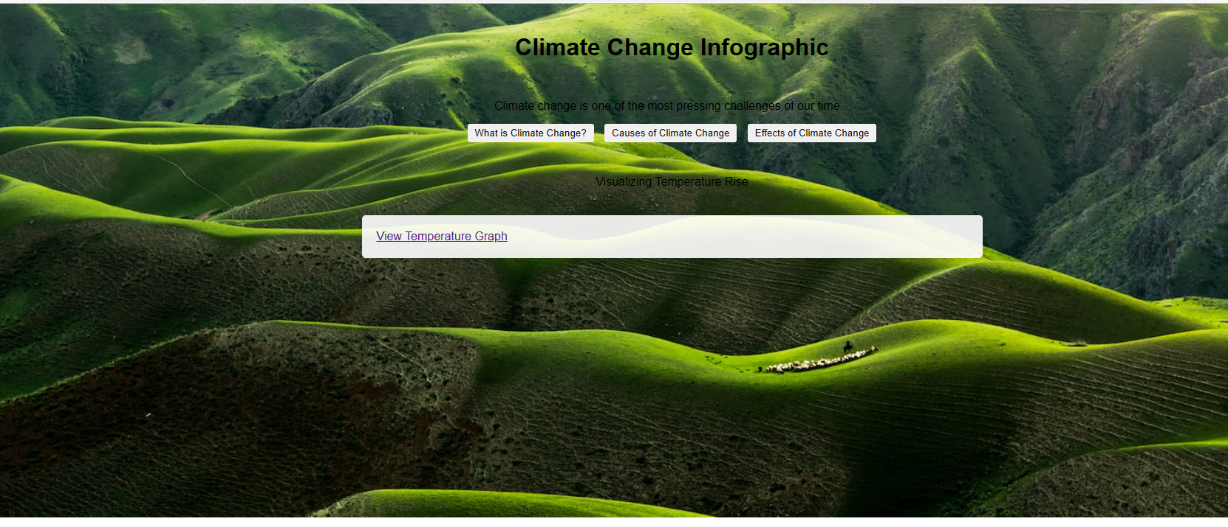

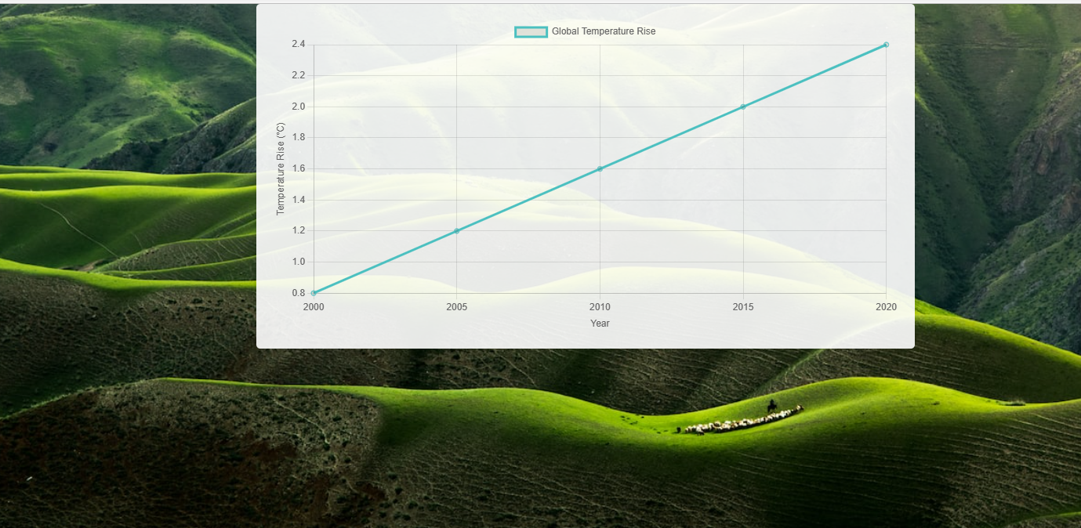

**Conclusion:**

The Climate Change Infographic web page is your gateway to understanding the intricacies of our changing climate. Through the convergence of data, visuals, and accessible explanations, we strive to empower individuals with the knowledge to make informed decisions and drive positive change.