Deep Learning Project: Charity Funding

Predictor

Deep learning and neural networks were used to determine if applicants would be successfully funded by Alphabet Soup, whom previously funded over 34,000 organizations.

Data Processing

The dataset removed any irrelevant information; therefore, EIN and NAME were dropped from the model. The remaining columns were considered features for the model. Although NAME was added back in the second test. CLASSIFICATION and APPLICATION_TYPE was replaced with ‘Other due to high fluctuation. The data was split into training and testing sets of data. The target variable for the model is “IS_SUCCESSFUL” and is verified by the value, 1 was considered yes and 0 was no. APPLICATION data was analyzed, and CLASSIFICATION’s value was used for binning. Each unique value used several data point as a cutoff point to bin “rare” categorical variables together in a new value, ‘Other’. Afterwards checked to see if binning was successful. Categorical variables were encoded by ‘pd.get_dummies().

Compiling, Training, and Evaluation the Model

Neural Network was applied on each model multiple layers, three in total. The number of features dictated the number of hidden nodes.

A three-layer training model generated 477 parameters. The first attempt came close at 72% which was under the desired 75%.

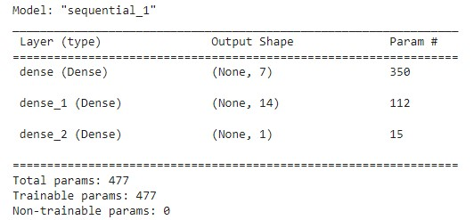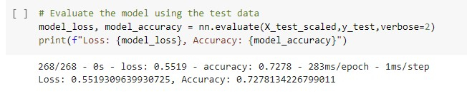

# Optimization

The second attempt added ‘NAME’ back into the dataset, this time I achieved 79% which was 4% over target. A total of 3,298 params.

Deep learning models should have multiple layers, since it is machined based it teaches a computer to filter inputs through the layers to learn how to predict and classify information.

