

DESKTOP PUBLISHING PROJECT REPORT

NAME- Prince Thakur

UID- 23BCA10045

SECTION- 3-B

PROJECT TITLE- DESIGNED A POSTER USING PHOROSHOP

**CONTENTS: -**

1. INTRODUCTION…………………………………………………

The goal of this project is to develop creative skills in designing poster that cater to various contexts, keeping in mind the principles of visual hierarchy, color theory, typography, and user engagement. Through this project, participants will learn to use design tools, explore layout strategies, and understand the significance of branding in poster creation.

1. OBJECTIVE OF PROJECT……………………………………..

The objective of this project is to design visually appealing and effective poster that communicate messages clearly, align with branding goals, and engage the target audience across various digital and print platforms.

1. PROCEDURE OF DESIGNING……………………………..

Followed the right steps for creating poster using Adobe photoshop.

1. PROJECT OUTPUT IMAGES…………………………………

Pasted the results of poster designing.

1. CONCLUSION………………………………………………….

This project highlights the importance of well-designed poster in communication and branding. By applying design principles, creative tools, and layout techniques, participants gain valuable skills to create effective poster that capture attention and deliver messages clearly across different platforms.

**Poster Design Using Adobe Photoshop**

**Introduction:**

Poster design is a creative process that involves combining text, imagery, and graphic elements to communicate messages effectively. It serves various purposes, such as promoting events, advertising products, or spreading awareness. Adobe Photoshop is a powerful tool that allows designers to bring their ideas to life, offering a wide range of features for photo editing, typography, and layout creation.

**Objective:**

The objective of this project is to design a visually appealing poster using Adobe Photoshop that effectively communicates a specific message, captures attention, and aligns with the intended theme or purpose.

1. Learning essential poster design principles.
2. Mastering Photoshop tools like layers, text, and effects.
3. Designing a poster with specific dimensions and resolution.
4. Applying creativity and branding consistency.
5. Exporting the poster in formats suitable for web or print.

**1. Create a New Document**

* **Open Photoshop and create a new document with dimensions that suit your needs (e.g., 1080x1920 pixels for a poster).**
* **Set the resolution to 300 dpi for high-quality printing.**

**2. Background Setup**

* **Fill the background layer with a dark blue color (use the color picker to get a shade that matches the poster).**
* **To create a gradient effect, apply a radial gradient with a soft, light pink in the center. This creates the glow behind the text.**

**3. Adding the Text**

* **Use the Text Tool (T) to add the main title ("FUTURE DESTINY").**
* **Choose a bold, sans-serif font similar to the one in the poster. Fonts like *Bebas Neue* or *Montserrat* could work well.**
* **For the neon effect, go to the Layer Style settings:**
  + **Outer Glow: Set the color to white or light blue with high opacity and adjust the size for a soft glow around the text.**
  + **Drop Shadow: Add a subtle drop shadow to enhance depth.**
* **Add the smaller text ("A FILM BY AVERY DAVIS" and "IN THEATER ON 26 DECEMBER") above and below the main title using a thin sans-serif font. Set the color to white.**

**4. Creating the Robotic Hand**

* **If you have a 3D model of a robotic hand, you can import it. Otherwise, find a high-quality stock image of a robotic hand.**
* **Cut out the hand from its background using the Quick Selection Tool or Pen Tool and paste it onto your canvas.**

**5. Positioning and Adjusting the Hand**

* **Scale and position the hand so it points upward in the center of the poster, leaving room for the text.**
* **Apply a slight Drop Shadow effect in the Layer Style menu to create a bit of depth.**

**6. Adding the Butterfly**

* **Find a high-quality image of a butterfly.**
* **Cut out the butterfly and place it near the fingertip of the robotic hand.**
* **Resize it to fit proportionally with the hand and rotate if necessary.**
* **Apply a Glow effect by duplicating the butterfly layer, applying Gaussian Blur to the duplicate, and lowering its opacity.**

**7. Neon Glow Effect on the Butterfly**

* **To enhance the neon glow on the butterfly, add a layer above the butterfly layer, set it to Overlay or Soft Light, and paint with a soft brush around the butterfly using a neon blue or purple color.**

**8. Finishing Touches**

* **Adjust the overall contrast and colors with Adjustments > Hue/Saturation or Color Balance.**
* **You might also want to add a Vignette Effect by creating a new layer, filling it with black, and using the Elliptical Marquee Tool to select the center. Feather the selection, delete the middle, and reduce opacity.**

**9. Exporting**

* **Once satisfied, export your design by going to File > Export > Save for Web (Legacy) or Export As and select a high-resolution format like PNG or JPEG.**

10. REVIEW AND FEEDBACK: -

Review the final poster for any design or content errors.

Share the design with stakeholders or team members for feedback and make necessary revisions.

OUTPUT IMAGE: -

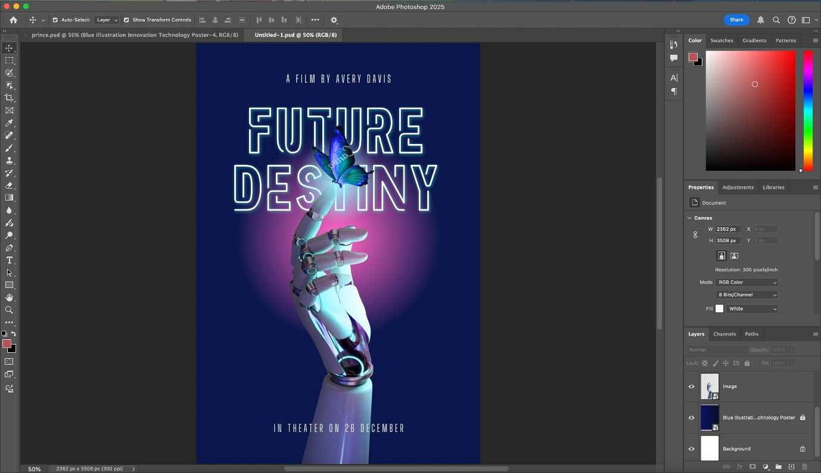

**Conclusion:**  
Designing a poster using Adobe Photoshop is a comprehensive process that combines creativity with technical skills. Through this project, users learn how to effectively use tools like typography, imagery, and graphic elements to convey messages in a visually engaging way. The steps covered—ranging from setting up the canvas to applying effects and exporting—ensure a polished final product suitable for both digital and print platforms. This project not only enhances proficiency in Photoshop but also provides valuable insights into design principles, helping participants create professional posters that align with the desired theme and purpose.