CharSequence | SpannableString | Spanned | SpannedString
Interface that provides read only access to objects whose class has implemented the interface. | A class specific to android framework contains text which is immutable but markup objects like Typeface, color etc could be attached and detached | Interface which extends CharSequence and implemented directly by spanned string. | Concrete Implementation of Spanned interface.
 | Using this object multiple markup object could be attached to text.  It also implements spanned interface indirectly. | Using this interface mark up objects attached to a specific portion of a text could be found. It provides immutable markup.
 | It’s content is immutable. |  | It’s content is immutable.
https://stackoverflow.com/questions/17546955/android-spanned-spannedstring-spannable-spannablestring-and-charsequence

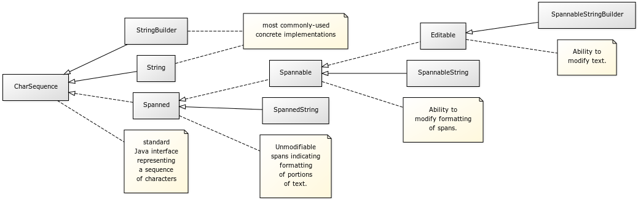
Fig: Hierarchy of android text framework.

Spans: A mechanism for applying different styles to a block of text to character level.

