Output
- Console Output: The accuracy, R2 score, and Mean Squared Error for both models (Logistic Regression and Random Forest Classifier) are displayed in the console.
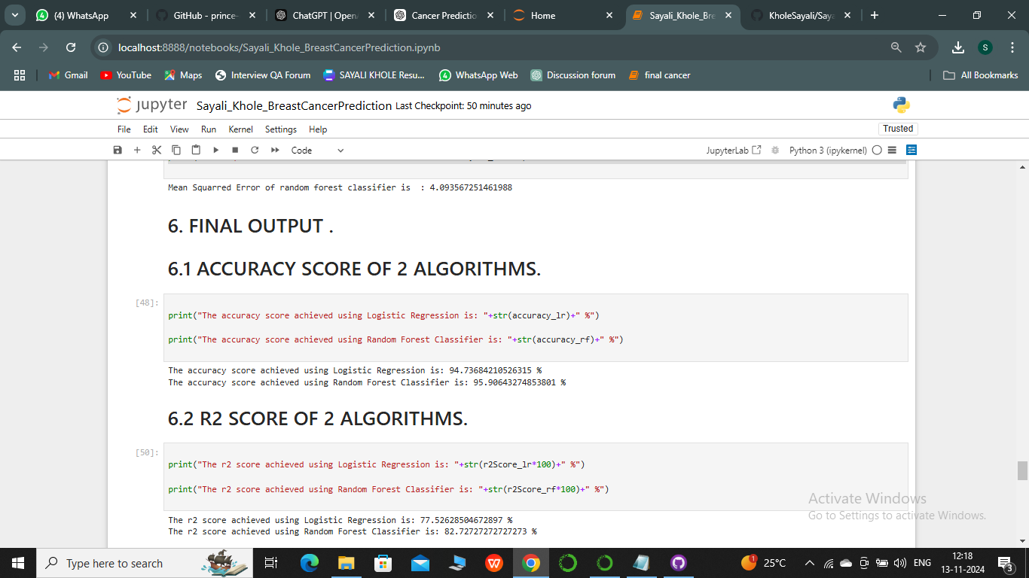
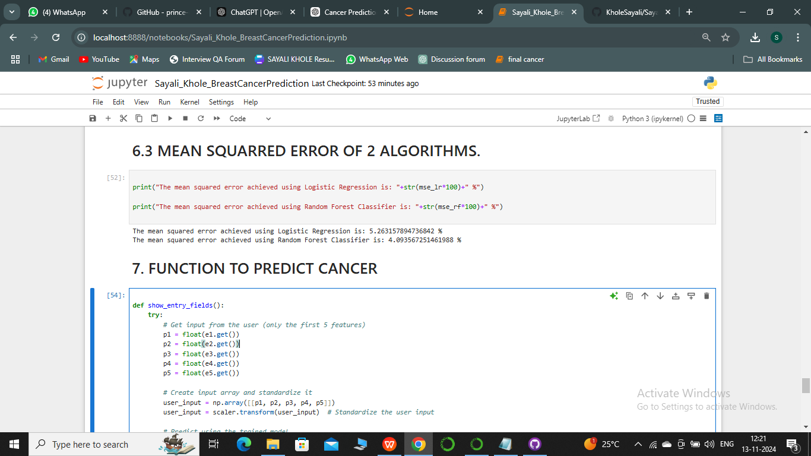

- GUI Output: Based on user input, the application predicts whether the patient has cancer or not and displays the result in the GUI window.
