**LIBRARY SYSTEM FOR STI COLLEGE   
PASAY-EDSA WITH QR CODE APPLICATION**

**A Capstone Project Proposal**

**Presented to the Faculty of the**

**Information and Communications Technology Program**

**STI College Pasay-Edsa**

**In Partial Fulfilment**

**of the Requirements for the Degree**

**Bachelor of Science in Information Technology**

**Joven Paul T. Pagal  
John Albert M. Santos  
Jayson C. Gonzales  
Earldell C. Cantonjos**

**Approval sheet**

This capstone project proposal titled : **Library System for STI COLLEGE   
Pasay-Edsa with QR Code Application** prepared and submitted by **Eardell C.** **Cantojos**, **Joven Paul T. Pagal**, **John Albert M. Santos** and **Jayson C. Gonzales** in partial fulfillment of the requirements for the degree of Bachelor of Science in Information Technology, has been examined and is recommended for acceptance and approval.

Mr. Raven Red Amandy  
 **Capstone project adviser**

Accepted and approved by the Capstone project Review panel

In partial fulfillment of the requirements for the degree of Bachelor of Science

In Information Technology.

Mr. Jonel Esmaña Mr. Raven Red Amandy

**Panel Member Panel Member**

Mr. Sherwin Keith Rivera  
**Lead Panelist**

**Noted:**

Engr. Elizier L. Obamos ME, CoE Engr. Elizier L. Obamos ME, CoE  
**Capstone Project Coordinator** **Program Head**

**Acknowledgement**

We are very grateful to our Almighty God for without his the gift of life, continuous guidance and unending gifts nothing is possible. We revere the patronage and moral support extended with love, by our parents whose support and passionate encouragement made it possible for us to do this project.

We would like to extend our deepest gratitude to Mr. Raven Red Amandy, Capstone Adviser, for the support, guidance and monitoring our capstone’s progress. We would also like to thank Engr. Elizier L. Obamos ME, CoE for his valuable lessons and suggestions during the planning and development of our Capstone Project. Their guidance, Enthusiasm and Knowledge continue to help us in conducting this project.

**Abstract**

**Title of research:** Library System for STI COLLEGE   
 Pasay-Edsa with QR Code Application

**Researchers: John Albert M. Santos**

**Eardell C. Cantojos**

**Jayson C. Gonzales**

**Joven Paul T. Pagal**

**Degree: Bachelor of Science in Information Technology**

**Date of Completion : May 23, 2022**

As mentioned, The proposed title, Library System for STI COLLEGE   
 Pasay-Edsa with QR Code Application. Its goal is to be of help in every transaction inside the library, this includes the availability and details of the Books, the information of the students, the borrowing and returning of book. The purpose of this is to helps reduce manual work and creates a friendly interface for it to provide a dependable search facility for the staff and students.

**TABLE OF CONTENTS**

PAGE

**Title Page1**

**Approval sheet2**

**Acknowledgement3**

**Abstract4**

**Introduction5**

**Objectives of the study6**

**Objectives of the study6**

**Objectives of the study6**

**Objectives of the study6**

**Objectives of the study6**

**Objectives of the study6**

**Objectives of the study6**

**Objectives of the study6**

**INTRODUCTION**

**Project Context**

In today's library environment, a library software is a critical tool. Many libraries today use a library system management software to manage their collections through a computerized system. Using a system like this for a library will make visits and transactions easier for the librarian and its visitors.

STI College Pasay-Edsa is one of the many schools affected by the pandemic at an unfortunate time. Many systems were not established due to classes shifting from a face-to-face way of teaching to classes being conducted online. One of the systems that was not set was for the school’s library. With the possibility of students going back to school at a normal capacity a need for a library system is one of the things needed by our school.

Our idea for a library system is that it will aid the proper management of data in a library. All pertinent information about students, books, and transactions is stored in the library database. Our biometrics-capable library management system will help in tracking student’s in and out of the library’s premises. Our system will be based on QR code tracking. This means that every book, details of the book (title, theme and type) and transactions will be under how a QR code works.

**Purpose and description of the Project**

The main objective of our Library management system is to be in charge of every transaction inside the library, this includes the availability and details of the Books, the information of the students, the borrowing and returning of book. The purpose of this is to helps reduce manual work and creates a friendly interface for it to provide a dependable search facility for the staff and students.

This project has two different interface one for students which is to help them use their time inside the library more efficiently, Be updated with the announcement that the library has, be aware of the rules and regulations while in the library and be knowledgeable of the procedure of every transaction inside the library.

The library management system Provides various factors, such as the ID number of the students, their information, the QR codes of the books and the Information of the books. The transaction is executed in an off- line connectivity. Modifying, adding and updating the database records improves the result of managing the resources of each book that are borrowed, return and pending.

**Objectives of the Study**

To accomplish this project, our objectives will be:

1. Design a Library System for STI College Pasay-Edsa with Q.R Code with the following features:

**Front-end**

* 1. Student log-in
  2. Student’s main menu
     + Announcements
     + Rules and regulations
     + Transaction History
     + Search bar

**Back-end**

* 1. Admin’s main menu
     + Search bar
     + Announcements Updater
     + Borrowed books
     + Return books
     + Add Books
     + Fines Checker
     + Student Sign up
     + Delete books
     + Student Points

**SCOPE AND LIMITATIONS**

**SCOPE**

**Modules**

**Front-end**

1. **Student log-in –** This is where the student will login via their account
2. **Student’s main menu** – This page contains the modules below:

* **Announcements –** This module will display the announcement entered by librarian.
* **Rules and Regulations –** This module displays the rules and regulations inside the library. Guiding the students how to borrow books, how to return books and understanding about the penalties if the student fails to return the borrowed books.
* **Transaction History –** This module displays every transaction every student made. This includes the following information like the Borrowed books, Date, Unreturned books, Due dates and fines.
* **Search bar –** In here, the student could search the title of the book, author, subject, date published and availability.

**Back-end**

1. **Admins main menu** – This page contains the following modules:

* **Search bar** – In here, the admin could search the title of the book, author, subject, date published and availability.
* **Announcements Updater –** On this module, librarian can input or edit the announcements.
* **Borrow books –** This module is where the admin will input the details of the students. It includes the borrower information such as student ID, first name, middle name, last name, contact number, course and year.
* **Return books –** This module contains a button that is connected to the scanner. After scanning the Q.R Code the following descriptions will appear inside the table.
* **Add Books –** This module is where the admin can add and update the details of the new books. It includes the title, description, author, date published and category.
* **Delete books –** It is where the admin can delete the books that are not available in the library.
* **Student Sign-up –** The student provides the information needed for them to have a library I.D with the unique Q.R code.
* **Student Points –** This is where the admin adds or deduct points to each library user

**LIMITATIONS**

1. Not an online system.
2. A QR system for the library of STI College Pasay-Edsa that will track the in and out of students in the library’s premises that is 100% accurate.
3. A reminder for the student about their unreturned books when outside the library.
4. The use for accumulated fines.
5. Rewards description for points accumulated by students.
6. The way students return the books in proper/designated places.

**Significance of the study**

Our project is about providing STI Pasay-Edsa a computerized system that will help manage a library better. This system will be beneficial to the students and staff of STI Pasay-Edsa by making library transaction easier and faster. Our system also aims to allow administrators to keep track and record the things done inside the library. Students will also have a better and faster way to know the availability of the resources they need inside the library. To provide a way for the staff of the library to record transactions with the use of automation by QR code.

# review of related literature/systems

A Methodological, systematic, theoretical review is a collection of interconnected concepts. These framework guides any researchers, by determining the ideas how they measure the relationship that they will look for. It is also the study of illustrations used in the system that can help to support the theory research work. It links the researcher to existing research by knowing the similarities guided by related theory.

**Review of Related Literature**

Analysis of STI College Taft Library Management System

This study about information and information sources are as modern and diverse. Libraries are no longer accommodated in religious buildings, but are now integral parts of organizations, particularly educational institutions, where knowledge acquisition is a goal. Any organization, whether religious, political, social, commercial, or educational, envisions a way to obtain and maintain quality service. Schools are no exception. As it deals with the upgrading of its numerous services, including the library service, to accommodate the most recent trends in information technology.

The first business electronic information system consisted of a computer and programs that recorded transactions. A transactions processing system is primarily used to record data collected at the organization's boundaries.

The library is an important part of the school that should be computerized in order to fully achieve goals. The use of software applications, particularly in information systems, facilitates transactions of library procedures and processes, ensuring that information required by students, faculty and personnel, and visiting researchers is adequately provided. The library system is a type of transaction processing system. This system is intended to carry out the processes involved in monitoring and cataloguing. The library has been defined as the main repository or storage of reading and reference materials, as well as other important information, and is an essential part of any institution. (Canada et al, 2002)

Table 1: Comparison between the of STI College Taft Library Management System between the Library System for STI College Pasay-Edsa with QR Code Application.

|  |  |
| --- | --- |
| Analysis of STI College Taft Library Management System | Library System for STI College Pasay-Edsa with QR Code Application |
| A computerized file maintenance to facilitate entries for addition, modification, deletion or archive for library holdings information. | A Dashboard module that displays all completed transactions. Borrowed books, total number of books, and number of books available |
| A module to generate library reports like: Borrowers List, Book List Report, Pending Book Reports, Student Pending Book Reports. | Transaction History this module will display book transactions that are pending, returned, or completed. |
| A relational database store library holdings information, students’ information, faculty and staff information, library transactions and other pertinent information such as overdue and recently published books. | Transaction Records this module is where the administrator will reap the benefits of the database, which contains all of the users. |
| A monitoring module to oversee and automatically update the status number of library holdings classified as books. | Manage books which the administrator can use this module to add or remove books. The requirements for adding a new book are an international standard book number, title, author, and publication date. |

The table above compares and contrasts the STI College Taft Library Management System Analysis and the STI College Pasay-Edsa Library System with QR Code Application. The computerized library system will be introduced in this comparison of the two systems. This will provide a tool that will allow library personnel to work more quickly and efficiently.

**National University Library System: A Mobile and Web Application**

**Framework for National University Learning Resource Center.**

National University Library System is a mobile and web application framework for National University Learning Resource Center that applied in an academic library and aiming to support the entire operations of the business in processing and acquiring library resources. It helps the librarians in preserving and making the materials available for the user. It is also specially created for the library that helps to operate the acquisition, cataloging, selection and circulation of print collections. As this system continues to improve, Integrated Library System is upgraded by taking advantage of network advancements and cloud computing to offer and allow the library to share data with users or other libraries.

This project focused on providing services that enhance the intellectual and literacy of the people as it focusses on giving proper content for them. There are three main categories in the library; the school library, the academic library and the public library. The school libraries are aiming for the schools with students ranging from kindergarten up to grade 12 as it offers general information about the basic subjects. The academic libraries are for the colleges and universities as it aims the users that are currently taking a bachelor, master and doctoral degree. Lastly, the public libraries which are funded by the government, are available in towns and cities as it is open publicly for the community that needs the service. [Baetiong et al. 2018]

**TABLE 1: Comparison between the features of the National University Library System: A Mobile and Web Application Framework for National University Learning Resources Center and the Library System for STI College Pasay-EDSA with QR Code Application.**

|  |  |
| --- | --- |
| **Similarities** | **Differences** |
| Automated and efficient | The (NULS) are allowing the library to share data with other libraries. The Library System for STI College Pasay-EDSA is exclusive for school |
| Processing and acquiring library resources | (NULS) has an online book database for the users. The database of Library System for STI College Pasay-EDSA is accessible only in library computer server. |
| It helps the librarians in preserving and making the materials available for the users | (NULS) integrate both web and mobile application. Library System for STI College Pasay-EDSA processes and integrate in web application |
| Focused on providing services and enhance the intellectual and literacy of people on giving proper content | Library System for STI College Pasay-EDSA will use QR Code and the (NULS) has barcode scanner to be used in inventory process |

The Table above shows that similarities and differences between the National Library System: A Mobile and Web Application Framework for NULS and the Library System for STI College Pasay-EDSA with QR Code. The researchers are strongly convinced to use QR Code scanner to retrieve faster and low chances of error compared to skilled personnel.

**QR Code based Library Management System**

A Library management system with a QR code Provides easy access in most of the modern library. This research aimed to develop smart library management system using QR code. QR code in Library management system is very easy but still in primary stage. Library should try to keep up with digital world with various technologies in this modern age. The importance of library system is because these systems are used as primary resource of information by Students and staff. Most of the libraries currently working with large number of persons for daily activities and supervision.

QR code-based Library management system is very efficient and reliable for Librarian, staff and students. This system will simplify library processes to keep track of all records, and make library more directly accessible to its users. This system works in real time and easy access to information to every member associated with the system. Users must be registered with the system administration after which they can access their accounts and database. It reduces the bourdon on the librarian as it will help to track the books available and issued person for any book and total number of books along with ageing analysis. *Asmita, Rajesh, P. (2020). International Journal of Emerging Technologies and Innovative Research*

Table 1. QR Code based Library Management System

|  |  |
| --- | --- |
| Similarities | Differences |
| Both of the system manage to record database and effortless for the users to have accessibility on the library system | They used a python QT5 for the for interactive GUI and provides simplicity for the library |
| Both scan the QR code of the book and the students information and uses a camera for it to scan | Wider Connectivity through smart phones/smart mobiles |
| Fast and simple for the user to manage and have the overview of the library system | This provides not only for the librarian students and staff to access but also for the outsiders to come and visit the library for access and transaction |

**Related Studies and/or Systems**

**University of Northern Philippines Library Management System**

The University of Northern Philippines, located at Tamag in Vigan City, has a library that uses a manual system for their everyday transactions. Their librarian faces several problems in providing their services because of their outdated system. They locate the availability of books through a library classification wherein there is a system of documents, library materials or any information according to their subject and allocating a call number to that information resource.

This thesis is proposing a Library Management System for the University of the Northern Philippines to increase the efficiency and manageability of the processes in searching, borrowing, returning and managing of books and also to safeguard the number and inventory of books under the care of the University librarians.

The goal of their System is to identify the processes involved in a Library System and make it easier for students and staff to make use of it. specifically, to Search specific book titles and authors, Search the availability of books students want to borrow, Real-time Inventory Count and Record Summary and to track missing and unreturned books.

**Table: Comparison between UNP’s Library System and Proposed Library System with QR code for STI Pasay-Edsa.**

|  |  |
| --- | --- |
| UNP’s proposed library system | STI Pasay-Edsa library system with QR code |
| Goal is to make transactions inside the library faster and easier. | The proposed system’s goal is to make transactions inside it’s library faster and easier |
| Books details are set up (for borrowing and returning | Uses QR code for details of books (for borrowing and returning) |
| Uses a library ID | Library ID has a QR code that will have the owner’s details. |
| Has different modules for students and staff | Has different modules for students and staff |
| Policies are not shown | Policies are indicated for students and staff’s reference |

The Table above shows differences and similarities between two Library System (University of Northern Philippines and proposed STI Pasay-Edsa). The researchers thought that features from UNP’s System was few and lacking. The proposed System uses QR code to simplify work of staff in looking for details of students and books.

**TECHNICAL BACKGROUND**

Technicality of the project

The system includes on collecting, recording and manage transaction processing system. A progression and research have been conducted in this project for the STI Pasay-Edsa library system do develop an environmental library system that suits the need and requirement of the school.

**Project Research Design**

Hierarchical Input Process Output (HIPO)

The Hierarchy Input Process Output (HIPO) approach is a planning and/or documentation tool for computer programs. A HIPO model is made up of a hierarchy chart that graphically displays the program's control structure and a series chart that describe the inputs, outputs, and functions performed by each module on the hierarchy chart. Designers can use the HIPO approach to assess and modify a program's design and remove problems prior to execution.

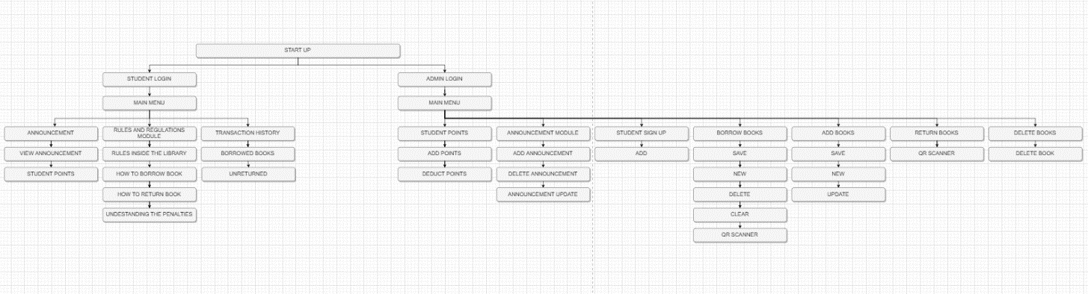

**Figure 1. Hipo Chart of Library System for STI College**

**Pasay-Edsa with QR Code Application.**

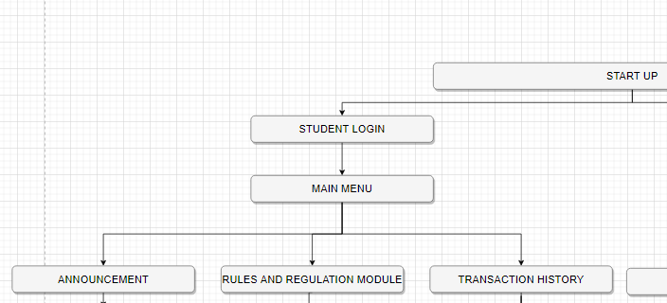

**Figure 2. Student Log in And Main Menu Module.**

This Log in and Student Main Menu Module of Library System for STI College Pasay-Edsa with QR Code Application. Contains Announcement, Rules and Regulation Module and Transaction History.

* Announcement – This module is to view announcement about STI College Pasay Edsa
* Rules and Regulation – This module is to inform students about rules inside the library
* Transaction History – This module is to view your borrow books history, unreturned books and due dates.

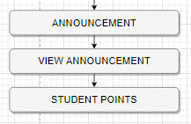

**Figure 3. Student Announcement Module**

This module shows announcement of STI College Pasay Edsa

* View Announcement – This module is to view announcement in STI College Pasay Edsa
* Student Points - This Shows the points of the student

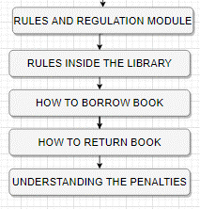

**Figure 4. Student Rules and Regulation Module**

This module shows the Rules and Regulation inside the library and to inform the students about the understanding the penalties

* Rules Inside the Library – This shows the rules inside the library.
* How to Borrow Books – This shows the guide on how to borrow books.
* How to Return Books – This shows the guide on how to return books.
* Understanding the Penalties - This shows the terms and agreement inside the library.

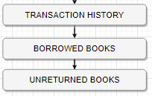

**Figure 5. Student Transaction History Module**

This module is to show the student their transaction history about the books they borrowed

* Borrowed Books - This shows the borrowed books of the students.
* Unreturned Books - This shows the unreturned books of the students.

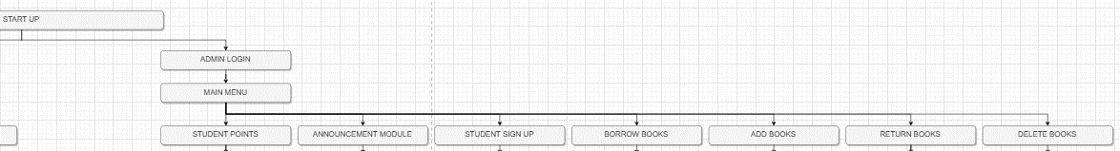

**Figure 6. Admin Log in And Main Menu Module.**

This Admin Log in and Admin Main Menu Module of Library System for STI College Pasay-Edsa with QR Code Application. Contains Student Points, Announcement Module, Student Sign up, Borrow Books, Add Books, Return Books and Delete Books.

* Student Points -
* Announcement Module – This module is for the admin to post about the latest news of STI College Pasay Edsa
* Student Points - The student provides the information needed for them to have a library I.D with the unique Q.R code.
* Borrow Books – This module is where the admin will input the details of the students. It includes the borrower information such as student ID, first name, middle name, last name, contact number, course and year.
* Add Books - This module is where the admin can add and update the details of the new books. It includes the title, description, author, date published and category.
* Return Books – It is where the admin can delete the books that are not available in the library.
* Delete Books - It is where the admin can delete the books that are not available in the library.

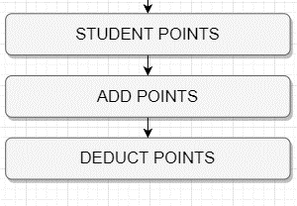

**Figure 7. Admin Student Points**

This module allows the admin to add and to deduct points of the student

* Add Points – This module allow admin to add points
* Deduct Points – This module allow admin to deduct points

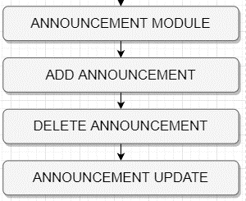

**Figure 8. Admin Announcement Module**

This Announcement module is for to post about the latest updates of STI College Pasay Edsa

* Add Announcement – This allows the admin to add announcement
* Delete Announcement – This allows the admin to delete announcement
* Announcement Updates – This allows the admin to edit a current announcement

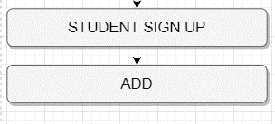

**Figure 9. Student Sign Up**

In this module the student provides the information needed for them to have a library I.D with the unique Q.R code.

* Add – This allows the admin to add student information

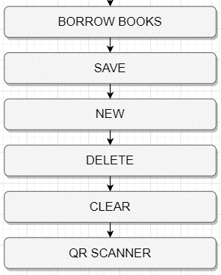

**Figure 10. Admin Borrow Book**

In this module is to add borrower, delete borrower and to view overdue book return books

* Save – This allows admin to save borrower or existing borrower
* New – This allows admin to add new borrowers
* Delete – This allows admin to delete borrowers or existing borrowers
* Clear – This allows the admin to clear all information about the borrowers
* QR Scanner – This allows admin to scan the QR code to put information of the borrower

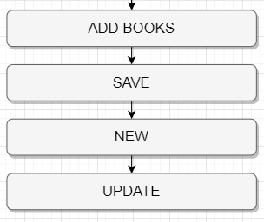

**Figure 11. Admin Add Book**

In this module admin can add book, save and update existing books.

* Save – This module allows admin to save books
* New – This module allows admin to create new books
* Update - This module allows admin to update existing books

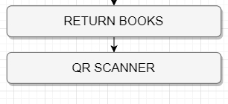

**Figure 12. Admin Return Book**

This module contains a button that is connected to the scanner. After scanning the Q.R Code the following descriptions will appear inside the table.

* QR Scanner – This allows the admin to scan the unique QR code of a book to show the detailed information of the book and the borrower

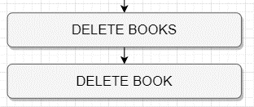

**Figure 13. Admin Delete Books**

In this module admin can delete existing books

* Delete Book – This module allows the admin to delete books

**Calendar of Activities**

The Gantt chart summarizes the activities. The activities are listed, and their execution times are listed opposite them.

**Gantt Chart of Activities**

|  |  |  |  |  |  |  |  |  |  |  |  |  |  |  |  |  |  |  |  |  |  |  |  |  |  |  |  |  |  |  |  |  |  |  |  |  |  |  |  |  |  |  |  |  |
| --- | --- | --- | --- | --- | --- | --- | --- | --- | --- | --- | --- | --- | --- | --- | --- | --- | --- | --- | --- | --- | --- | --- | --- | --- | --- | --- | --- | --- | --- | --- | --- | --- | --- | --- | --- | --- | --- | --- | --- | --- | --- | --- | --- | --- |
| MONTH | FEBRUARY | | | | MARCH | | | | APRIL | | | | MAY | | | | JUNE | | | | JUNE | | | | JULY | | | | AUGUST | | | | SEPTEMER | | | | NOVEMBER | | | | DECEMBER | | | |
| ACTIVITIES |
| Composing Capstone title |  |  |  |  |  |  |  |  |  |  |  |  |  |  |  |  |  |  |  |  |  |  |  |  |  |  |  |  |  |  |  |  |  |  |  |  |  |  |  |  |  |  |  |  |
| Capstone introduction |  |  |  |  |  |  |  |  |  |  |  |  |  |  |  |  |  |  |  |  |  |  |  |  |  |  |  |  |  |  |  |  |  |  |  |  |  |  |  |  |  |  |  |  |
| Purpose of the project |  |  |  |  |  |  |  |  |  |  |  |  |  |  |  |  |  |  |  |  |  |  |  |  |  |  |  |  |  |  |  |  |  |  |  |  |  |  |  |  |  |  |  |  |
| Objective pf the study |  |  |  |  |  |  |  |  |  |  |  |  |  |  |  |  |  |  |  |  |  |  |  |  |  |  |  |  |  |  |  |  |  |  |  |  |  |  |  |  |  |  |  |  |
| Scope of the project |  |  |  |  |  |  |  |  |  |  |  |  |  |  |  |  |  |  |  |  |  |  |  |  |  |  |  |  |  |  |  |  |  |  |  |  |  |  |  |  |  |  |  |  |
| Limitation |  |  |  |  |  |  |  |  |  |  |  |  |  |  |  |  |  |  |  |  |  |  |  |  |  |  |  |  |  |  |  |  |  |  |  |  |  |  |  |  |  |  |  |  |
| interview |  |  |  |  |  |  |  |  |  |  |  |  |  |  |  |  |  |  |  |  |  |  |  |  |  |  |  |  |  |  |  |  |  |  |  |  |  |  |  |  |  |  |  |  |
| Local review of related literature/System |  |  |  |  |  |  |  |  |  |  |  |  |  |  |  |  |  |  |  |  |  |  |  |  |  |  |  |  |  |  |  |  |  |  |  |  |  |  |  |  |  |  |  |  |
| International RRLS |  |  |  |  |  |  |  |  |  |  |  |  |  |  |  |  |  |  |  |  |  |  |  |  |  |  |  |  |  |  |  |  |  |  |  |  |  |  |  |  |  |  |  |  |
| Technical background |  |  |  |  |  |  |  |  |  |  |  |  |  |  |  |  |  |  |  |  |  |  |  |  |  |  |  |  |  |  |  |  |  |  |  |  |  |  |  |  |  |  |  |  |
| Resources |  |  |  |  |  |  |  |  |  |  |  |  |  |  |  |  |  |  |  |  |  |  |  |  |  |  |  |  |  |  |  |  |  |  |  |  |  |  |  |  |  |  |  |  |
| System Design |  |  |  |  |  |  |  |  |  |  |  |  |  |  |  |  |  |  |  |  |  |  |  |  |  |  |  |  |  |  |  |  |  |  |  |  |  |  |  |  |  |  |  |  |
| coding |  |  |  |  |  |  |  |  |  |  |  |  |  |  |  |  |  |  |  |  |  |  |  |  |  |  |  |  |  |  |  |  |  |  |  |  |  |  |  |  |  |  |  |  |
| Create Acknowledgement |  |  |  |  |  |  |  |  |  |  |  |  |  |  |  |  |  |  |  |  |  |  |  |  |  |  |  |  |  |  |  |  |  |  |  |  |  |  |  |  |  |  |  |  |
| Abstract |  |  |  |  |  |  |  |  |  |  |  |  |  |  |  |  |  |  |  |  |  |  |  |  |  |  |  |  |  |  |  |  |  |  |  |  |  |  |  |  |  |  |  |  |
| Designing |  |  |  |  |  |  |  |  |  |  |  |  |  |  |  |  |  |  |  |  |  |  |  |  |  |  |  |  |  |  |  |  |  |  |  |  |  |  |  |  |  |  |  |  |
| Table of contents |  |  |  |  |  |  |  |  |  |  |  |  |  |  |  |  |  |  |  |  |  |  |  |  |  |  |  |  |  |  |  |  |  |  |  |  |  |  |  |  |  |  |  |  |

**Resources**

* **Hardware**Hardware is collection of physical elements that comprise a computer system. Computer hardware refers to the physical parts or components of a computer such as monitor, keyboard, hard disk, etc. it is basically referred to objects that you can actually touch or is tangible. A combination of hardware and software forms a usable computing system.

Below is the list of specific hardware resource that is needed for the project.

* + 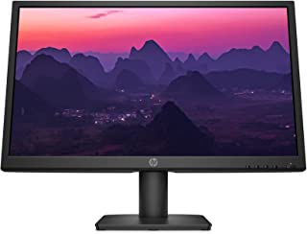HD/SD Monitor with VGA/HDMI At least (ICON Monitor 22 inch 75hz)
  + Computer Case
  + Motherboard: GIGABYTE A320m
  + CPU At least higher than A4-3420 processor; intel core i3 10th Gen (recommend)
  + At least 32- bit Operating system
  + At least 4Gb Ram
  + 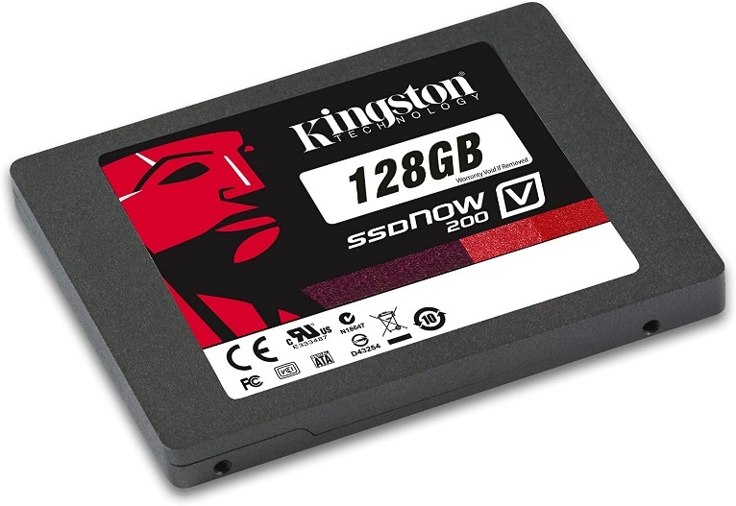At least 128 Storage
  + Computer fans



* + 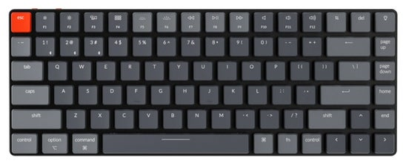Keyboard
  + Mouse
  + QR Code Scanner
* **Software**Software is a set of instructions, data, or programs used to run computers and carry out specified activities is referred to as software. It is the inverse of hardware, which describes a computer's physical components. Software is a catch-all phrase for apps, scripts, and programs that execute on a device.

Below is the list of specific software resource that is needed for the project.

* Microsoft Office - Microsoft Office is a suite of applications designed to help with productivity and completing common tasks on a computer. [subjectguides 2020]

*This Microsoft program is used to enter text, assemble documents, and create a PowerPoint presentation.*

* Figma – Figma is a vector graphics editor and prototyping tool which is primarily web-based, with additional offline features enabled by desktop applications for macOS and Windows.

*This Software used in designing and constructing the face of the Project.*

Photoshop - Adobe Photoshop is software that is extensively used for raster image editing, graphic design and digital art. It makes use of layering to allow for depth and flexibility in the design and editing process, as well as provide powerful editing tools, that when combined, are capable of just about anything.  
  
*This Software also used in designing and constructing the face of the Project.*

* App.diagram - diagrams.net is free online diagram software for making flowcharts, process diagrams, org charts, UML, ER and network diagrams.

*This Software used in Create diagram for the Hierarchical Input Process Output (HIPO).*

* Snipping tool- Snipping tool used in capturing the project and other.

**Appendix**

**REFERENCES**

Dani, A. (2020, June 1). *QR Code based Library Management System*. Https://Www.Jetir.Org. <https://www.jetir.org/view?paper=JETIR2006271>

A. (2021, August 18). *Library Management System | Library Management Software in India*. SkoolBeep. <https://www.skoolbeep.com/blog/library-management-system/>

*Library Management System - Engineering Projects*. (2018). Library Management System. <http://www.muengineers.in/computer-project-list/java-projects-list/library-management-system>

Mall, S. (2019, June 26). *Advantages of QR Code: 5 real reasons to use them*. Scanova Blog. <https://scanova.io/blog/blog/2016/02/16/advantages-of-qr-code/>

Kaspersky. (2022, April 5). *QR Code Security: What are QR codes and are they safe to use?* Www.Kaspersky.Com. <https://www.kaspersky.com/resource-center/definitions/what-is-a-qr-code-how-to-scan>

Kappagantula, S. (2022, March 26). How To Create Library Management System Project in Java? Edureka. <https://www.edureka.co/blog/library-management-system-project-in-java>

*What Is a QR Code? QR Code Meaning & Example*. (2017). What Is a QR Code. <https://www.sproutqr.com/blog/what-is-a-qr-code>

De La Salle University Manila. (2022, May 20). *The Libraries - De La Salle University-Manila*. De La Salle University. <https://www.dlsu.edu.ph/library/>

A. (2021, February 17). *Library management system project in C*. Aticleworld. <https://aticleworld.com/library-management-system-project-in-c/>

*The Complicated Role of the Modern Public Library*. (2021). The National Endowment for the Humanities. <https://www.neh.gov/article/complicated-role-modern-public-library>

LIBRARY MANAGEMENT SYSTEM (QR SCANNER). (2020, March 31). YouTube. <https://www.youtube.com/watch?v=8rblfDpceNA>

*Developing a QR Code-based Library Management System with Case Study of Private School in Surakarta City Indonesia*. (2018, October 1). IEEE Conference Publication | IEEE Xplore. <https://ieeexplore.ieee.org/document/8780424>

**SCREEN DESIGN**

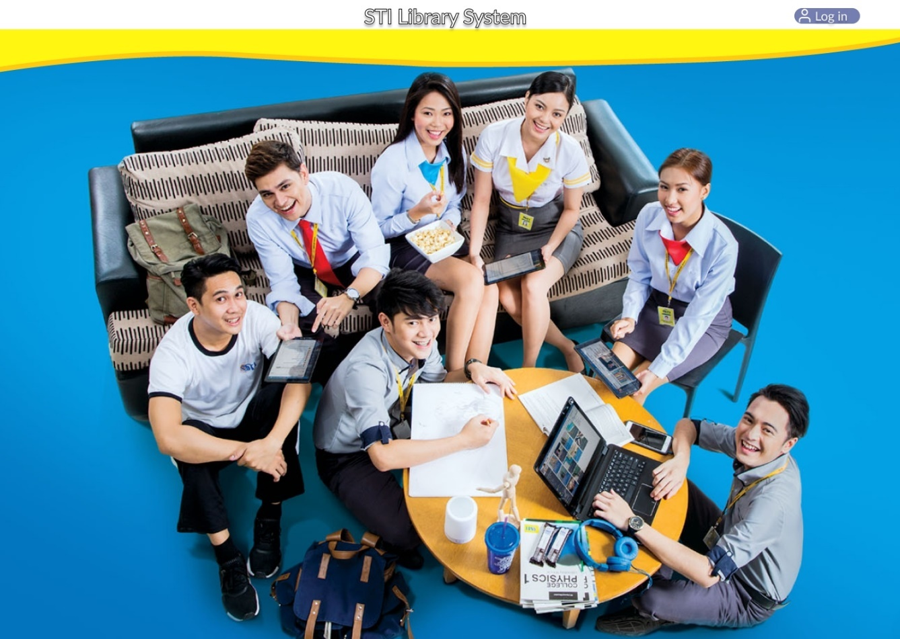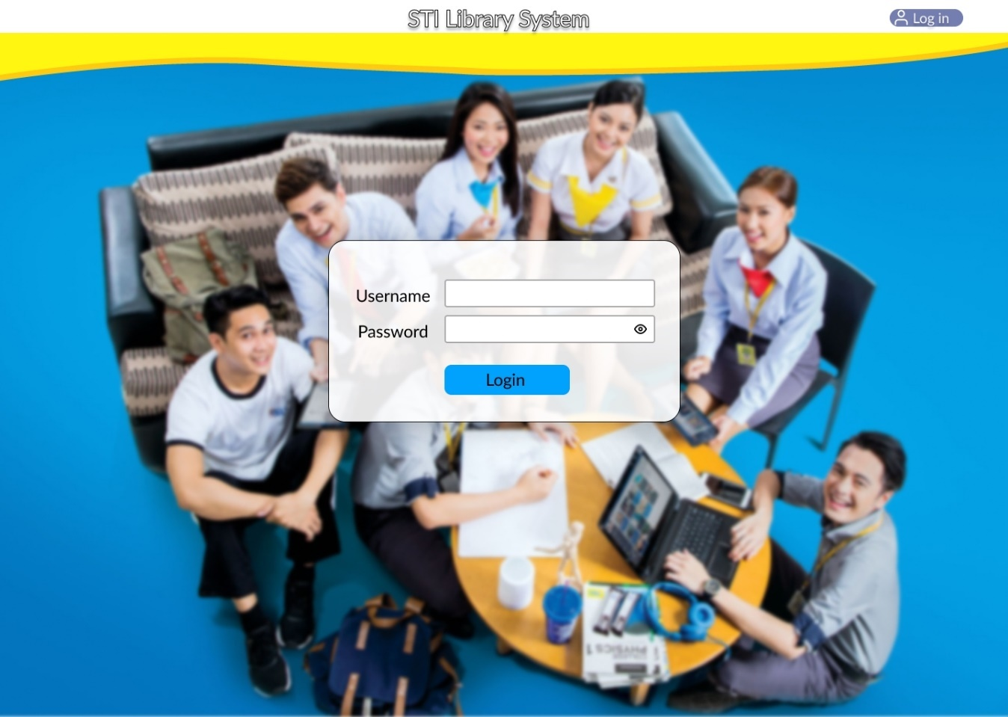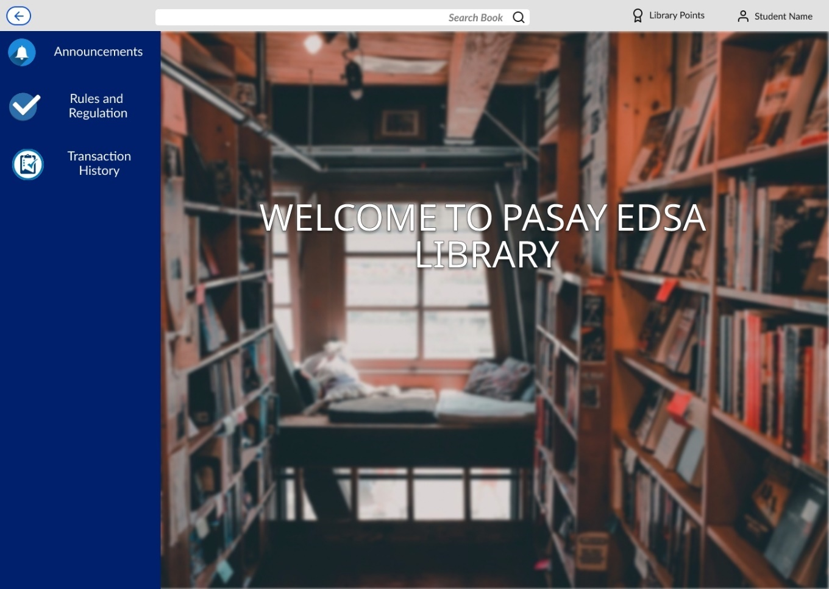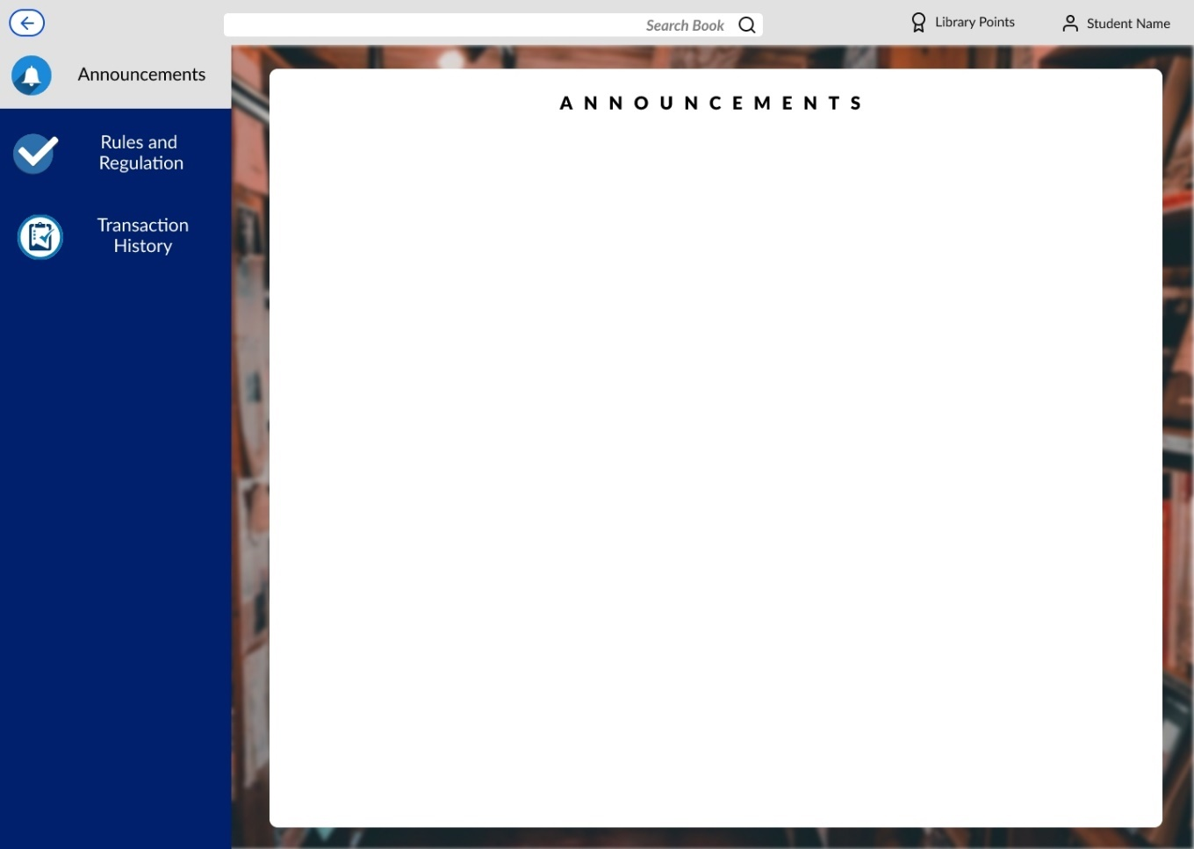

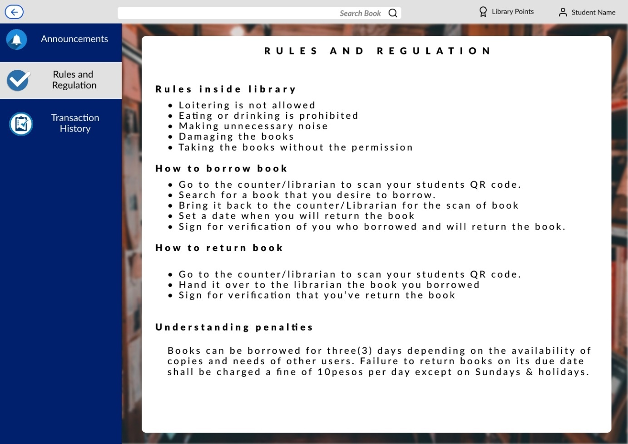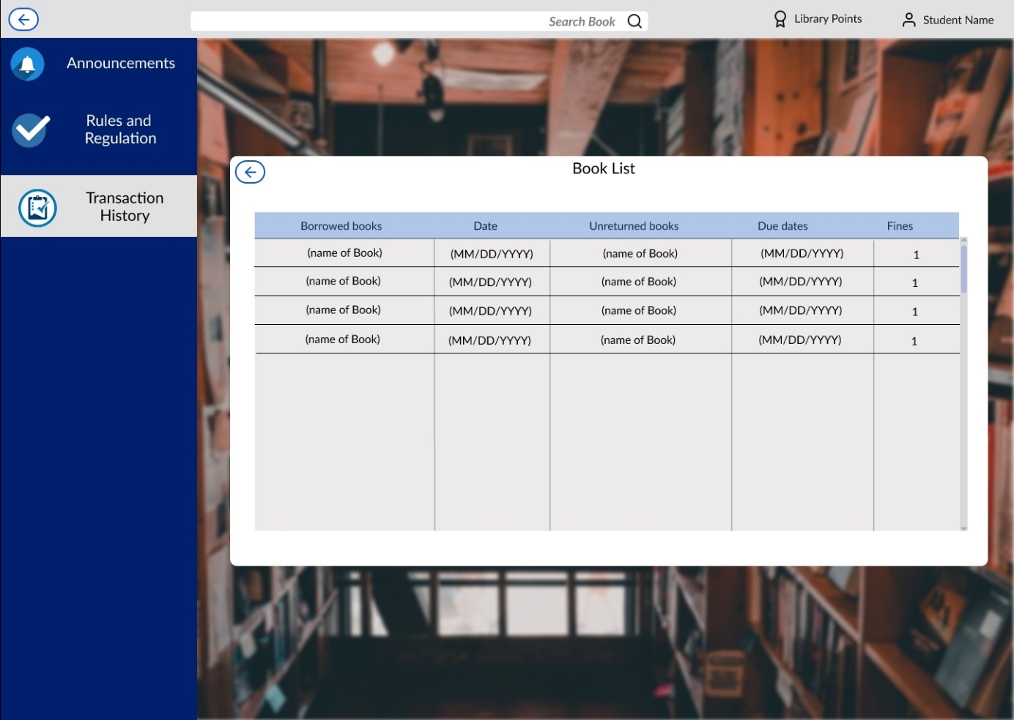

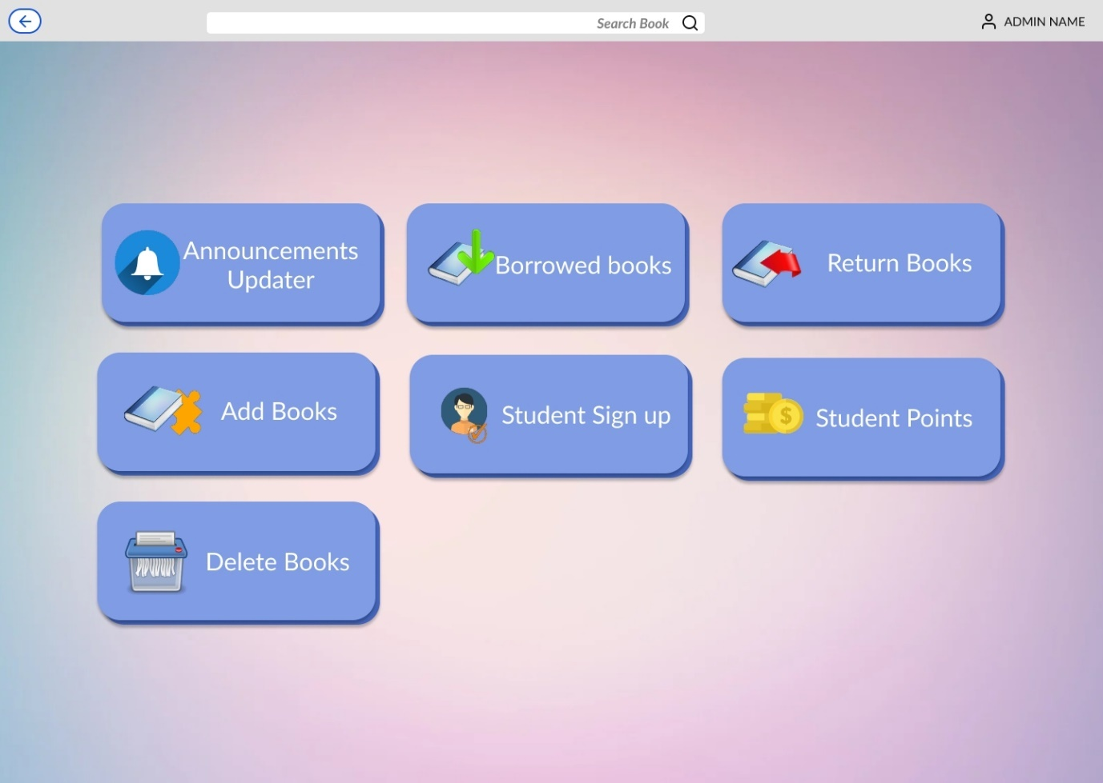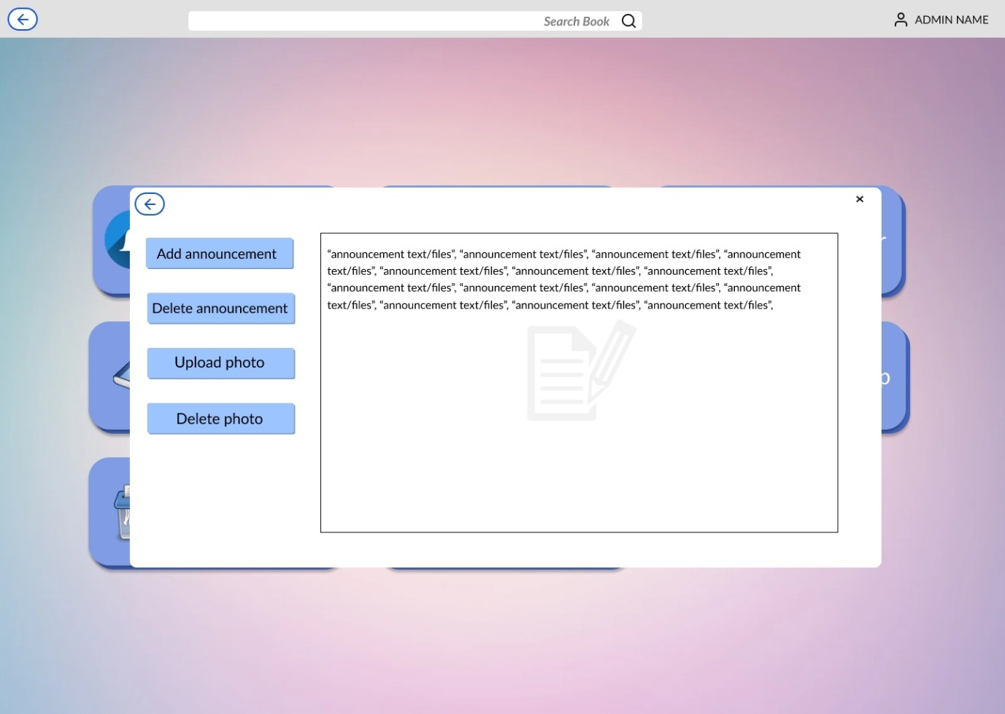

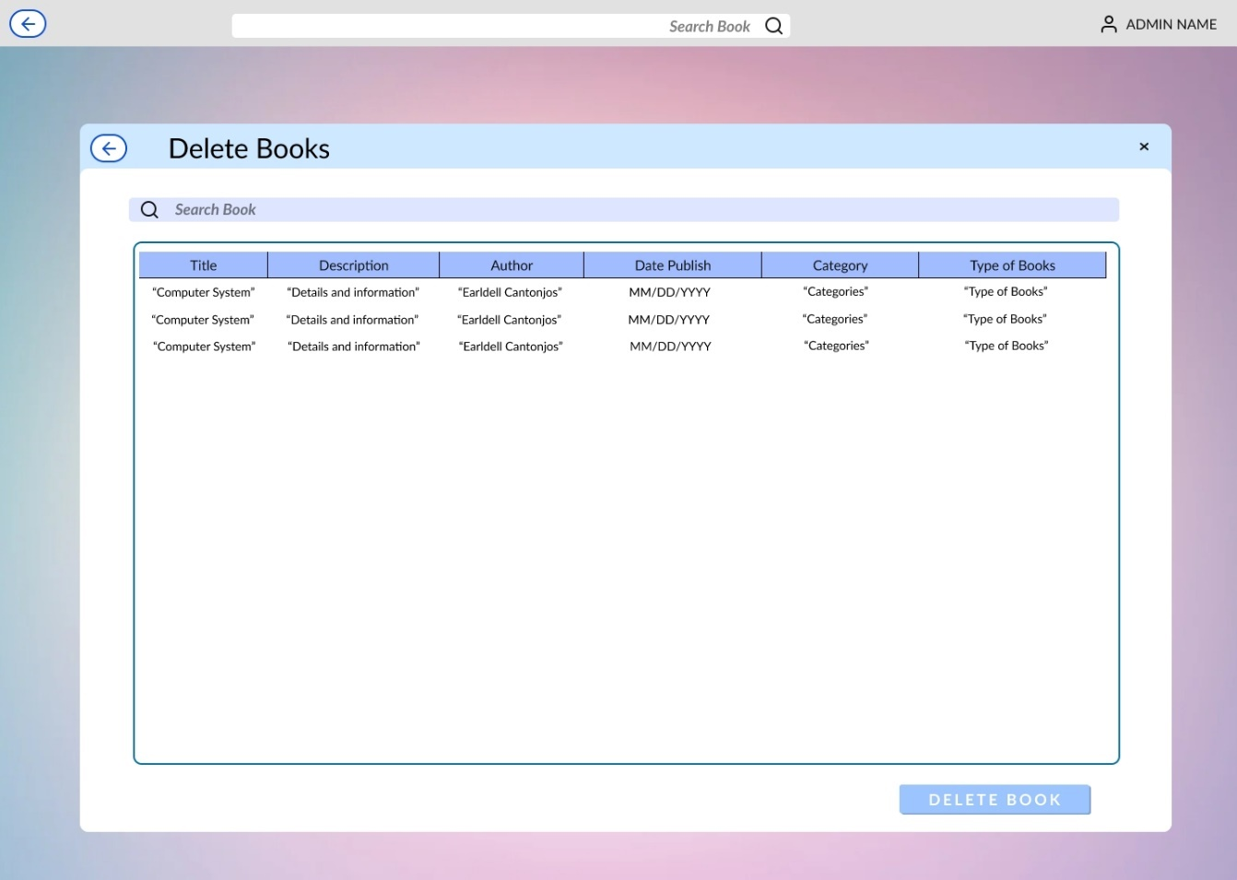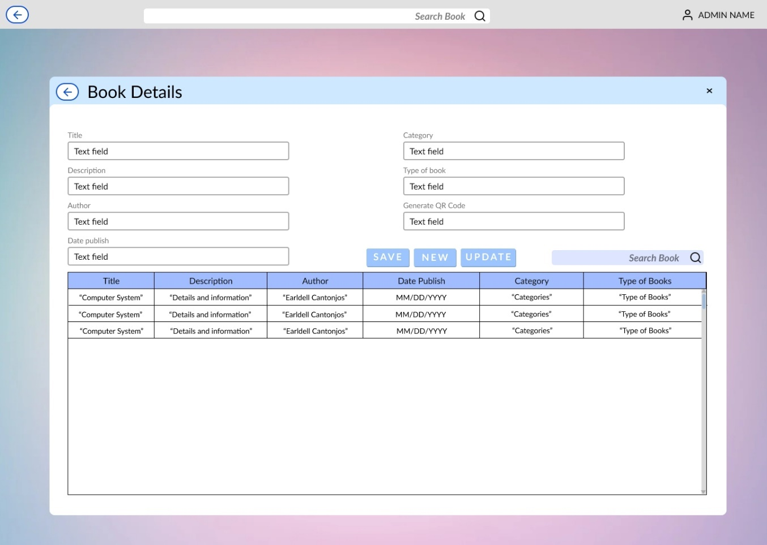

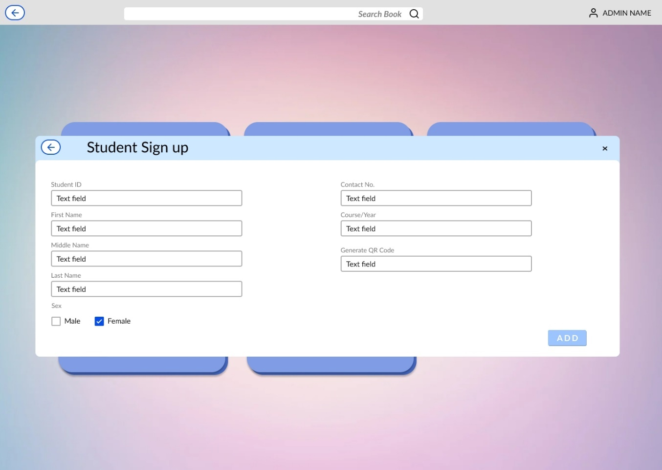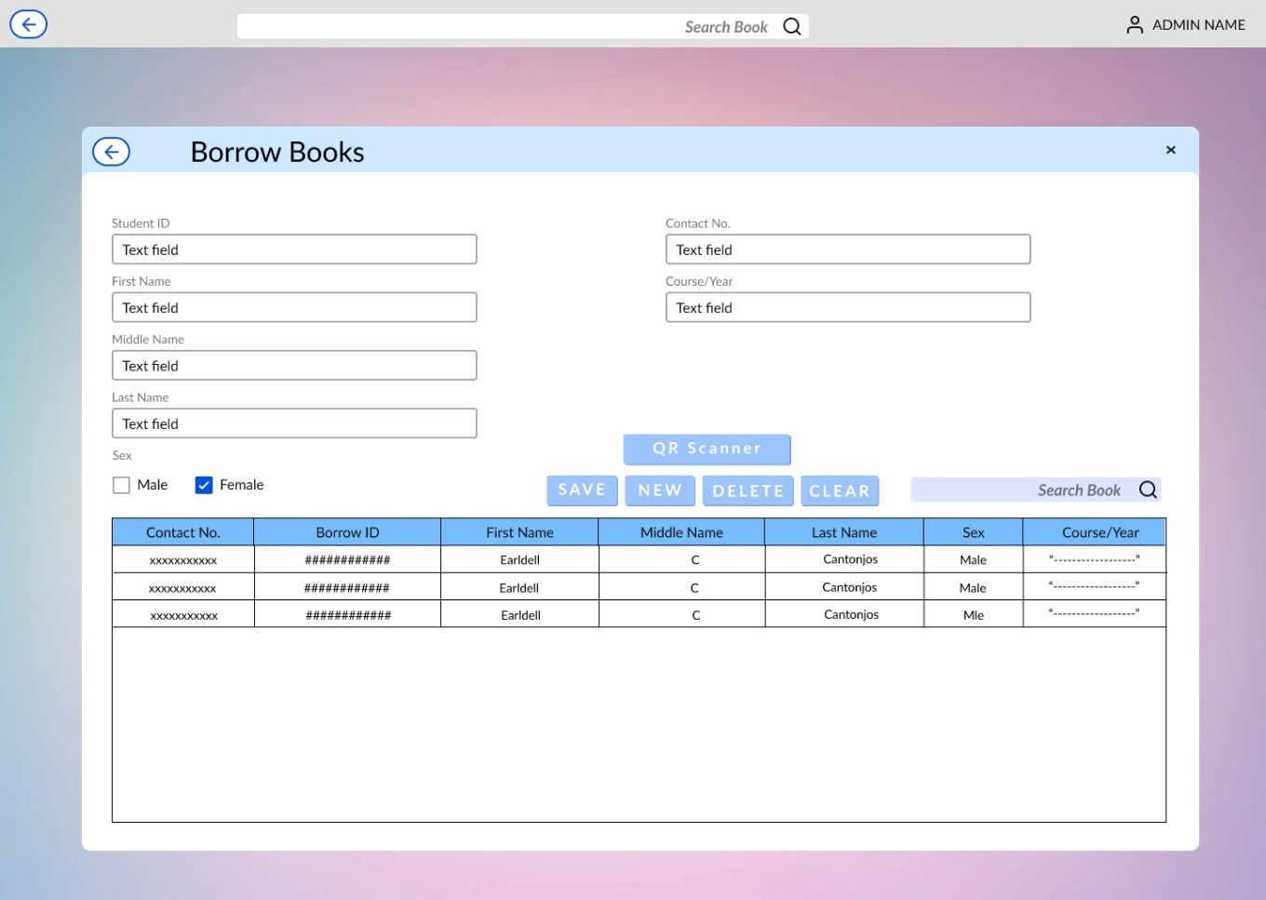

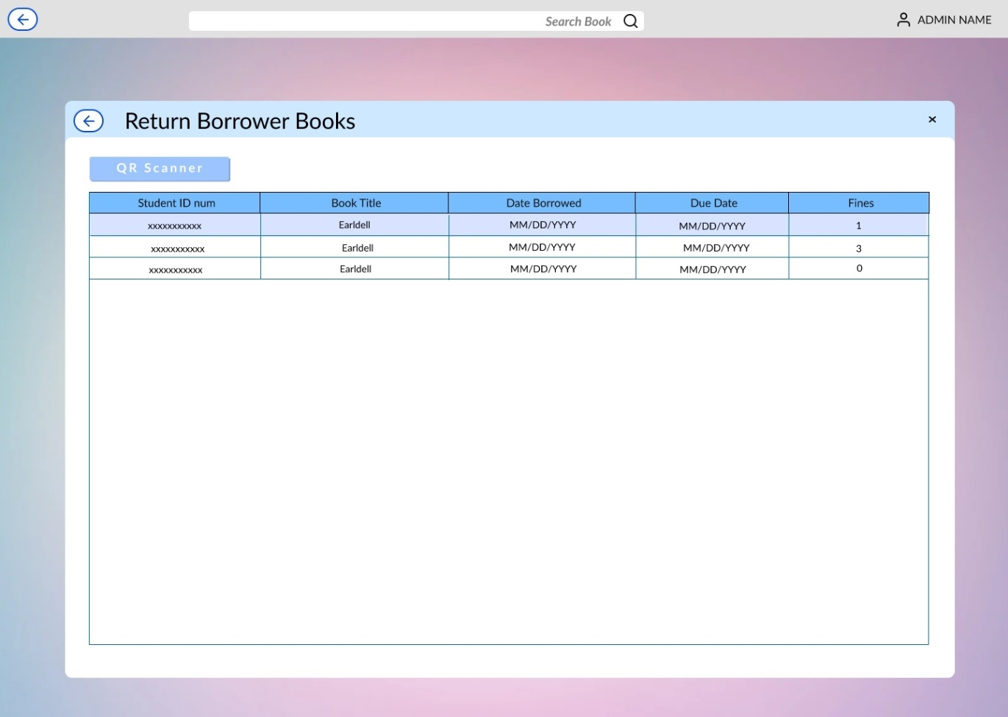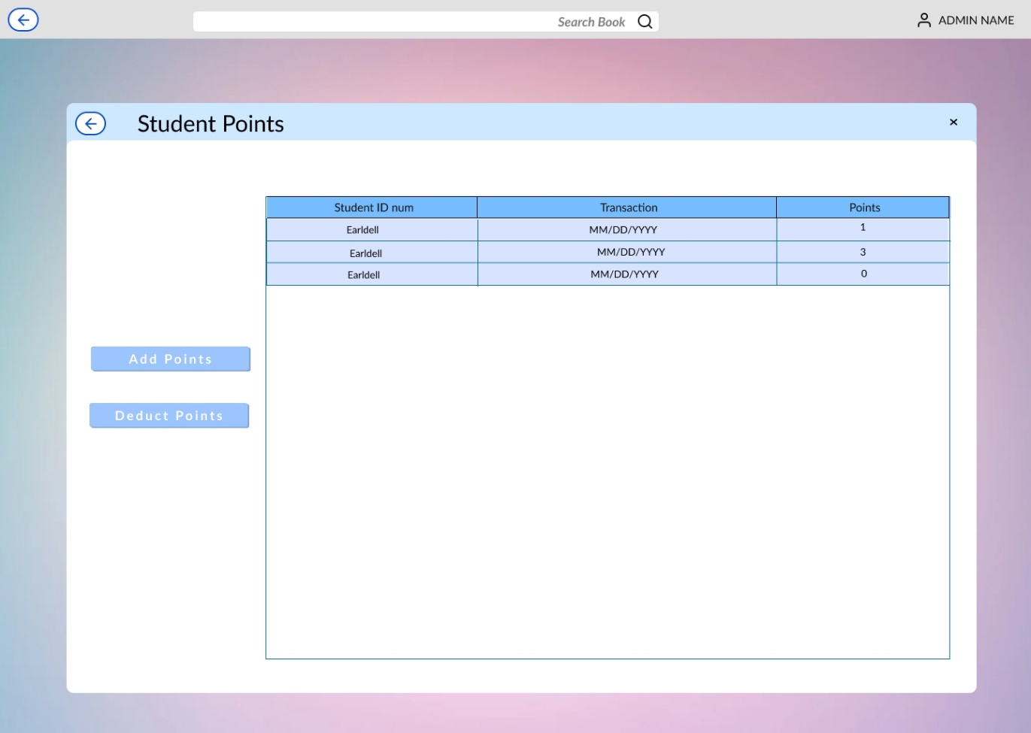

Curriculum Vitae of

JOVEN PAUL T. PAGAL

0328 Quirino Ave Don Galo Parañaque City

Tempel.joven09@gmail.com

09565929455

EDUCATIONAL BACKGROUND

|  |  |  |
| --- | --- | --- |
| Level | Inclusive Dates | Name of school/institution |
| Tertiary | 2020 – Present | STI College Pasay-Edsa |
| Vocational/technical | - | - |
| High school | 2009 – 2013 | Elizabeth Seton School |
| Elementary | 2003 - 2009 | Elizabeth Seton School |

|  |  |  |
| --- | --- | --- |
|  |  |  |

SKILLS

|  |  |  |
| --- | --- | --- |
| SKILLS | Level of Competency | Date Aquired |
| Computer Literate  (Microsoft offices) | basic | 2014 |
| Editing skills | basic | 2019 |
| Programming skills  (C#, python, java) | basic | 2020 |

Curriculum Vitae of

EARLDELL C. CANTONJOS

1323 Narra St. Caa Bf International Las Pinas City

[cantonjosearldell14@gmail.com](mailto:cantonjosearldell14@gmail.com)

09493918195

EDUCATIONAL BACKGROUND

|  |  |  |
| --- | --- | --- |
| Level | Inclusive Dates | Name of school/institution |
| Tertiary | 2020 - present | STI College Pasay-Edsa |
| Vocational/technical | 2017-2019 | Olivarez College |
| High school | 2013-2017 | Caa National High school |
| Elementary | 2007-2013 | Caa Elementary school |

SKILLS

|  |  |  |
| --- | --- | --- |
| SKILLS | Level of Competency | Date Aquired |
| Editing design | Basic | 2018 |
| Computer Literate (MS Word, Powerpoint) | Basic | 2016 |

Curriculum Vitae of

JOHN ALBERT M. SANTOS

#356 3rd St. Pildera II Brgy. 193, NAIA Pasay City

JAMSantos102493@gmail.com

09301528219

EDUCATIONAL BACKGROUND

|  |  |  |
| --- | --- | --- |
| Level | Inclusive Dates | Name of school/institution |
| Tertiary | 2019 - present | STI College Pasay-Edsa/Paranaque |
| Vocational/technical |  |  |
| High school | 2006-2010 | San Jose Academy of Bulacan |
| Elementary | 2000-2006 | San Jose Academy of Bulacan |

SKILLS

|  |  |  |
| --- | --- | --- |
| SKILLS | Level of Competency | Date Aquired |
| Computer Literate (MS Word, Excel, Powerpoint) | Basic | 2008 |
|  |  |  |
|  |  |  |

Curriculum Vitae of

JAYSON C. GONZALES

Manuyo Dos. Green valley Compound, Las Pinas

[Jhaysong25@gmail.com](mailto:Jhaysong25@gmail.com)

09496104203

EDUCATIONAL BACKGROUND

|  |  |  |
| --- | --- | --- |
| Level | Inclusive Dates | Name of school/institution |
| Tertiary | 2019 - present | STI College Pasay-Edsa |
| Vocational/technical | 2017-2019 | Batanes National High school |
| High school | 2013-2017 | Batanes National High school |
| Elementary | 2007-2013 | Batanes Elementary school |

SKILLS

|  |  |  |
| --- | --- | --- |
| SKILLS | Level of Competency | Date Aquired |
| Editing design | Basic | 2018 |
| Computer Literate (MS Word, Excel, Powerpoint) | Basic | 2016 |
| Programming skills  (C#, python, java) | Basic | 2020 |