Svelte Portfolio project
Prince Novotna [C0031369]
Fort this project, we have been tasked with creating a custom portfolio website of our work, using the Svelte framework. For the purposes of hurrying up the progress, I have started from a previous group project file, created from a modified template we were provided with already.
Referring back to my older portfolio website design ideas, I used these prototype sketches as a base and main source of inspiration, without necessarily strictly following them, to potentially improve upon the design as I worked. One of these changes was the early abandonment of the bordered background “floating” on top idea, as this could easily result in a very cluttered interface, especially in the case of mobile devices.
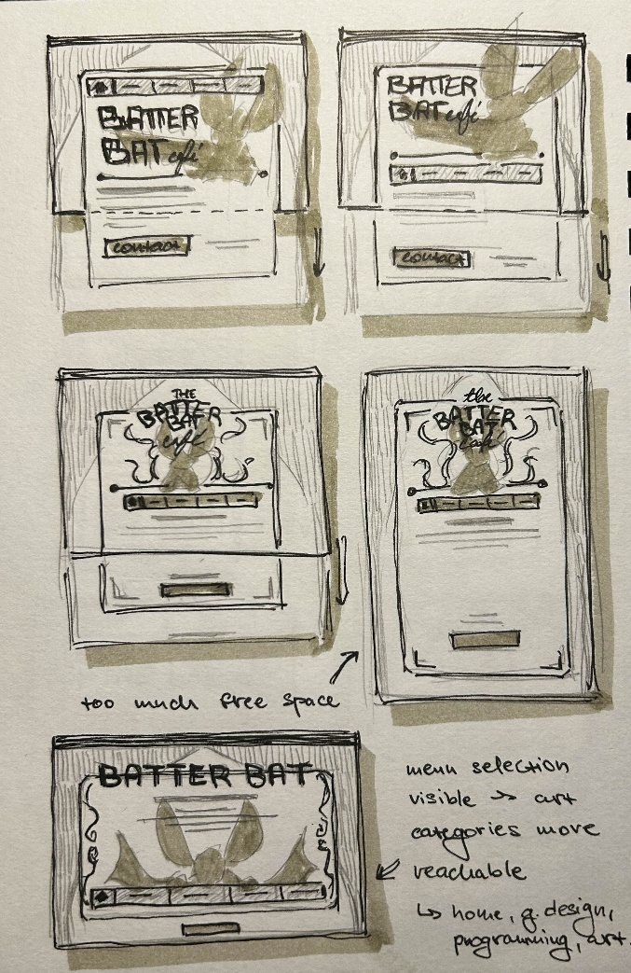
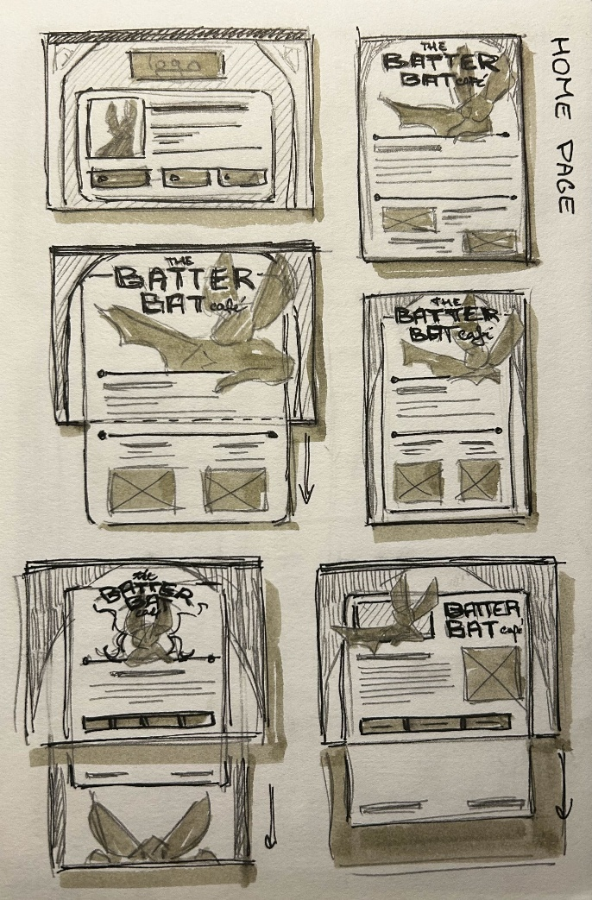
Opting to go for colours I personally like and would like to associate with my future accounts/brand while keeping in mind need for contrast, I decided to go for a darker aesthetic with pops of lighter colours for legibility. This palette is also reflected within the illustrated mascot present in the heading.
To further push this look, I have chosen “edgy” bold fonts for headings and buttons.
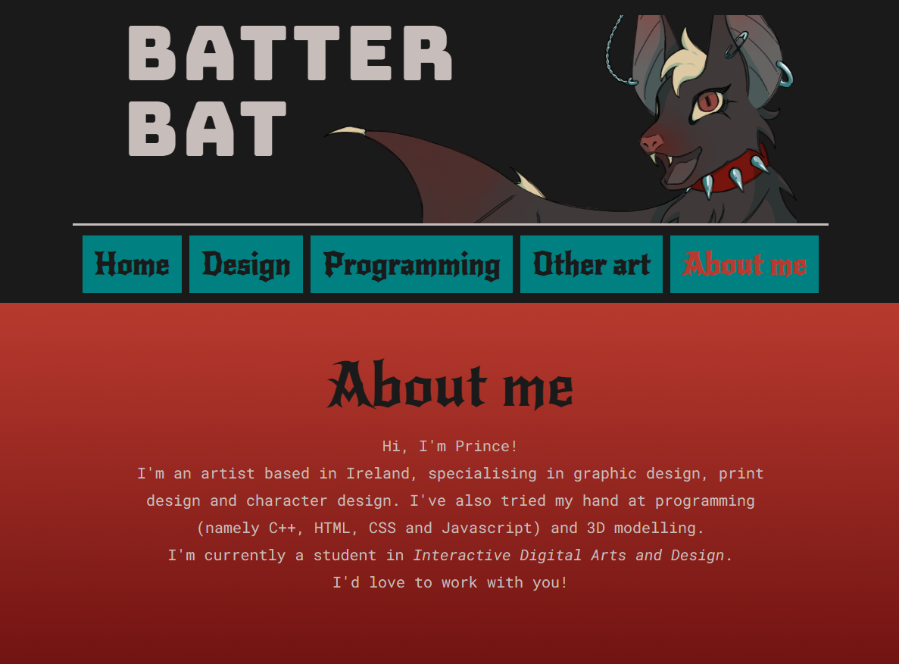
The home page features a form for visitors to type in their email address and message. This would theoretically then connect to a real address, which would receive this inquiry.
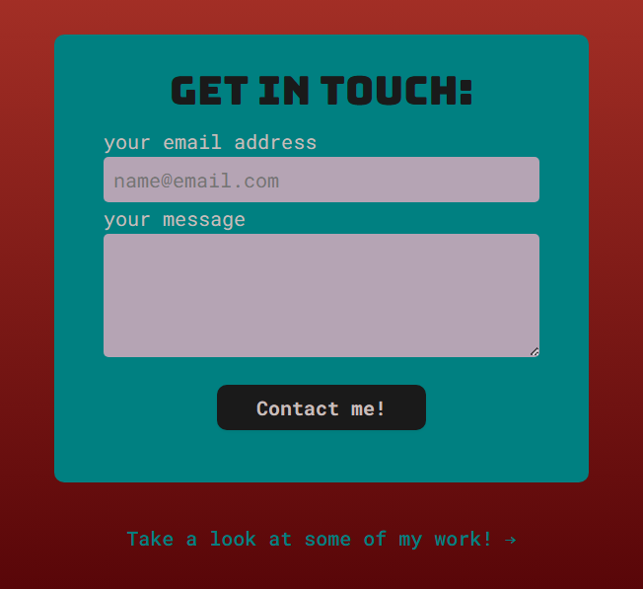
For the individual categories, for now I have sorted them by type/media with each tab having a couple of placeholder examples of my work. To sort them, I have reused the categorisation left over from my base – a news site – meaning this would in the future allow me to add more by category without needing to hard code their order in.
These items are shortly described to draw the attention to the images themselves, with additional information being provided when clicking on them.
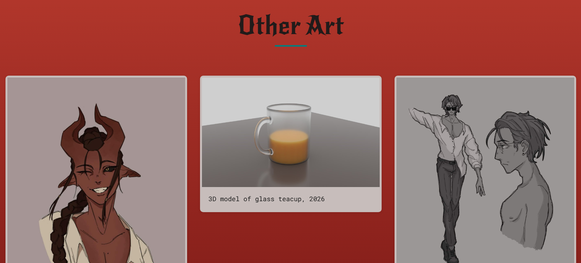

Usability testing
Tested task: Start from the home page, navigate to the contact form, type in a dummy email address and message, submit message.
Participants: 2 participants, tested on May 15th on Windows 11 device (Opera browser)
Taken paths: All participants were able to locate the contact form as it is located on the homepage.
Found Issues: While all participants were able to complete the task successfully, both experienced confusion when no pop-up message confirming their submission was shown. This led to both participants repeatedly pressing the submit button, thinking that the reaction might just e delayed.
Implemented changes: The appropriate fix would be adding a popup alert to let the user know their action had been registered and had an impact of some kind.
Unfortunately though, I was not able to finish testing as my website became unreachable both locally and through pages due to an npm error. I was not able to fix this issue in the end. Due to this I was also unable to deploy the site to Github Pages.

