Web Programming

President University Faculty of Computing

Week 05 - CSS Advanced Properties

Border Radius
Control the style of the border and make it possible to have rounded borders, also to set image as the borders

Property | Description | Possible Values
border-radius | A shorthand property for setting all border radius | border-top-left-radius  border-top-right-radius  border-bottom-right-radius  border-bottom-left-radius
border-top-left-radius | Set top left corner radius | pixel  %
border-top-right-radius | Set top right corner radius | pixel  %
border-bottom-right-radius | Set bottom right corner radius | pixel  %
border-bottom-left-radius | Set bottom left corner radius | pixel  %

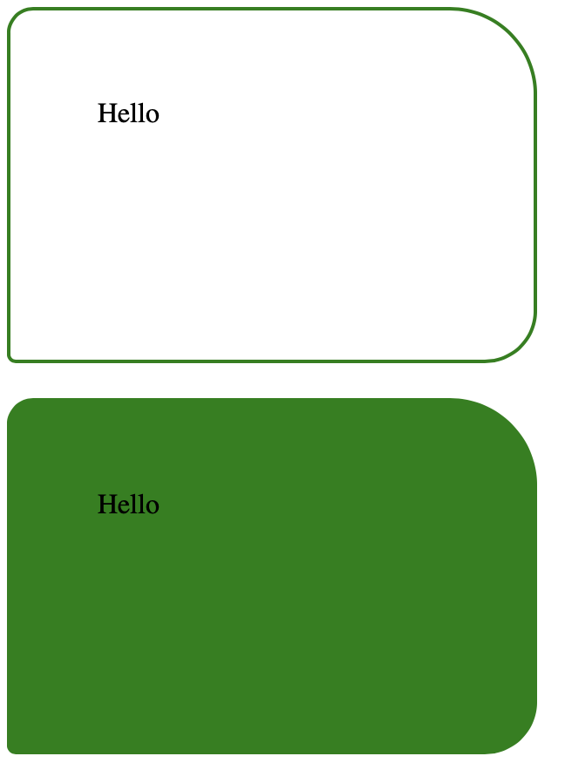
- Set all borders by properties and shorthand
<head>
<style>
div {
border: 2px solid green;
width: 200px;
height: 100px;
margin-top: 20px;
padding: 50px;
}

.corner-each {
border-top-left-radius: 15px;
border-top-right-radius: 50px;
border-bottom-right-radius: 30px;
border-bottom-left-radius: 5px;
}

.corner-4 {
background-color: green;
border-radius: 15px 50px 30px 5px;
}
</style>
</head>
<body>
<div class="corner-each">
Hello
</div>
<div class="corner-4">
Hello
</div>
</body>

- Set only one, two, three values only
<head>
<style>
div {
border: 2px solid green;
width: 200px;
height: 100px;
margin-top: 20px;
padding: 50px;
}

.one {
border-radius: 50px;
}

.two {
border-radius: 50% 30px;
}

.three {
border-radius: 40px 60px 15px;
}
</style>
</head>
<body>
<div class="one">
One value is for all corners
</div>
<div class="two">
If two values:<br/>
First is for top-left and bottom-right<br/>
Second is for top-right and bottom-left
</div>
<div class="three">
If three values:<br/>
First is for top-left<br/>
Second is for top-right and bottom-left<br/>
Third is for bottom-right
</div>
</body>

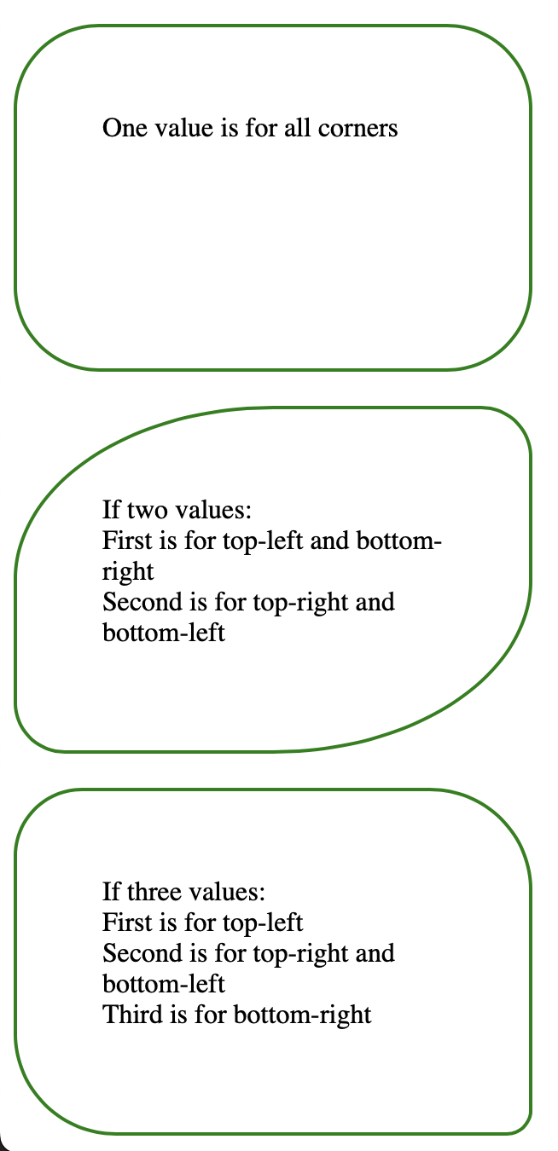

- Set border to ellipse
<head>
<style>
#corner1 {
border-radius: 50px / 15px;
background: #73AD21;
padding: 20px;
width: 200px;
height: 150px;
}

#corner2 {
border-radius: 15px / 50px;
background: #73AD21;
padding: 20px;
width: 200px;
height: 150px;
}

#corner3 {
border-radius: 50%;
background: #73AD21;
padding: 20px;
width: 200px;
height: 150px;
}
</style>
</head>
<body>
<p>Elliptical border - border-radius: 50px / 15px:</p>
<p id="corner1"></p>

<p>Elliptical border - border-radius: 15px / 50px:</p>
<p id="corner2"></p>

<p>Ellipse border - border-radius: 50%:</p>
<p id="corner3"></p>
</body>

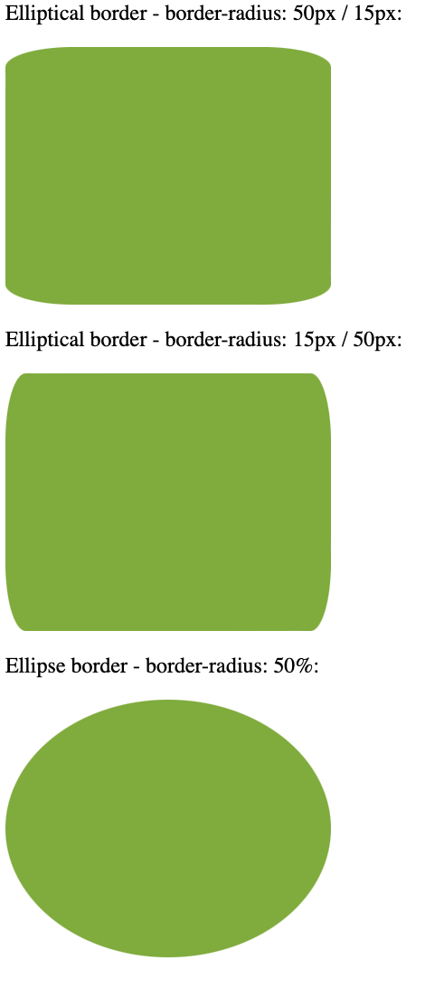

Border Image
Use an image as a border. As a note, to use this property, the border property must be included!

Property | Description | Possible Values
border-image | A shorthand property to set image to use as border | border-image-source  border-image-slice  border-image-width  border-image-outset  border-image-repeat
border-image-source | Specifies the path to the image to be used as a border | url(URL)
border-image-slice | Specifies how to slice the border image | fill  number  %
border-image-width | Specifies the widths of the border image | auto  number  %
border-image-outset | Specifies the amount by which the border image area extends beyond the border box | length  number
border-image-repeat | Specifies whether the border image should be repeated, rounded or stretched | stretch  repeat  round  space

- Border Image
<head>
<style>
#border-img-round {
border: 10px solid transparent;
padding: 15px;
border-image: url(border.png) 30 round;
}

#border-img-stretch {
border: 10px solid transparent;
padding: 15px;
border-image: url(border.png) 30 stretch;
}
</style>
</head>
<body>
<div>
Original Image is <img src="border.png"/>
</div>
<br/>
<div id="border-img-round">
border-image: url(border.png) 30 round;
</div>
<br/>
<div id="border-img-stretch">
border-image: url(border.png) 30 stretch;
</div>
</body>

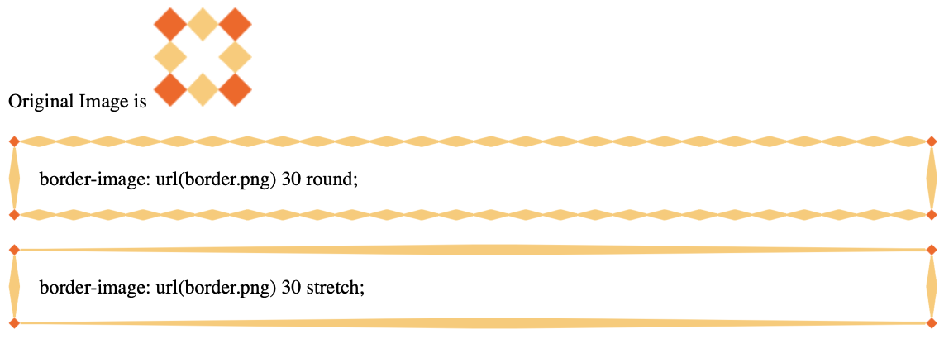

- Border Image using Separate properties
<head>
<style>
div {
border: 10px solid transparent;
padding: 15px;
border-image-source: url(border.png);
}

#bd1 {
border-image-slice: 5 fill;
}

#bd2 {
border-image-slice: 30;
border-image-repeat: space;
border-image-width: 20px;
}

#bd3 {
border-image-slice: 30;
border-image-repeat: space;
border-image-outset: 10px;
}
</style>
</head>
<body>
<div id="bd1">
border-image-slice: 5 fill;
</div>
<br/>
<div id="bd2">
border-image-slice: 30;
border-image-repeat: space;
border-image-width: 20px;
</div>
<br/>
<div id="bd3">
border-image-slice: 30;
border-image-repeat: space;
border-image-outset: 10px;
</div>
</body>

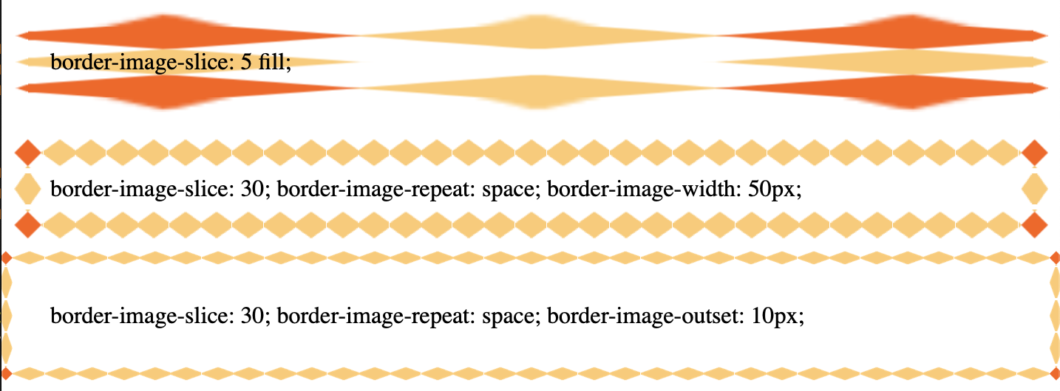

Color Functions
Options of function to set color values in CSS, including RGB, saturation, opacity, and taking current color (currentcolor)

Property | Description | Possible Values
 | RGB | rgb(0-255, 0-255, 0-255)
 | RGB with Alpha | rgba(0-255, 0-255, 0-255, 0.0-1.0)
 | HSL (Hue, Saturation, Lightness) | hsl(0-360, 0-100%, 0-100%)
 | HSL with Alpha | hsla(0-360, 0-100%, 0-100%, 0.0-1.0)
 | Use same color in the tag | currentcolor
opacity | Sets the opacity / transparency of the element | Number from 0.0 - 1.0

- Using RGB, RGBA, HSL, and HSLA
<head>
<style>
div {
display: inline-block;
width: 100px;
height: 100px;
text-align: center;
}

.rgb {
background-color: rgb(200, 143, 87);
}

.rgba {
background-color: rgb(154, 80, 210, 0.6);
}

.hsl {
background-color: hsl(120, 60%, 30%);
}

.hsla {
background-color: hsla(240, 37%, 54%, 0.4);
}
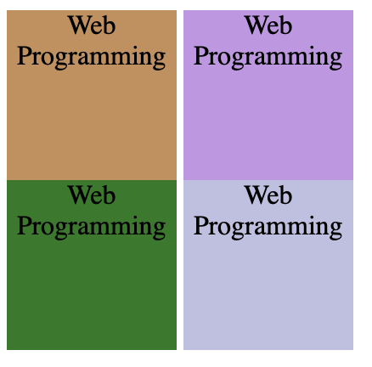
</style>
</head>
<body>
<div class="rgb">
Web Programming
</div>
<div class="rgba">
Web Programming
</div>
<br/>
<div class="hsl">
Web Programming
</div>
<div class="hsla">
Web Programming
</div>
</body>

- Using currentcolor and opacity
<head>
<style>
div {
color: blue;
border: 1px dashed currentcolor;
height: 200px;
width: 200px;
}

.opaque {
color: red;
background-color: blue;
opacity: 0.4;
}
</style>
</head>
<body>
<div>
Web Programming
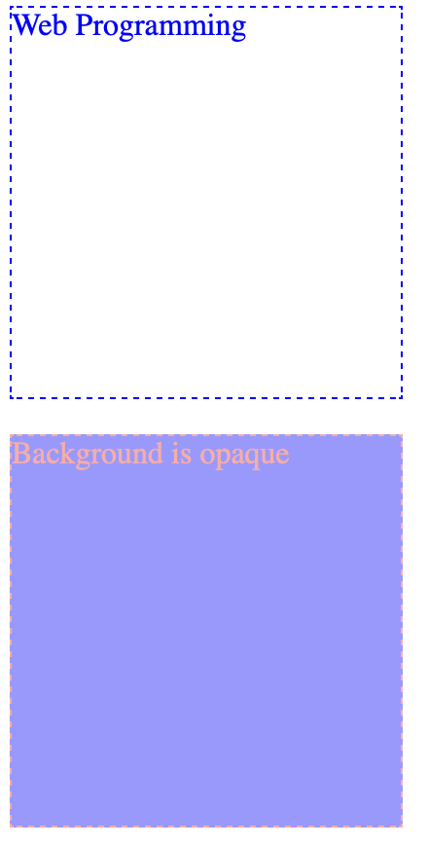
</div>
<br/>
<div class="opaque">
Background is opaque
</div>
</body>

Tooltips
Add tooltip in the elements to help user when the user hovers the pointer to a certain element

- Right Tooltip
<head>
<style>
.tooltip {
position: relative;
display: inline-block;
border-bottom: 1px dotted black;
}

.tooltip .tooltiptext {
visibility: hidden;
width: 120px;
background-color: black;
color: #fff;
text-align: center;
border-radius: 6px;
padding: 5px 0;

/* Position the tooltip */
position: absolute;
z-index: 1;
top: -5px;
left: 105%;
}

.tooltip:hover .tooltiptext {
visibility: visible;
}
</style>
</head>
<body style="text-align:center;">
<p>Move the mouse over the text below:</p>
<div class="tooltip">Hover over me
<span class="tooltiptext">Tooltip text</span>
</div>
</body>

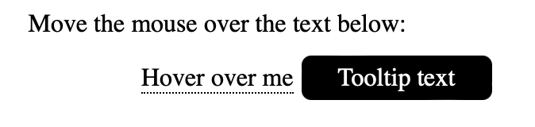

- Left Tooltip
<head>
<style>
.tooltip {
position: relative;
display: inline-block;
border-bottom: 1px dotted black;
}

.tooltip .tooltiptext {
visibility: hidden;
width: 120px;
background-color: black;
color: #fff;
text-align: center;
border-radius: 6px;
padding: 5px 0;

/* Position the tooltip */
position: absolute;
z-index: 1;
top: -5px;
right: 105%;
}

.tooltip:hover .tooltiptext {
visibility: visible;
}
</style>
</head>
<body style="text-align:center;">
<p>Move the mouse over the text below:</p>
<div class="tooltip">Hover over me
<span class="tooltiptext">Tooltip text</span>
</div>
</body>

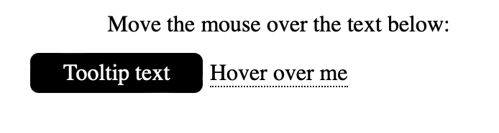

- Top Tooltip
<style>
.tooltip {
position: relative;
display: inline-block;
border-bottom: 1px dotted black;
}

.tooltip .tooltiptext {
visibility: hidden;
width: 120px;
background-color: black;
color: #fff;
text-align: center;
border-radius: 6px;
padding: 5px 0;

/* Position the tooltip */
position: absolute;
z-index: 1;
bottom: 100%;
left: 50%;
margin-left: -60px;
}

.tooltip:hover .tooltiptext {
visibility: visible;
}
</style>
<body style="text-align:center;">

<p>Move the mouse over the text below:</p>

<div class="tooltip">Hover over me
<span class="tooltiptext">Tooltip text</span>
</div>

</body>

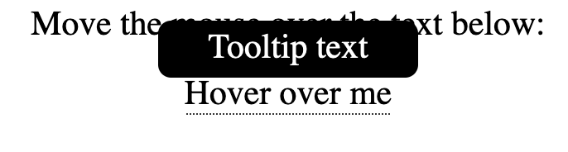

- Bottom Tooltip
<style>
.tooltip {
position: relative;
display: inline-block;
border-bottom: 1px dotted black;
}

.tooltip .tooltiptext {
visibility: hidden;
width: 120px;
background-color: black;
color: #fff;
text-align: center;
border-radius: 6px;
padding: 5px 0;

/* Position the tooltip */
position: absolute;
z-index: 1;
top: 100%;
left: 50%;
margin-left: -60px;
}

.tooltip:hover .tooltiptext {
visibility: visible;
}
</style>
<body style="text-align:center;">
<p>Move the mouse over the text below:</p>

<div class="tooltip">Hover over me
<span class="tooltiptext">Tooltip text</span>
</div>

</body>

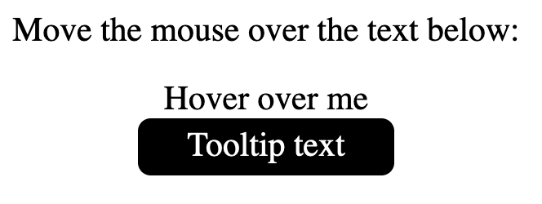

Gradient Functions
Function to set color in gradients. There are 3 (three) main gradient types: Linear, Radial, and Conic gradients. Linear is defined by the directions (up, down, left, right, diagonal), Radial is defined by the center, and Conic is defined by the rotation of the center point.

Property | Description | Possible Values
 | Define a linear gradient | linear-gradient(angle, color1, color2, …, colorN)  linear-gradient(direction, color1, color2, …, colorN)
 | Using linear gradient with repeat | repeating-linear-gradient(color1 %, color2 %, …, colorN %)  repeating-linear-gradient(angle, color1 %, color2 %, …, colorN %)
 | Define a radial gradient (must be 2 colors minimum) | radial-gradient(color1, color2, …, colorN)  radial-gradient(shape, color1, color2, …, colorN)
 | Using radial gradient with repeat | repeating-radial-gradient(color1 %, color2 %, …, colorN %)  repeating-radial-gradient(shape, color1 %, color2 %, …, colorN %)
 | Define a conic gradient | conic-gradient(color1, color2, …, colorN)  conic-gradient(shape, color1, color2, …, colorN)
 | Using conic gradient with repeat | repeating-conic-gradient(color1 %, color2 %, …, colorN %)  repeating-conic-gradient(deg color1, deg color2, …, deg colorN)

- Linear Gradient variations
<head>
<style>
div {
height: 200px;
width: 200px;
}

#grd {
color: white;
background-image: linear-gradient(63deg, red, blue, green);
}

#right-grd {
color: black;
background-image: linear-gradient(to right, rgba(100, 0, 0, 0.1), rgba(255, 0, 0, 1.0));
}

#repeat-grd {
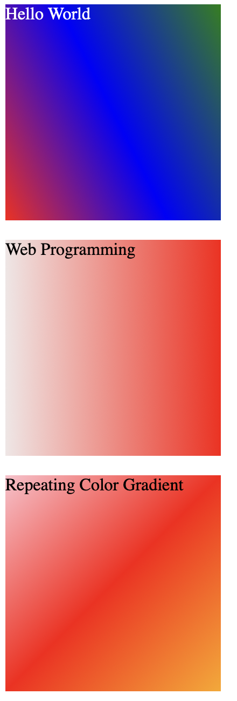
background-image: repeating-linear-gradient(135deg, pink, red, orange);
}
</style>
</head>
<body>
<div id="grd">
Hello World
</div>
<br/>
<div id="right-grd">
Web Programming
</div>
<br/>
<div id="repeat-grd">
Repeating Color Gradient
</div>
</body>

- Radial Gradient variations
<head>
<style>
div {
height: 200px;
width: 200px;
}

#grd {
color: white;
background-image: radial-gradient(pink, purple, black);
}

#right-grd {
color: black;
background-image: radial-gradient(circle, red, yellow, blue);
}

#repeat-grd {
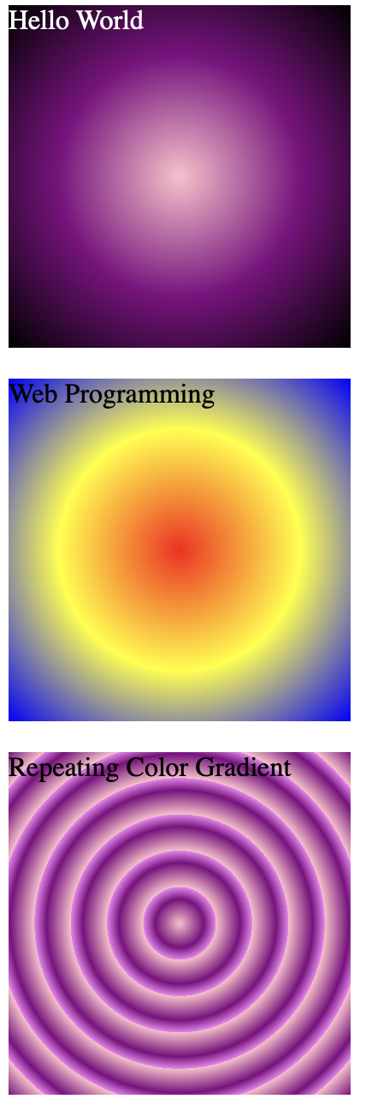
background-image: repeating-radial-gradient(pink, purple 10%, violet 15%);
}
</style>
</head>
<body>
<div id="grd">
Hello World
</div>
<br/>
<div id="right-grd">
Web Programming
</div>
<br/>
<div id="repeat-grd">
Repeating Color Gradient
</div>
</body>

- Conic Gradient variations
<head>
<style>
div {
height: 200px;
width: 200px;
}

#grd {
color: white;
background-image: conic-gradient(pink, purple, black);
}

#right-grd {
color: black;
background-image: conic-gradient(red 120deg, yellow 120deg, blue);
}

#repeat-grd {
background-image: repeating-conic-gradient(pink, purple 10%, violet 15%);
}
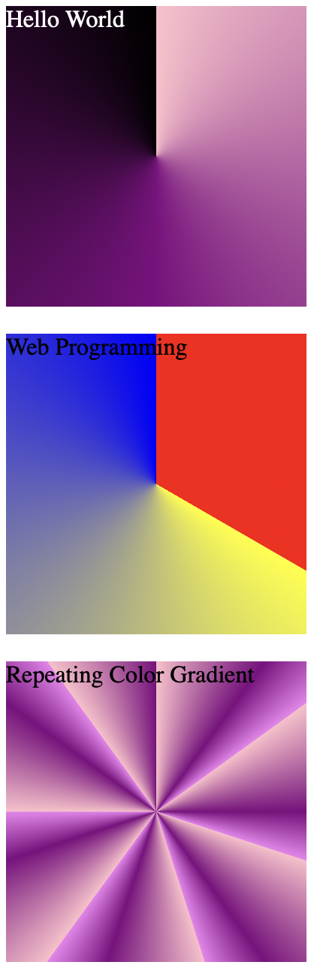
</style>
</head>
<body>
<div id="grd">
Hello World
</div>
<br/>
<div id="right-grd">
Web Programming
</div>
<br/>
<div id="repeat-grd">
Repeating Color Gradient
</div>
</body>

Shadow Manipulation
Add effects of shadow in the text or element

Property | Description | Possible Values
text-shadow | Applies shadow to text | vertical (px)  horizontal (px)  color  blur
box-shadow | Applies shadow to element as box | vertical (px)  horizontal (px)  color  blur  spread (px)  inset

- Text Shadowing using normal, color and blur
<head>
<style>
.shadow1 {
text-shadow: 2px 2px;
}

.pink-shadow {
text-shadow: 3px 3px pink;
}

.red-blur {
text-shadow: 3px 3px 5px red;
}
</style>
</head>
<body>
<h2 class="shadow1">
Text Shadow
</h2>
<h2 class="pink-shadow">
Text Shadow
</h2>
<h2 class="red-blur">
Text Shadow
</h2>
</body>

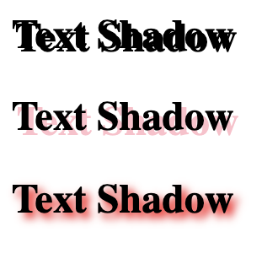

- Multi Shadow and Text Border
<head>
<style>
.multi-shadow {
color: white;
text-shadow: 2px 2px 3px black, 0 0 30px red, 0 0 2px yellow;
}

.text-border {
color: yellow;
text-shadow: -1px 0 black, 0 1px black, 1px 0 black, 0 -1px black;
}
</style>
</head>
<body>
<h2 class="multi-shadow">
Text Shadow
</h2>
<h2 class="text-border">
Text Border
</h2>
</body>


- Box Shadow
<head>
<style>
div {
background-color: orange;
width: 150px;
height: 150px;
}
.single {
box-shadow: 10px 10px;
}

.multi {
box-shadow: 5px 5px blue, 10px 10px red, 15px 15px green;;
}
</style>
</head>
<body>
<div class="single">
Box with shadow
</div>
<br/>
<div class="multi">
Box with Multi Shadow
</div>
</body>

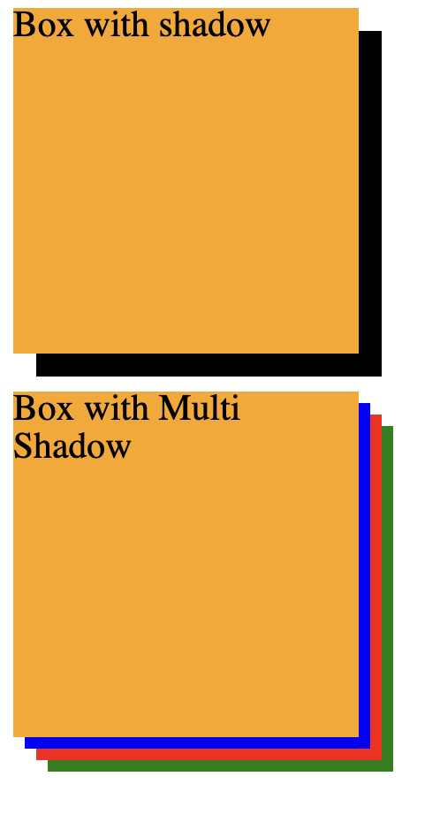

Transformation
Transform object or element using CSS in 2-dimensional and 3-dimensional aspects

Property | Description | Possible Values
transform | Property to handle transformation of elements in 2D or 3D perspective  Use matrix to combine all 2D and 3D transformation methods into one as shorthand.  For 2D:  matrix(  scaleX(n),  skewY(angle),  skewX(angle),  scaleY(n),  translateX(n),  translateY(n)  ) | For 2D:  translate(x, y)  translateX(n)  translateY(n)  rotate(angle)  scale(x, y)  scaleX(n)  scaleY(n)  skew(x-angle, y-angle)  skewX(angle)  skewY(angle)  matrix(n, n, n, n, n, n)  For 3D:  translate3d(x, y, z)  translateX(n)  translateY(n)  translateZ(n)  scale3d(x, y, z)  scaleX(n)  scaleY(n)  scaleZ(n)  rotate3d(x, y, z, angle)  rotateX(angle)  rotateY(angle)  rotateZ(angle)  perspective(n)  matrix3d(n, n, n, n, n, n, n, n, n, n, n, n, n, n, n, n)
transform-origin | Change position of transformed elements  X-axis and Y-axis (2D)  X-axis, Y-axis, Z-axis (3D) | x-axis (left, center, right, length, %)  y-axis (top, center, bottom, length, %)  z-axis (length)
transform-style | (3D Only) Specifies how nested elements are rendered in 3D space | flat  preserve-3d
perspective | (3D Only) Give 3D-positioned element some perspective | length
perspective-origin | (3D Only) Defines position from which the user is looking at the 3D elements and only the CHILDREN elements will get the effect and must be used with perspective property | x-axis (left, center, right, length, %)  y-axis (top, center, bottom, length, %)
backface-visibility | (3D Only) Defines if the backface of an element should be visible when facing user | visible  hidden
2D transformation
- Translation
<head>
<style>
div {
width: 100px;
height: 100px;
border: 1px solid black;
}
.translate {
transform: translate(50px, 100px);
}
.translateX {
transform: translateX(200px);
}
.translateY {
transform: translateY(100px);
}
</style>
</head>
<body>
<div class="translate">
move 50px to right and 100px down
</div>
<div class="translateX">
move 200px to right
</div>
<div class="translateY">
move 100px down
</div>
</body>

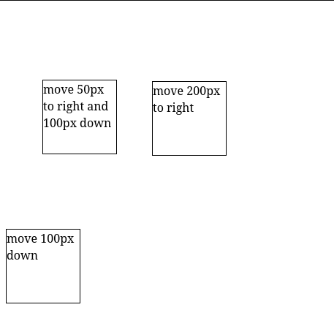

- Rotate Clockwise (positive value) and Counter-Clockwise (negative value)
<head>
<style>
div {
margin: 50px 50px;
width: 100px;
height: 100px;
border: 1px solid black;
}
.rotateCW {
transform: rotate(30deg);
}
.rotateCCW {
transform: rotate(-45deg);
}
</style>
</head>
<body>
<div class="rotateCW">
Rotate CW
</div>
<div class="rotateCCW">
Rotate CCW
</div>
</body>

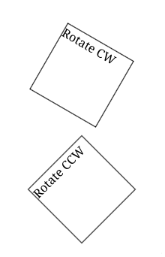

- Scaling elements, by X-Axis and Y-Axis
<head>
<style>
div {
display: inline-block;
margin: 50px 50px;
width: 100px;
height: 100px;
border: 1px solid black;
}
.scale {
transform: scale(2, 3);
}
.scaleX {
transform: scaleX(0.5);
}
.scaleY {
transform: scaleY(0.5);
}
</style>
</head>
<body>
<div class="scale">
Scale width 2x and height 3x
</div>
<div class="scaleX">
Scale width half the size
</div>
<div class="scaleY">
Scale height half the size
</div>
</body>

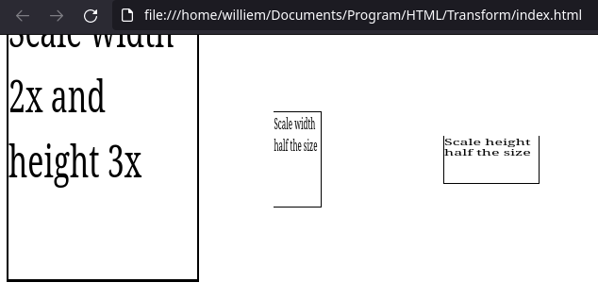

- Skewing elements
<head>
<style>
div {
display: inline-block;
margin: 50px 50px;
width: 100px;
height: 100px;
border: 1px solid black;
}
.skew {
transform: skew(20deg, 30deg);
}
.skewX {
transform: skewX(10deg);
}
.skewY {
transform: skewY(40deg);
}
</style>
</head>
<body>
<div>normal</div>
<div class="skew">Skew X 20deg and Y 30deg</div>
<div class="skewX">Skew X 10deg</div>
<div class="skewY">Skew Y 40deg</div>
</body>

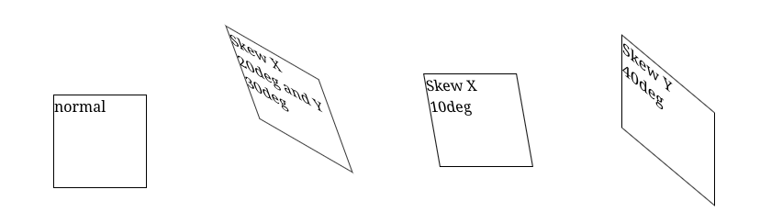

- Combining all transformations using matrix function
<head>
<style>
div {
width: 300px;
height: 100px;
background-color: yellow;
border: 1px solid black;
}

div#myDiv1 {
transform: matrix(1, -0.3, 0, 1, 0, 0);
}

div#myDiv2 {
transform: matrix(1, 0, 0.5, 1, 150, 0);
}
</style>
</head>
<body>
<div>
This a normal div element.
</div>
<div id="myDiv1">
Using the matrix() method.
</div>
<div id="myDiv2">
Another use of the matrix() method.
</div>
</body>

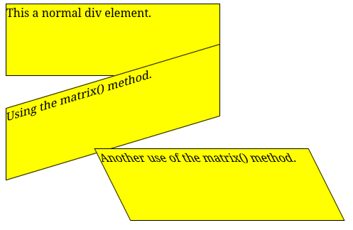

3D transformation
- Rotate by X-Axis
<head>
<style>
div {
width: 300px;
height: 100px;
background-color: yellow;
border: 1px solid black;
}

#rotateX {
transform: rotateX(150deg);
}
</style>
</head>
<body>
<div>
This a normal div element.
</div>
<div id="rotateX">
This div element is rotated 150 degrees.
</div>
</body>

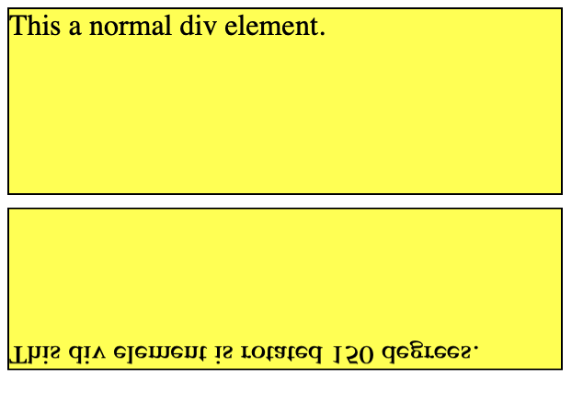

- Rotate by Y-Axis
<head>
<style>
div {
width: 300px;
height: 100px;
background-color: yellow;
border: 1px solid black;
}

#rotateY {
transform: rotateY(150deg);
}
</style>
</head>
<body>
<div>
This a normal div element.
</div>
<div id="rotateY">
This div element is rotated 150 degrees.
</div>
</body>

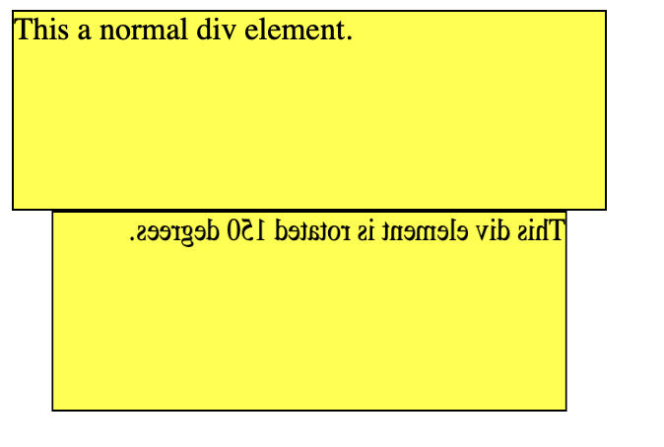

- Rotate by Z-Axis
<head>
<style>
div {
width: 300px;
height: 100px;
background-color: yellow;
border: 1px solid black;
}

#rotateZ {
transform: rotateZ(150deg);
}
</style>
</head>
<body>
<div>
This a normal div element.
</div>
<div id="rotateZ">
This div element is rotated 150 degrees.
</div>
</body>

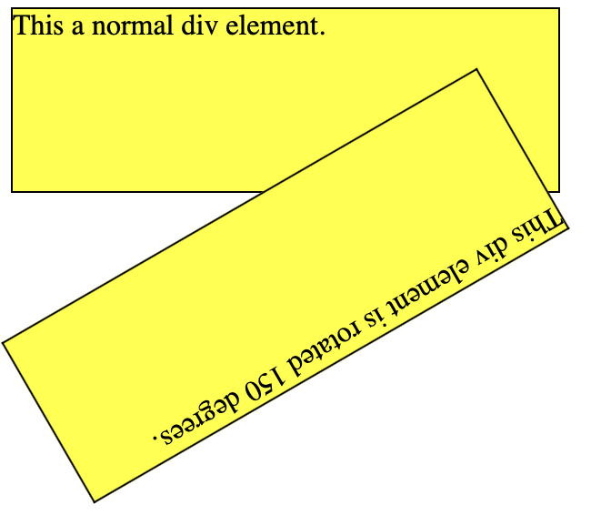

- Perspective, using lesser value means closer to the user, and preserve the 3D perspective
<head>
<style>
#div1 {
position: relative;
width: 150px;
height: 150px;
margin-left: 60px;
border: 1px solid blue;
perspective: 100px;
}

#div3 {
position: relative;
width: 150px;
height: 150px;
margin-left: 60px;
border: 1px solid blue;
perspective: none;
}

#div2, #div4 {
position: absolute;
padding: 50px;
border: 1px solid black;
background-color: rgba(100, 100, 100, 0.5);
transform-style: preserve-3d;
transform: rotateX(45deg);
}
</style>
</head>
<body>
<div id="div1">
DIV1
<div id="div2">DIV2</div>
</div>
<br/>
<div id="div3">
DIV3
<div id="div4">DIV4</div>
</div>
</body>

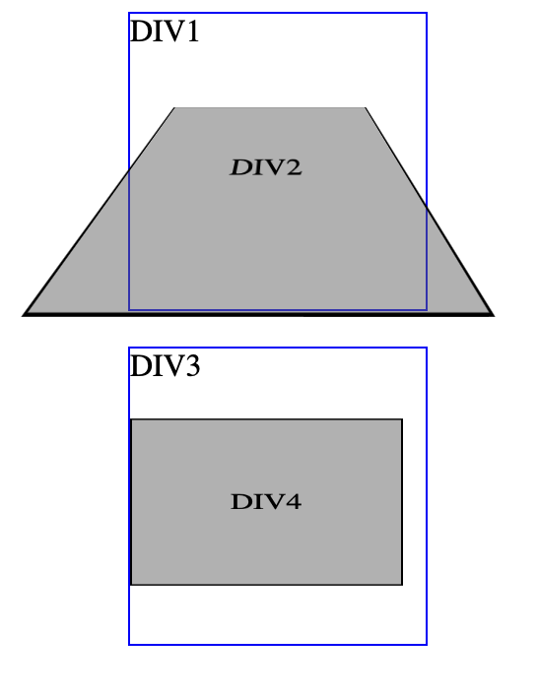

- Perspective origin
<head>
<style>
#div1 {
position: relative;
height: 150px;
width: 150px;
margin-left: 60px;
border: 1px solid blue;
perspective: 100px;
perspective-origin: left;
}
#div2, #div4, #div6 {
padding: 50px;
position: absolute;
border: 1px solid black;
background-color: red;
background: rgba(100,100,100,0.5);
transform-style: preserve-3d;
transform: rotateX(45deg);
}
#div3 {
position: relative;
height: 150px;
width: 150px;
margin-left: 60px;
border: 1px solid blue;
perspective: 100px;
perspective-origin: bottom right;
}
#div5 {
position: relative;
height: 150px;
width: 150px;
margin-left: 60px;
border: 1px solid blue;
perspective: 100px;
perspective-origin: -90%;
}
</style>
</head>
<body>
<h2>perspective-origin: left:</h2>
<div id="div1">DIV1
<div id="div2">DIV2</div>
</div>

<h2>perspective-origin: bottom right:</h2>
<div id="div3">DIV3
<div id="div4">DIV4</div>
</div>

<h2>perspective-origin: -90%:</h2>
<div id="div5">DIV5
<div id="div6">DIV6</div>
</div>
</body>

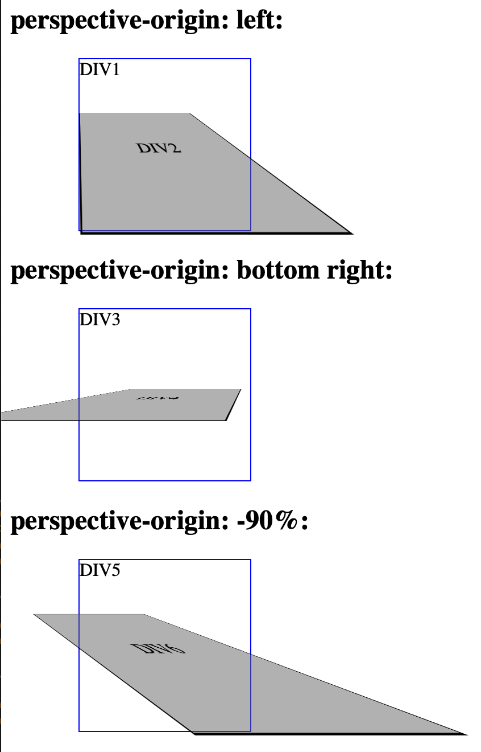

- Create a Cube
<head>
<style>
.ex1 {
perspective: 800px;
}

.cube {
font-size: 4em;
width: 2em;
margin: 1.5em auto;
transform-style: preserve-3d;
transform: rotateX(-45deg) rotateY(30deg);
}

.side {
position: absolute;
width: 2em;
height: 2em;
background: rgba(100,100,100,0.5);
border: 1px solid red;
text-align: center;
line-height: 2em;
}

.front {transform: translateZ(1em);}
.top {transform: rotateX(90deg) translateZ(1em);}
.right {transform: rotateY(90deg) translateZ(1em);}
.left {transform: rotateY(-90deg) translateZ(1em);}
.bottom {transform: rotateX(-90deg) translateZ(1em);}
.back {transform: rotateY(-180deg) translateZ(1em);}
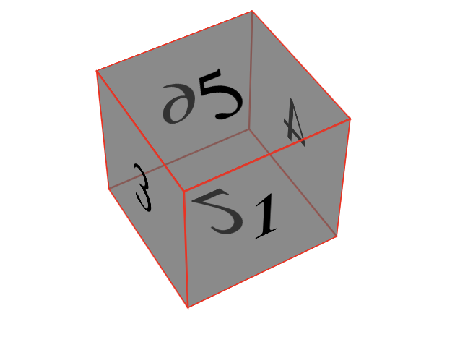
</style>
</head>
<body>
<div class="ex1">
<div class="cube">
<div class="side front">1</div>
<div class="side back">6</div>
<div class="side right">4</div>
<div class="side left">3</div>
<div class="side top">5</div>
<div class="side bottom">2</div>
</div>
</div>
</body>

Transitions
Create effect of transition

Property | Description | Possible Values
transition | Shorthand property to set all transitions | transition-duration  transition-delay  transition-property  transition-timing-function
transition-delay | Specify delay in seconds for the transition effect | time_in_seconds
transition-duration | Specify how many seconds of milliseconds for effect to complete | time_in_seconds  time_in_milliseconds
transition-property | Specify name of CSS property to take effect | CSS properties
transition-timing-function | Specify speed curve of transition effect | ease  linear  ease-in  ease-out  ease-in-out  step-start  step-end

- Transition using shorthand
<head>
<style>
div {
width: 100px;
height: 100px;
background-color: pink;
transition: 2s 0s width linear;
}

div:hover {
width: 300px;
}
</style>
</head>
<body>
Hover cursor over the box
<div></div>
</body>

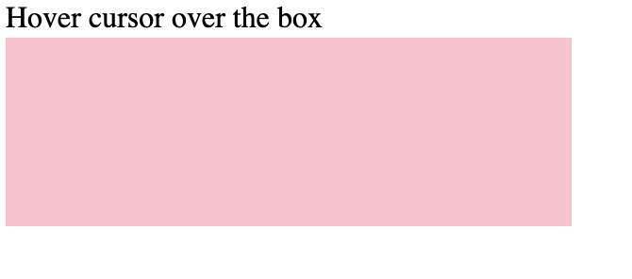

- Transition using all properties
<head>
<style>
div {
width: 100px;
height: 100px;
background-color: pink;
transition-delay: 0s;
transition-duration: 2s;
transition-property: width;
transition-timing-function: linear;
}

div:hover {
width: 300px;
}
</style>
</head>
<body>
Hover cursor over the box
<div></div>
</body>

- Mixed transition
<head>
<style>
div {
width: 100px;
height: 100px;
background-color: pink;
transition-delay: 0s;
transition-duration: 2s;
transition-property: width background-color border-radius;
transition-timing-function: linear;
}

div:hover {
width: 300px;
background-color: black;
border-radius: 50%;
}
</style>
</head>
<body>
Hover cursor over the box
<div></div>
</body>

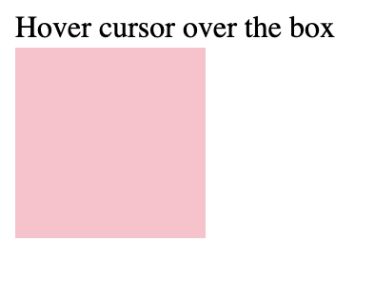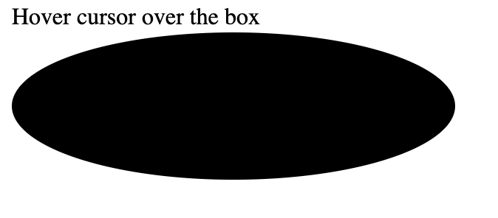

Animations
Add animation in CSS

Property | Description | Possible Values
animation | Shorthand property to set all animation properties | animation-name  animation-duration  animation-timing-function  animation-delay  animation-iteration-count  animation-direction  animation-fill-mode  animation-play-state
animation-delay | Specify delay before starting animation | time
animation-duration | Specify how long should the animation run | time
animation-name | Specify name of @keyframes animation | keyframe name
animation-iteration-count | Specify how many times animation should play | infinite  n-times
animation-direction | Specify how the animation should play | normal  reverse  alternate  alternate-reverse
animation-timing-function | Specify speed of curve in animation | linear  ease  ease-in  ease-out  ease-in-out  step-start  step-end  steps(int, start, end)  cubic-bezier(n, n, n, n)
animation-fill-mode | Specify a style when animation is not playing | none  forwards  backwards  both
animation-play-state | Specify if animation is playing or being paused | paused  running
@keyframes | Specify animation codes | animationname {keyframes-selector {css-styles;}}

- Keyframes to add animation based on name
<head>
<style>
div {
width: 100px;
height: 100px;
background-color: red;
animation-name: example;
animation-duration: 4s;
}

@keyframes example {
from {background-color: red;}
to {background-color: yellow;}
}
</style>
</head>
<body>
<div></div>
<p><b>Note:</b> Go to original state after finished.</p>

</body>

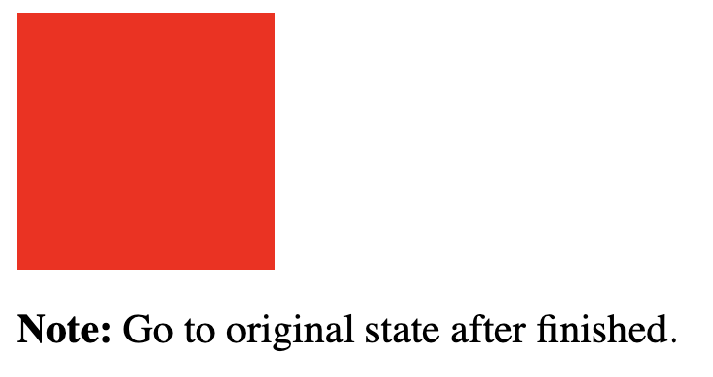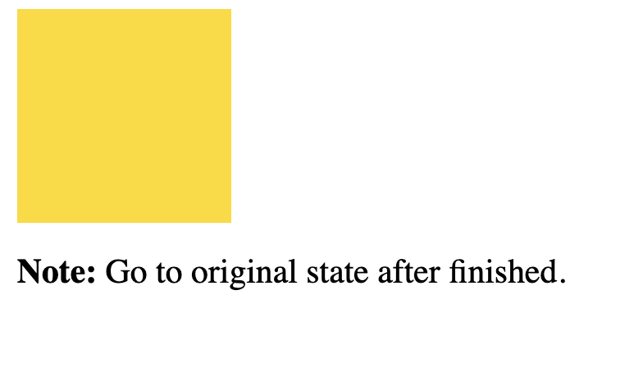

- Infinite animation, with 2 seconds delay at start
This animation runs for 4 seconds
<head>
<style>
div {
width: 100px;
height: 100px;
background-color: red;
position: relative;
animation-name: example;
animation-duration: 4s;
animation-delay: 2s;
animation-iteration-count: infinite;
}

@keyframes example {
0% {background-color:red; left:0px; top:0px;}
25% {background-color:yellow; left:200px; top:0px;}
50% {background-color:blue; left:200px; top:200px;}
75% {background-color:green; left:0px; top:200px;}
100% {background-color:red; left:0px; top:0px;}
}
</style>
</head>
<body>
<h1>Infinite Moving Animation</h1>
<div></div>
</body>

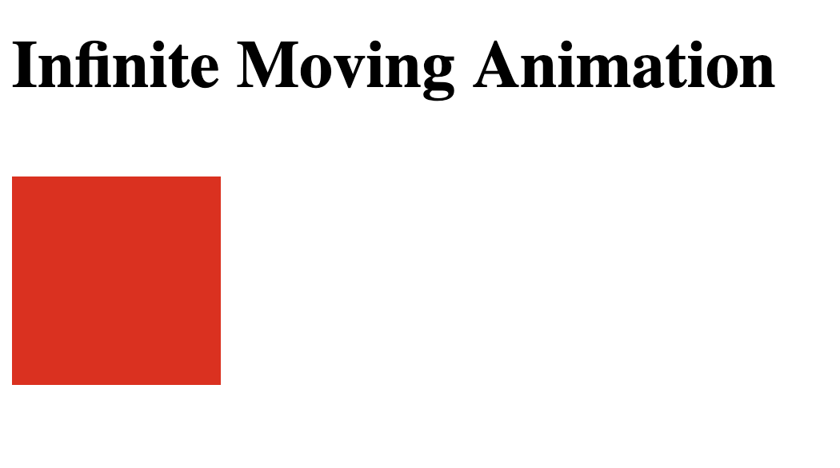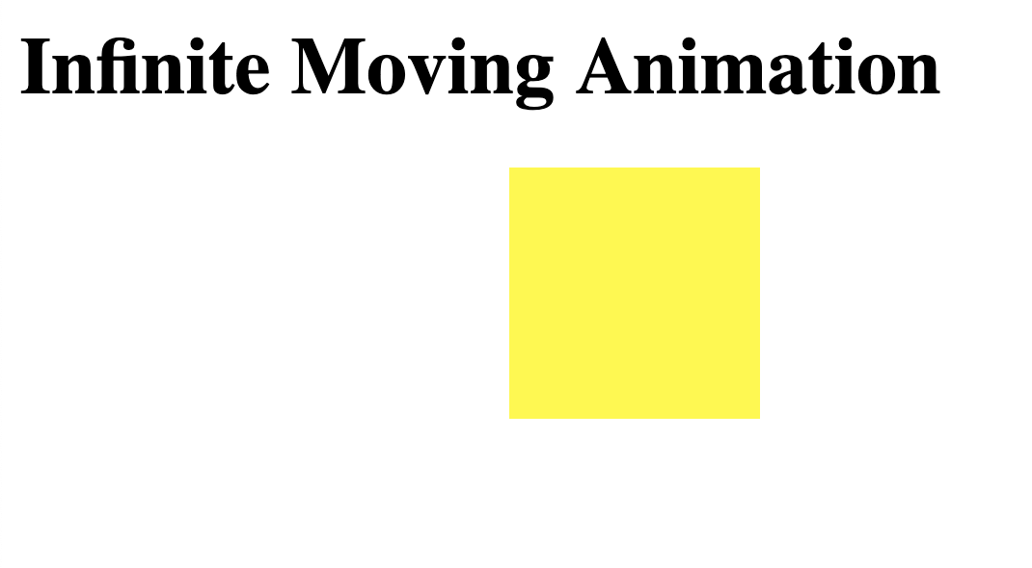

- Shorthand
<head>
<style>
div {
width: 100px;
height: 100px;
background-color: red;
position: relative;
animation: example 4s infinite ease-in-out;
}

@keyframes example {
0% {background-color:red; left:0px; top:0px;}
25% {background-color:yellow; left:200px; top:0px;}
50% {background-color:blue; left:200px; top:200px;}
75% {background-color:green; left:0px; top:200px;}
100% {background-color:red; left:0px; top:0px;}
}
</style>
</head>
<body>
<h1>Infinite Moving Animation</h1>
<div></div>
</body>

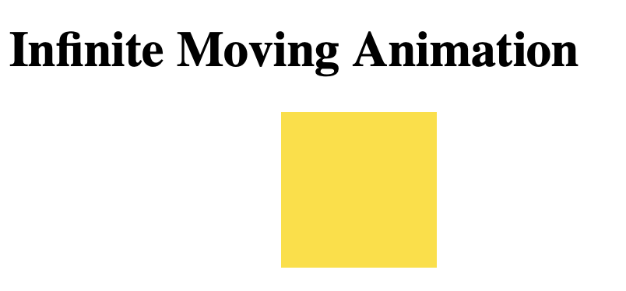

- Mixed Mode: Transition, Transform and Animation
<head>
<style>
div {
margin: 100px 100px;
height: 100px;
width: 100px;
border: 1px solid transparent;
transition: 1s linear;
background-color: red;
animation: example 1s infinite linear;
border-radius: 30%;
}

h1 {
animation: text 1s infinite linear;
}

@keyframes text {
0% {
background-image: radial-gradient(red, orange, yellow);
}
25% {
background-image: radial-gradient(lime, greenyellow, green);
}
50% {
background-image: radial-gradient(teal, turquoise, skyblue);
}
75% {
background-image: radial-gradient(royalblue, blue, mediumblue);
}
100% {
background-image: radial-gradient(red, orange, yellow);
}
}

@keyframes example {
0% {
background-image: radial-gradient(red, orange, yellow);
transform: rotate(0deg) scale(0.5);
}
25% {
background-image: radial-gradient(lime, greenyellow, green);
transform: rotate(90deg) scale(1.0);
}
50% {
background-image: radial-gradient(teal, turquoise, skyblue);
transform: rotate(180deg) scale(1.5);
}
75% {
background-image: radial-gradient(royalblue, blue, mediumblue);
transform: rotate(270deg) scale(1.0);
}
100% {
background-image: radial-gradient(red, orange, yellow);
transform: rotate(360deg) scale(0.5);
}
}
</style>
</head>
<body>
<h1><marquee>LET'S HAVE FUN</marquee></h1>
<div></div>
</body>

