# GitHub

GitHub is a code hosting platform for version control and collaboration. It lets you and others work together on projects from anywhere. It is also known as version control system.

Terms we must know about –

**Local Repository -** created into a local machine.

**Remote Repository** – created on cloud and we can access this using its url.

There are two kind of repository we can create into github.

1. Public – (free available) our code in public repository can be accessed from anywhere.
2. Private - (charges applicable) this repository has featured to decide who can access this repository.

GitHub offers both plans for private repositories, and free accounts which are commonly used to host open-source software projects.

Similar to TFS we can also create branch in repositories. By default it works in a branch called ‘master’.

Following are the commands we need to use while communicating with code using github remote repository.

|  |  |
| --- | --- |
| **Init** | Creates an empty Git repository (required only in case we start code from scratch) |
| **Clone** | Clone/ copy a repository |
| **Fetch** | Download code from remote repository |
| **Pull** | Fetch code from downloaded code and put it into local repository |
| **Status** | To check status of each new/modified/deleted file |
| **Add** | Add changes into index |
| **Commit** | Commit/stage the changes |
| **Push** | Push the staged changes into the remote repository |

In GitHub there is a feature to keep some files only into the local repository. We need to create a file ‘**.gitignore**’. In this file we can put all those file names which we want to keep locally. All those files which have entry into .gitignore file will not be pushed into remote repository.

Software’s required/ suggested to work using GitHub.

1. Github desktop application – <https://github-windows.s3.amazonaws.com/GitHubSetup.exe>
2. Visual studio code – <https://go.microsoft.com/fwlink/?LinkID=623230>

*This setup is required for the project itself, not for GitHub.

1. Node js - <https://nodejs.org/dist/v6.9.1/node-v6.9.1-x64.msi>

*This setup is required for the project itself, not for GitHub.

**Note** – you are required to create your account on GitHub. This account will be needed when you will push your local changes into remote repository.

Make sure that you select a meaning full username while creating account.

E.g.: Put your complete name in username field – prince-sehgal

After installing above both software’s into your machine follow the below steps to get code from GitHub remote repository to your local machine.

1. Start command prompt with administrator rights.

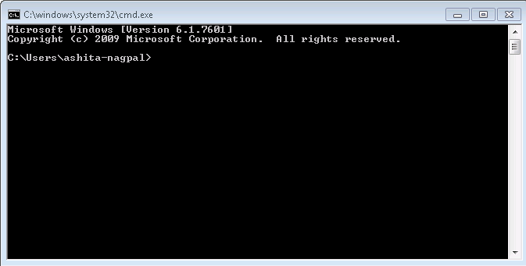

1. Type cd c:\ and press enter.

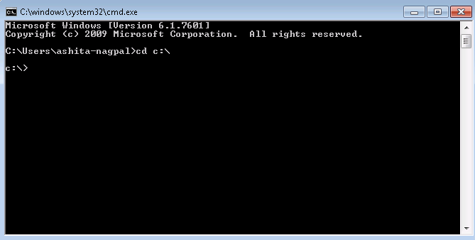

1. Type git clone “<https://github.com/prince-sehgal/showcase.git>” and press enter.

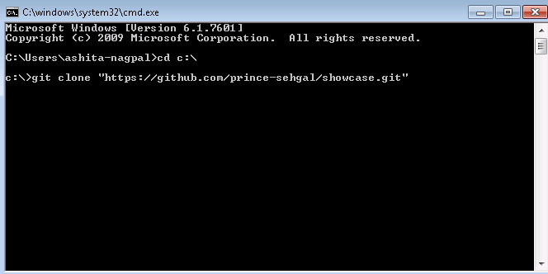

1. Type cd showcase and press enter.

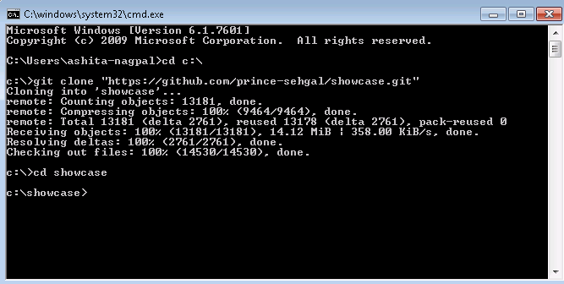

1. Type gulp serve and press enter.

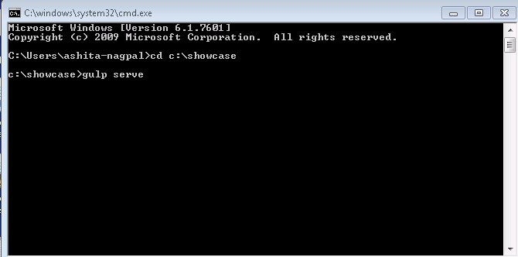

The sample code will execute into your default browser.

You may work with the required files present at “c:\showcase” location as per your requirement by following some steps similar to TFS.

Every time before you start working on code follow below steps –

1. GoTo command prompt



1. Type cd c:\showcase and press enter

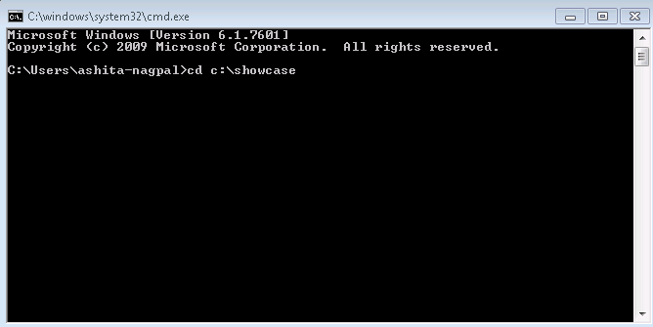

1. Type git fetch and press enter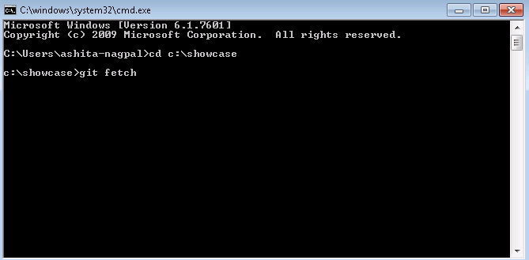

This command will download all different code/ files from remote repository (if available)

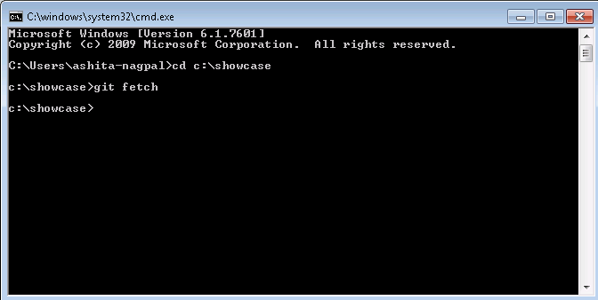

1. Type git pull and press enter

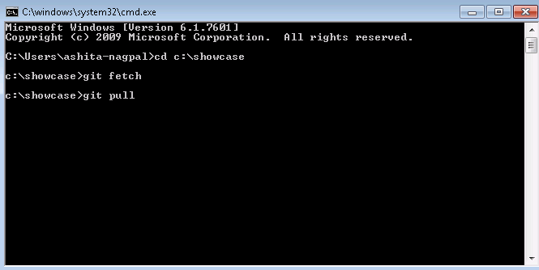

This command will add downloaded code/files to your local repository

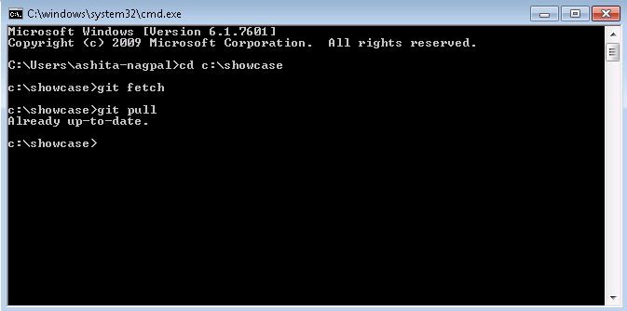

Now, you may start your work on project/showcase using visual studio code or any other text editor.

After doing your changes into code follow below steps –

1. GoTo command prompt



1. Type cd c:\showcase and press enter



1. Type git status and press enter

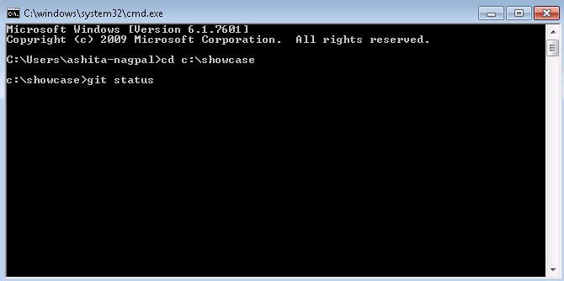

This command will show you differences between your local repository and remote repository

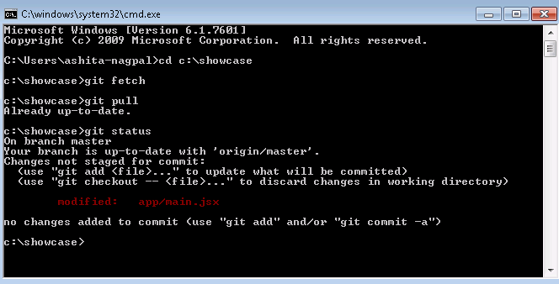

1. Type git add * and press enter

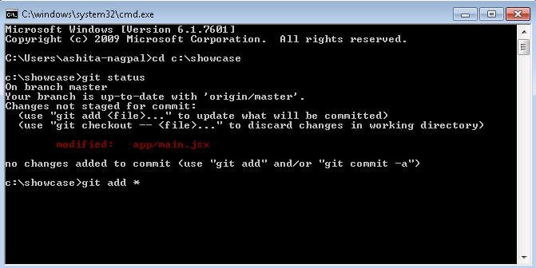

This command will add all changes into git index

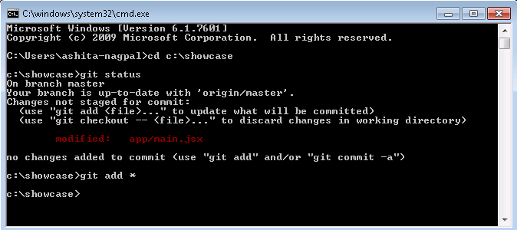

1. Type git commit –m “your comments” and press enter

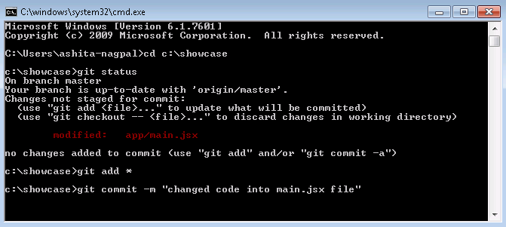

This command will stage all your changes

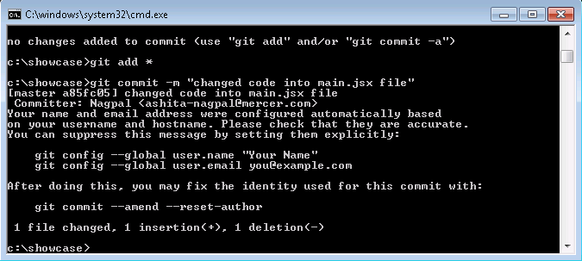

1. Type git push and press enter

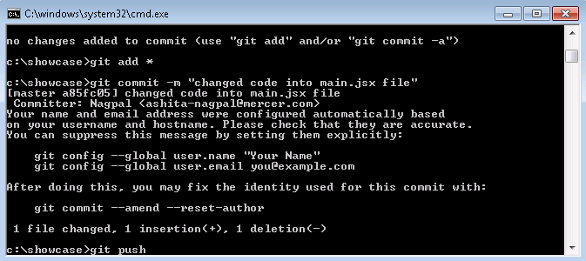

Add staged changes into remote repository

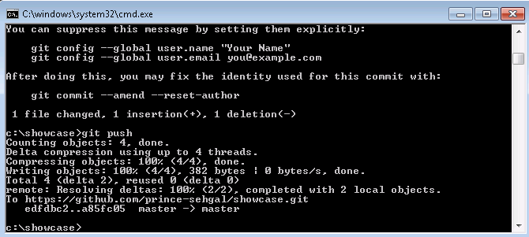

Note – If any of the file you don’t want to add into remote repository simply pass that file name into .gitignore file and push .gitignore file to remote repository.

For example, I have created a file into same “c:\showcase” project folder with name “LocalTestFile.txt”

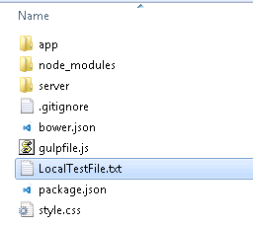

Now, I run git status command into command prompt.

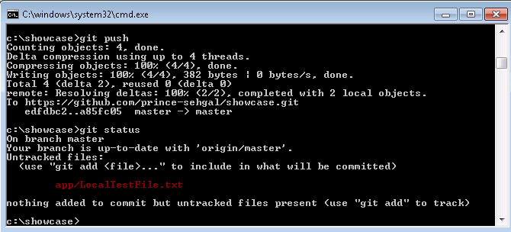

It is showing that created one file and asking to add this file into git repository.

If you want to keep this file only into your local repository and don’t want to add it into remote repository then follow the below steps –

1. GoTo c:\showcase location.

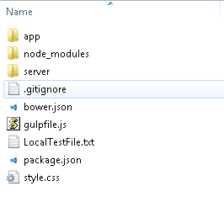

1. Open .gitignore file.

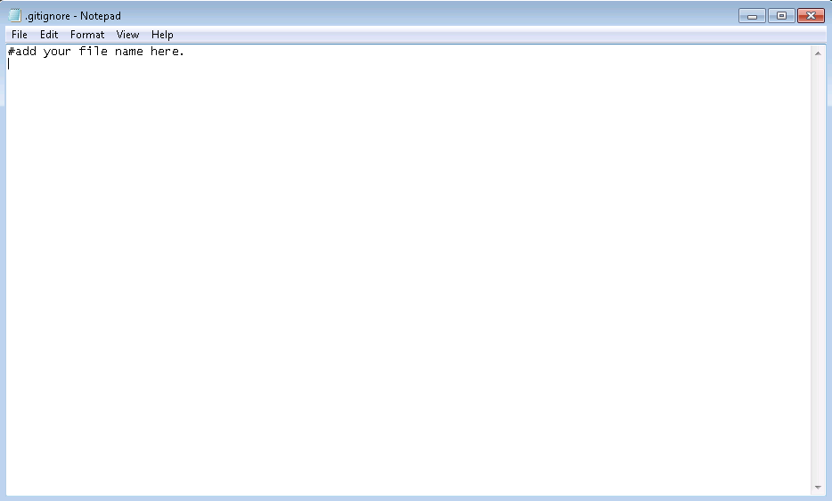

1. Add file name and save this file.

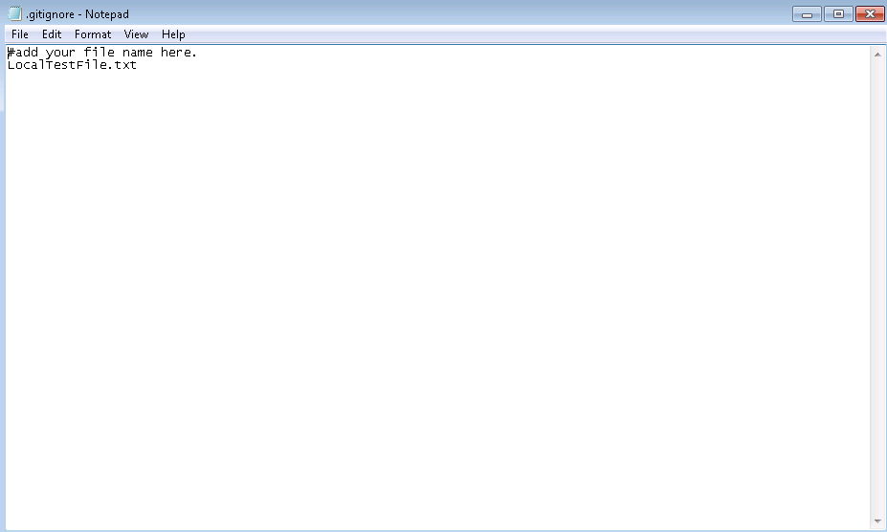

Now, follow the same process to merge your changes to remote repository and add .gitignore file into remote repository.

1. Git status

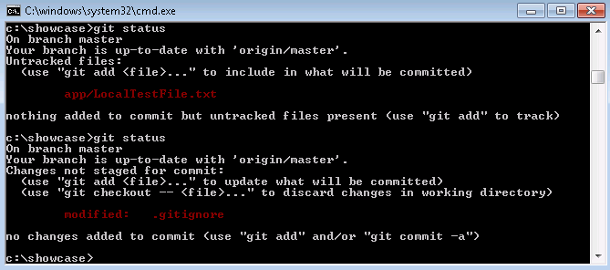

1. Git add *

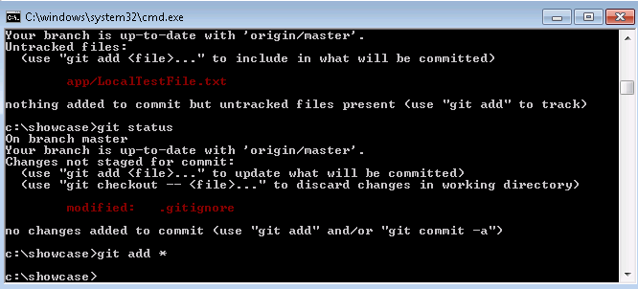

1. Git commit –m ”comment”

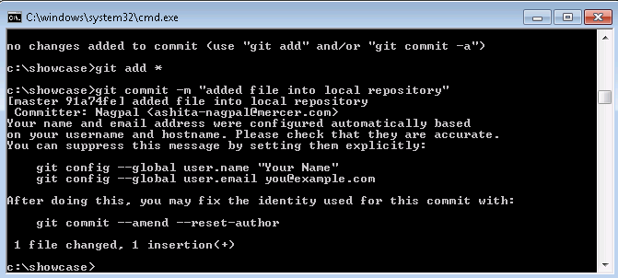

1. Git push

