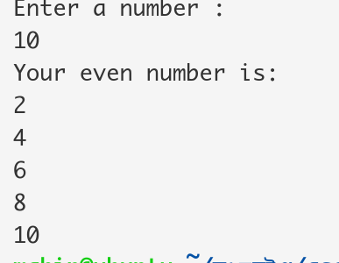Even Number:

*#!/bin/bash*

**echo** "Enter a number : "

**read** num

**echo** "Your even number is: "

for((i=1;i<=num;i++))

do

out=$(( $i % 2 ))

if [ $out -eq 0 ]

then

**echo** $i

fi

done

Sumation:

*#!/bin/bash*

**echo** "Enter number: "

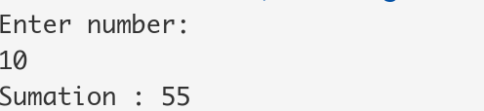**read** num

sum=0

for ((i=1;i<=num;i++))

do

sum=$((sum+i))

done

**echo** "Sumation : $sum"

Reverse string :

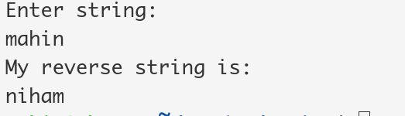*#!/bin/bash*

**echo** "Enter string: "

**read** str

**echo** "My reverse string is: "

**echo** $str | rev

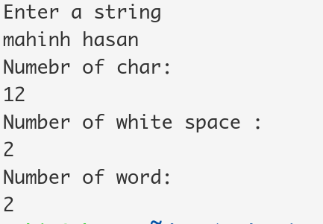Number of char ,space word:  
*#!/bin/bash*

**echo** "Enter a string"

**read** str

**echo** "Numebr of char: "

**echo** -n $str | wc -c

**echo** "Number of white space : "

**echo** grep -o "" <<< $str | wc -w

**echo** "Number of word: "

**echo** -n $str | wc -w

Student Grade:

**read** -p "Please enter number of subject: " num

if [ $num -gt 60 ]

then

**echo** "First Division"

elif [ $num -le 60 && $num -gt 50 ]

then

**echo** "Second Divison"

elif [ $num -le 50 && $num -gt 40 ]

then

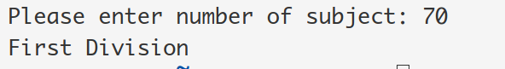**echo** "Thid Division"

else

**echo** "Fail"

fi

Shell comand using grep: