InternSpark — ML Classification Project
Task 1: Supervised Classification Model

1. Objective
Build and evaluate a supervised binary classification model, compare at least two algorithms, and report standard classification metrics.

2. Dataset
Breast Cancer Wisconsin Diagnostic dataset from scikit-learn. It contains 569 observations, 30 numeric features, and two target classes.

3. Methodology
- Loaded the dataset using scikit-learn.
- Used an 80/20 stratified train/test split with random_state=42.
- Applied StandardScaler before Logistic Regression.
- Compared Logistic Regression and Random Forest.
- Used 5-fold Stratified Cross-Validation on the training data.
- Evaluated the held-out test set using accuracy, precision, recall, F1 and ROC-AUC.
- Generated ROC and metric-comparison plots.

4. Test-set Results
Model | Accuracy | Precision | Recall | F1 | ROC-AUC
Logistic Regression | 0.9825 | 0.9861 | 0.9861 | 0.9861 | 0.9954
Random Forest | 0.9474 | 0.9583 | 0.9583 | 0.9583 | 0.9937

5. Cross-Validation Summary
Logistic Regression
- ACCURACY: mean=0.9780, std=0.0098
- PRECISION: mean=0.9795, std=0.0162
- RECALL: mean=0.9860, std=0.0131
- F1: mean=0.9825, std=0.0078
- ROC-AUC: mean=0.9959, std=0.0050
Random Forest
- ACCURACY: mean=0.9626, std=0.0164
- PRECISION: mean=0.9718, std=0.0086
- RECALL: mean=0.9684, std=0.0233
- F1: mean=0.9700, std=0.0135
- ROC-AUC: mean=0.9923, std=0.0049

6. Visual Results
The following figures are generated from the same reproducible experiment:
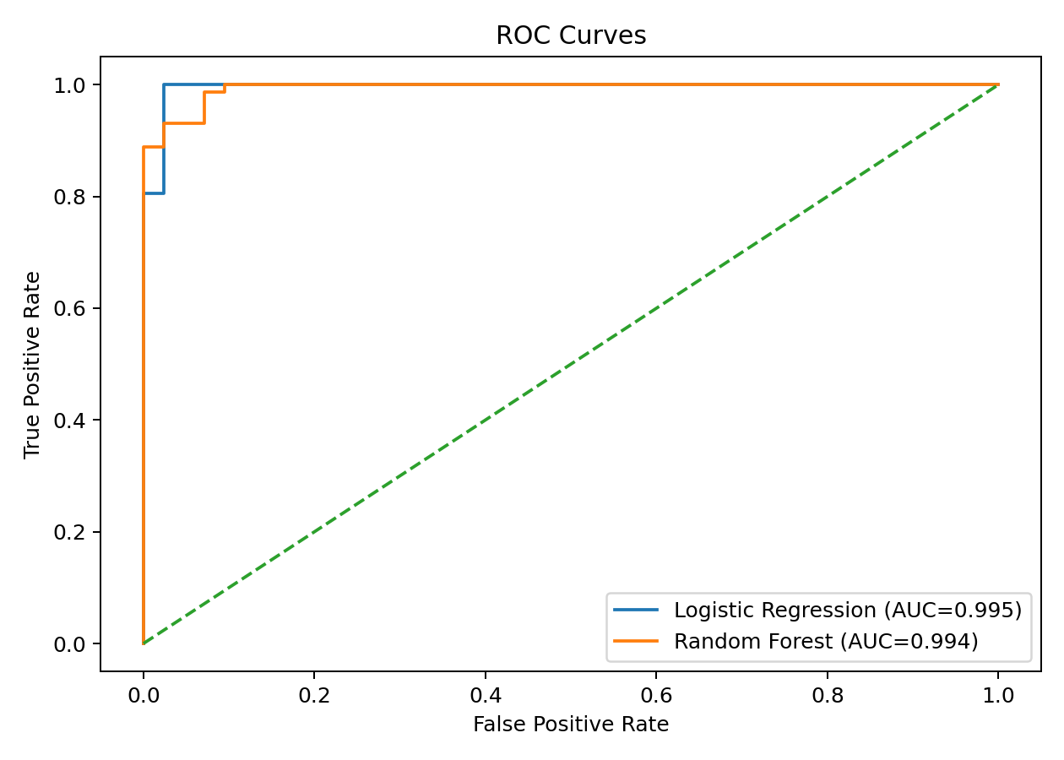
Figure 1: ROC curves for the two models.
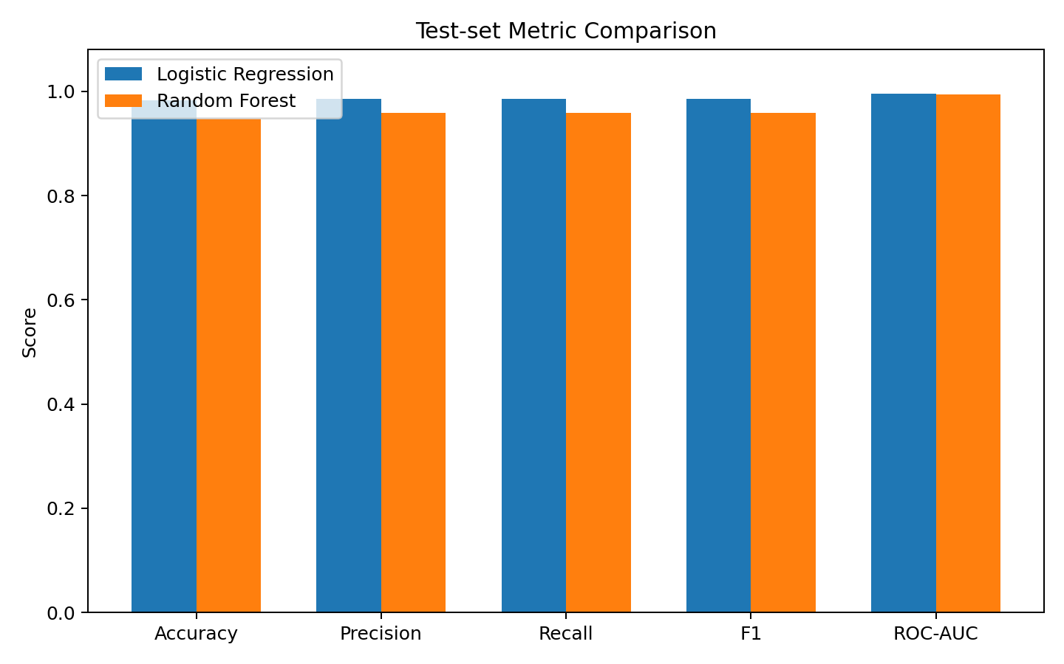
Figure 2: Test-set metric comparison.

7. Interpretation
Both classifiers perform strongly on the held-out test set. The reported metrics should be considered together: precision and recall describe different error types, F1 balances precision and recall, and ROC-AUC summarizes ranking performance across thresholds.

8. Conclusion
The requested classification workflow is complete: preprocessing, train/test split, cross-validation, comparison of two algorithms, required metrics, and visual evaluation. The notebook and Python script provide reproducible implementations.

9. Reproducibility and Files
Install requirements.txt, then run ML_Classification_Project.ipynb with Jupyter or classification_project.py from a terminal. The experiment uses fixed random seeds (42).
Main files: ML_Classification_Project.ipynb, classification_project.py, README.md, requirements.txt, and this report.

