InternSpark Task 1 — Supervised Classification
Project: Breast Cancer Wisconsin Classification

1. Objective
Build and evaluate supervised classification models with preprocessing, an 80/20 train/test split, 5-fold cross-validation, and multiple evaluation metrics.

2. Dataset
The scikit-learn Breast Cancer Wisconsin dataset was used. It contains 569 samples, 30 numeric features, and two target classes: malignant and benign.

3. Preprocessing
Missing values were checked. A stratified 80/20 train/test split was used. StandardScaler was applied to Logistic Regression through a pipeline; Random Forest used the numeric features directly.

4. Models
Logistic Regression was used as the baseline classifier and Random Forest as the second, nonlinear ensemble classifier.

5. Results
Model | CV Acc. | Test Acc. | Precision | Recall | F1 | ROC-AUC
Logistic Regression | 0.9780 | 0.9825 | 0.9861 | 0.9861 | 0.9861 | 0.9954
Random Forest | 0.9626 | 0.9474 | 0.9583 | 0.9583 | 0.9583 | 0.9937
Best model by ROC-AUC in this run: Logistic Regression.

6. Conclusion
Both classifiers were trained and evaluated using the same test set. Model selection should consider the full metric set and cross-validation stability rather than a single score.

7. Submission files
- Task_1_Supervised_Classification.ipynb
- README.md
- requirements.txt
- results.csv

8. Screenshots
Screenshots from the completed notebook are included below.

Screenshot 1 — Dataset
Dataset loading, shape, class names, and sample output.
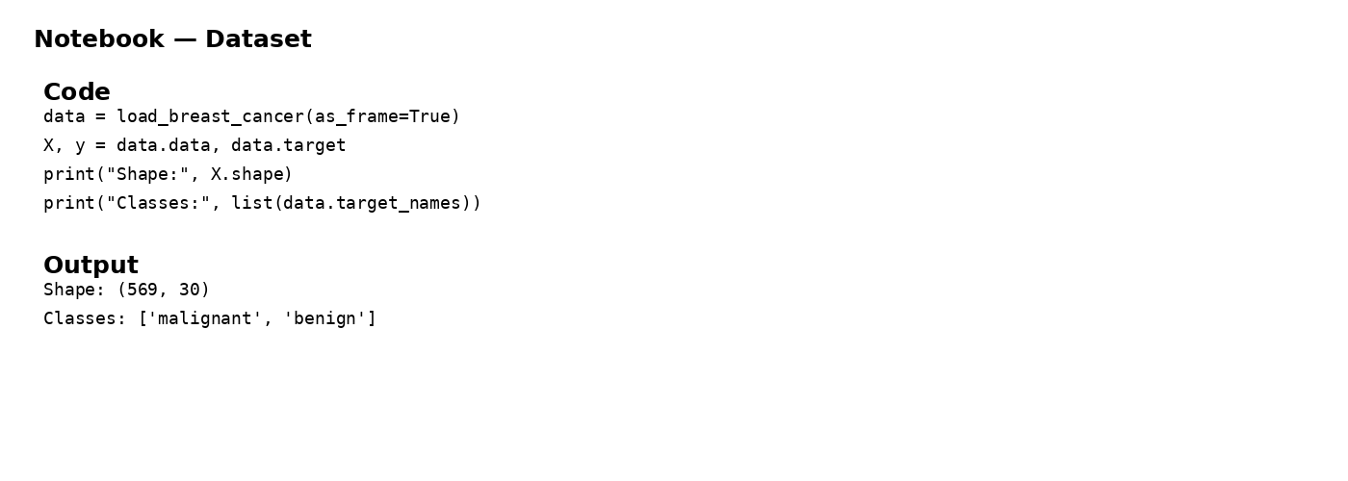

Screenshot 2 — Preprocessing
Missing-value check and train/test split.
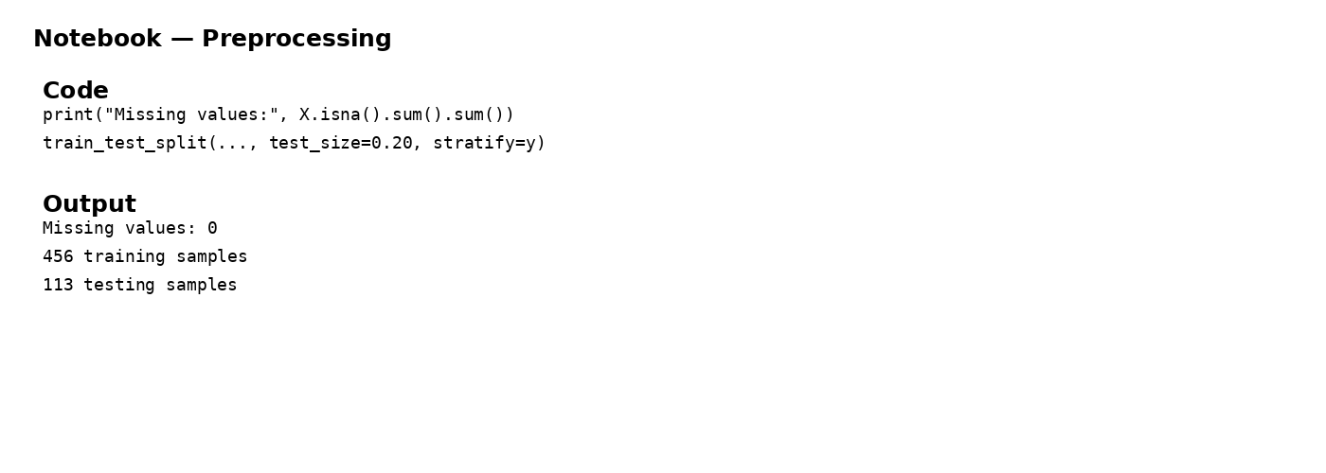

Screenshot 3 — Models
Logistic Regression and Random Forest definitions.
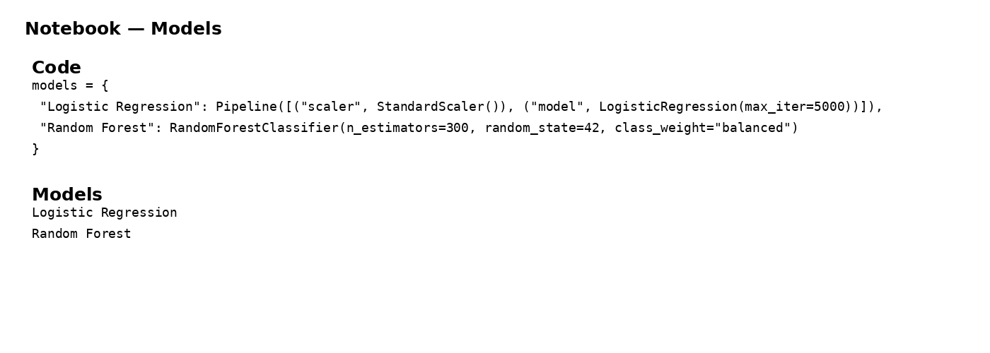

Screenshot 4 — Results
Accuracy, Precision, Recall, F1 and ROC-AUC results.
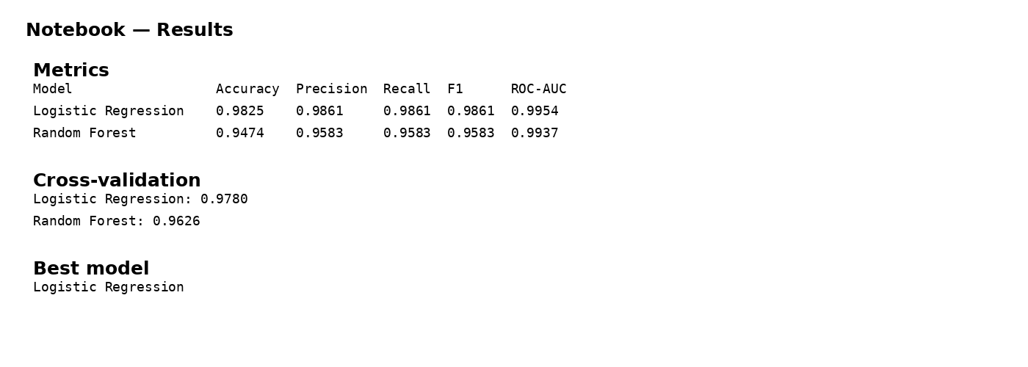

Screenshot 5 — ROC Curve
ROC curve comparison of both classifiers.
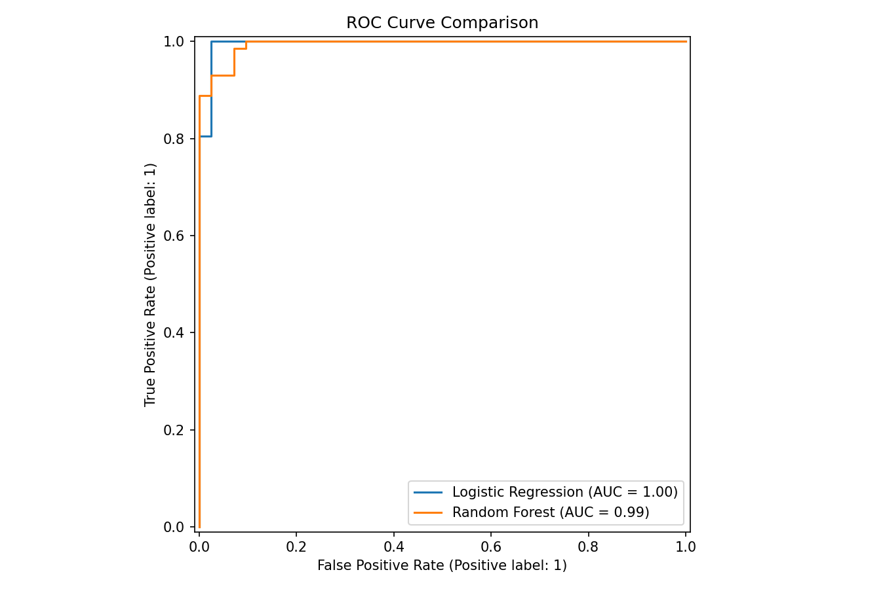

9. Final Submission Checklist
- Notebook (.ipynb) completed and all cells run.
- Short report (.docx) completed with screenshots.
- README.md included.
- requirements.txt included.
- results.csv included.
- All required files uploaded to GitHub.

