**Assignment:**

Understanding of Hardware and Its Components

Section 1: Multiple Choice

1. Which of the following is NOT a component of the CPU?

ANS= 2) RAM

2.What is the function of RAM in a computer?

ANS= RAM is a crucial component of a computer's hardware. Its primary function is to store data temporarily while the computer is running, allowing for fast access and processing of information.

3. Which of the following is a primary storage device?

ANS= 4) 1and2both

4. What is the purpose of a GPU?

ANS=A GPU is designed to accelerate graphics rendering, gaming performance, and computational tasks, offloading intense calculations from the CPU for faster processing.

Section 2: True or False

5.The motherboard is the main circuit board of a computer where other components are attached. - True

6.A UPS (Uninterruptible Power Supply) is a hardware device that provides emergency power to a load when the input power source fails. - True

7. An expansion card is a circuit board that enhances the functionality of a component.

-True

Section 3: Short Answer

8. Explain the difference between HDD and SSD.

ANS=HDD uses spinning disks and mechanical heads to store data, while SSD uses flash memory to store data. SSDs are faster, more reliable, and energy-efficient, while HDDs offer higher storage capacity at a lower cost per GB. In short:

HDD: Spinning disks, mechanical heads, slower access times

SSD: Flash memory, faster access times, lower latency

9. Describe the function of BIOS in a computer system.

ANS=BIOS initializes hardware, loads the operating system, and configures settings, acting as a "middleman" between hardware and OS, ensuring a smooth boot process.

10. List and briefly explain three input devices commonly used with

computers.

ANS=Here are three input devices commonly used with computers:

1. Keyboard: Enters text and commands into the computer.

2. Mouse: Controls the cursor and interacts with graphical user interfaces.

3. Scanner: Captures images or text from physical documents into digital format.

Section 4: Practical Application

11. Identify and label the following components on a diagram of a

motherboard:

• CPU

• RAMslots

• SATAconnectors

• PCI-E slot

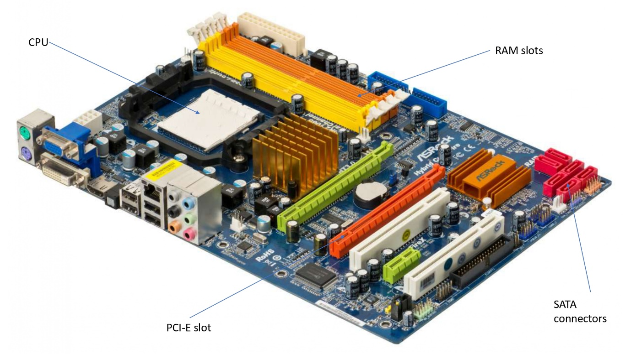

12. Demonstrate how to install a RAM module into a computer.

Ans:

* Shut down your computer completely.
* Unplug all cables, to ensure there’s no electrical current.
* Refer to your computer’s manual for instructions on how to open the case.
* Typically, you’ll need to remove a side panel. This often requires removing a few screws.
* To avoid static discharge, which can damage components, wear an antistatic wrist strap. Alternatively, you can touch a metal part of the case to discharge any static electricity from your body.
* The RAM slots are typically located near the CPU. They are long slots, often with clips at both ends.
* Check your motherboard’s manual to identify the correct slots to use, especially if you are adding RAM and not replacing it.
* If you need to remove existing RAM, gently press down on the clips at either end of the RAM slot. The module should pop up slightly, allowing you to pull it out.
* Align the notch on the RAM module with the key in the RAM slot. This ensure the module is oriented correctly
* insert the RAM is securely installed, replace the side panel of your computer case and secure it with screws.
* Reconnect all cables, including the power cable.
* Turn on your computer.
* Once the computer boots up, check that the new RAM is recognized by the system.
* On windows, you can do this by right-clicking on “my computer” or “this pc,” selecting “properties,” and looking under “installed memory (RAM”).
* On a mac, go to “about this mac” under the apple menu and check the “memory” tab.

13. Discuss the importance of proper cooling mechanisms in a computer system. Include examples of cooling methods and their effectiveness.

Ans:

**The Crucial Role of Cooling Mechanisms in Computer Systems**

In modern computing, where performance demands and system complexities are continually evolving, maintaining an optimal operating temperature is essential. Proper cooling mechanisms are not just a supplementary component; they are fundamental to ensuring that a computer system functions efficiently, reliably, and for an extended period. This essay explores the importance of cooling mechanisms in computer systems and examines various cooling methods, their effectiveness, and their impact on system performance and longevity.

The Importance of Proper Cooling :

Effective cooling is crucial for several reasons. First and foremost, it directly impacts the performance of a computer system. Modern processors and graphics cards are designed to operate within specific thermal limits. When temperatures exceed these limits, systems may engage in thermal throttling—reducing performance to lower heat output. This can significantly degrade the user experience, as the system may not perform optimally under demanding tasks. By maintaining lower temperatures through effective cooling, a computer system can operate at its full potential without unnecessary performance throttling.

In addition to performance, cooling mechanisms are vital for the longevity of computer components. Heat is one of the primary factors that contribute to the degradation of electronic components. Excessive heat accelerates wear and tear, leading to a shortened lifespan of critical parts like the CPU, GPU, and motherboard. Over time, high temperatures can cause solder joints on the motherboard to weaken and components to fail. Proper cooling mitigates these risks, thereby extending the lifespan of the hardware and reducing the likelihood of costly repairs or replacements.

Moreover, system reliability is closely tied to effective cooling. High temperatures can lead to system instability, causing unexpected crashes, freezes, or even complete shutdowns. Such instability not only disrupts workflow but can also result in data loss. Consistent cooling helps maintain system stability, ensuring that the computer operates reliably under various conditions. This is particularly important in environments where uninterrupted operation is critical, such as in data centers or during intensive computational tasks.

Cooling Methods and Their Effectiveness

Several cooling methods are employed in computer systems, each with its advantages and limitations.

Air Cooling : Air cooling is the most common method and involves the use of heatsinks and fans. A heatsink, made of metal with a high thermal conductivity, is attached to the CPU or GPU to absorb heat. Fans then blow air over the heatsink to dissipate the absorbed heat into the surrounding environment. Air cooling is effective for many desktop systems due to its simplicity, cost-effectiveness, and ease of installation. However, it may become less efficient in high-performance scenarios or overclocked systems where heat output is significantly higher. Additionally, air cooling can be noisy, and its effectiveness is influenced by the quality of the heatsink and fan.

Liquid Cooling : Liquid cooling systems use a liquid coolant to transfer heat away from critical components. This method involves a pump that circulates the coolant through a closed loop, consisting of water blocks (which are mounted on the CPU or GPU), a radiator, and a reservoir. The radiator dissipates the heat into the air. Liquid cooling is highly efficient and is particularly advantageous for high-performance or overclocked systems that generate substantial heat. It is generally quieter than air cooling and can offer superior cooling performance. However, it is more complex to install and maintain, and there is a risk of leaks, which can damage components.

Phase Change Cooling : This advanced method operates on the principle of phase change, similar to refrigeration. A coolant undergoes a phase change from liquid to gas, absorbing heat in the process. The gas is then compressed and cooled before re-entering the system. Phase change cooling can achieve extremely low temperatures, making it suitable for extreme overclocking and specialized applications. Despite its effectiveness, phase change cooling is expensive and complex, making it impractical for everyday use.

Peltier Cooling: Peltier coolers utilize the Peltier effect, where an electric current creates a temperature differential across two different materials. This method can cool one side of the device while heating the other. Peltier cooling can provide significant temperature reductions but is generally less efficient compared to other methods. It often requires additional cooling solutions to manage the heat generated on the hot side of the device.

Immersion Cooling : Immersion cooling involves submerging the entire computer system or specific components in a non-conductive liquid that absorbs and dissipates heat. This method is highly effective and is used in data centers and high-performance computing environments. It offers excellent cooling efficiency and reduces the need for traditional cooling components such as fans. However, immersion cooling is complex and costly, making it suitable mainly for specialized applications.

Conclusion:

In summary, proper cooling mechanisms are integral to the effective operation of computer systems. They play a crucial role in optimizing performance, extending component lifespan, and ensuring system reliability. While air cooling remains a popular choice due to its simplicity and cost-effectiveness, advanced methods like liquid and phase change cooling offer superior performance for high-demand scenarios. Each cooling method has its own set of advantages and limitations, making it important to choose the right solution based on the specific needs of the system. As computing technology continues to advance, effective cooling will remain a key factor in maintaining system performance and reliability.

14. Explain the concept of bus width and its significance in computer architecture.

Ans:

**Understanding Bus Width and Its Significance in Computer Architecture**

In the realm of computer architecture, the term "bus width" is a fundamental concept that significantly impacts the performance and efficiency of a computer system. Bus width refers to the number of bits that can be transmitted simultaneously over a computer's data bus, a crucial pathway that facilitates communication between various components of the system, such as the CPU, memory, and peripheral devices. This essay delves into the concept of bus width, exploring its definition, significance, and implications for computer performance and design.

The Concept of Bus Width

At its core, bus width defines the capacity of the data bus, which is a collection of electrical pathways used to transfer data between different parts of a computer system. The data bus is responsible for carrying data to and from the CPU, memory, and input/output devices. Bus width is typically measured in bits (e.g., 8, 16, 32, 64 bits) and directly corresponds to the number of parallel lines or channels that can carry data simultaneously.

For instance:

- An 8-bit bus can transmit 8 bits of data at a time.

- A 32-bit bus can handle 32 bits of data simultaneously.

The width of the data bus determines how much data can be transferred in a single operation, affecting the overall data throughput and system performance.

Significance of Bus Width

1. Data Transfer Rate:

The bus width is a critical determinant of the data transfer rate, which is the speed at which data is moved between components. A wider bus can transmit more data per cycle, thereby increasing the overall bandwidth of the system. For example, a 64-bit data bus can transfer twice as much data per cycle as a 32-bit bus, leading to faster data processing and reduced bottlenecks. This is especially important in tasks that require large volumes of data to be processed quickly, such as multimedia applications, gaming, and scientific computations.

2. System Performance:

Bus width has a direct impact on system performance. A wider bus can enhance the efficiency of data exchanges between the CPU and memory, as well as between other system components. For instance, in a computer with a 64-bit CPU and a 64-bit memory bus, the system can handle larger chunks of data more efficiently compared to a system with a narrower bus. This results in faster application loading times, smoother multitasking, and better overall system responsiveness.

3. Memory Addressing:

Bus width also affects the computer's memory addressing capabilities. A wider address bus allows the CPU to access a larger address space, which translates to the ability to utilize more memory. For example, a 32-bit address bus can address up to 4 GB of memory, while a 64-bit address bus can address significantly more, theoretically up to 16 exabytes. This expanded memory addressing capability is crucial for modern computing tasks that require large amounts of RAM, such as running virtual machines or handling large datasets.

4. Data Integrity and Error Handling:

A wider bus can improve data integrity and error handling mechanisms. With a wider data bus, there is a greater chance to implement error-correcting codes (ECC) and other error-detection technologies, which are essential for maintaining data accuracy and reliability. ECC can detect and correct errors that may occur during data transmission, thereby enhancing the stability and reliability of the computer system.

5. Scalability and Future-Proofing:

As technology advances, the need for greater data throughput and memory capacity increases. Systems with wider buses are better positioned to handle future demands and upgrades. For example, transitioning from a 32-bit to a 64-bit bus allows for a more scalable architecture, accommodating newer technologies and larger amounts of data. This future-proofing aspect is vital for ensuring that a computer system remains relevant and capable of supporting emerging applications and workloads.

Practical Implications and Examples

To illustrate the practical implications of bus width, consider the evolution of computer architectures. Early personal computers often used 8-bit or 16-bit buses, which limited their data transfer rates and memory addressing capabilities. As computing needs grew, the industry moved to 32-bit and eventually 64-bit architectures, enabling significant improvements in performance, memory capacity, and overall system capabilities.

For example, modern desktop and laptop computers predominantly use 64-bit architectures, which support higher memory capacities and deliver superior performance compared to older 32-bit systems. This shift has been instrumental in supporting the demands of contemporary software applications, such as high-definition video editing, complex simulations, and advanced gaming.

Conclusion

In conclusion, bus width is a fundamental aspect of computer architecture that plays a pivotal role in determining a system's data transfer rate, performance, memory addressing capabilities, and overall efficiency. A wider bus facilitates faster and more efficient data communication, which enhances system performance and supports larger memory capacities. As technology continues to advance, the significance of bus width in designing and optimizing computer systems remains crucial, influencing everything from everyday computing tasks to cutting-edge applications. Understanding bus width and its implications is essential for appreciating how modern computer systems achieve their impressive performance and capabilities.