Experiment – 7

AIM- Write a program to implement LL(1) predictive parser

Description - LL parser (Left-to-right, Leftmost derivation) is a top-down parser for a subset of context-free languages. It parses the input from Left to right, performing Leftmost derivation of the sentence.

LL parser consists of:
1. input buffer (source code)
2. stack
3. parsing table (state machine)

Parsing table: Table is used to get the next production number to apply, based on current symbol from the buffer, and the symbol (terminal or non-terminal) on top of the stack.
- Rows in the table are non-terminals
- Columns are terminals

Parsing algorithm:
- if the top of the stack is *terminal*, and matches current symbol in buffer, then just discard it from the stack, and move cursor further. (if doesn't match -- parse error).
- Else (it must be a non-terminal), replace it with an alternative production, corresponding to the production number.(if no production -- parse error).

$ - is a special symbol used to mark bottom of the stack
and end of the buffer.

S - is a start symbol.

Code -
#include <bits/stdc++.h>

using namespace std;

int main(){
int i = 0, j = 0, k = 0, m = 0, n = 0, o = 0, o1 = 0,
var = 0, l = 0, f = 0, c = 0, f1 = 0;
char str[30], str1[40] = "E", temp[20],
temp1[20], temp2[20], tt[20], t3[20];
temp1[0] = '\0';
temp2[0] = '\0';
char t[10];
char array[6][5][10] = {
"NT", "id", "+", "*", ";",
"E", "Te", "Error", "Error", "Error",
"e", "Error", "+Te", "Error", "\0",
"T", "Vt", "Error", "Error", "Error",
"t", "Error", "\0", "*Vt", "\0",
"V", "id", "Error", "Error", "Error"};
cout << "\n\tLL(1) PARSER TABLE \n";
for (i = 0; i < 6; i++){
for (j = 0; j < 5; j++){
cout.setf(ios::right);
cout.width(10);
cout << array[i][j];
}
cout << endl;
}
cout << endl;
cout << "\n\tENTER THE STRING :";
cin >> str;
if (str[strlen(str) - 1] != ';'){
cout << "END OF STRING MARKER SHOULD BE ';'";
exit(1);
}
cout << "\n\tCHECKING VALIDATION OF THE STRING ";
cout << "\n\t" << str1;
i = 0;

while (i < strlen(str)){
again:
if (str[i] == ' ' && i < strlen(str)){
cout << "\n\tSPACES IS NOT ALLOWED IN SOURSE STRING ";
exit(1);
}
temp[k] = str[i];
temp[k + 1] = '\0';
f1 = 0;
again1:
if (i >= strlen(str)){
exit(1);
}
for (int l = 1; l <= 4; l++){
if (strcmp(temp, array[0][l]) == 0){
f1 = 1;
m = 0, o = 0, var = 0, o1 = 0;
temp1[0] = '\0';
temp2[0] = '\0';
int len = strlen(str1);
while (m < strlen(str1) && m < strlen(str)){
if (str1[m] == str[m]){
var = m + 1;
temp2[o1] = str1[m];
m++;
o1++;
}else{
if ((m + 1) < strlen(str1)){
m++;
temp1[o] = str1[m];
o++;
}else{
m++;
}
}
}
temp2[o1] = '\0';
temp1[o] = '\0';
t[0] = str1[var];
t[1] = '\0';
for (n = 1; n <= 5; n++){
if (strcmp(array[n][0], t) == 0){
break;
}
}
strcpy(str1, temp2);
strcat(str1, array[n][l]);
strcat(str1, temp1);
cout << "\n\t" << str1;

if (array[n][l][0] == '\0'){
if (i == (strlen(str) - 1)){
int len = strlen(str1);
str1[len - 1] = '\0';
cout << "\n\t" << str1;
cout << "\n\n\tENTERED STRING IS VALID";
exit(1);
}
temp1[0] = '\0';
temp2[0] = '\0';
t[0] = '\0';
goto again1;
}
if (strcmp(array[n][l], "Error") == 0){
cout << "\n\tERROR IN YOUR SOURCE STRING";
exit(1);
}
tt[0] = '\0';
strcpy(tt, array[n][l]);
t3[0] = '\0';
f = 0;
for (c = 0; c < strlen(tt); c++){
t3[c] = tt[c];
t3[c + 1] = '\0';
if (strcmp(t3, temp) == 0){
f = 0;
break;
}
else{
f = 1;
}
}

if (f == 0){
temp[0] = '\0';
temp1[0] = '\0';
temp2[0] = '\0';
t[0] = '\0';
i++;
k = 0;
goto again;
}else{
temp1[0] = '\0';
temp2[0] = '\0';
t[0] = '\0';
goto again1;
}
}
}
i++;
k++;
}
if (f1 == 0)
cout << "\nENTERED STRING IS INVALID\n";
else
cout << "\n\n\tENTERED STRING IS VALID\n";

cout << endl << endl;
return 0;
}

Output –
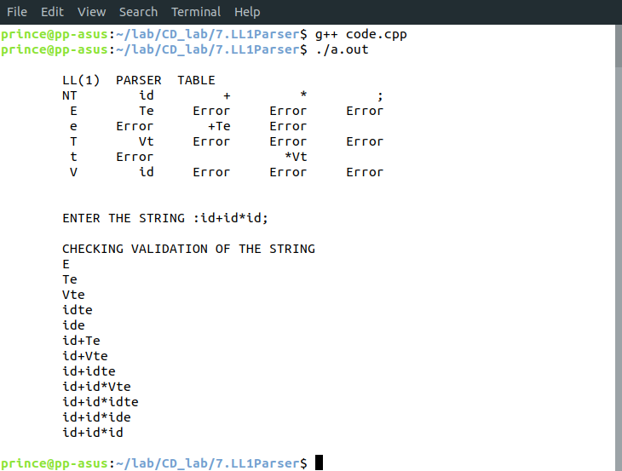
Learnings – Using LL1 parser we can analyse any code, given proper grammer and codes. It is widely used in Syntax Analysers.

