Experiment – 1

AIM- Write a program to find whether the given program has single line comment or multi line comment.

Description -
Single line Comment
Represented as // double forward slash
It is used to denote single line comment. It apply comment to a single line only. It is refereed as C++-style comments as it is originally part of C++ programming.
for example: // single line comment
Multi-line comment
Represented as /* any_text */ start with forward slash and asterisk (/*) and end with asterisk and forward slash (*/).
It is used to denote multi-line comment. It can apply comment to more than a single line. It is referred as C-Style comment as it was introduced in C programming.

Code -

#include <bits/stdc++.h>

using namespace std;

void ifComments(string program){
int n = program.length();
string res;

bool singleLineComment = 0;
bool multiLineComment = 0;

for (int i = 0; i < n; i++){
if (program[i] == '/' && program[i + 1] == '/'){
singleLineComment = 1;
}else if (program[i] == '/' && program[i + 1] == '*'){
while(i<n){
if(program[i] == '*' && program[i+1] == '/'){
multiLineComment = 1;
break;
}
i++;
}
}
}

if (multiLineComment == 1){
cout << "Multiline comment is present" << endl;
}
if (multiLineComment == 0){
cout << "Multiline comment is not present" << endl;
}
if (singleLineComment == 1){
cout << "Singleline comment present" << endl;
}
if (singleLineComment == 0){
cout << "Singleline comment not present" << endl;
}
}

int main(){
string program = " /* Test program */ \
int main(){ \
// variable declaration \
int sum, y, z; \
/* This is a \
multiline \
comment for \
testing */ \
sum = y + z; \
return 0; \
} \
";
ifComments(program);
return 0;
}

Output –
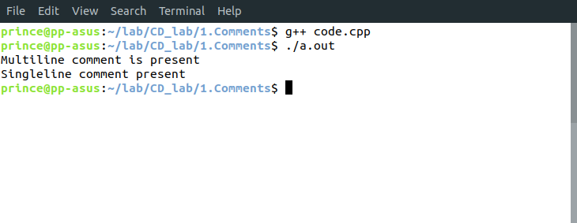
Learnings –

