Experiment – 5

AIM- Write a program to find first of given production of grammar.

Description -

FIRST
FIRST(X) for a grammar symbol X is the set of terminals that begin the strings derivable from X.
Rules to compute FIRST set:
1. If x is a terminal, then FIRST(x) = { ‘x’ }
2. If x-> Є, is a production rule, then add Є to FIRST(x).
3. If X->Y1 Y2 Y3....Yn is a production,
1. FIRST(X) = FIRST(Y1)
2. If FIRST(Y1) contains Є then FIRST(X) = { FIRST(Y1) – Є } U { FIRST(Y2) }
3. If FIRST (Yi) contains Є for all i = 1 to n, then add Є to FIRST(X).

Code -
#include <bits/stdc++.h>
using namespace std;

map<string, vector<string> > grammar;

bool isCapital(char ch){
if(ch>='A' && ch<='Z'){
return true;
}
return false;
}
bool ifEpsilon(set<string> s){
return (s.count("^") > 0) ? true : false;
}
void setPrint(set<string> s){
for(auto i:s){
cout<<i<<", ";
}
}
void setUnion(set<string> &s1, set<string> &s2){
for(auto i:s2){
if(i != "^"){
s1.insert(i);
}
}
return;
}
void calcFirst(string nonTerminal, set<string> &firstTemp){
vector<string> prods = grammar[nonTerminal];
bool epsilon = false;

for(auto p:prods){
set<string> temp;
string prod = p;

if(prod=="^"){
firstTemp.insert("^");
continue;
}
if(!isCapital(prod[0])){
firstTemp.insert(string(1, prod[0]));
continue;
}
calcFirst(string(1, prod[0]), temp);

setUnion(firstTemp, temp);

if(ifEpsilon(temp)){
int j = 1;

while(j<prod.size() && ifEpsilon(temp) && isCapital(prod[j])){
temp.clear();
calcFirst(string(1, prod[j]), temp);
setUnion(firstTemp, temp);
j++;
}
if(j==prod.size() && ifEpsilon(temp)){
epsilon = true;
}
if(j<prod.size() && ifEpsilon(temp)) {
firstTemp.insert(string(1, prod[j]));
}
}
}
if(epsilon){
firstTemp.insert("^");
}
return;
}

int main(int argc, char const *argv[]){
int nProds;

cout<<"Enter the no. of non-terminals: ";
cin>>nProds;

for (int i=0;i<nProds;i++){
cout<<"\nEnter the non-terminal: ";
string str;
cin>>str;

grammar[str] = vector<string> ();
cout<<"Enter the number of productions: ";
int n;
cin>>n;

cout<<"Enter the productions from '"
<<str
<<"' (space separated): ";
for (int j=0;j<n;j++){
string temp;
cin>>temp;
grammar[str].push_back(temp);
}
}
cout<<"\nEnter start symbol: ";
string startSymbol;
cin>>startSymbol;

cout<<"\nFirst of Non-Terminals in Given Grammer: \n";
for(auto p:grammar){
cout<<"\t";
set<string> firstTemp;
calcFirst(p.first, firstTemp);
cout<<p.first<<" => { ";
setPrint(firstTemp);
cout<<"}"<<endl;
}
return 0;
}

Output –
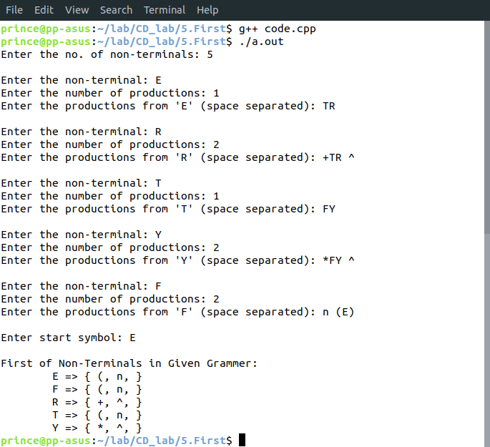
Learnings –

