Experiment – 6

AIM- Write a program to find follow of given production of grammar.

Description -

FOLLOW
Follow(X) to be the set of terminals that can appear immediately to the right of Non-Terminal X in some sentential form.
Rules to compute Follow set:
To compute FOLLOW(A) for all non-terminals A, apply the following rules until nothing can be added to any FOLLOW set.
1. Place $ in FOLLOW(S), where S is the start symbol and $ is the input right endmarker.
2. If there is a production A->αBβ, then everything in FIRST(β) except for ε is placed in FOLLOW(B).
3. If there is a production A->αB, or a production A->αBβ where FIRST(β) contains ε, then everything in FOLLOW(A) is in FOLLOW(B).

Code -
#include <bits/stdc++.h>

using namespace std;

map<string, vector<string> > grammar;

bool isCapital(char ch){
if(ch>='A' && ch<='Z'){
return true;
}
return false;
}

bool ifEpsilon(set<string> s){
return (s.count("^") > 0) ? true : false;
}

void setPrint(set<string> s){
for(auto i:s){
cout<<i<<", ";
}
}

void setUnion(set<string> &s1, set<string> &s2){
for(auto i:s2){
if(i != "^"){
s1.insert(i);
}
}
return;
}

void calcFirst(string nonTerminal, set<string> &firstTemp){
vector<string> prods = grammar[nonTerminal];
bool epsilon = false;

for(auto p:prods){
set<string> temp;
string prod = p;

if(prod=="^"){
firstTemp.insert("^");
continue;
}
if(!isCapital(prod[0])){
firstTemp.insert(string(1, prod[0]));
continue;
}
calcFirst(string(1, prod[0]), temp);

setUnion(firstTemp, temp);

if(ifEpsilon(temp)){
int j = 1;

while(j<prod.size() && ifEpsilon(temp) && isCapital(prod[j])){
temp.clear();
calcFirst(string(1, prod[j]), temp);
setUnion(firstTemp, temp);
j++;
}
if(j==prod.size() && ifEpsilon(temp)){
epsilon = true;
}
if(j<prod.size() && ifEpsilon(temp)) {
firstTemp.insert(string(1, prod[j]));
}
}
}
if(epsilon){
firstTemp.insert("^");
}
return;
}

void calcFollow(string nonTerminal,
set < string > &followTemp,
string startingSymbol) {
for(auto p : grammar){
if(nonTerminal==startingSymbol){
followTemp.insert("$");
}

string non_terminal = p.first;
vector<string> prods = grammar[non_terminal];

for(auto pd:prods){
string prod = pd;
int pos = 0, sz = prod.size();
pos = prod.find(nonTerminal, 0);

while(pos<sz && pos!=-1){
if(pos==sz){
break;
}
if(pos==prod.size()-1 && non_terminal==nonTerminal){
break;
}
if(pos==prod.size()-1){
set < string > temp;
calcFollow(non_terminal, temp, startingSymbol);
setUnion(followTemp, temp);
break;
}
if(pos+1<sz && isCapital(prod[pos+1])){
set<string> temp;

calcFirst(string(1, prod[pos+1]), temp);
setUnion(followTemp, temp);

if(ifEpsilon(temp)){
pos++;
while(ifEpsilon(temp) && pos<sz-1){
temp.clear();
calcFirst(string(1, prod[pos+1]), temp);
setUnion(followTemp, temp);
pos++;
}
if(ifEpsilon(temp)){
set < string > tmp;
calcFollow(non_terminal, tmp, startingSymbol);
setUnion(followTemp, tmp);
}
}else{
setUnion(followTemp, temp);
}
}else{
set < string > temp;
temp.insert(string(1, prod[pos+1]));
setUnion(followTemp, temp);
}
pos = prod.find(nonTerminal, pos+1);
}
}
}
}

int main(int argc, char const *argv[]){
int nProds;

cout<<"Enter the no. of non-terminals: ";
cin>>nProds;

for (int i=0;i<nProds;i++){
cout<<"\nEnter the non-terminal: ";
string str;
cin>>str;

grammar[str] = vector<string> ();
cout<<"Enter the number of productions: ";
int n;
cin>>n;

cout<<"Enter the productions from '"<<str
<<"' (space separated): ";
for (int j=0;j<n;j++){
string temp;
cin>>temp;
grammar[str].push_back(temp);
}
}
cout<<"\nEnter start symbol: ";
string startSymbol;
cin>>startSymbol;

cout<<"\nFollow of Non-Terminals in Given Grammer: \n";
for(auto p:grammar){
cout<<"\t";
set<string> followTemp;

calcFollow(p.first, followTemp,startSymbol);
cout<<p.first<<" => { ";
setPrint(followTemp);
cout<<"}"<<endl;
}
return 0;
}

Output –
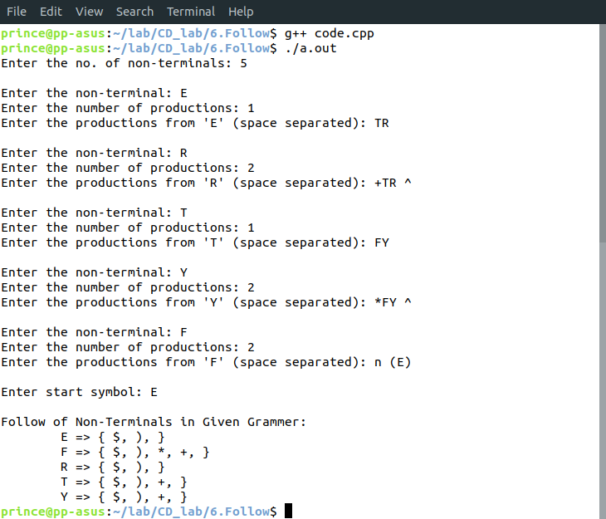
Learnings –

