Experiment – 2

AIM- Write a program to count the tokens in a c++ program.

Description -
In programming language, keywords, constants, identifiers, strings, numbers, operators and punctuations symbols can be considered as tokens. For example, in C language, the variable declaration line
int value = 100;

contains the tokens:

int (keyword), value (identifier), = (operator), 100 (constant) and ; (symbol).

Code -
#include <bits/stdc++.h>

using namespace std;

const int totalKeywords = 62;
string keywords[totalKeywords] = {
"auto","const","double","float","int","short","struct","unsigned",
"break","continue","else","for","long","signed","switch","void",
"case","default","enum","goto","register","sizeof","typedef",
"char","do","extern","if","return","static","union","while",
"asm","dynamic_cast","namespace","reinterpret_cast","try",
"bool","explicit","new","static_cast","typeid",
"catch","false","operator","template","typename",
"class","friend","private","this","using","volatile",
"const_cast","inline","public","throw","virtual",
"delete","mutable","protected","true","wchar_t"
};

int countDelimiters(string str){
int count =0;
char ch;
for(int i=0;i<str.length();i++){
ch = str[i];
if(ch == '{' || ch == '}' || ch == ';' || ch == ','
|| ch == '[' || ch == ']' || ch == ')'){
count++;
// cout<<ch<<" is Delimiter"<<endl;
}
}
return count;
}

bool isOperator(string ch){
if (ch == "+" || ch == "-" || ch == "*" ||
ch == "/" || ch == ">" || ch == "<" ||
ch == "=" || ch == "<<" || ch == ">>"){
return true;
}
return false;
}

int countOperators(string str){
int count = 0;
string tmp = "";

for(int i=0; i<str.length(); i++){
if(str[i]==' '){
if(isOperator(tmp)){
count++;
// cout<<tmp<<" is Operator"<<endl;
}
tmp = "";
}else{
tmp += str[i];
}
}
return count;
}

bool isKeyword(string str){
for(int i=0; i<totalKeywords; i++){
if(str == keywords[i]){
return true;
}
}
return false;
}

int countKeywords(string str){
int count = 0;
string tmp = "";

for(int i=0; i<str.length(); i++){
if(str[i]==' '){
if(isKeyword(tmp)){
count++;
// cout<<tmp<<" is Keyword"<<endl;
}
tmp = "";
}else{
tmp += str[i];
}
}
return count;
}

bool isLiteral(string str){
if(str.length() == 0){
return false;
}
if(isdigit(str[0])){
return true;
}
return false;
}

int countLiterals(string str){
int count = 0;
string tmp = "";

for(int i=0; i<str.length(); i++){
if(str[i]==' '){
if(isLiteral(tmp)){
count++;
// cout<<tmp<<" is Literal"<<endl;
}
tmp = "";
}else{
tmp += str[i];
}
}
return count;
}

int countIdentifiers(string str){
int count = 0;
string tmp = "";

for(int i=0; i<str.length(); i++){
if(str[i] == ' '){
if((countDelimiters(tmp)==0) && !isOperator(tmp) &&! isKeyword(tmp) &&
!isLiteral(tmp) && (tmp != "")){
count++;
// cout<<tmp<<" is Identifier"<<endl;
}
tmp = "";
}else{
tmp += str[i];
}
}
return count;
}

int main(int argc,char* argv[]){
string filename;
if(argc>1){
filename = argv[1];
}else{
cout<<"Please Enter name of the code file: ";
cin>>filename;
}
ifstream fin(filename);
if (!fin.is_open()){
cout << "Error opening the file\n";
exit(1);
}

int cDelimiters = 0;
int cOperators = 0;
int cKeywords = 0;
int cLiterals = 0;
int cIdentifiers = 0;
int total = 0;

string temp;

while(fin){
getline(fin,temp);
cDelimiters += countDelimiters(temp);
cOperators += countOperators(temp);
cKeywords += countKeywords(temp);
cLiterals += countLiterals(temp);
cIdentifiers += countIdentifiers(temp);
}

total = cDelimiters + cOperators + cKeywords +
cLiterals + cIdentifiers;

cout<<"Total Token Count: \t"<<total<<endl;
cout<<"Delimiters Count: \t"<<cDelimiters<<endl;
cout<<"Operators Count: \t"<<cOperators<<endl;
cout<<"Keywords Count: \t"<<cKeywords<<endl;
cout<<"Literals Count: \t"<<cLiterals<<endl;
cout<<"Identifiers Count: \t"<<cIdentifiers<<endl;

return 0;
}

Output –
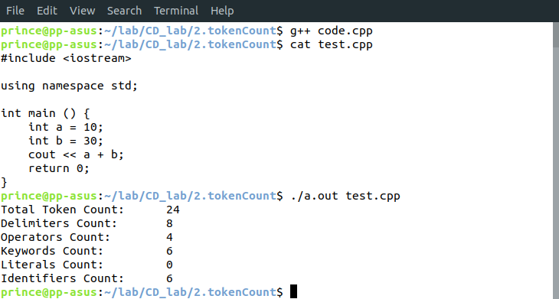
Learnings – Through this program, we learnt about tokens and we made a program that counted the number and frequency of the different types of tokens present in our program.

