Experiment – 3

AIM- To implement sliding window protocol (Go back N).

Description -
The Data link layer is used for error and flow control in computer networking. Sliding window protocol is a data link layer protocol that helps to implement both error control and flow control.
The key to Go-back-N is that we can send several packets before receiving acknowledgments, but the receiver can only buffer one packet. We keep a copy of the sent packets until the acknowledgments arrive.
Go-back-N uses Cumulative Acknowledgement. At the receiver side, it starts a acknowledgement timer whenever receiver receives any packet which is fixed and when it expires, it is going to send a cumulative acknowledgement for the number of packets received in that interval of timer. If receiver has received N packets, then the Acknowledgement number will be N+1. Important point is Acknowledgement timer will not start after the expiry of first timer but after receiver has received a packet.
The receive window makes sure that the correct data packets are received and that the correct acknowledgments are sent. In Go-Back-N, the size of the receive window is always 1. The receiver is always looking for the arrival of a specific packet. Any packet arriving out of order is discarded and needs to be resent.

Algorithms:
- Input number of frames and window size.
- Initialize current frame = 0
- do while current frame < number of frames:
  - Start with sender side.
  - Send frames from current frame to min(N, current frame + window size) – 1
  - Move to receiver side.
  - Input one by one which sent frames were successfully received. Do not accept frames that are out of order.
  - Send Acknowledgements for frames that were received successfully.
  - Move to sender side.
  - Check which acknowledgements were received successfully and update the variable current frame accordingly.

Code:
#include<bits/stdc++.h>
using namespace std;

int main(){
int n;
cout<<"Enter the number of frames: ";
cin>>n;
int wSize;
cout<<"Enter the window size: ";
cin>>wSize;
cout<<endl;

int currFrame = 0;
while(currFrame != n){
cout<<"Sender Side: "<<endl;
for(int i=currFrame; i<min(n, currFrame+wSize); i++){
cout<<"Sending Frame "<<i<<"..."<<endl;
}
cout<<endl;

cout<<"Receiver Side: "<<endl;
vector<int> ACKs;
for(int i=currFrame; i<min(n, currFrame+wSize); i++){
char ch;
cout<<"Did you receive Frame "<<i<<"? (y or n) ";
cin>>ch;
if(ch == 'n'){
break;
}else{
cout<<"Frame Received"<<endl;
cout<<"Sending ACK for frame "
<<i<<"..."<<endl;
ACKs.push_back(i);
}
}
cout<<endl;

cout<<"Sender Side:"<<endl;
int maxACK = currFrame - 1;
for (int i=0; i<ACKs.size(); i++){
char ch;
cout<<"Did you receive the ACK for frame "
<<ACKs[i]<<"? ";
cin>>ch;
if(ch == 'y'){
maxACK = max(maxACK, ACKs[i]);
cout<<"Successful Transmission for all frames till "
<< ACKs[i] << endl;
}
}
currFrame = maxACK + 1;
cout << "-------------------------------------------------------------------" << endl;
}
return 0;
}

Output:
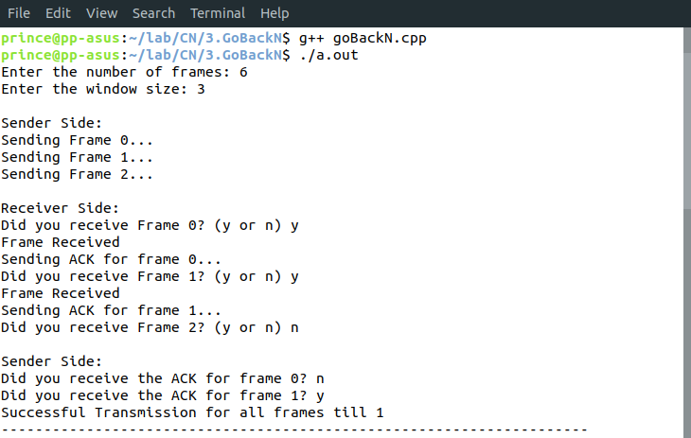
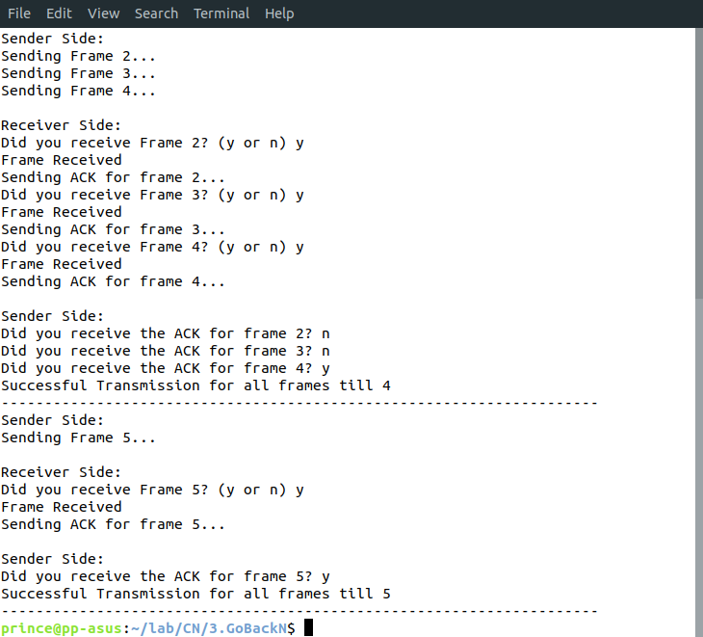

Learnings –
- Retransmits all the frames that sent after the frame which suspects to be damaged or lost.
- If error rate is high, it wastes a lot of bandwidth.
- No searching of frame is required neither on sender side nor on receiver. Maximum window size allowed is N – 1.
- The Go-Back-N protocol simplifies the process at the receiver. The receiver keeps track of only one variable, and there is no need to buffer out-of-order packets; they are simply discarded.

