Experiment – 6

AIM- To implement distance vector routing algorithm.

Description - A distance-vector routing (DVR) protocol requires that a router inform its neighbors of topology changes periodically. Historically known as the old ARPANET routing algorithm (or known as Bellman-Ford algorithm).

Algorithms:
- A router transmits its distance vector to each of its neighbors in a routing packet.
- Each router receives and saves the most recently received distance vector from each of its neighbors.
- A router recalculates its distance vector when:
  - It receives a distance vector from a neighbor containing different information that before.
  - It discovers that a link to a neighbor has gone down.

The DV calculation is based on minimizing the cost to each destination

Dx(y) = Estimate of least cost from x to y
C(x,v) = Node x knows cost to each neighbor v
Dx = [Dx(y): y ∈ N ] = Node x maintains distance vector
Node x also maintains its neighbors' distance vectors
– For each neighbor v, x maintains Dv = [Dv(y): y ∈ N ]

Code:
#include<bits/stdc++.h>
using namespace std;

int main(){
int n;
cout<<"Enter the number of nodes in the network: ";
cin>>n;

vector<vector<int>> distTable(n+1, vector<int> (n+1, 10000));
for(int i=1; i<=n; i++){
int childs;
cout<<endl;
cout<<"Enter the number of nodes connected to node "<<i<<": ";
cin >> childs;
distTable[i][i] = 0;
if(childs>0){
cout<<"Enter nodes and their distances: "<<endl;
}
for(int j = 0; j < childs; ++j){
int sibling;
int distance;
cin >> sibling >> distance;
distTable[i][sibling] = distance;
distTable[sibling][i] = distance;
}
}

bool done = false;
while(!done){
done = true;
for(int i=1; i<=n; i++) {
for(int j=1; j<=n ; j++){
for(int k=1; k<=n; k++){
if(distTable[i][j] > (distTable[i][k]+distTable[k][j])){
distTable[i][j] = distTable[i][k] + distTable[k][j];
done = false;
}
}
}
}
}
cout<<endl;
cout<<"Distance Matrix: "<<endl;
for(int i=1; i<=n ; i++){
for (int j=1; j<=n ; j++){
if(distTable[i][j] == 10000)
distTable[i][j] = -1;
cout<<distTable[i][j]<<" ";
}
cout<<endl;
}

return 0;
}
Output:
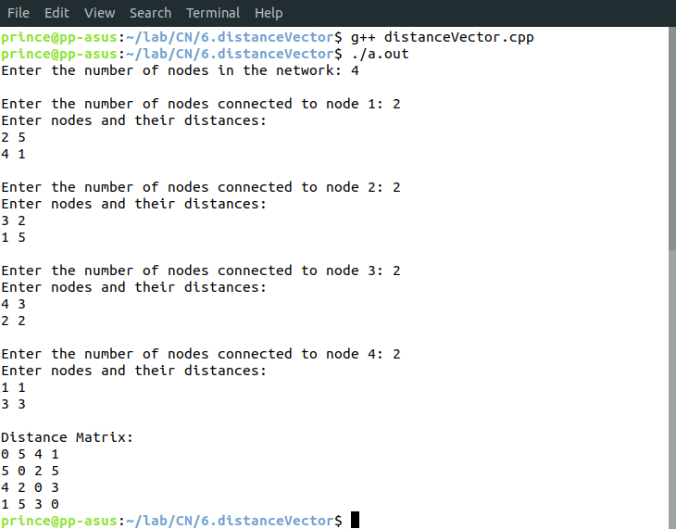
Learnings –
- Advantages of Distance Vector routing –
- It is simpler to configure and maintain than link state routing.
- Disadvantages of Distance Vector routing –
- It is slower to converge than link state.
- It is at risk from the count-to-infinity problem.

