

**CERTIFICATE**

**OF COMPLETION**

THIS CERTIFICATE IS PROUDLY PRESENTED TO

Prince Owusu

in recognition of your hardwork and dedication in completing the **Course 1 course** from **Feb 20, 2022** to **Feb 20, 2022** at academy of ours. Brilliant minds go a long way and you’re a perfect example.

***Thank you for being a part of academy of ours.***

*Best*

# AWARD



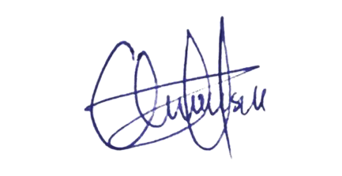**___________________________**

# Prince Owusu

Chief Executive Officer

Certificate ID: **77370709**