Ques : Create a project with different user groups and implement group policies. (AZURE DEVOPS)

SOLN:

KEY CONCEPTS:

Concept | Description
Project | A container for repositories, pipelines, boards, and more.
User Group | A collection of users with similar responsibilities.
Permissions | Define what actions a user or group can perform.
Security Policies | Rules such as requiring code reviews, limiting branch deletions, etc.
Azure AD Integration | Azure DevOps can integrate with Azure Active Directory to manage users more securely.

In real-world DevOps projects, different teams (developers, testers, managers) need different levels of access to code, pipelines, and project settings. Group policies in Azure DevOps help enforce role-based access control (RBAC), which prevents unauthorized changes and improves security. For example, only developers can push code, testers can trigger test runs, and managers can only view progress. This ensures accountability, compliance, and better collaboration without stepping on each other’s responsibilities. It also helps in auditing actions, especially in large teams or regulated industries like healthcare and finance

STEPS TO PERFORM IN AZURE DEVOPS

1. Create a New Project
- Go to Azure DevOps Portal.
- Click on "New Project".
- Enter:
  - Project name
  - Visibility (Private/Public)
  - Choose Git or TFVC for version control
- Click Create.

AZURE PORTAL:
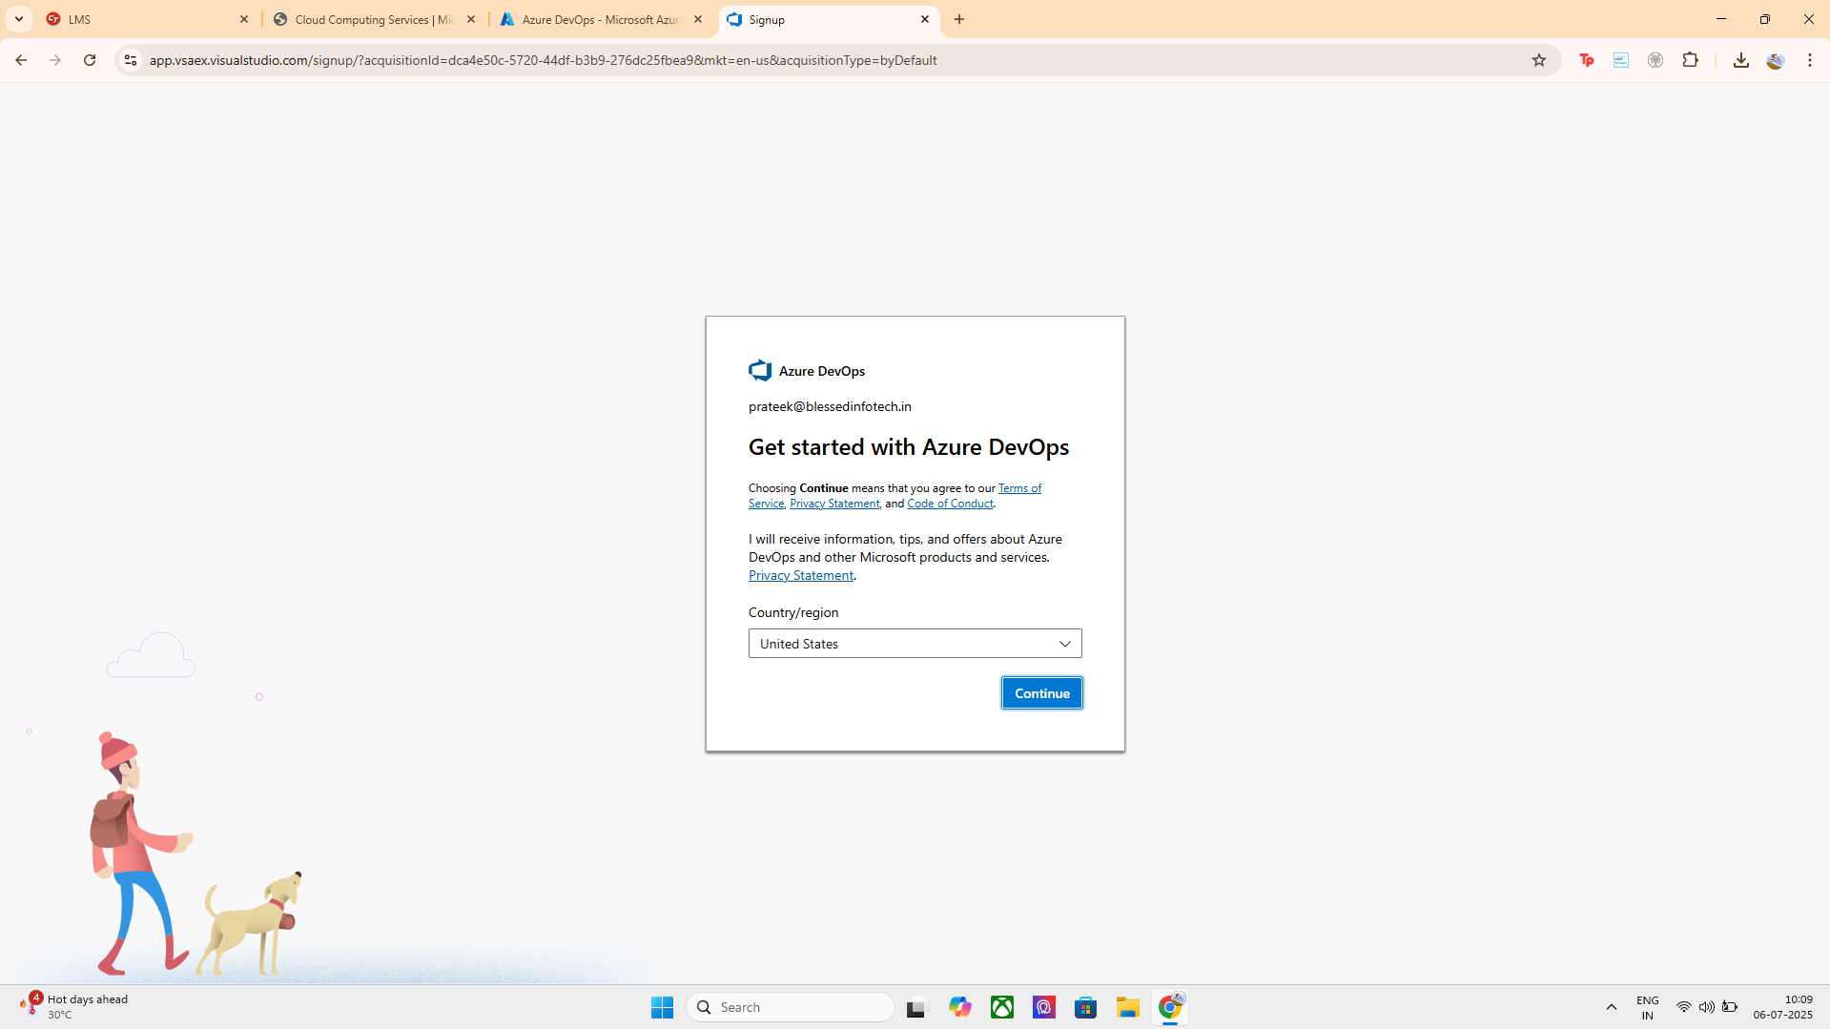
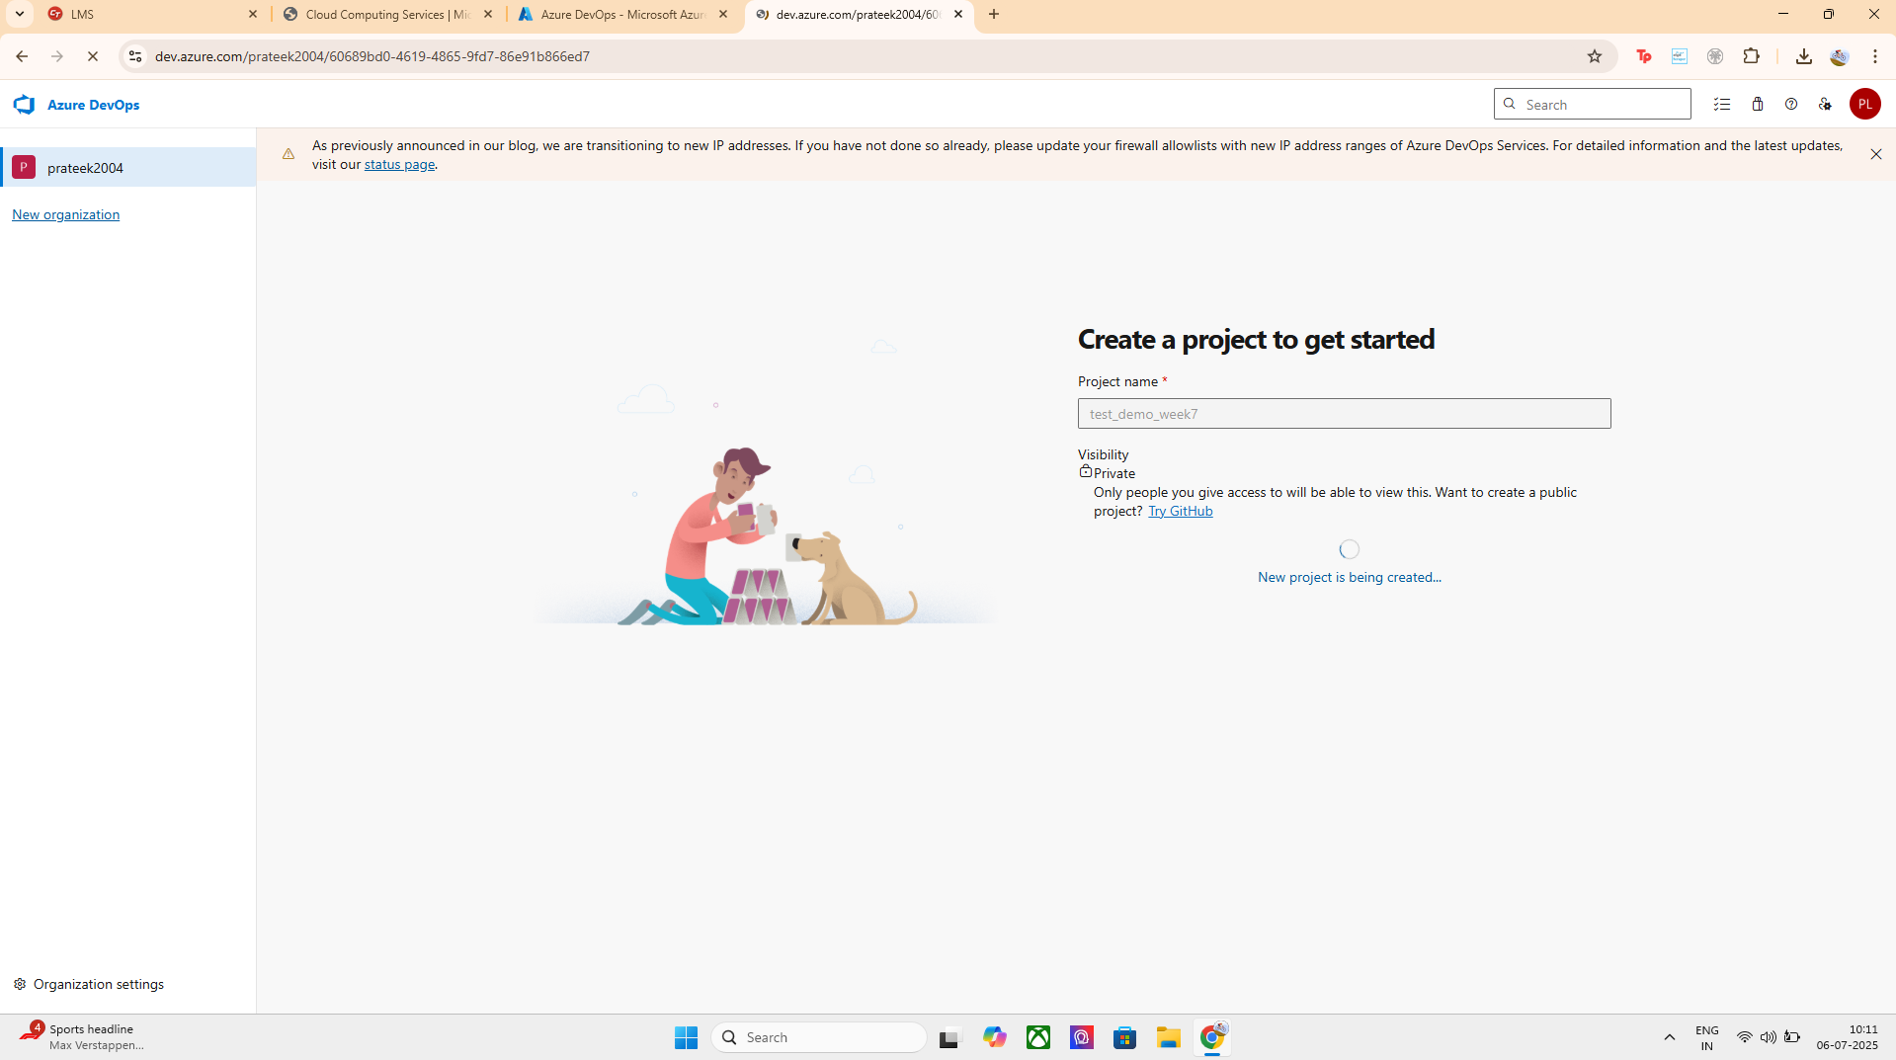
NAMING THE PROJECT:
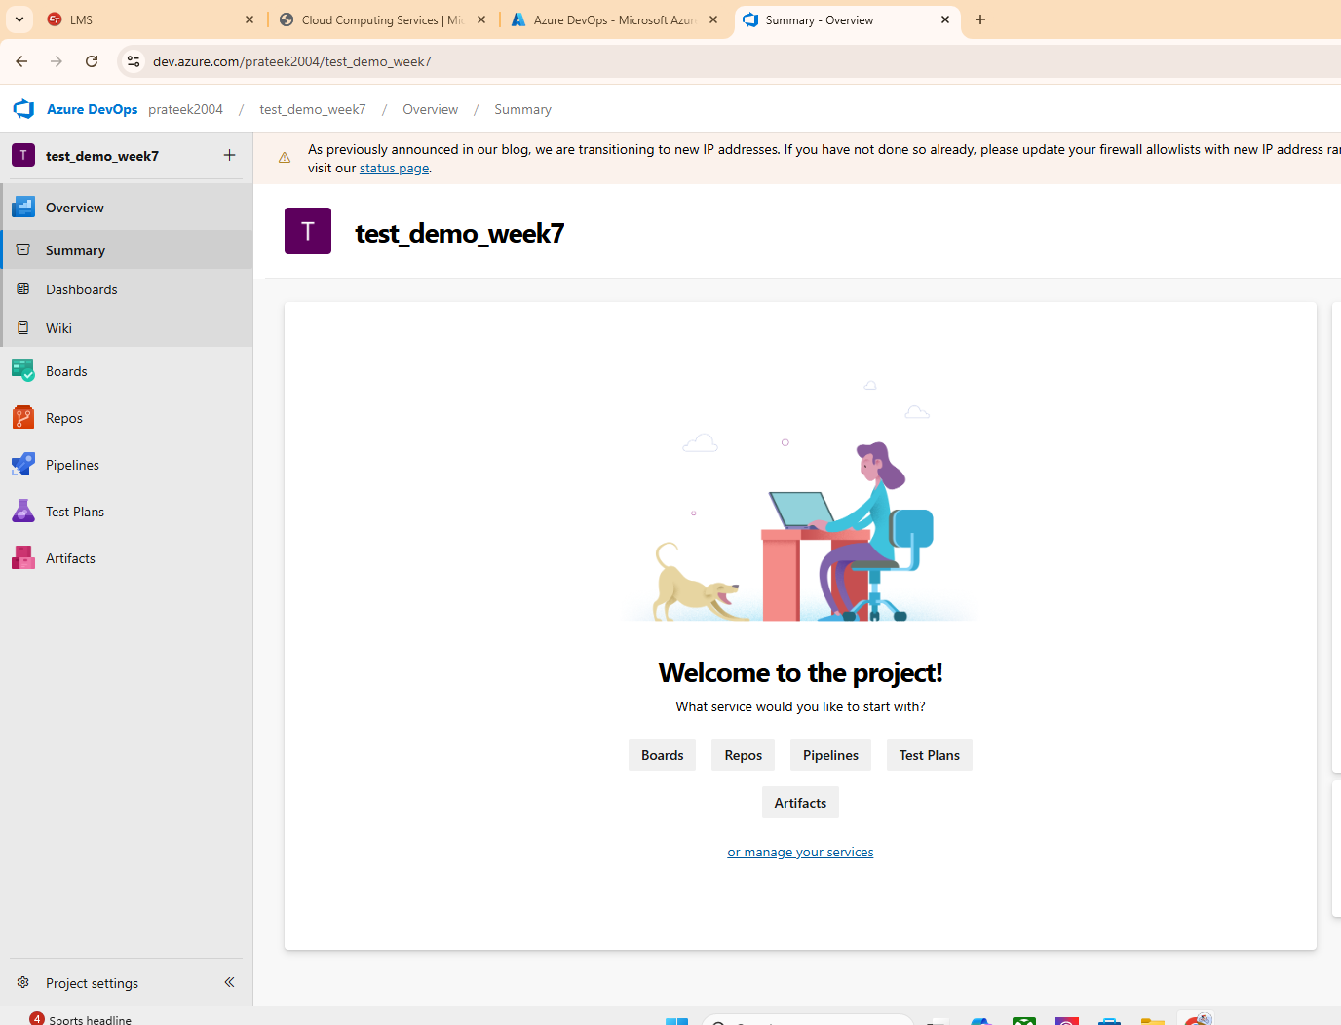
SUCESSFULLY CREATED :

2. Create Custom User Groups
- Navigate to: Project Settings > Permissions.
Click New Group.
  - Name the group (e.g., QA Team, Developers, Managers).
  - Add Members (users who should belong to this group).
  - Optionally assign from Azure AD.
- Click Create.

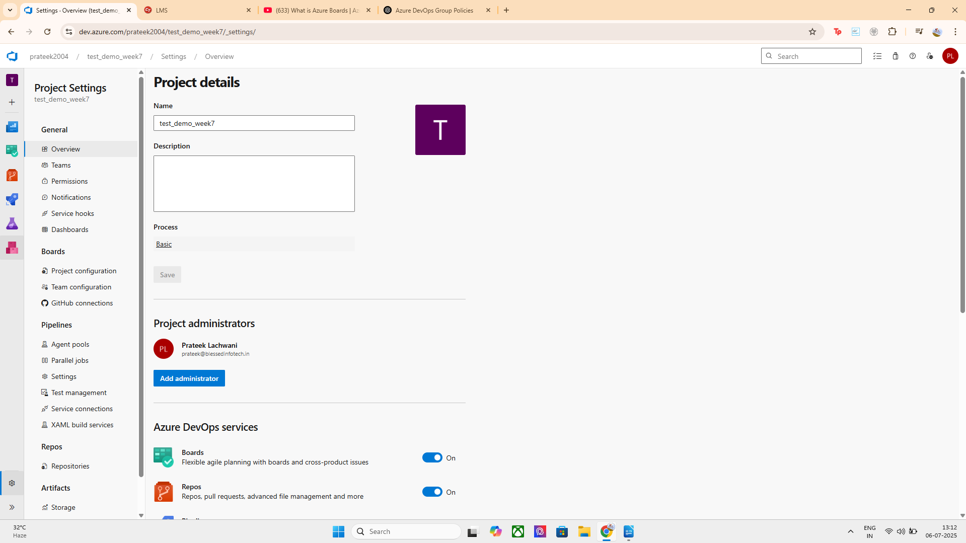
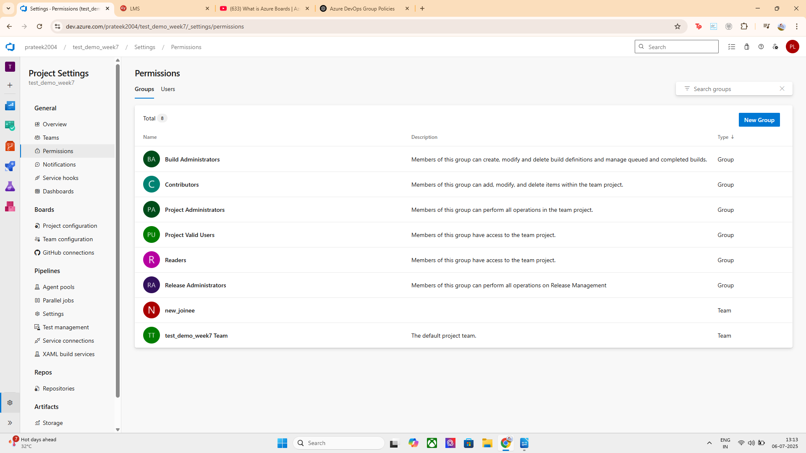

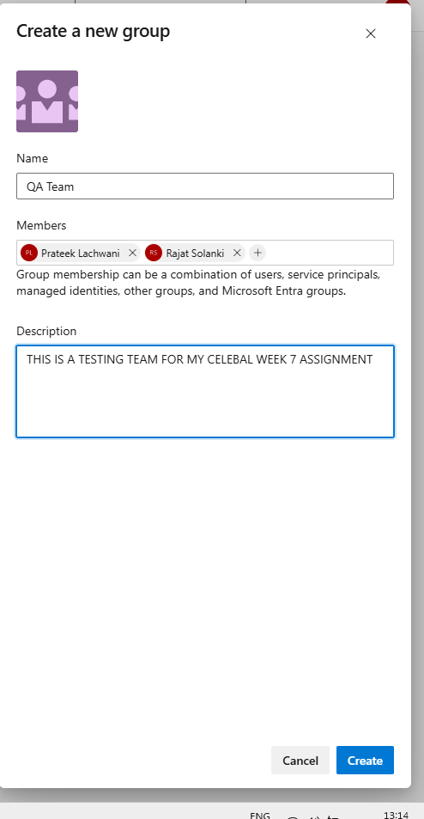
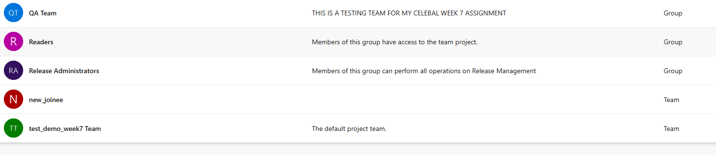
SUCESSFULLY CREATED WITH 2 GROUPS

QA TEAM AND NEW_JOINEE

3. Assign Permissions (Group Policies)
For each group, do the following:
- Still in Project Settings > Permissions:
  - Click on the group name.
  - Under Permissions, configure:
    - Repos: Read/write access
    - Pipelines: Run, edit, view permissions
    - Boards: Work item tracking
    - Artifacts: Access to feeds
- Set permission values:
  - Allow
  - Deny
  - Or leave as Not set (inherits from parent).

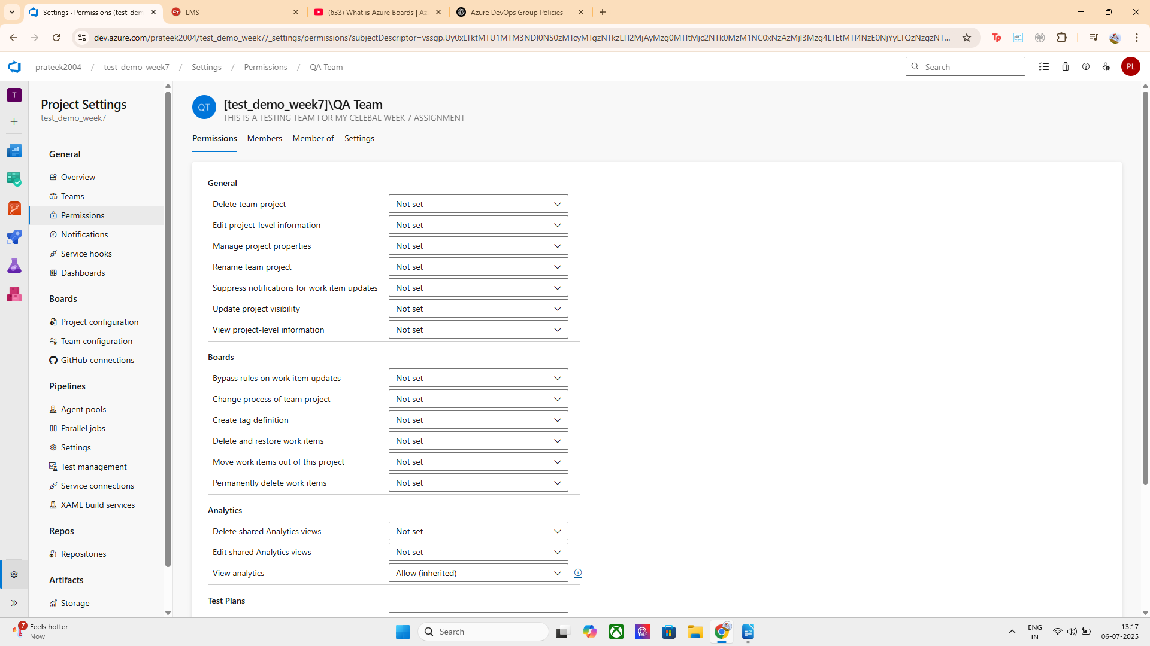
CONFIGURED PERMISSIONS FOR ALL THE GIVEN SCENARIOS:

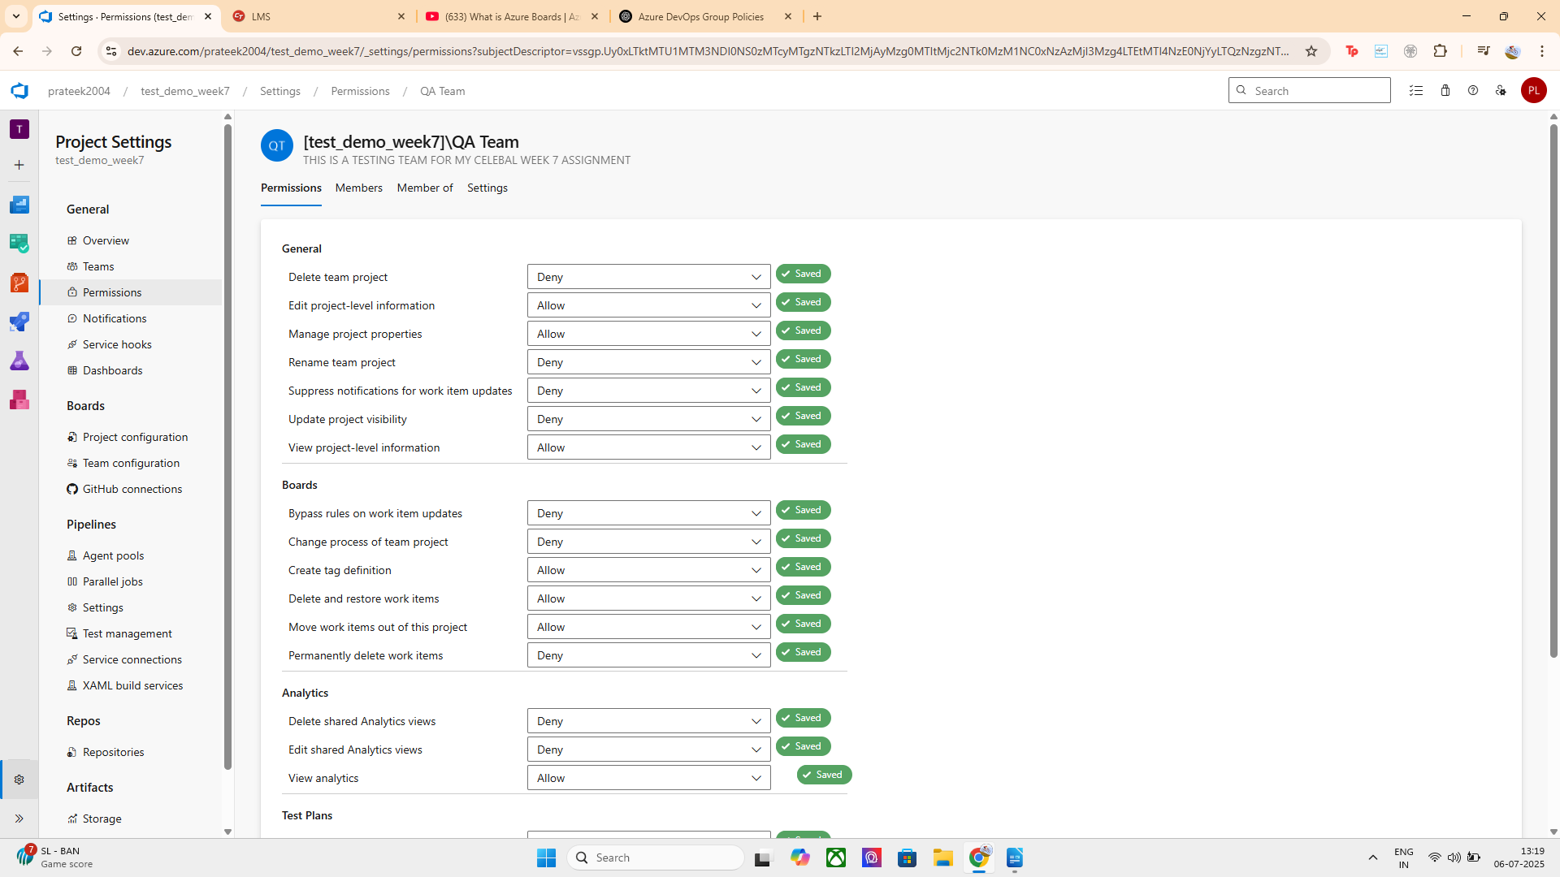

4. Set Branch Security Policies (if needed)
For code-based policies:
- Go to Repos > Branches.
- Choose the branch (e.g., main), click the ... > Branch Policies.
- Configure:
  - Minimum number of reviewers
  - Check for linked work items
  - Enforce merge strategy
  - Limit who can push directly

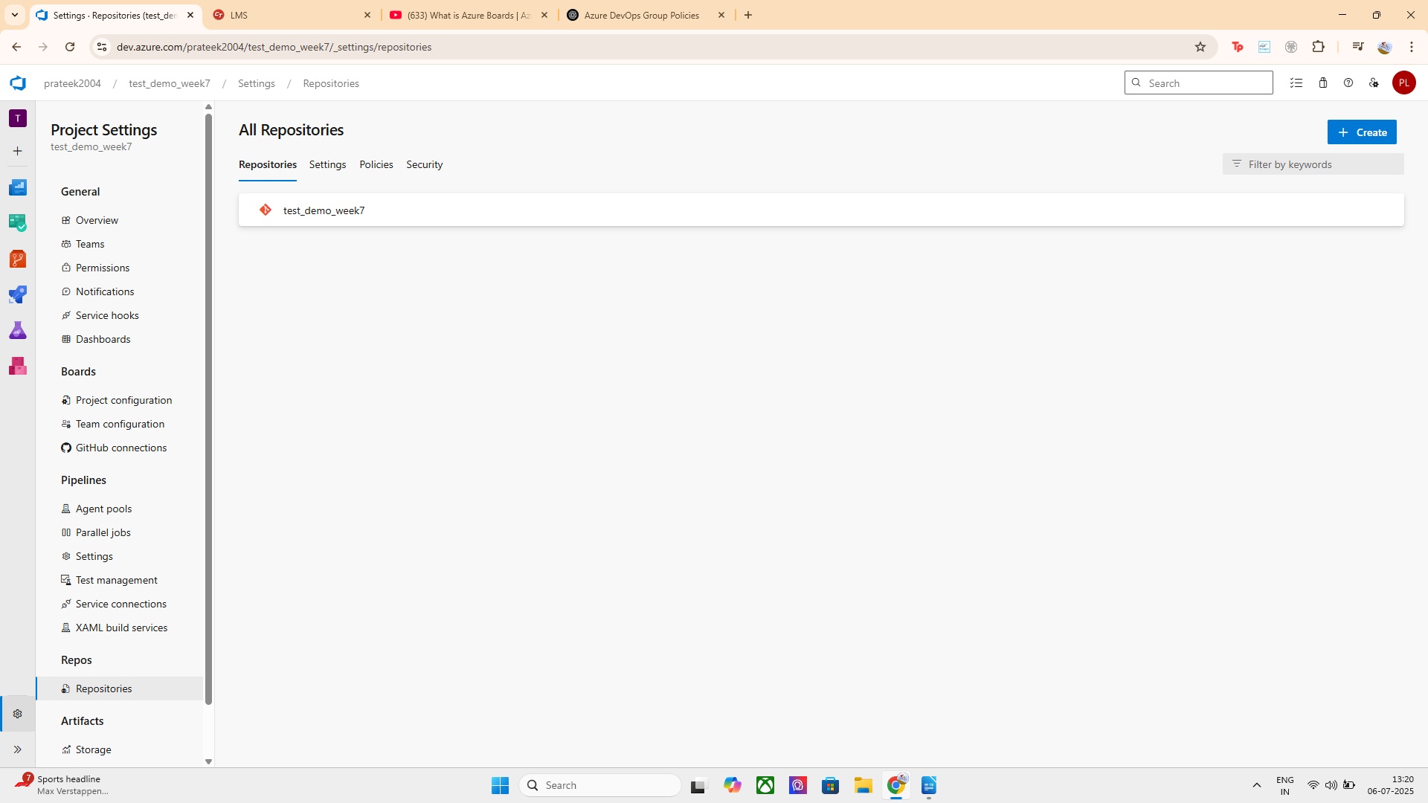
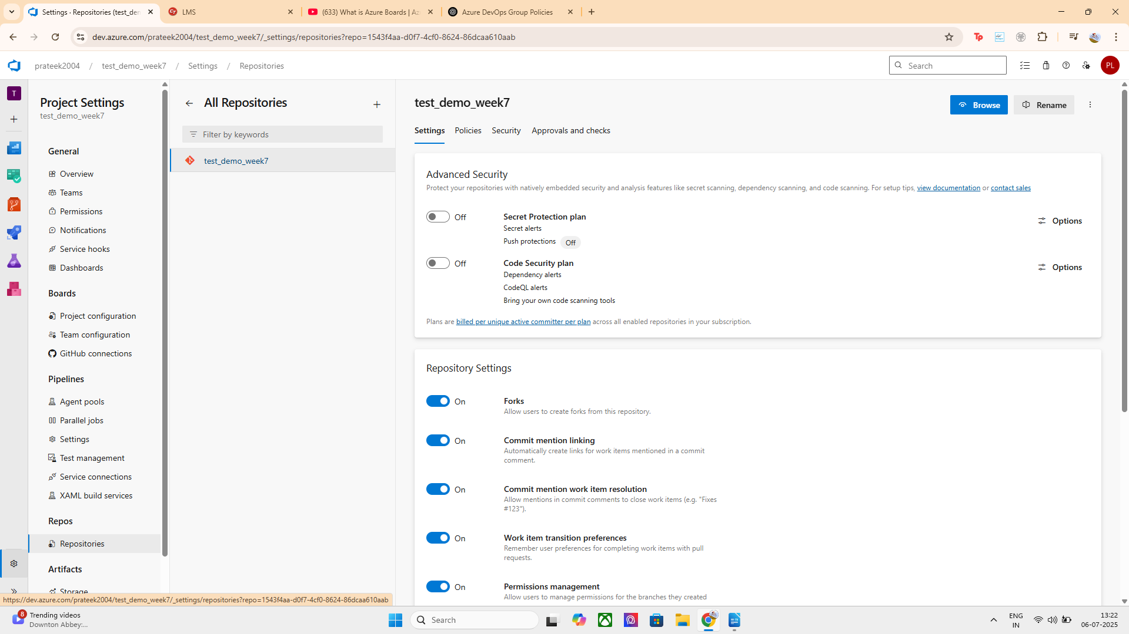
NEED OF ATTACHING THE GIT HUB REPOS TO SET AND MONITOR:
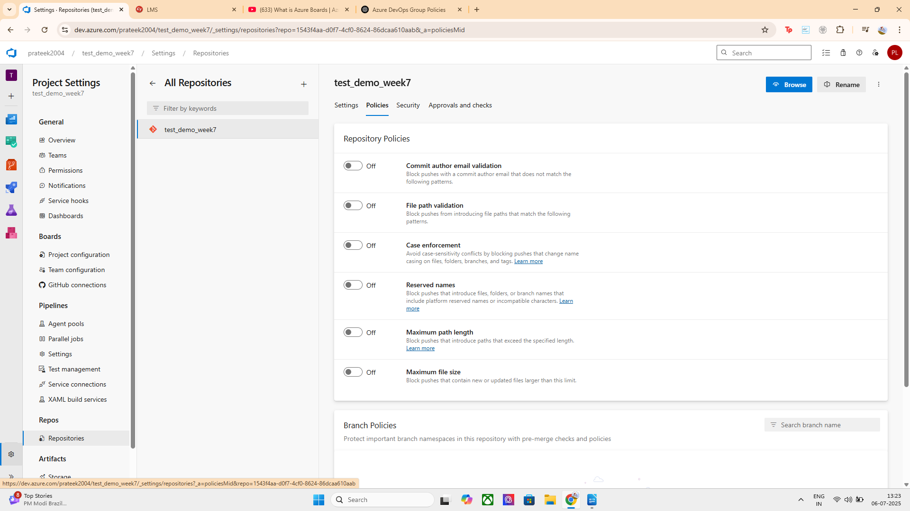

ATTACHING GITHUB REPO TO THE AZURE DEVOPS BOARD
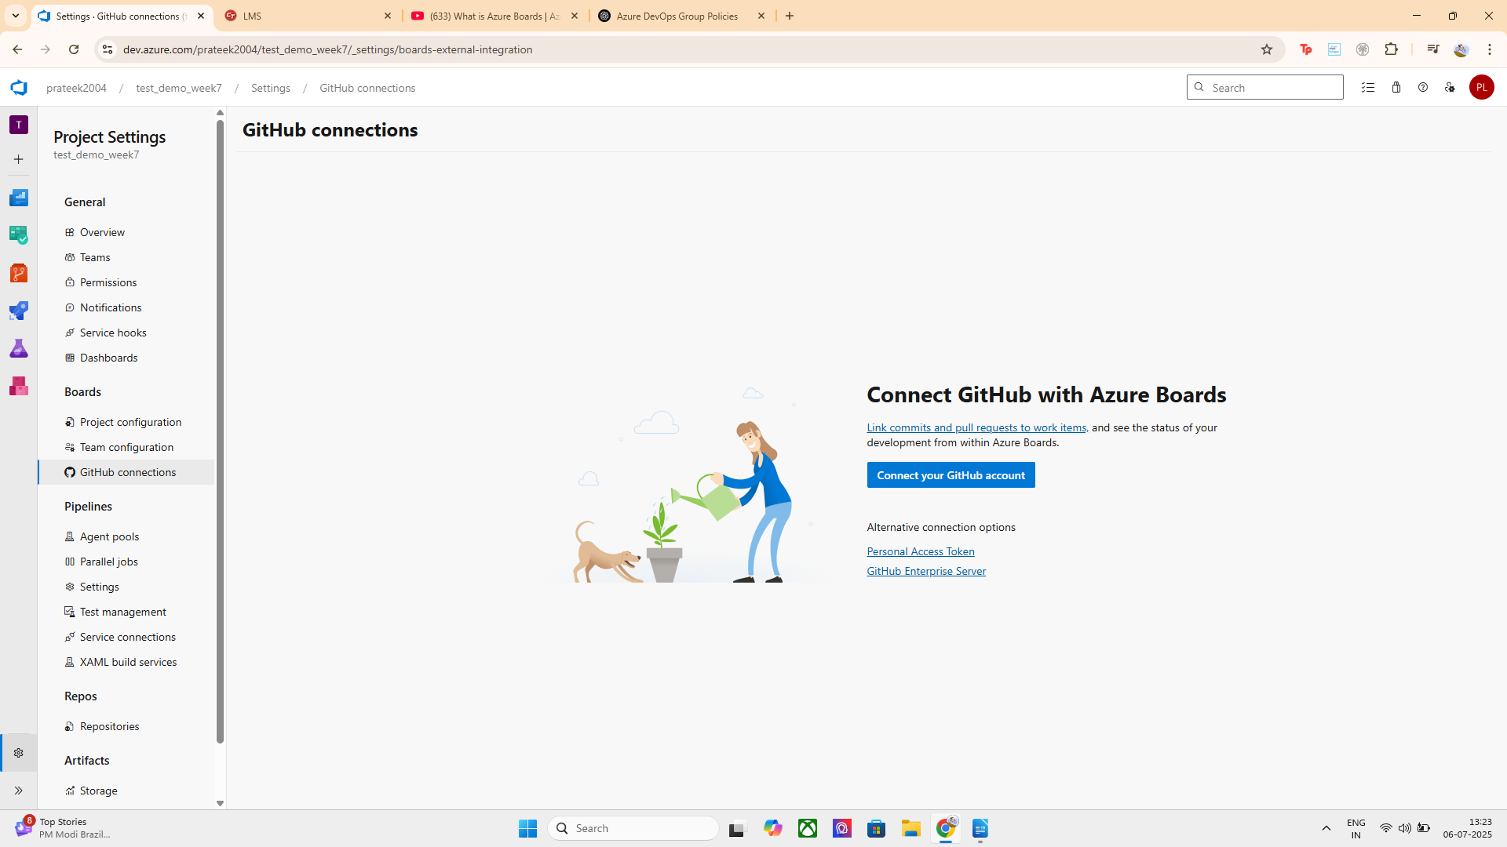

GITHUB REPO SUCCESSFULLY ATTACHED:
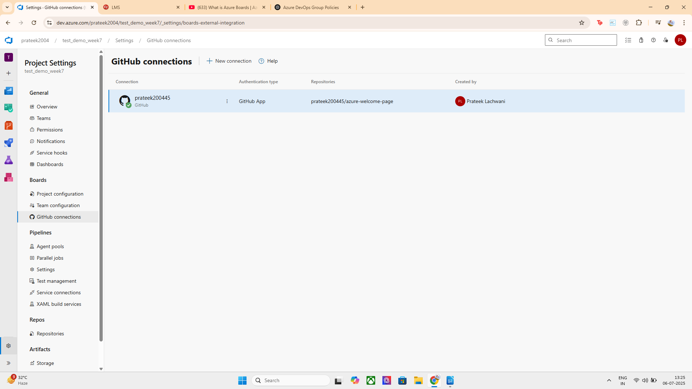

5. Test Permissions
Log in using different user accounts or ask teammates to test access:
- Try pushing code
- Editing pipelines
- Creating work items
Verify the permissions work as expected per group policy.
( IT’S WORKING FINE )

