Question: Use work items in pipelines

soln:

In Azure DevOps, work items (like user stories, tasks, bugs) help track what a pipeline run is related to. By linking work items to pipelines, you create traceability between code, builds, and deployments — which is essential for DevOps best practices.

Let’s say a developer is fixing Bug #121. They push code with the message:

Fixes #121: Resolve login failure
Now Azure DevOps automatically links Builds, Commits, PRs, and Releases to Work Item #121.
Later, QA or project managers can see exactly which code fixed which task, when, and by whom — making audits and rollbacks clear and manageable.

Implementation Steps :

THERE ARE TWO WAYS :

Option A: Link Work Items via Commit Messages (Recommended)
Steps:
- Go to your local repo (already cloned)
- Make a code change (e.g., edit a .txt or .js file)
- In your Git commit message, write:

Fixes #<WorkItemID>

Example:

git commit -am "Fixes #23 - Added login retry logic"

Push the code:

git push origin branch-name

Go to Pipelines > Pipelines → Check your latest pipeline run
- You’ll see the Linked Work Item #23 under that build
✔️ Azure DevOps auto-links it using the commit message.

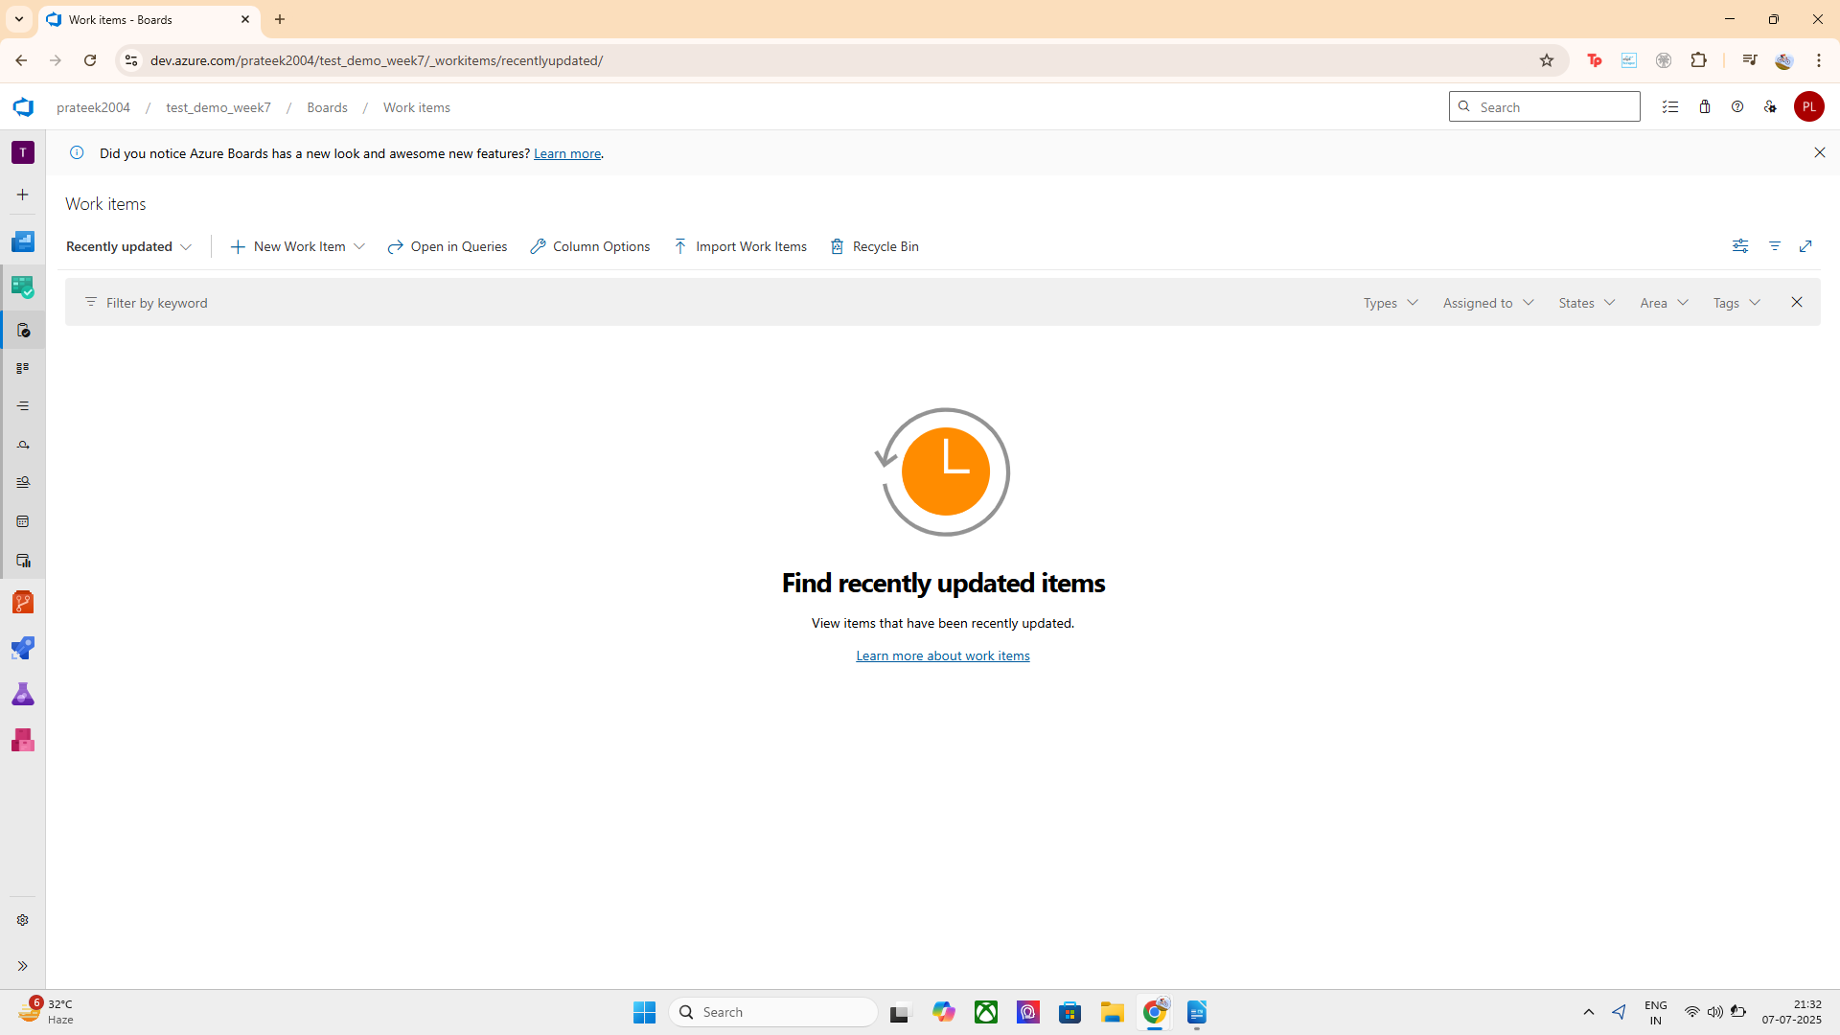
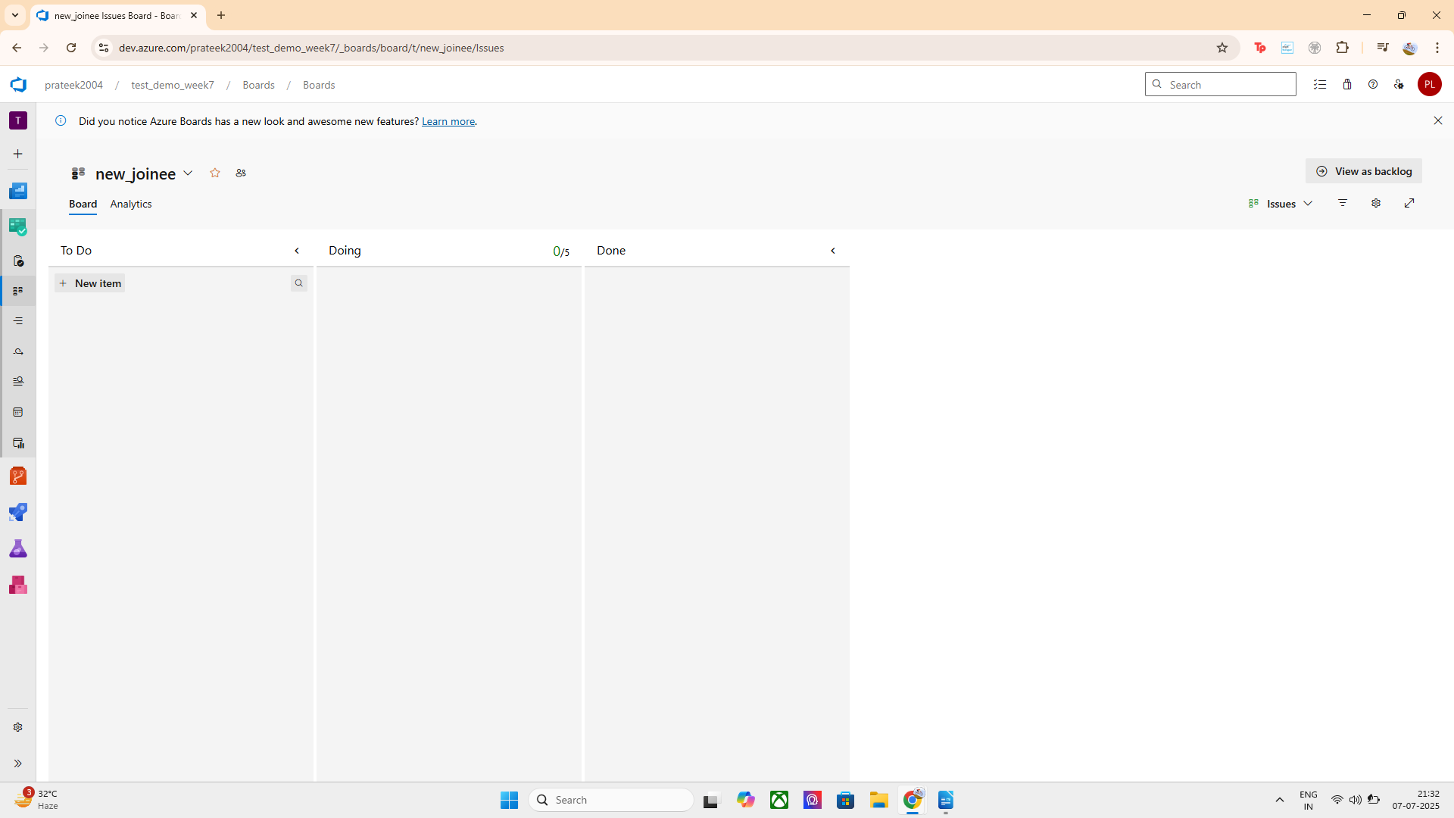

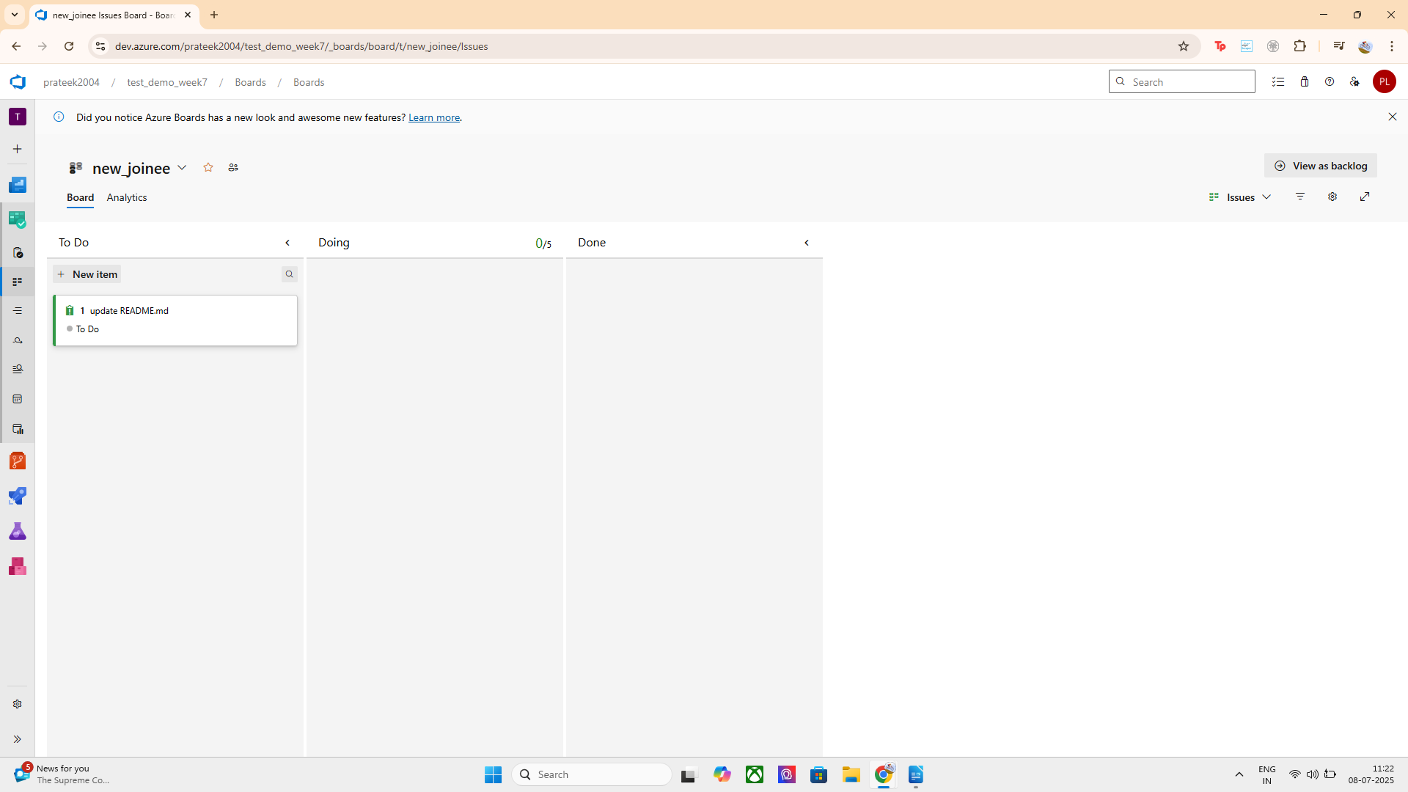
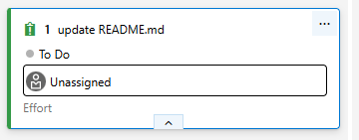

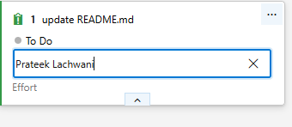

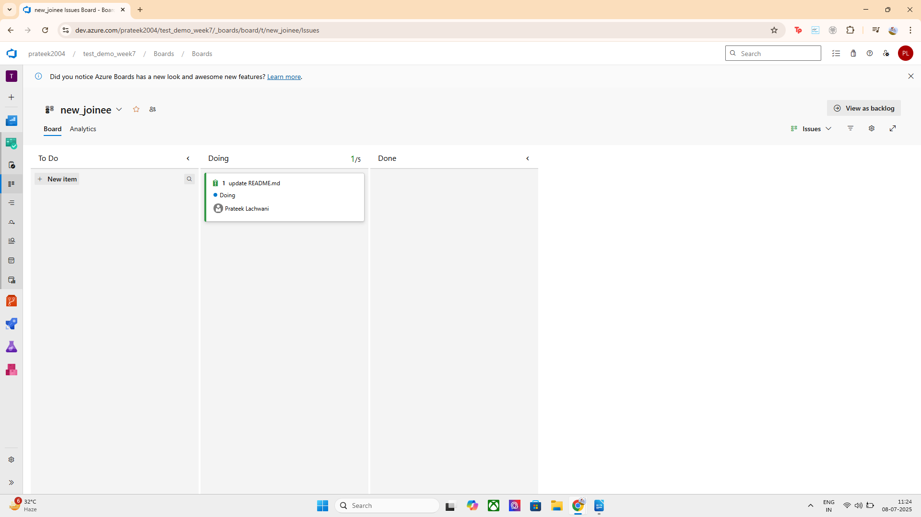
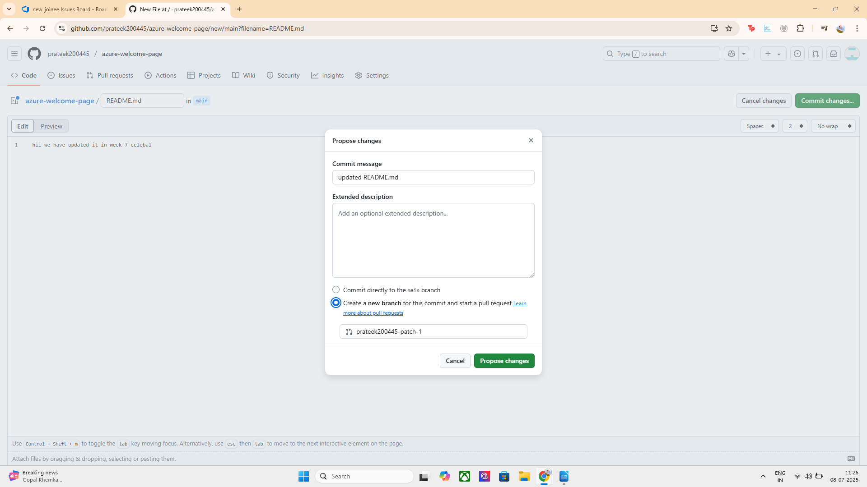
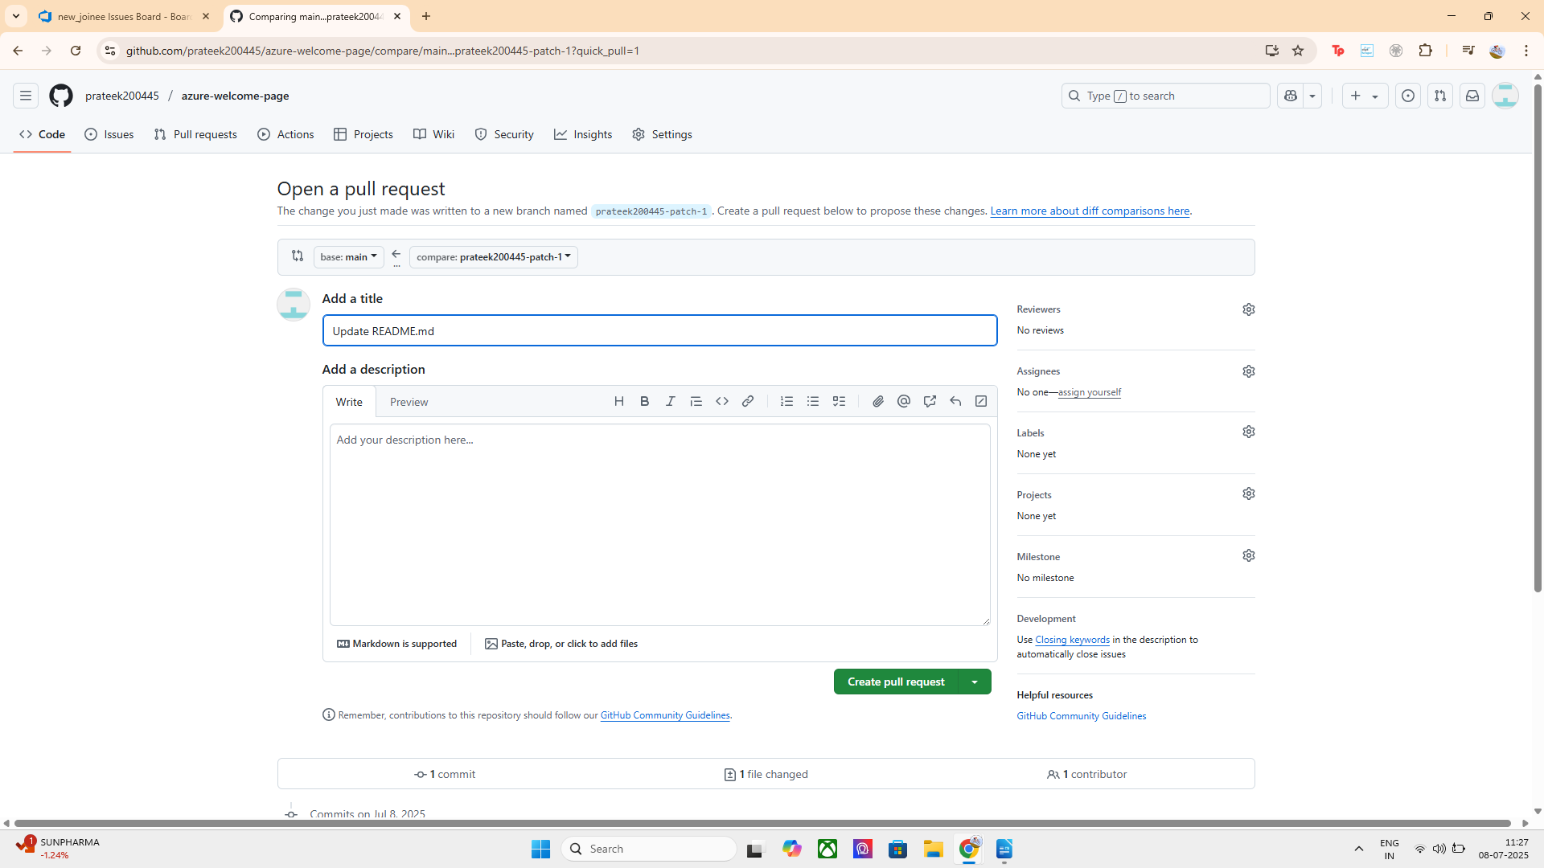

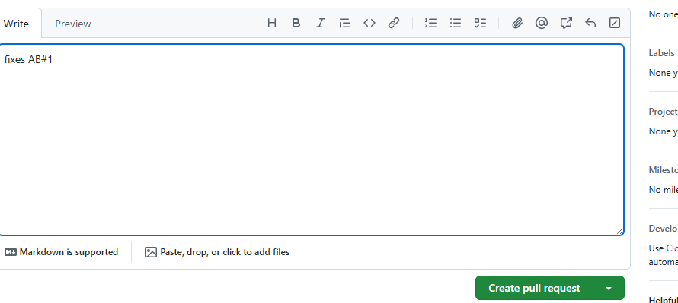
Created pull requests for the work item
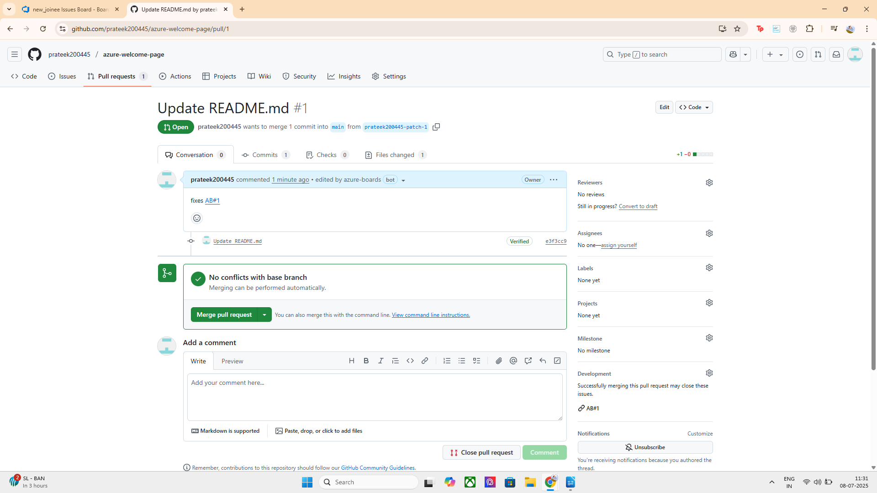

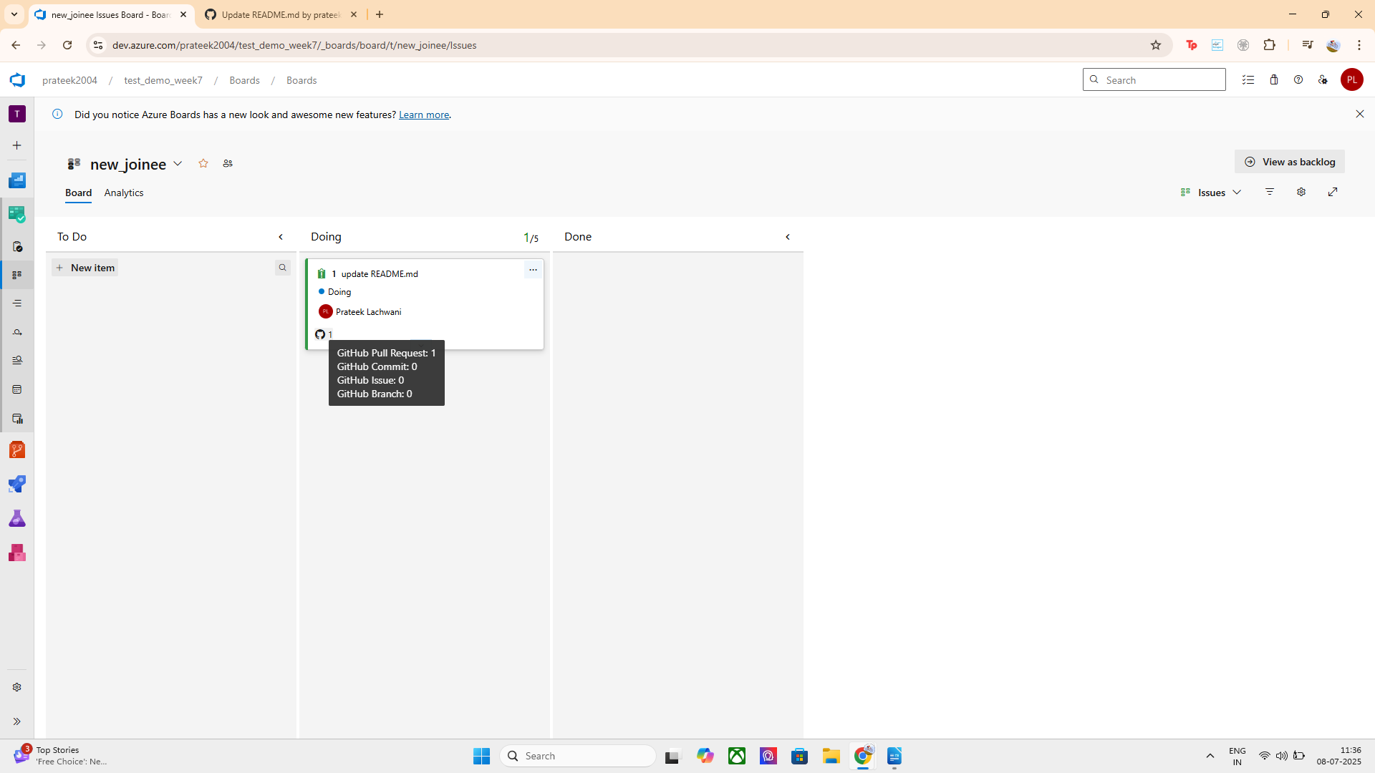
Hence pull requests are shown here:

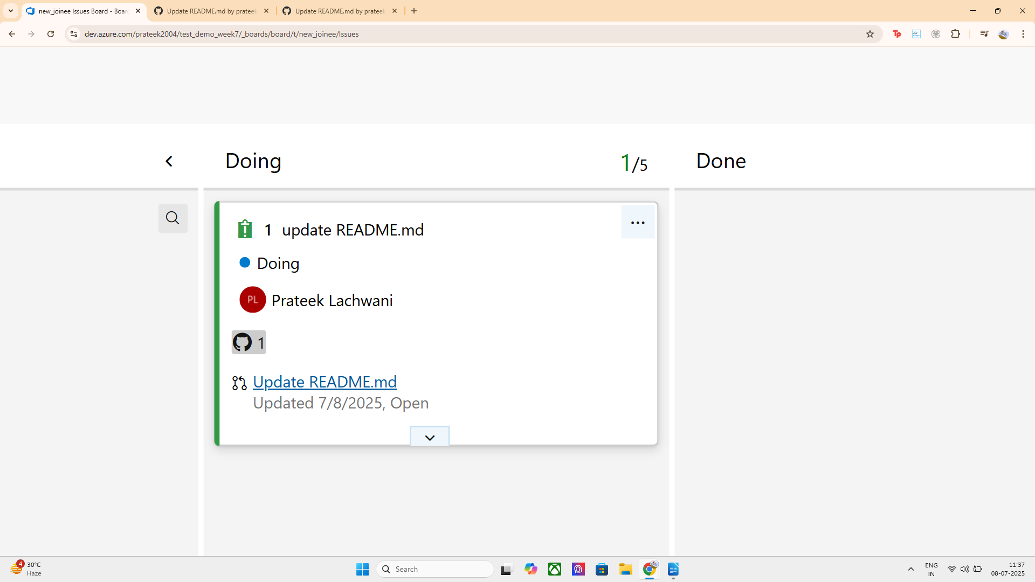

HENCE ITS MERGED SUCCESSFULLY:
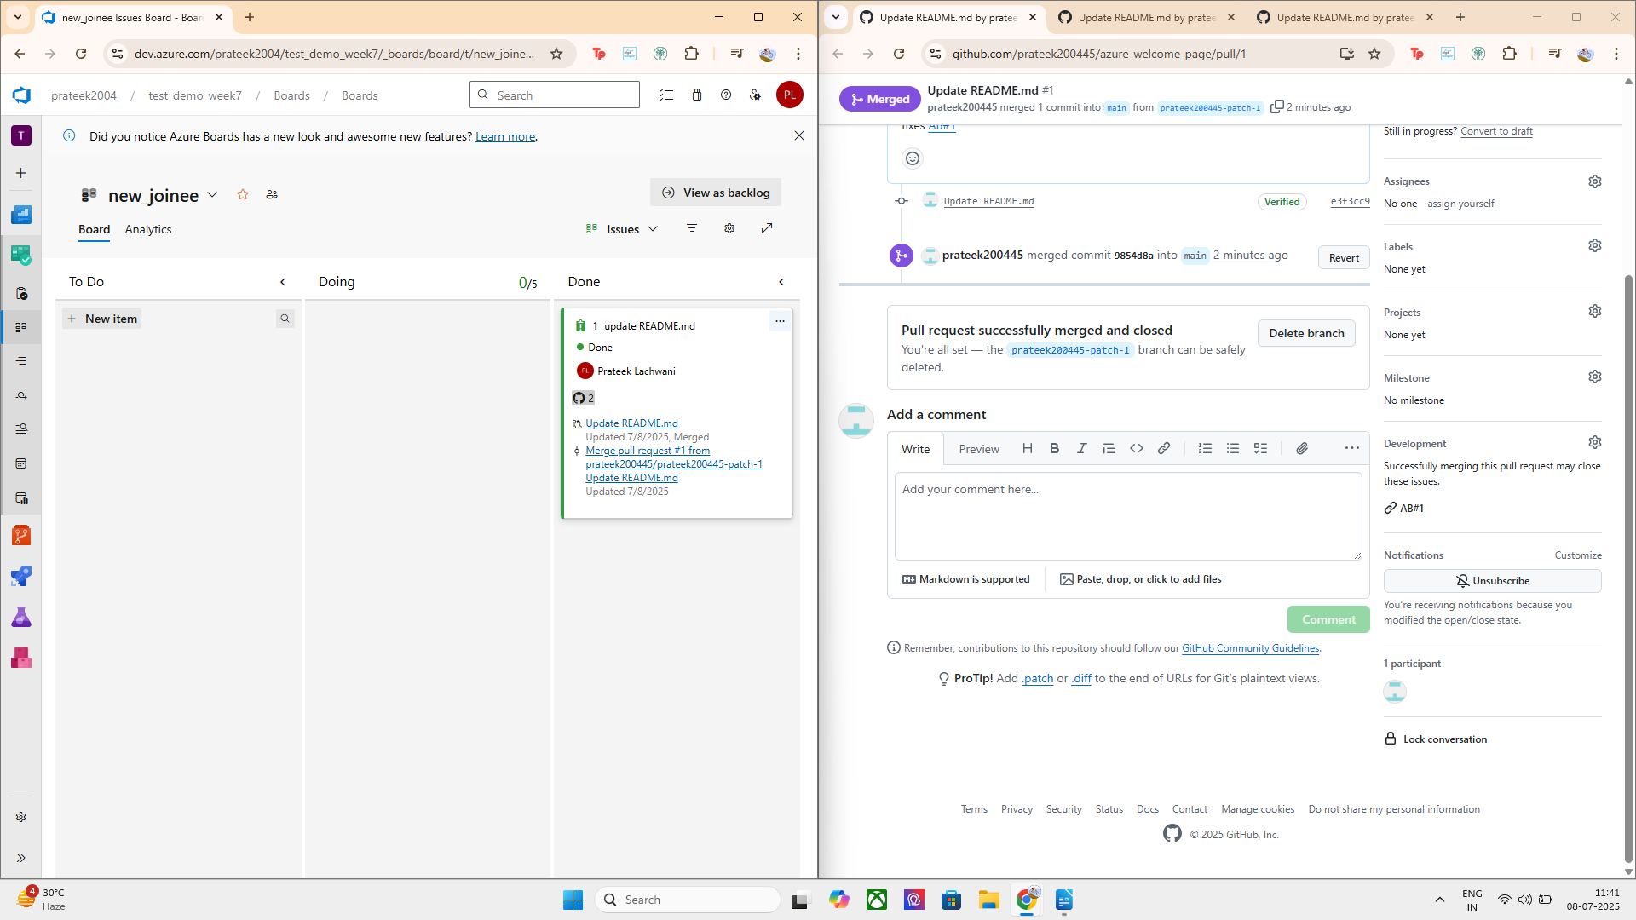

Option B: Link Work Items in Pull Requests
Steps:
- After pushing code, go to Repos > Pull Requests
- Create a new pull request
- In the “Work items” section of the PR form:
  - Click “+” → Select a work item (e.g., Bug #23 or Task #5)
- Create the PR
- After merging, the work item gets linked to the pipeline run automatically

LETS GO LITTLE BEYOND TO UNDERSTAAND THE CAPACITY OF WORKING INFRA:

If you want to enforce this for all users:
- Go to Repos > Branches
- Click Policies next to main
- Enable:
"Check for linked work items"

Implementation:
- I committed code with a message referencing a work item ID (e.g., Fixes #23).
- After pushing and running the pipeline, the related build run shows the linked work item.
- Alternatively, I created a pull request and manually linked a work item in the PR UI.
- This allows builds, code changes, and deployments to be traceable to specific tasks or bugs.

