QUES 4 : Apply branch filters and path filters

SOLN:

What Are Branch & Path Filters?
- Branch filters in Azure DevOps define which branches trigger a pipeline or policy (e.g., only run CI on develop or feature/*).
- Path filters control pipeline triggers or PR validations based on which files/folders were changed (e.g., only run build if /src/ changes).
- They help reduce unnecessary builds/tests, saving time and resources.
- Real-world use: You may want to test UI code only when frontend files change, not for backend edits.
- This ensures faster pipelines, efficient workflows, and better team-level code separation.

PART 2: HOW TO APPLY IN AZURE DEVOPS
You can apply branch and path filters in two areas:
- In Pipelines (YAML or Classic UI)
- In Branch Policies (under Repos > Branches)

METHOD 1: APPLY IN PIPELINE TRIGGERS

Steps (YAML-based CI/CD Pipeline):

STEP-BY-STEP:

Step 1: Click "Create Pipeline"
- Select "Azure Repos Git" (since your repo is in Azure DevOps).
- Choose your repository — test_demo_week7.
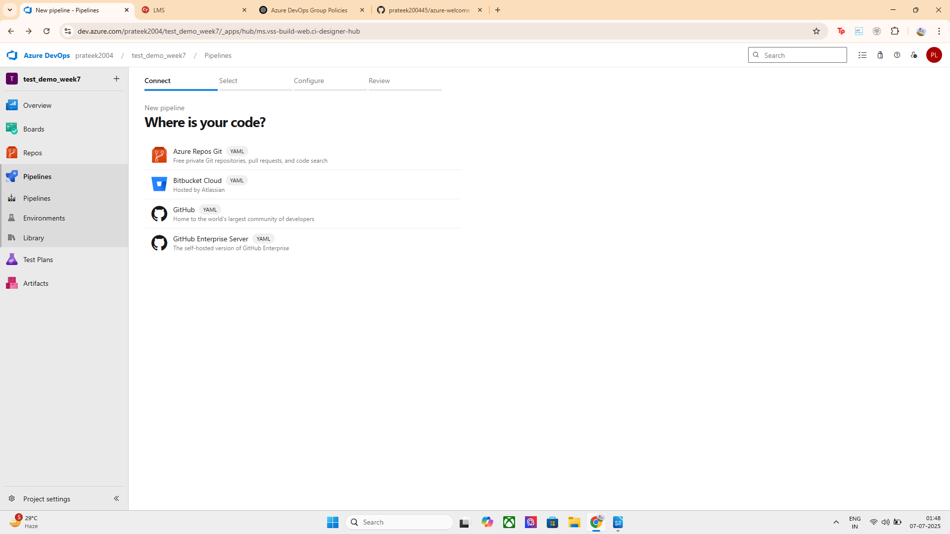
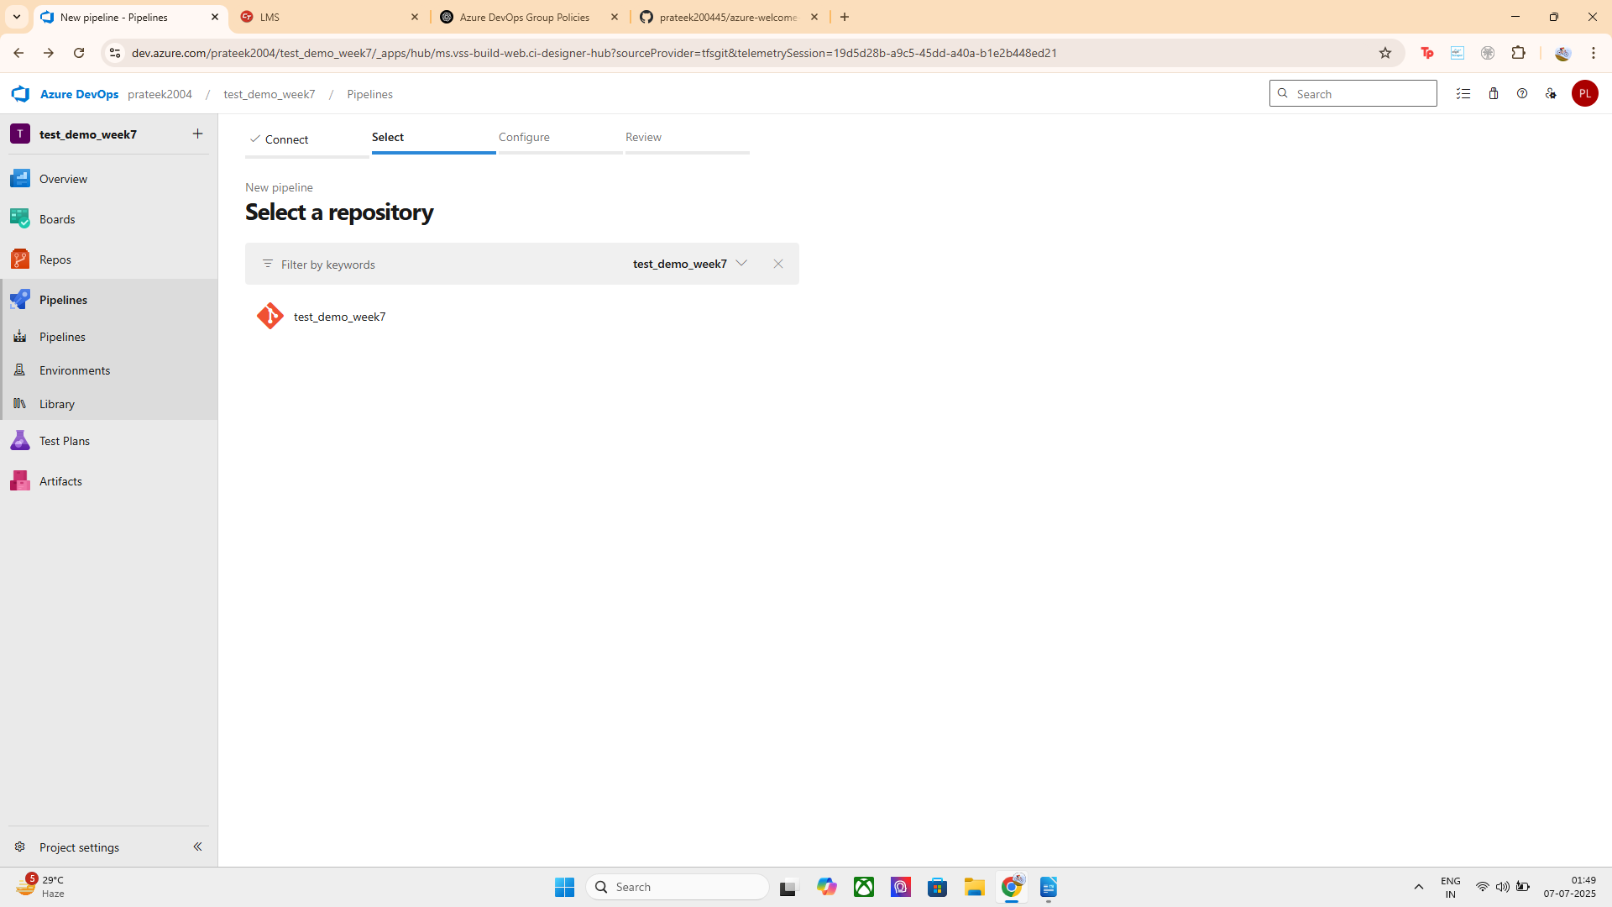
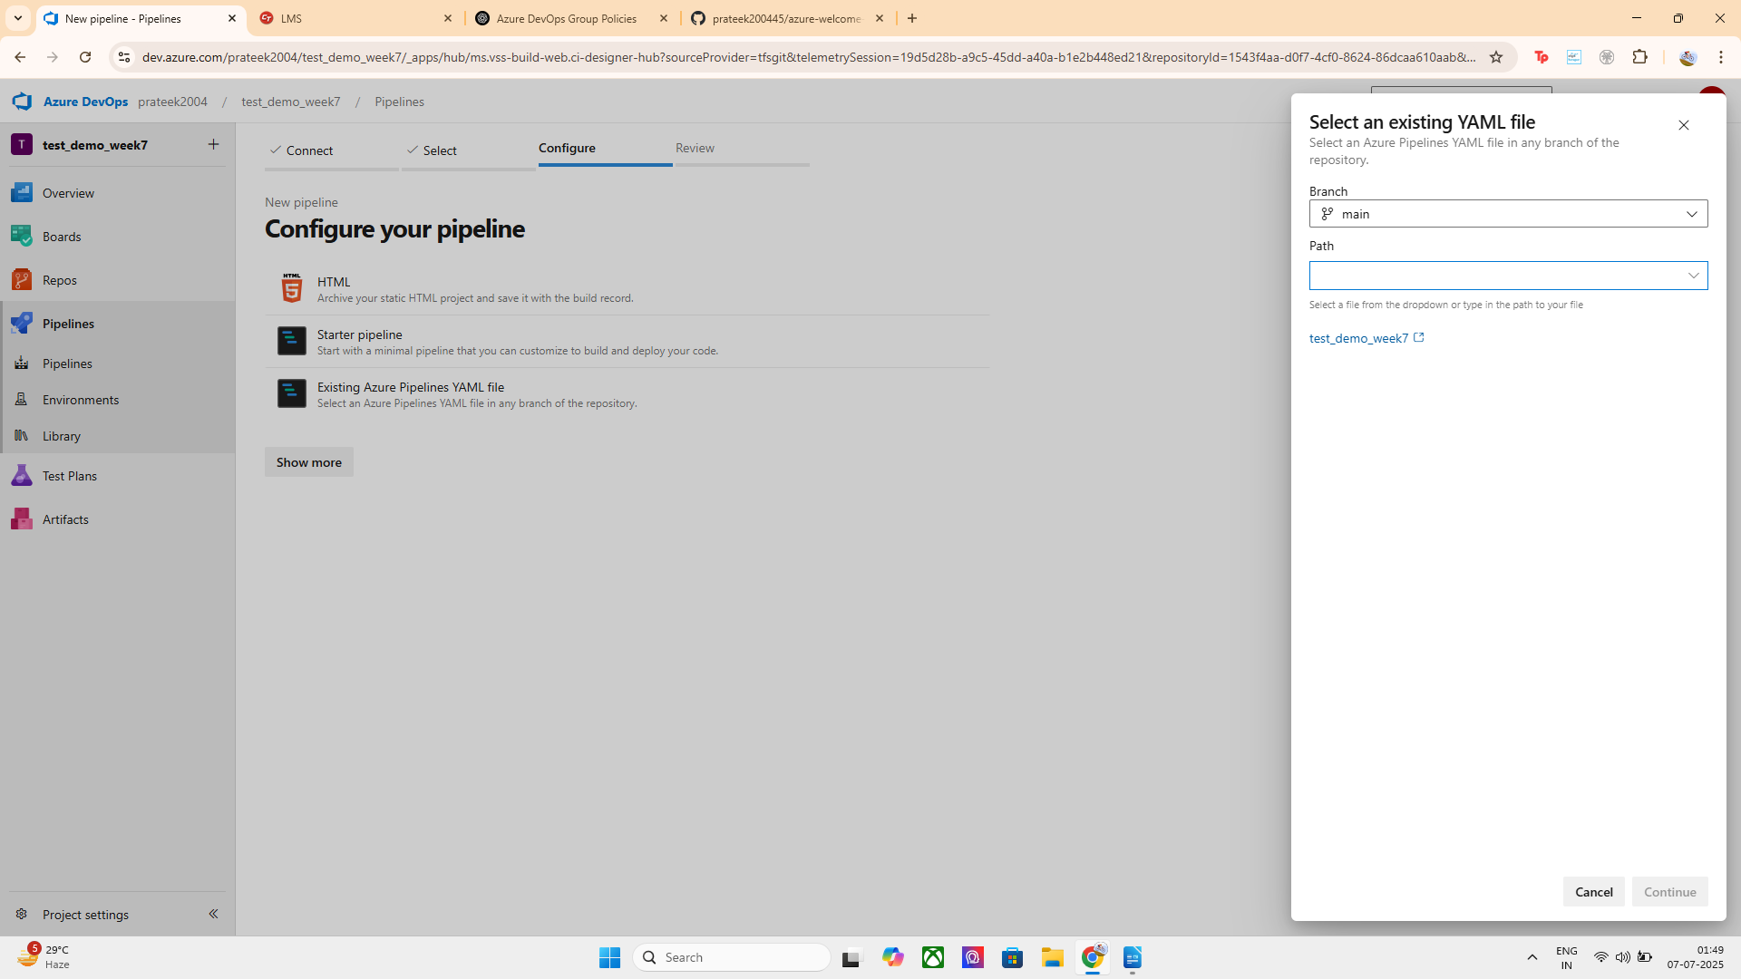

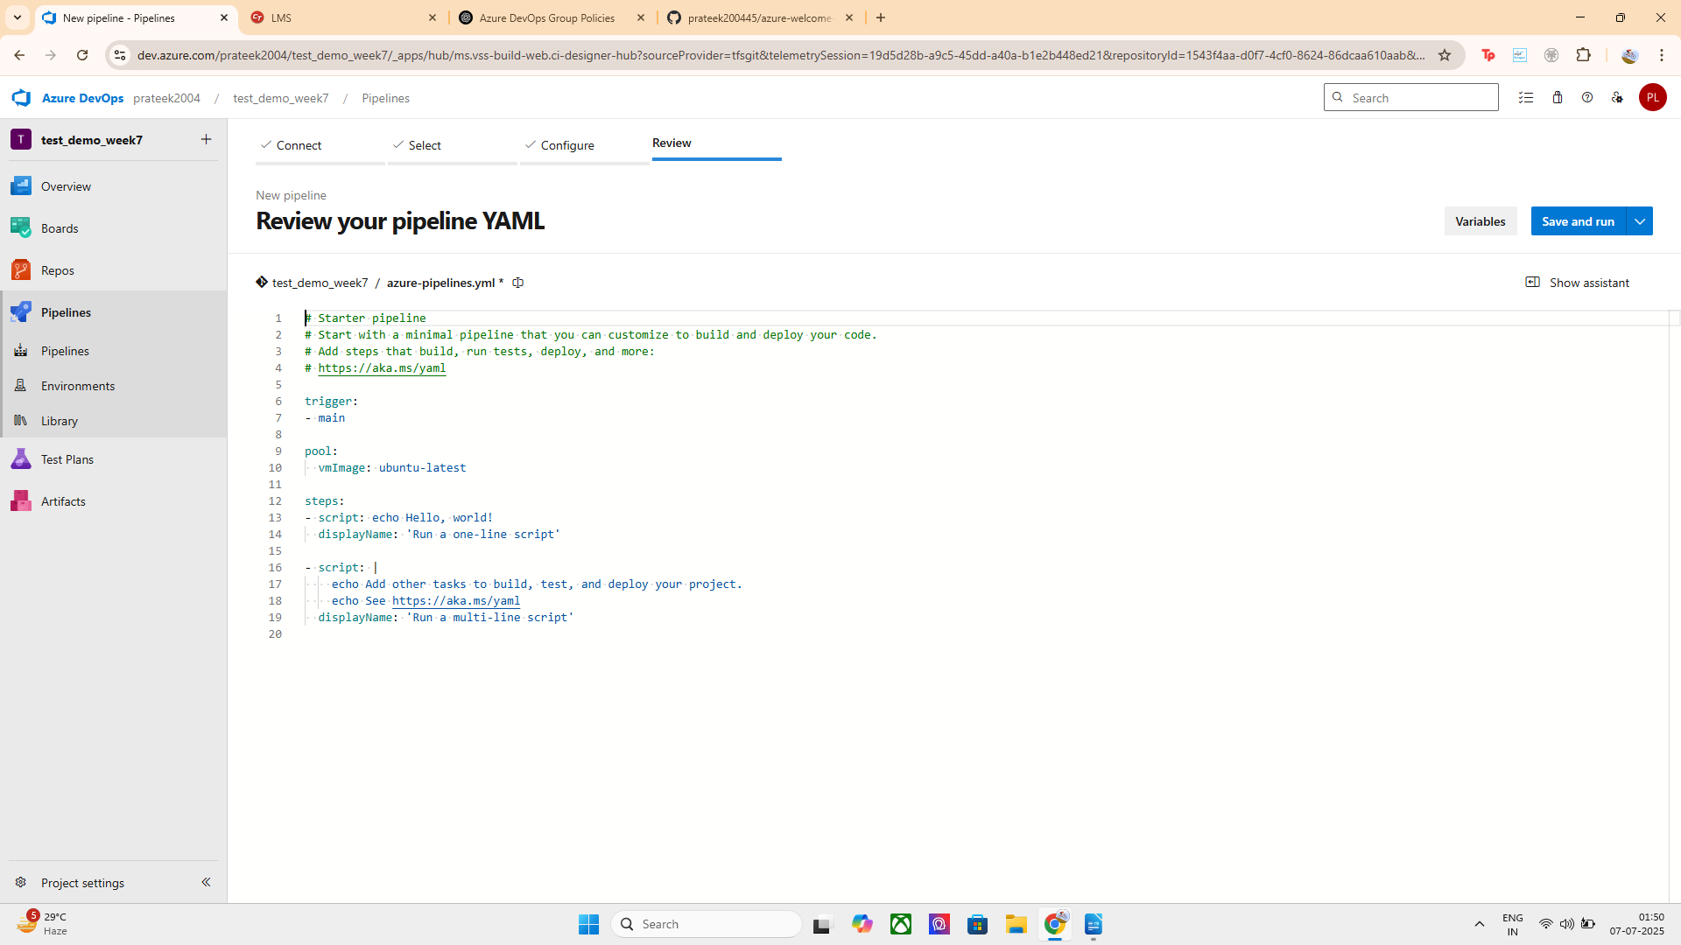
Step 2: Choose "YAML"
- When asked how you want to configure your pipeline, select "YAML" (not classic editor).
Step 3: Replace YAML With This (For Branch + Path Filters)

trigger:
branches:
include:
- main
- develop
paths:
include:
- src/*
- README.md
exclude:
- docs/*

pool:
vmImage: ubuntu-latest

steps:
- script: echo "Running pipeline only for allowed branches and paths"
displayName: 'Run Filtered CI'

This YAML does:
- Runs only when main or develop is pushed
- Runs only if files in src/ or README.md are changed
- Skips builds if only docs/ is changed
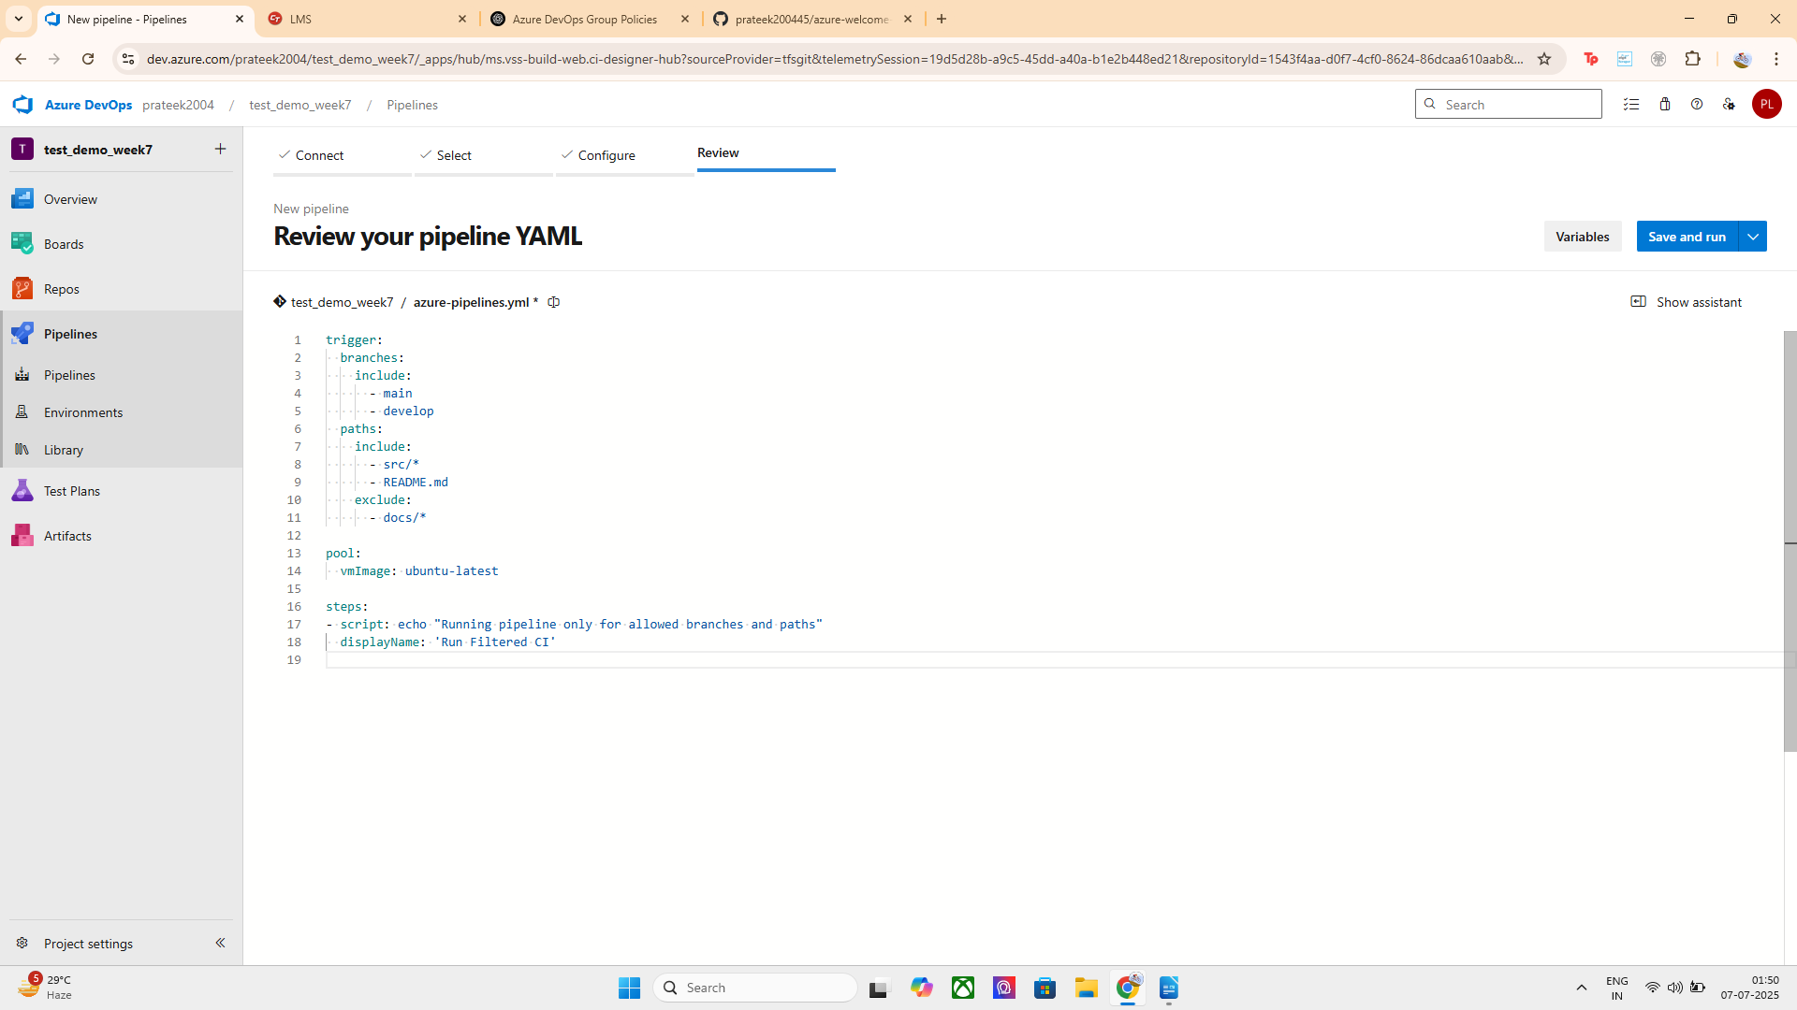

Step 4: Click "Save and Run"
- Save this pipeline
- Now it’s active and will only trigger as per your filters!
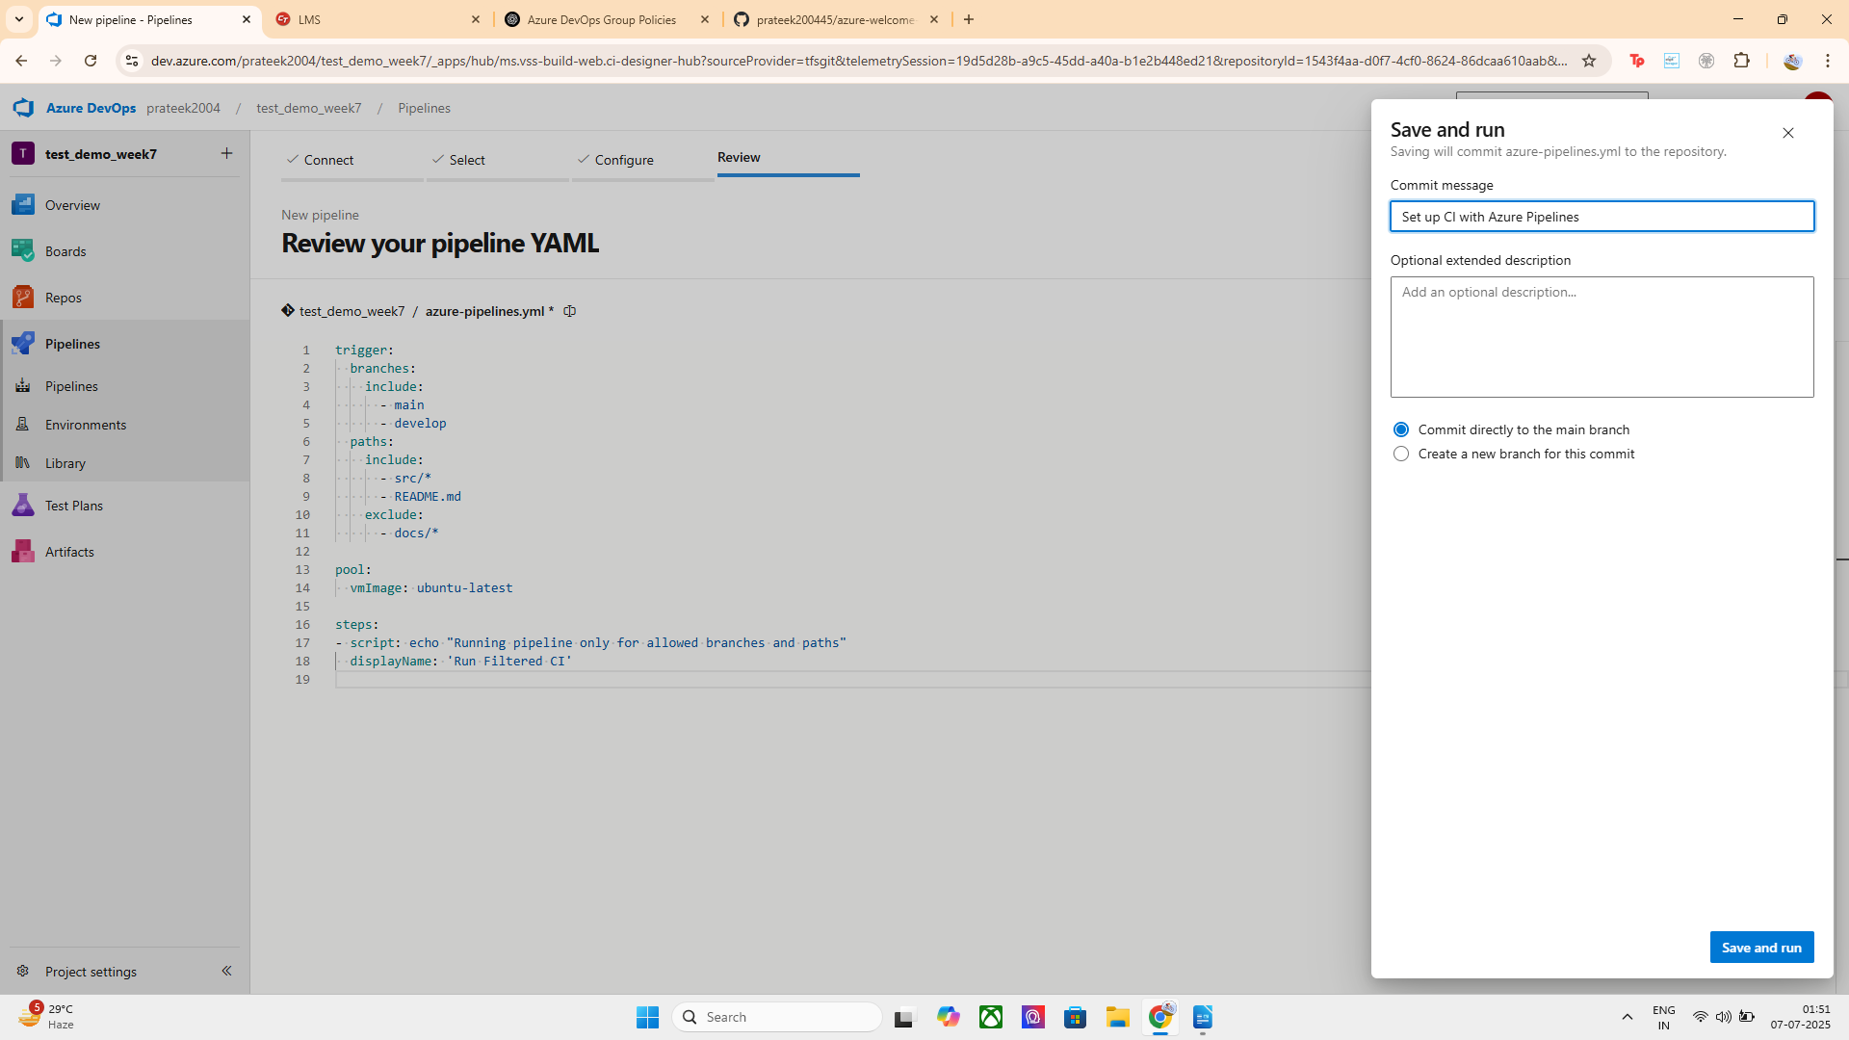
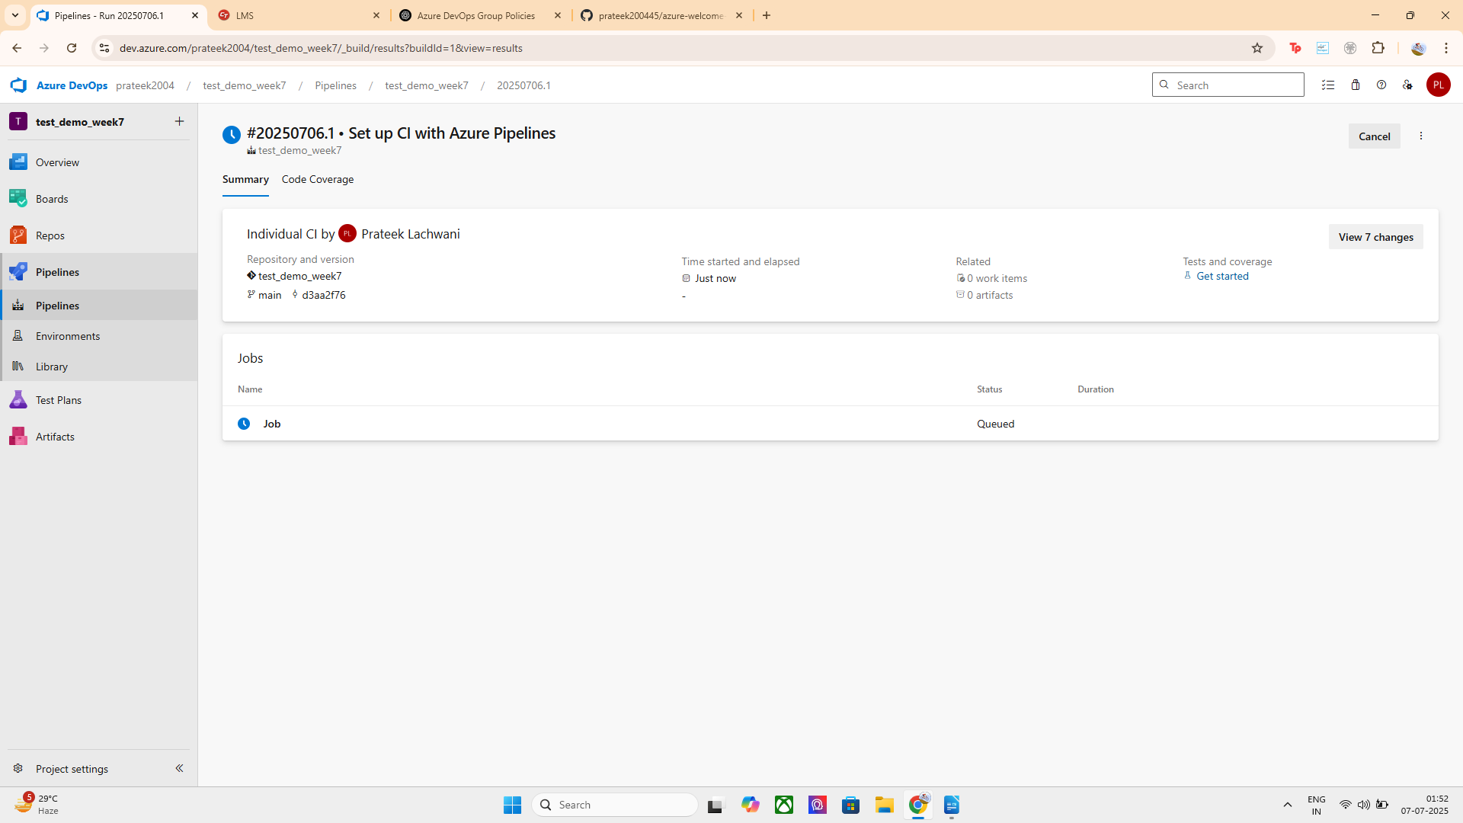

METHOD 2: APPLY IN BRANCH POLICIES

Steps:
- Go to Repos > Branches
- Click on ⋯ next to main branch → Branch Policies
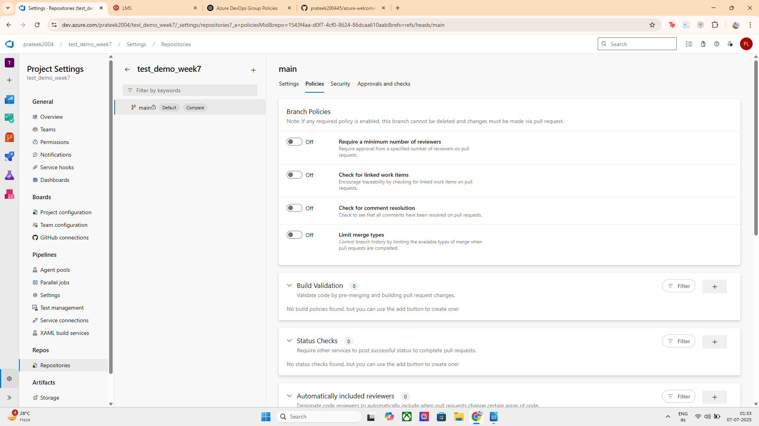
- Under Build Validation, click + Add build policy
- Select your pipeline
- Under Trigger, click:
  - ✅ Automatic
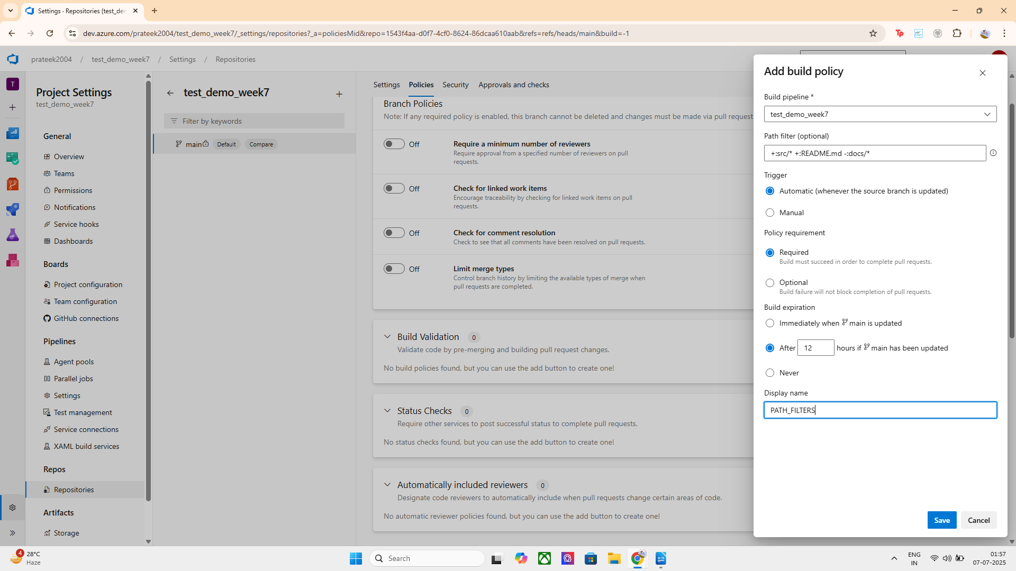
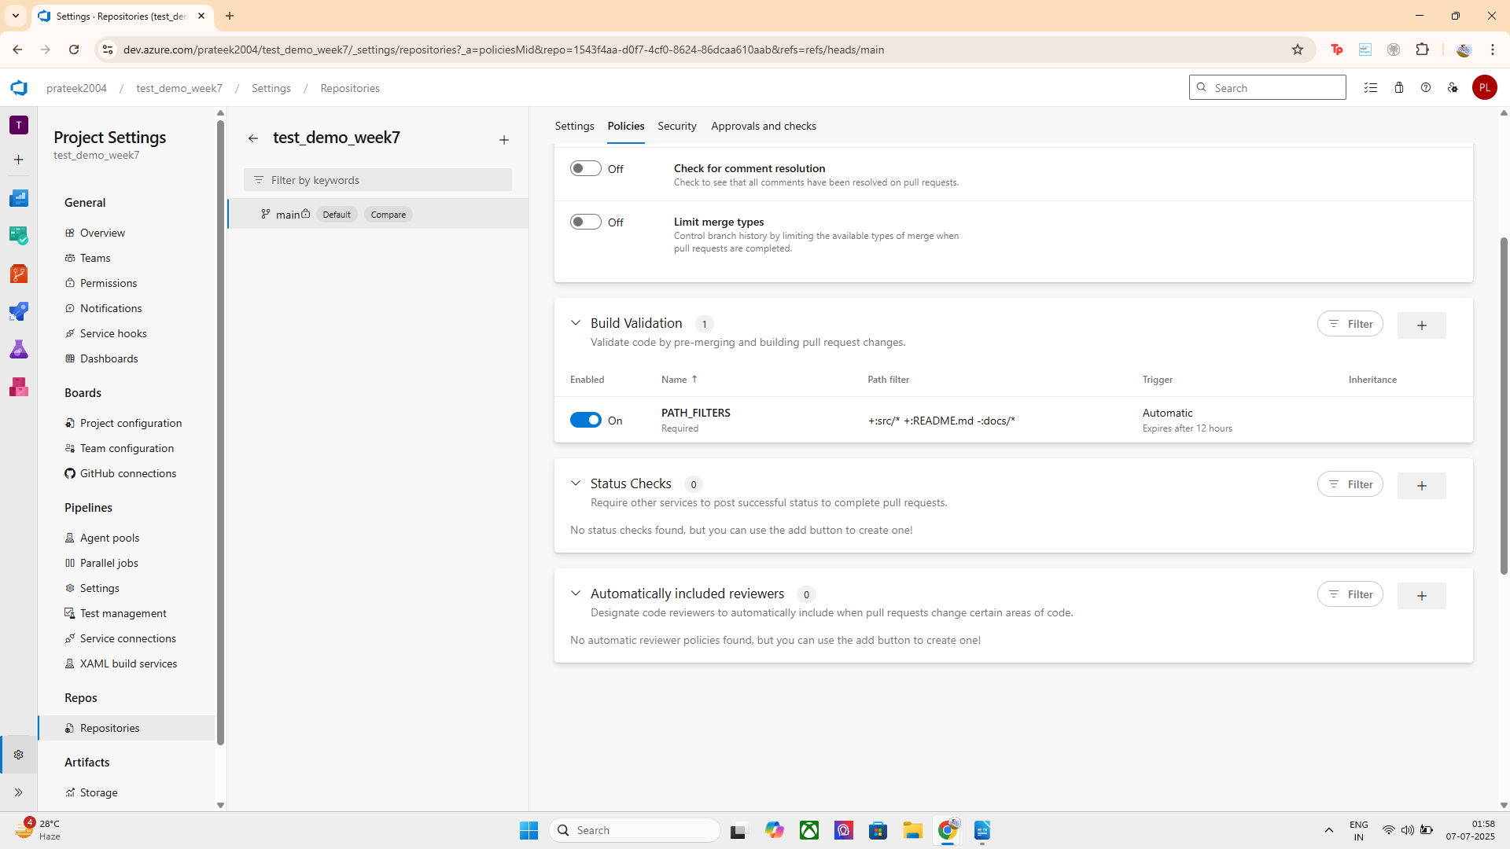
Both methods successfully apply branch and path filters.
- Method 1 offers code-based control (YAML), useful for versioning.
- Method 2 is GUI-driven, easier for team-wide management.
This setup ensures that only relevant changes trigger builds, optimizing CI/CD performance and enforcing branch protection.

Approach 1: YAML Pipeline Trigger
I configured a YAML pipeline with trigger settings to define branch and path filters directly in the code. The trigger runs automatically when changes are pushed to the main branch and only when specific files are modified:
- ✅ Included: src/*, README.md
- ❌ Excluded: docs/*
This ensures the pipeline only runs for meaningful code or documentation updates and ignores unrelated changes, reducing unnecessary builds.

Approach 2: Branch Policy → Build Validation
I also applied a Build Validation policy on the main branch via branch policies in Azure DevOps:
- The build is set to trigger automatically.
- It is marked as required for completing pull requests.
- Path filters configured:
  - ✅ Included: src/*, README.md
  - ❌ Excluded: docs/*
This policy enforces that only changes in important files trigger the build pipeline, ensuring critical paths are always validated before code is merged

