QUES : Apply a pull request

SOLN:

A pull request (PR) is a way to propose and collaborate on code changes before merging them into a branch (usually main or master). It allows code review, policy checks, and CI validation before integration.

Real-World Use Case
Imagine you're working on a large healthcare app where different team members work on different features. Instead of directly pushing code to the main branch (which could break the app), you create a pull request from your feature branch. Other teammates review it, automated tests run, and only then it gets merged — ensuring safe and stable deployment.

Steps to Implement a Pull Request in Azure DevOps

Create a Branch (if not already)
- Go to Repos > Branches.
- Click New branch, name it like feature-xyz, and set main as the source.
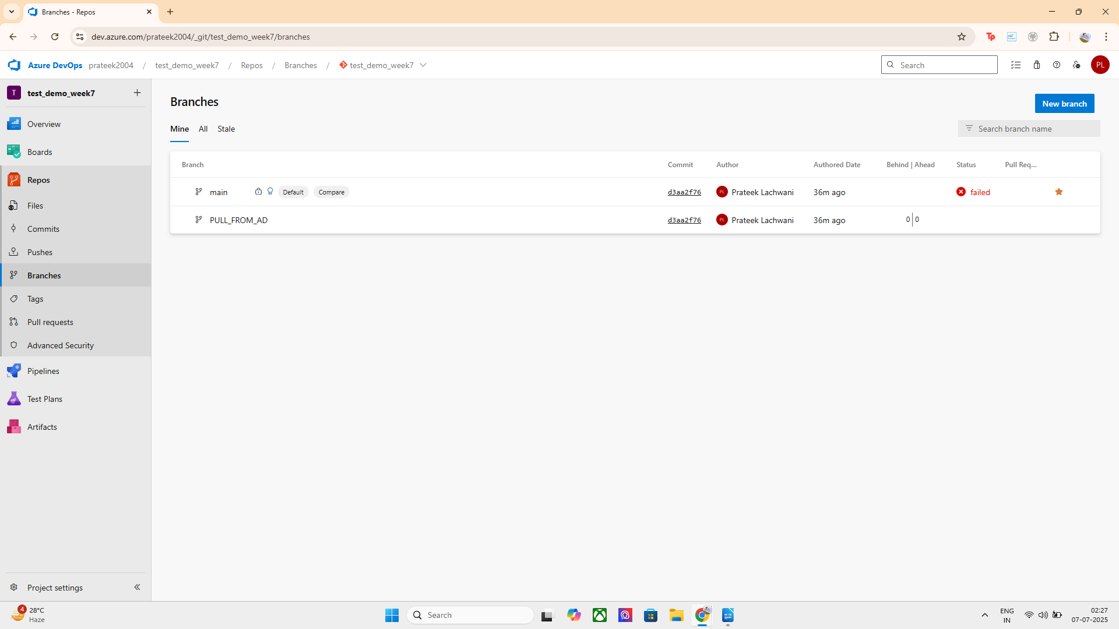

B. Make Code Changes
- Clone the repo locally.
- Checkout the feature branch:

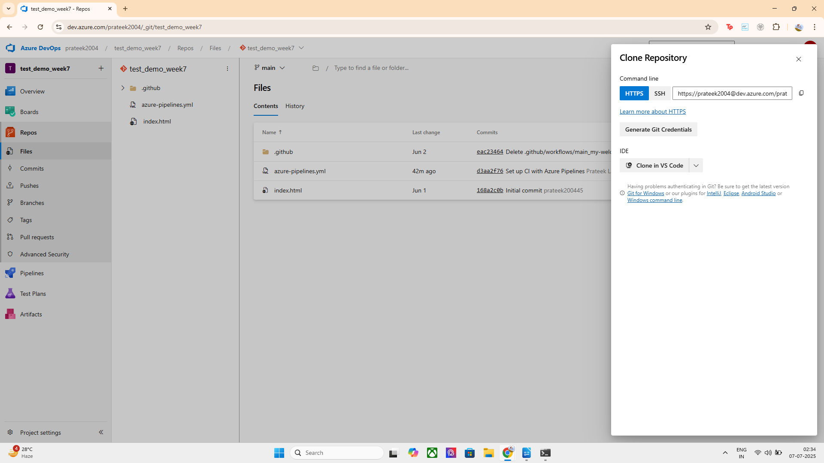
check the formation of the new branch
git checkout -b feature-xyz
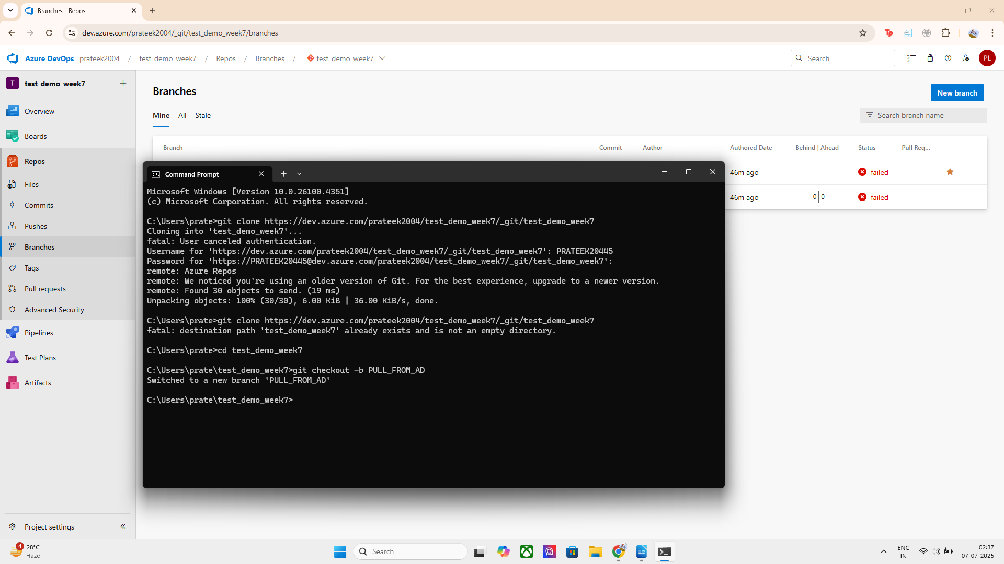

Make changes and commit them:

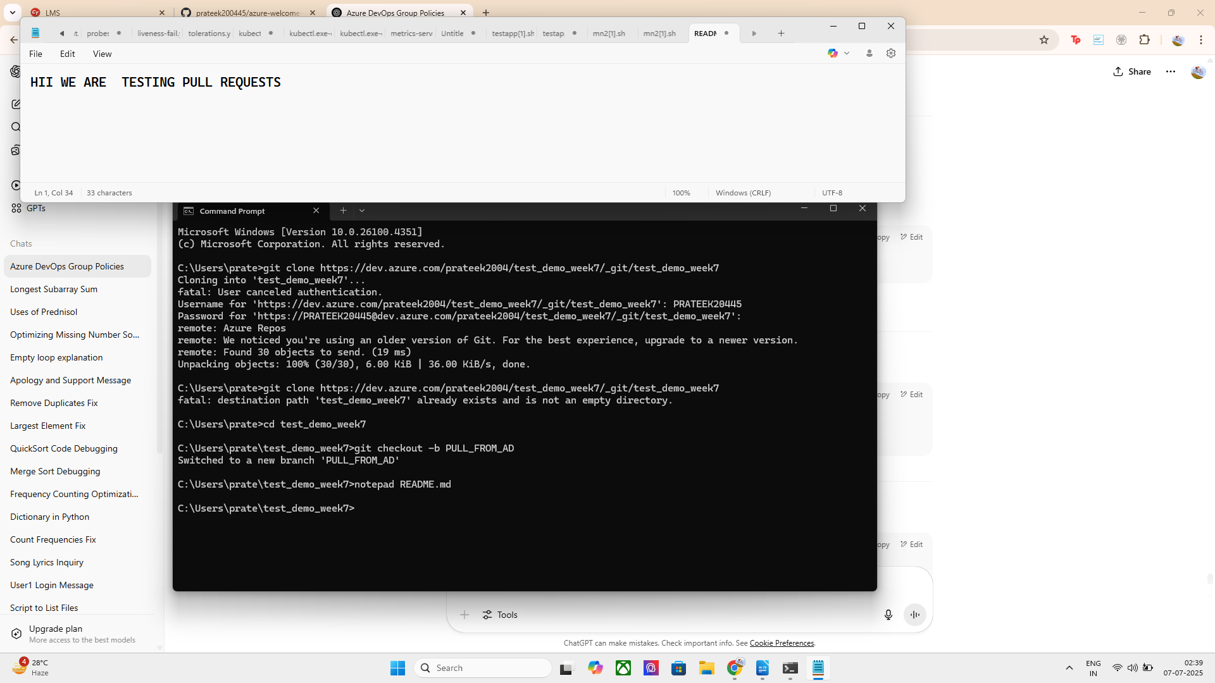
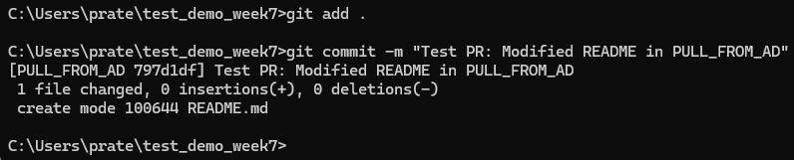

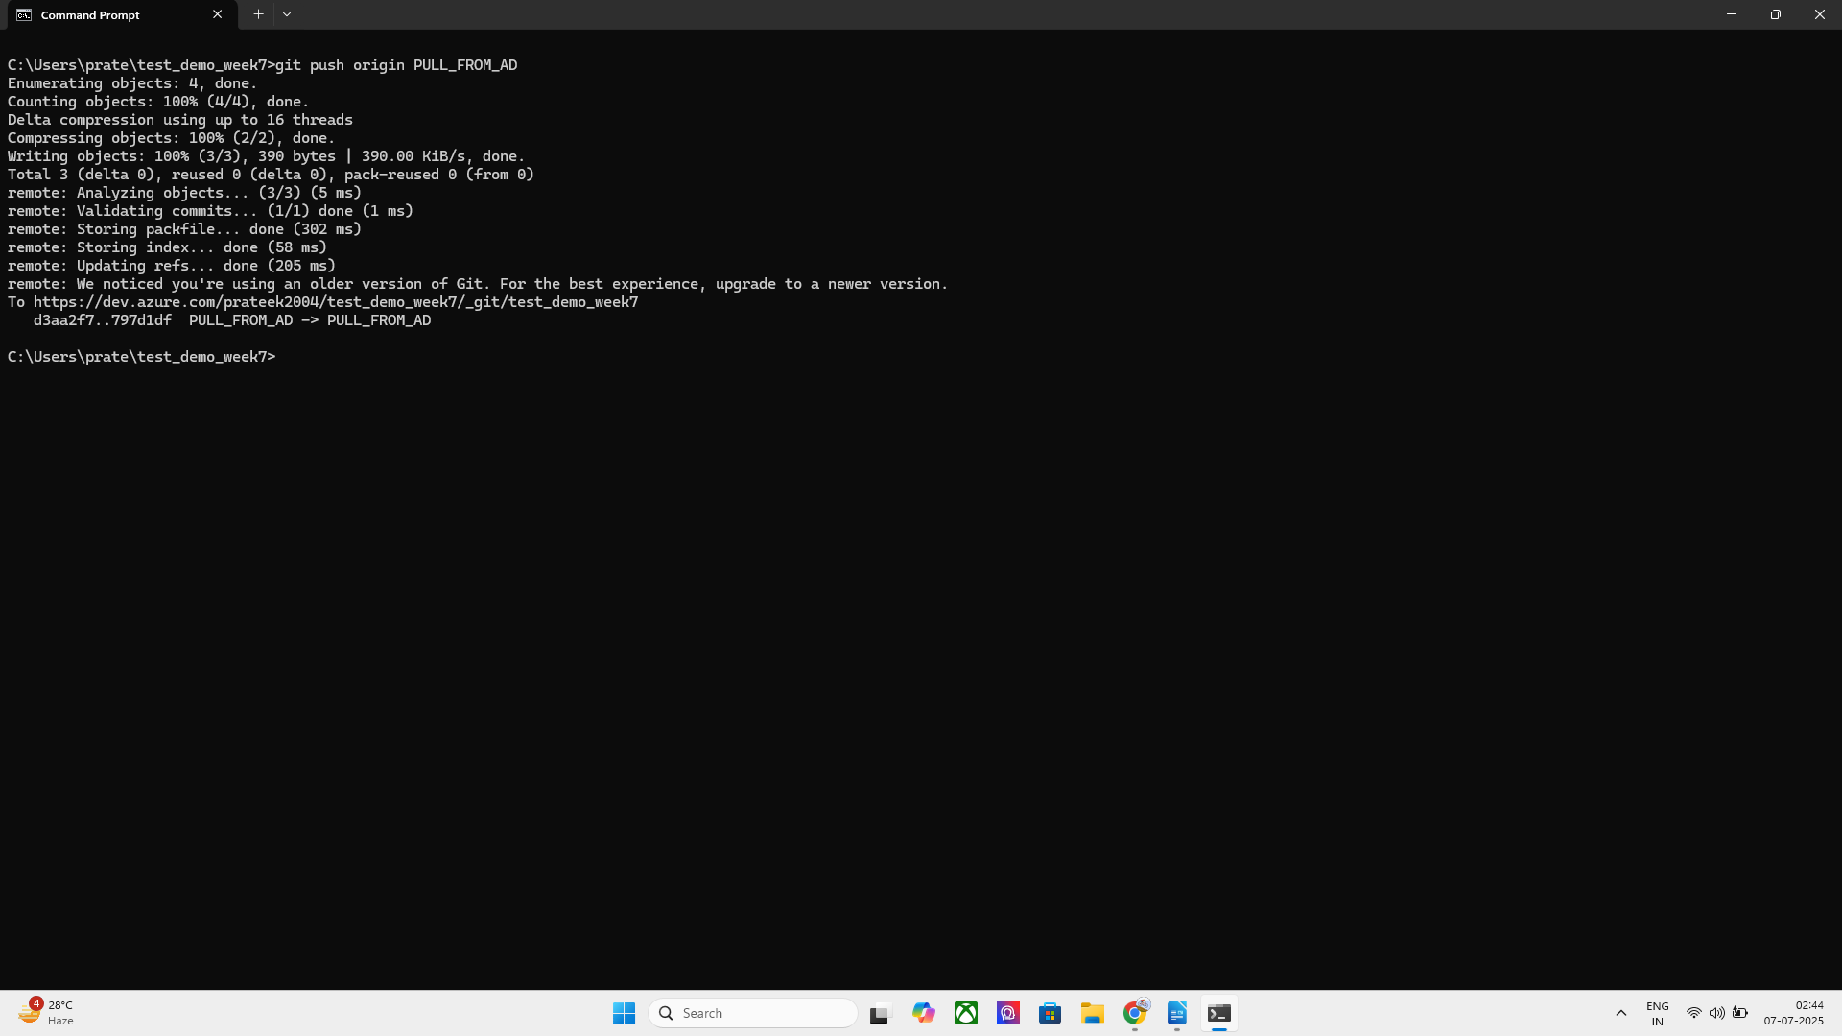
Push the Branch to Azure DevOps

Final Step: Create the Pull Request in Azure DevOps UI

Steps:
- Go to your Azure DevOps project.
- Navigate to Repos > Pull Requests (left sidebar).
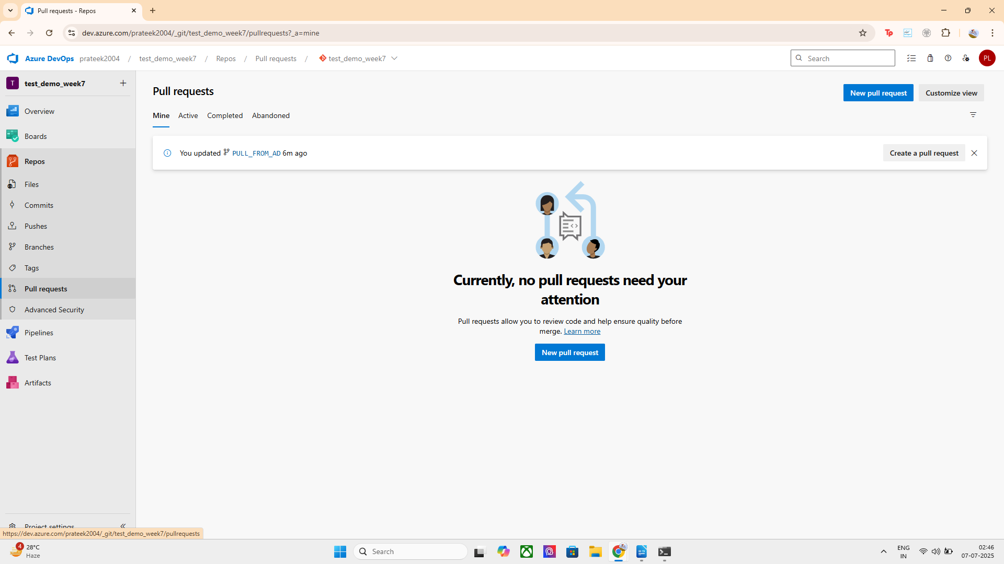
- Click "New Pull Request".
- Set:
  - Source branch: PULL_FROM_AD
  - Target branch: main
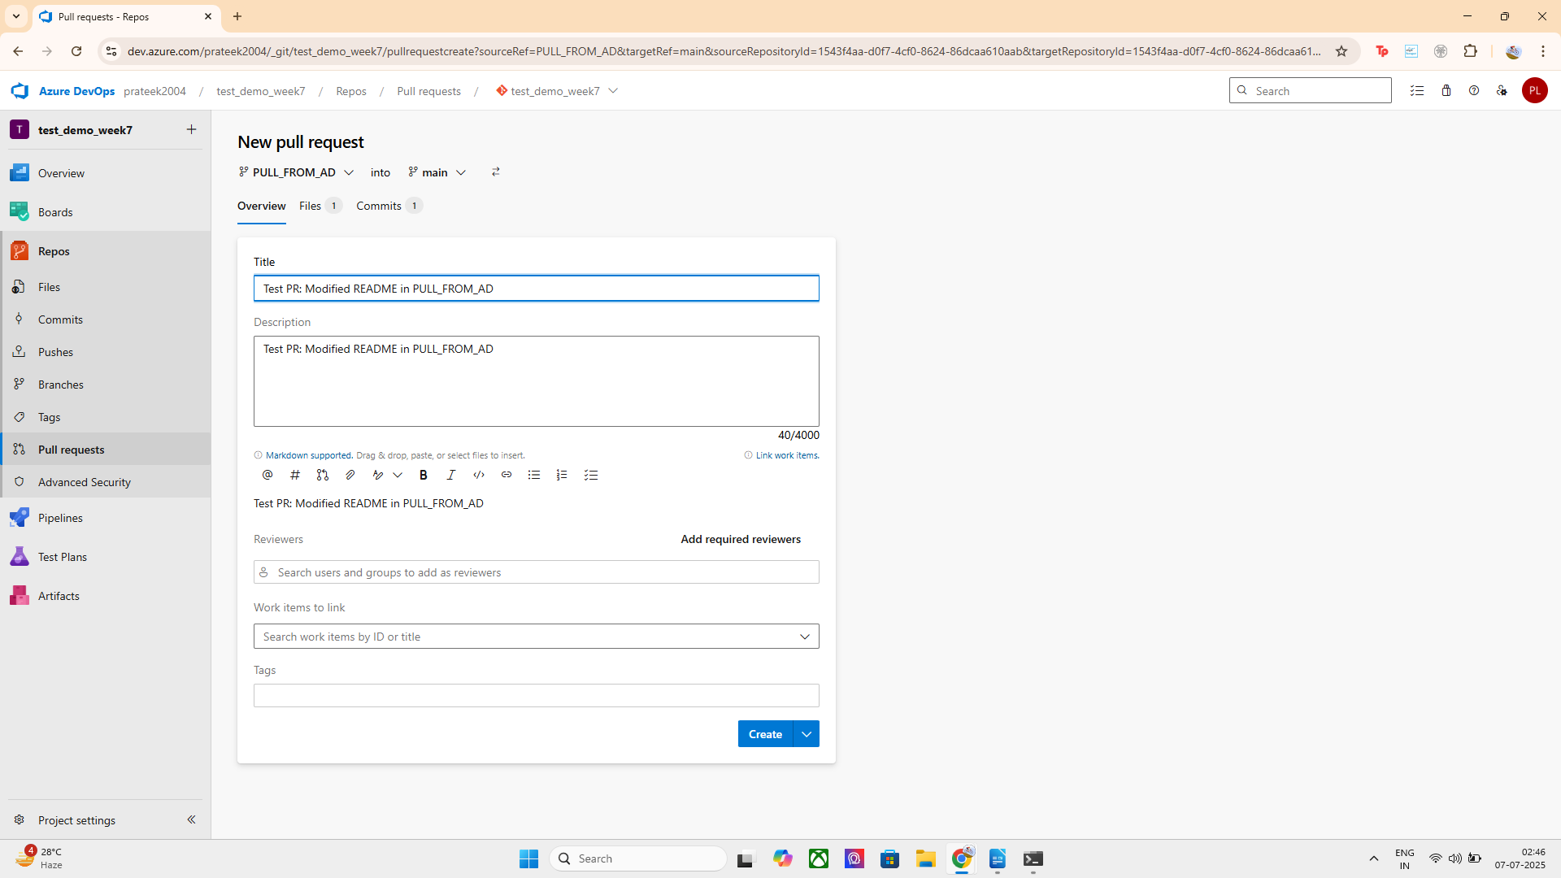
- Add a title and optional description.
- (Optional but recommended) Add reviewers or select work items to link.
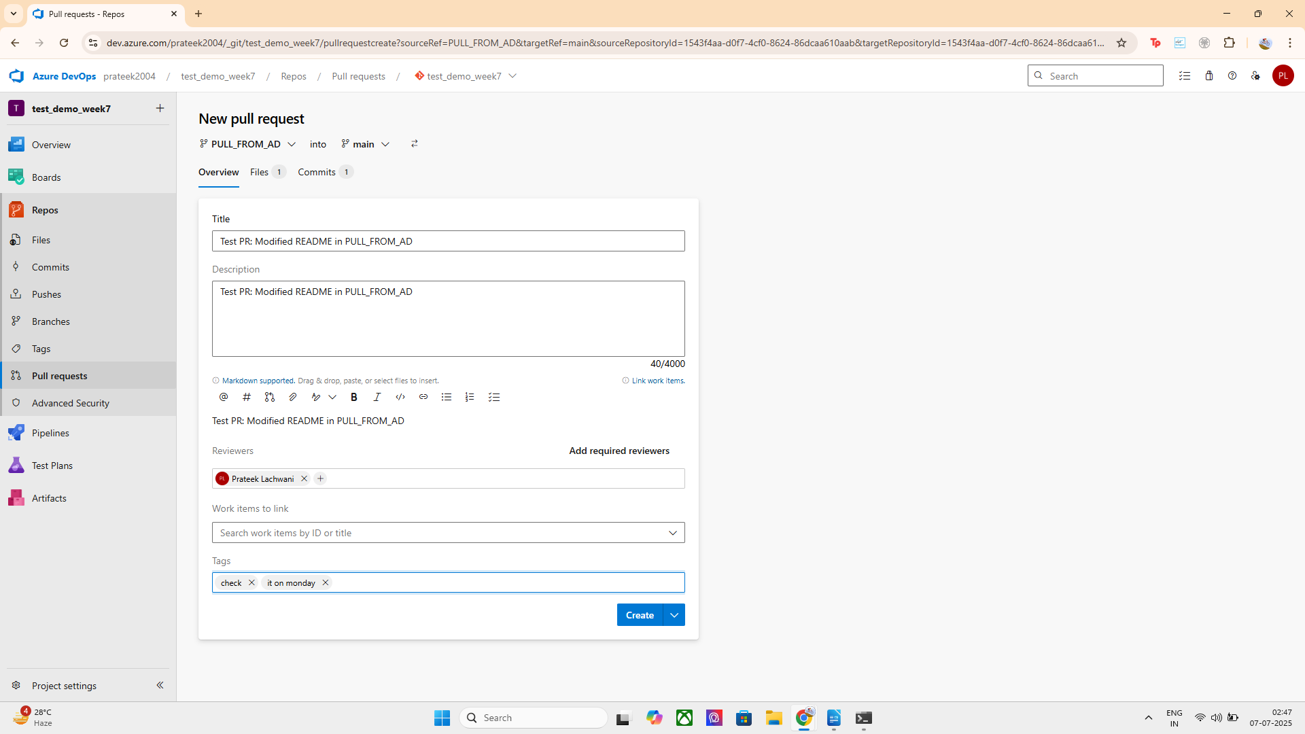
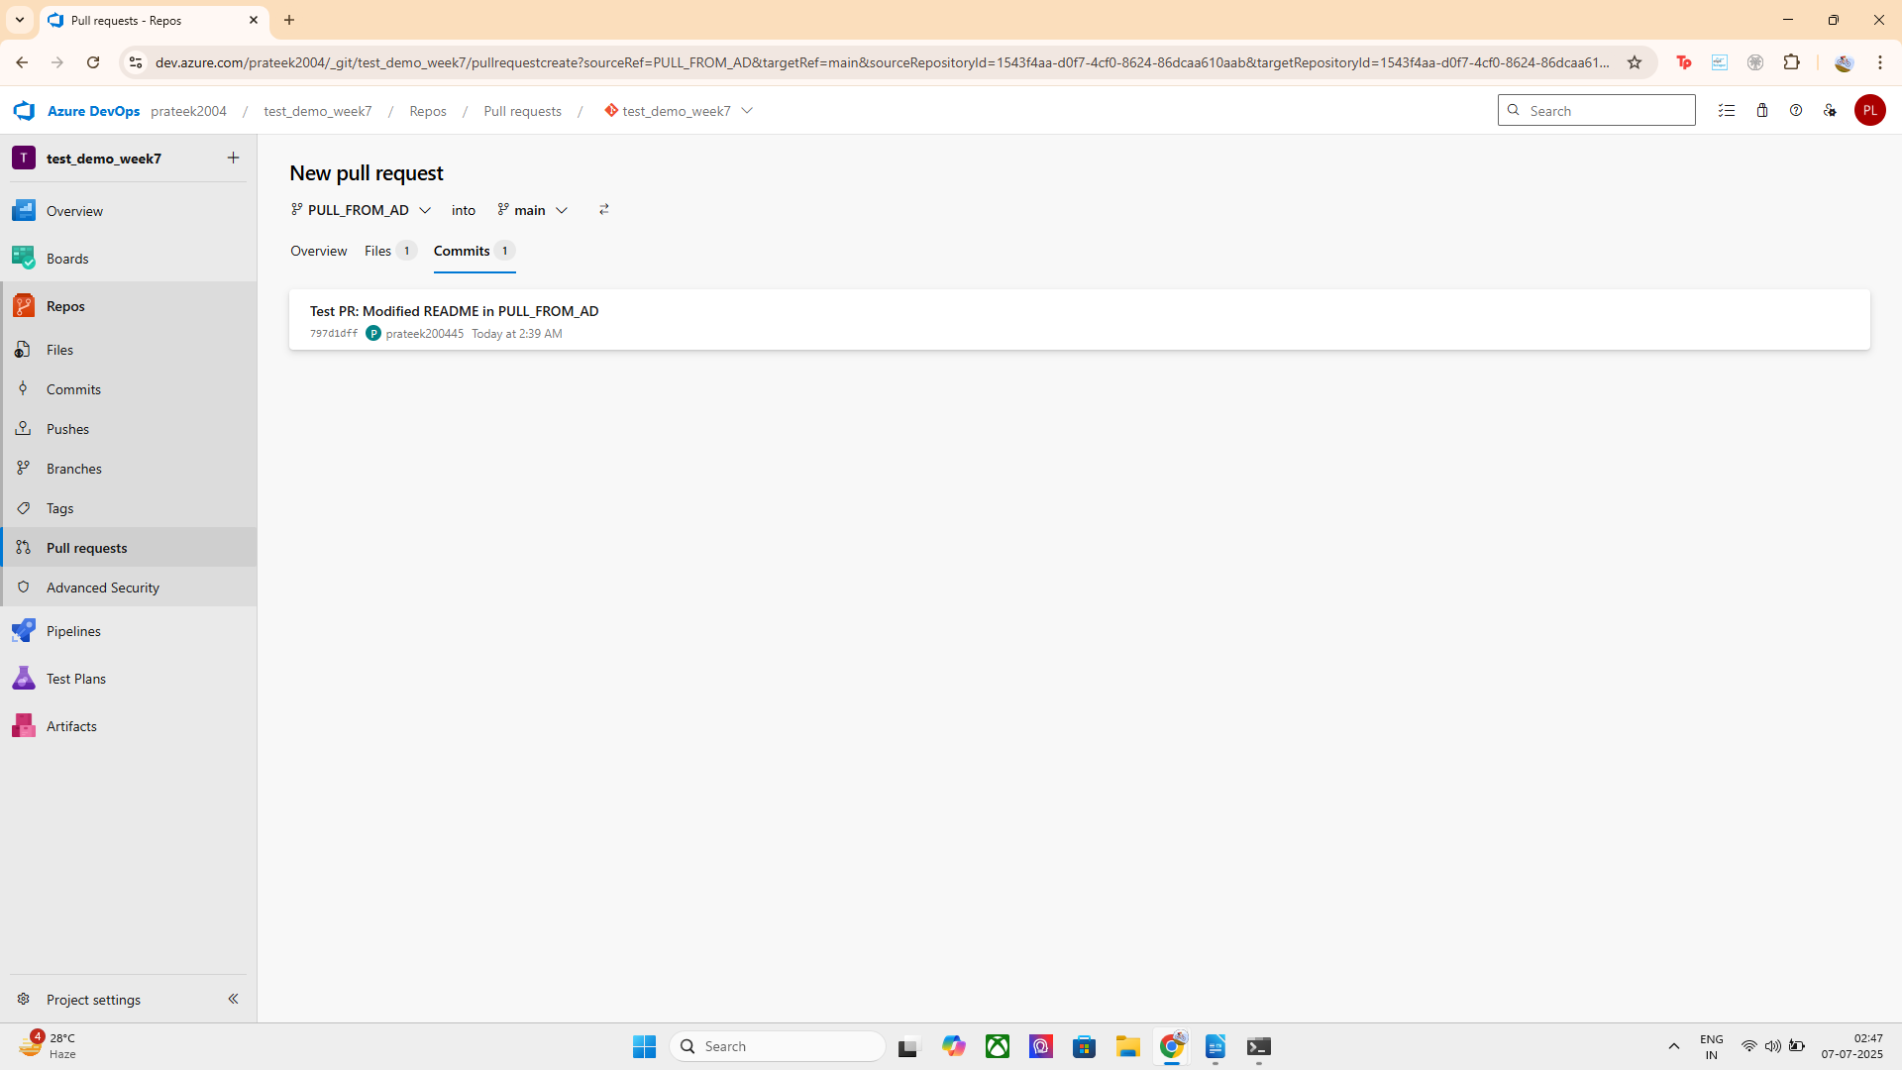
- Click "Create".

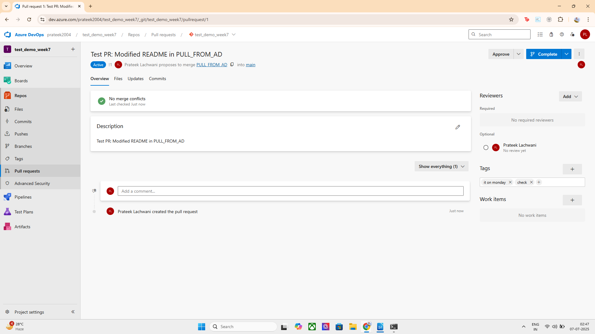

COMPLETING THE PULL REQUESTS AS I AM THE ADMINISTRATOR :

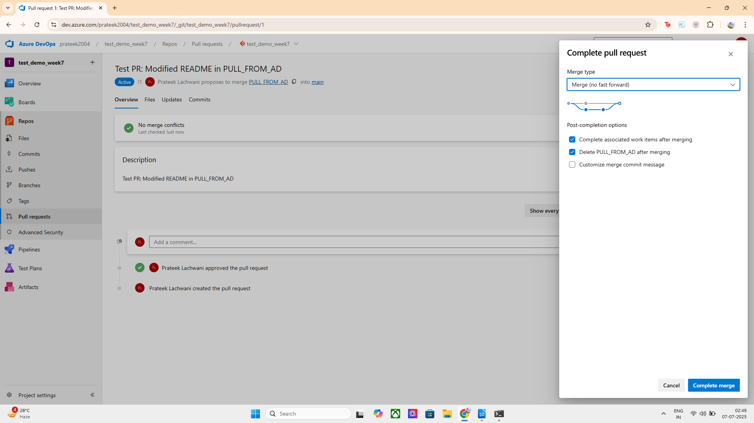
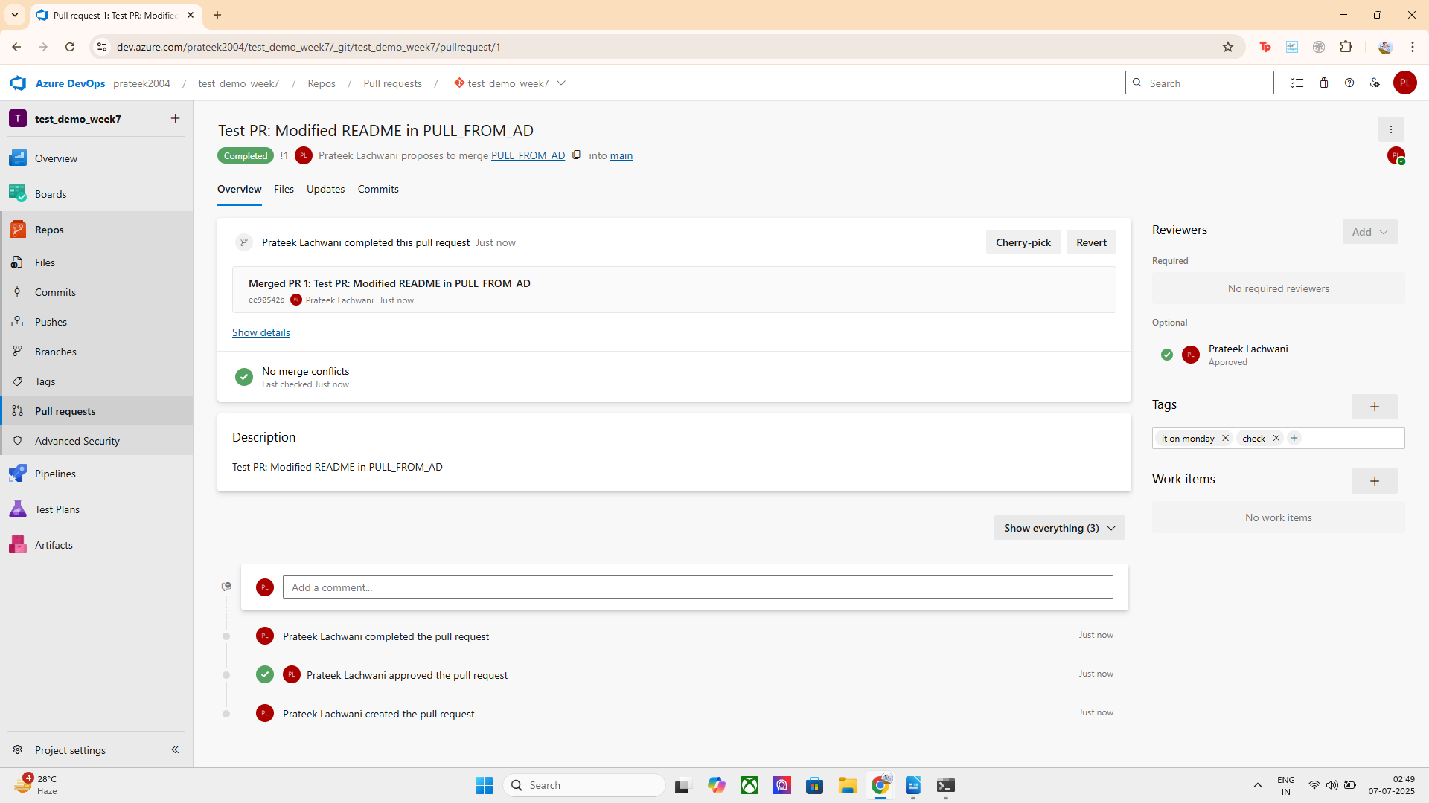

HENCE PULL REQUEST IS SUCCESSFULLY CONFIGURED AND VERIFIED AND MERGED TO THE MAIN BRANCH :
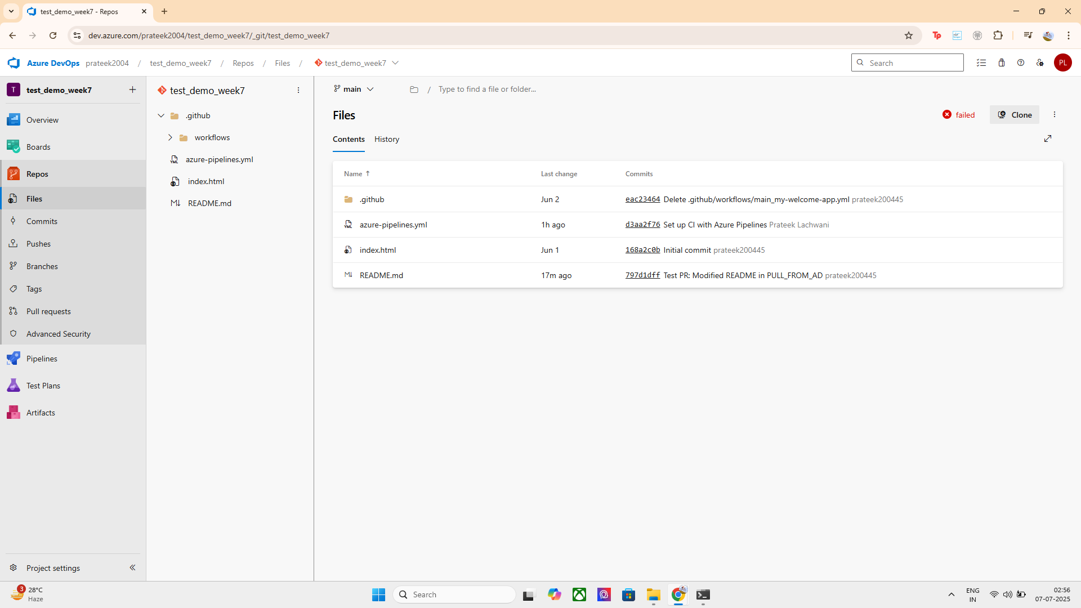
A pull request (PR) is a way to submit code changes from one branch to another, typically from a feature branch to the main branch. It enables collaboration, code review, and automated checks before merging.
Real-World Use Case:
In team environments, developers work on feature branches and raise pull requests to ensure changes are reviewed, tested, and approved before merging into the main codebase. This prevents bugs and ensures production stability.
Implementation Steps:
- Created a new branch locally named PULL_FROM_AD.
- Made changes to a file (README.md) and committed them.
- Pushed the branch to the Azure DevOps remote repository.
- Created a pull request in Azure DevOps by selecting PULL_FROM_AD as the source and main as the target.
- The pull request is now ready for review, approval, and merge.
I also reviewed and approved the pull request through Azure DevOps. As a project administrator, I verified the changes and marked them approved, allowing the code to be merged into the main branch securely.

