QUES 7 : Apply triggers in build and release

SOLN:

Triggers in Azure DevOps automatically start builds or releases based on events like code pushes, pull requests, or completed builds. They automate your CI/CD pipeline without manual intervention.

Real-World Use Case :
Imagine you're building a health app. Every time a developer pushes code to the main branch, you want a build pipeline to run tests. Once the build succeeds, a release pipeline should deploy the app automatically to a staging server. Triggers help automate this full workflow so no one has to do it manually — ensuring speed and consistency.

Steps to Apply Triggers in Build and Release :

A. Apply Triggers in Build Pipeline (CI Trigger) :

THERE ARE 2 METHODS TO APPLY TRIGGERS IN ANY BUILD PIPELINE:

Option 1: Via YAML file

trigger:
branches:
include:
- main

This triggers the build automatically on any push to the main branch.

Steps to Implement (Brief)

Step 1: Go to Your YAML Pipeline
- Go to Pipelines > Pipelines
- Click on your YAML-based pipeline (e.g., test_demo_week7)
- Click Edit

Step 2: Add the Trigger Section at the Top
At the top of the YAML file, add:

trigger:
branches:
include:
- main
This tells Azure DevOps to automatically run the pipeline on any push to the main branch.

Step 3: Save and Run
- Click Save
- Optionally click Run to test
- Now try pushing any change to the main branch — the pipeline will trigger automatically!

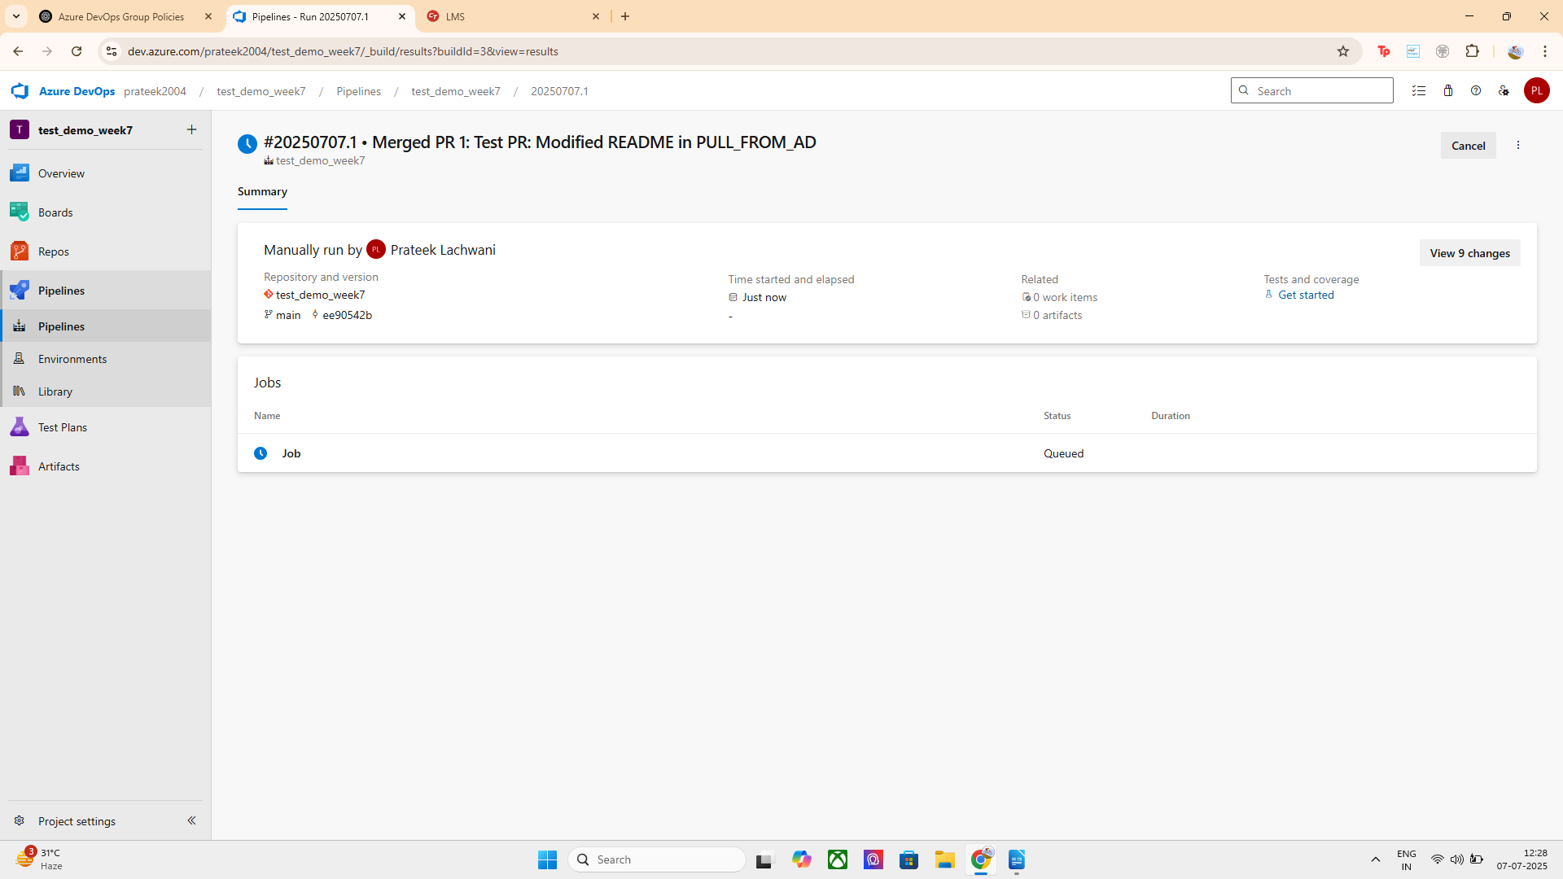

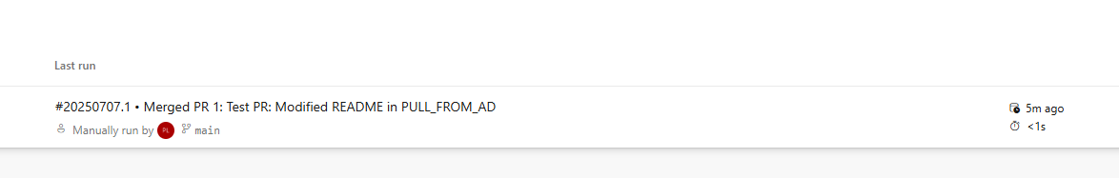

Option 2: Via Classic UI
- Go to Pipelines > Pipelines.
- Click on your build pipeline (test_demo_week7).
- Click Edit.
- In the top tabs, go to Triggers.
- Enable:
  - Continuous Integration (CI): for automatic builds on code push.
  - Optionally, enable Pull Request validation trigger.

Steps to Apply CI Trigger via Classic UI ( BREIF)

Step 1: Open Classic Pipeline
- Go to Azure DevOps → Pipelines > Pipelines
- Click on your classic pipeline OR CREATE NEW

Step 2: Click Edit
- Click the three dots (...) next to your pipeline → Edit

Step 3: Go to Triggers Tab
- At the top, click on the Triggers tab.

Step 4: Enable CI Trigger
- Check the box for "Enable continuous integration"
- Select branches like:
  - main
  - develop

Step 5 (Optional): Enable PR Trigger
- Scroll below and check "Enable pull request validation"
- Select branches you want to validate.

Step 6: Save & Queue
- Click Save
- You can also click "Run" to test the pipeline

Implementation:
1. YAML-based Pipeline Trigger:
- I created a build pipeline using YAML.
- Applied a trigger block that runs builds on changes to main and develop branches.
- Added paths filters to include only meaningful files (src/*, README.md) and exclude unnecessary ones (docs/*).
2. Classic UI-based Build Pipeline Trigger:
- I also created a pipeline using the Classic Editor in Azure DevOps.
- Added a Command Line Script task to print a message.
- Under the Triggers tab, enabled "Continuous Integration" for the main branch.
- This ensures that builds are automatically triggered via the UI without needing a YAML file.
Both pipelines validate that build triggers work via both code-based (YAML) and interface-based (Classic UI) methods.

B. Apply Triggers in Release Pipeline (CD Trigger) :

Go to Pipelines > Releases.
- Click New Release Pipeline or edit existing.
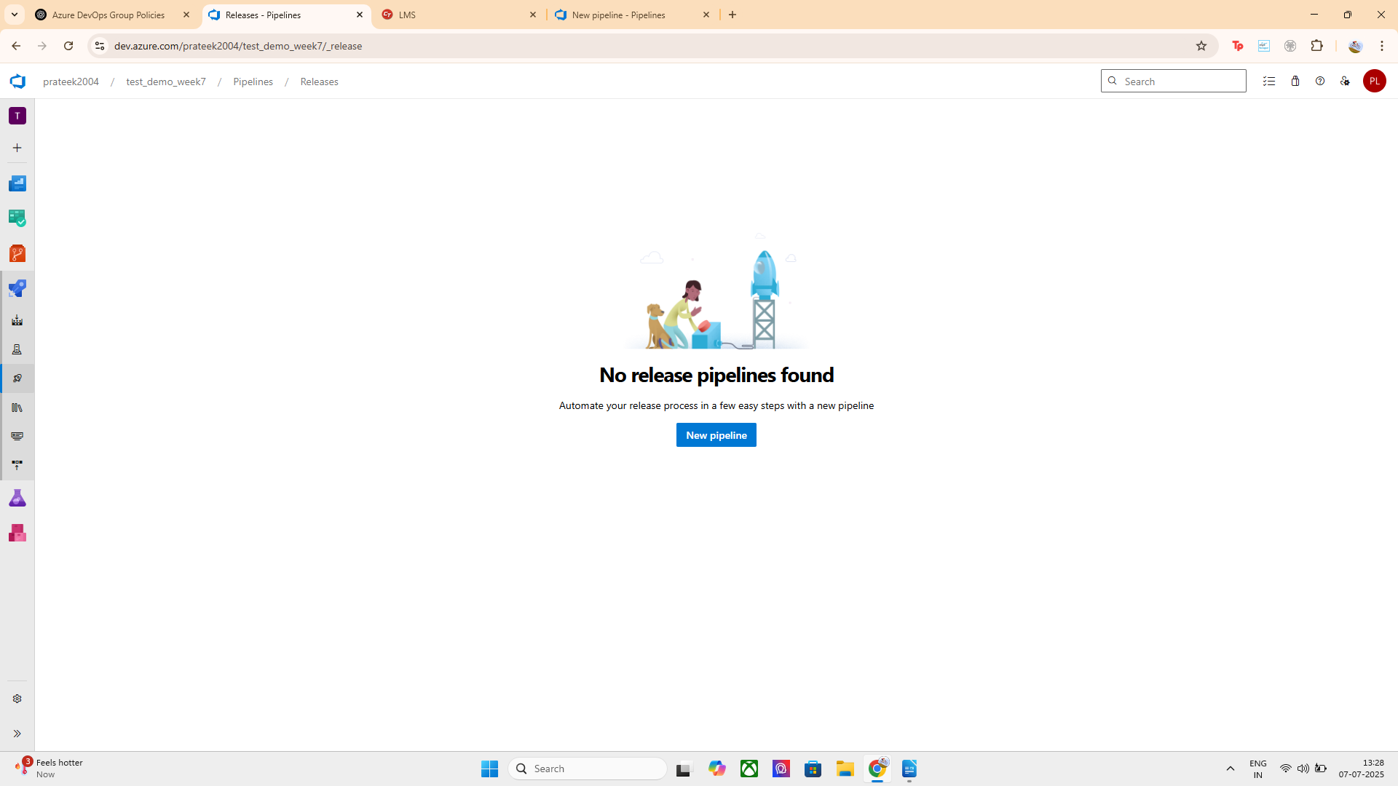
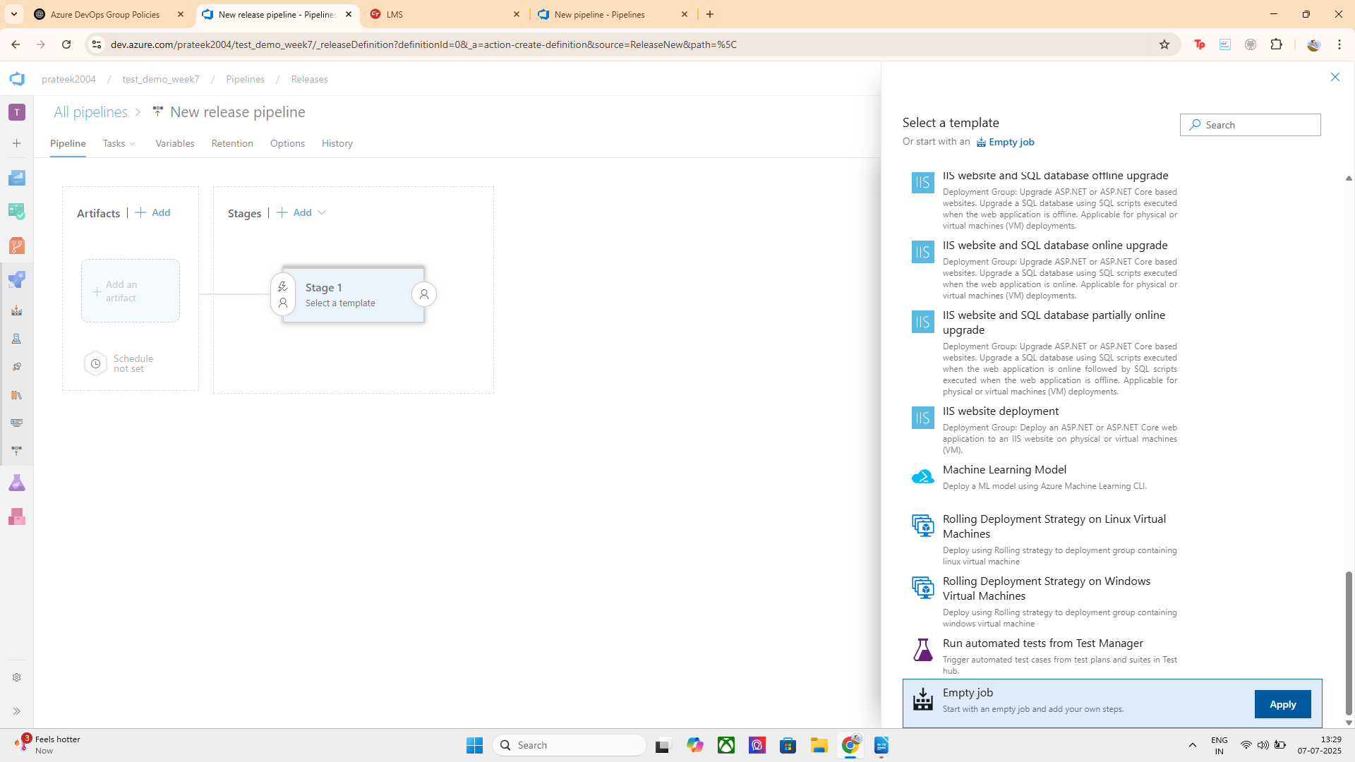
LETS CREATE ONE EMPTY JOB:

SETTING UP THE RELEASE CONFIGURATION AND BUILD TO COMMIT
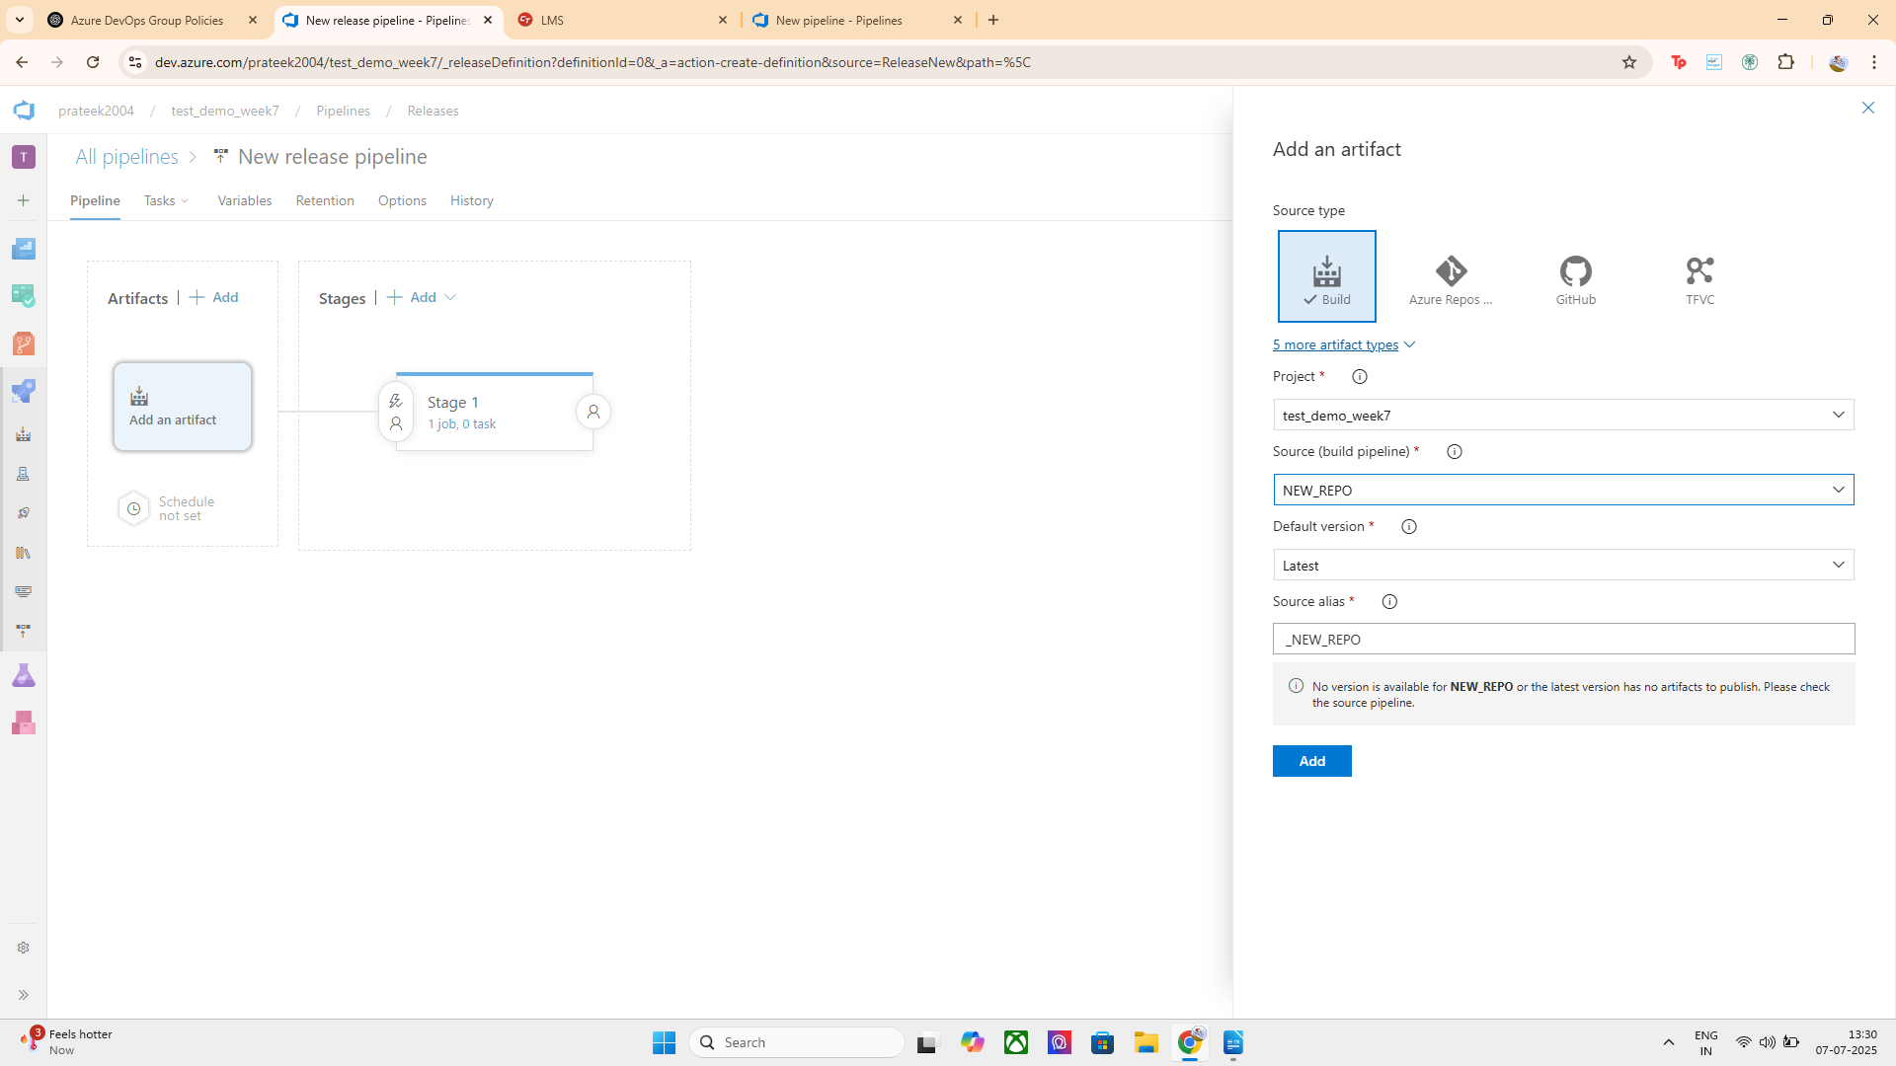
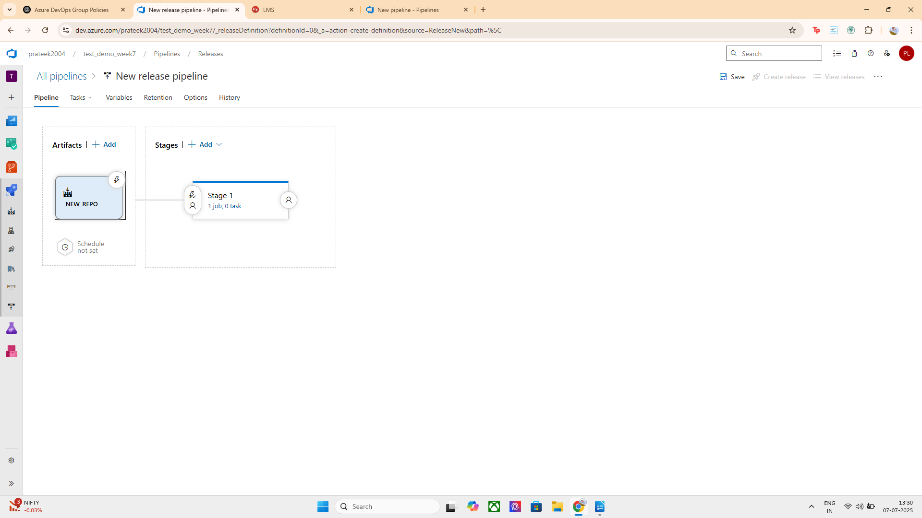

Under Artifacts, click the lightning bolt ⚡ icon.

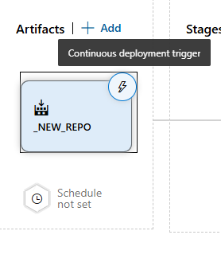
- Enable:
  - "Continuous Deployment Trigger" → Trigger release after successful build.
- Save the pipeline.
Now, whenever a build finishes successfully, a release will start automatically.

ALSO CREATED SOME ADDITIONAL BRANCH FILTERS FOR THE RELEASE PIPELINES:
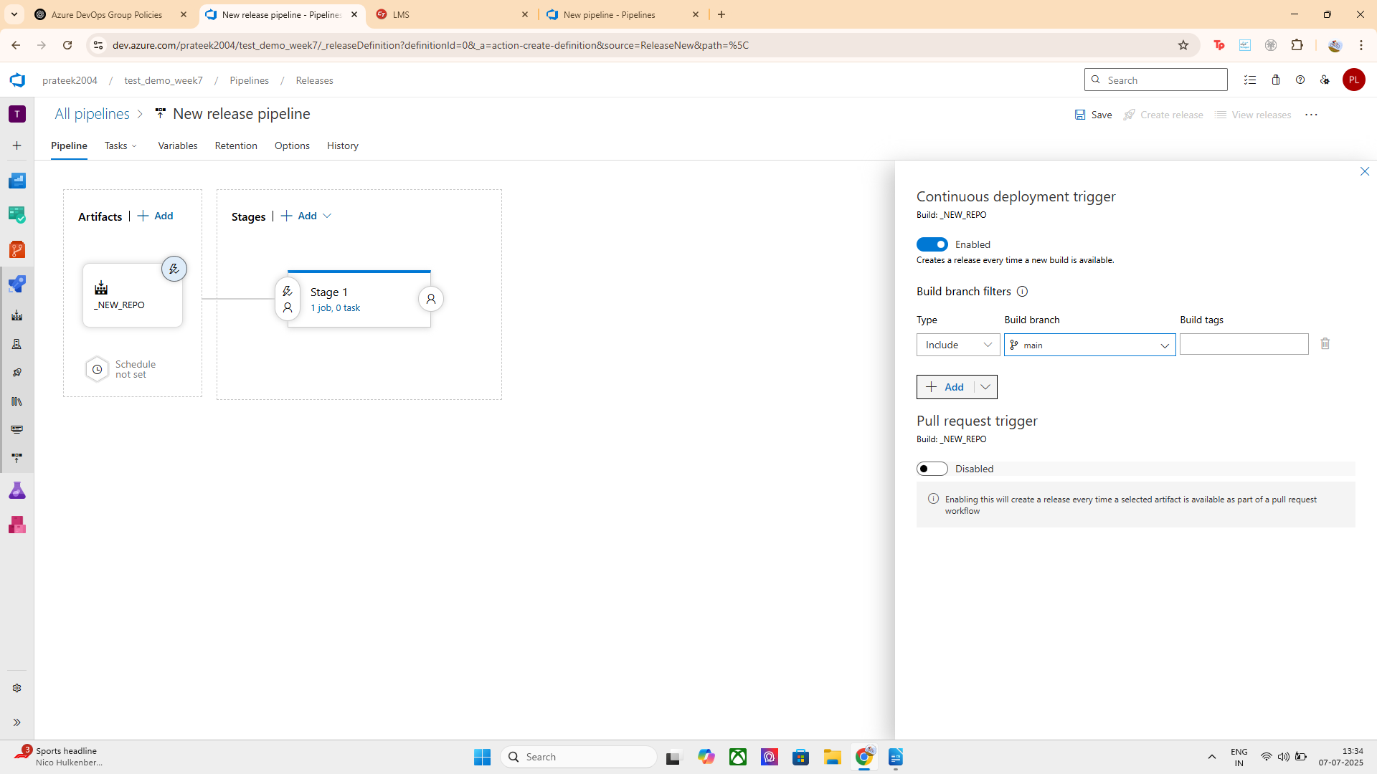

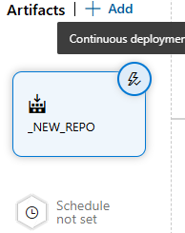

HENCE TRIGGER IN RELEASED PIPELINE IS CONFIGURED SUCCESSFULLY

I configured a release pipeline using _NEW_REPO as the build artifact.
- Enabled the ⚡ Continuous Deployment Trigger, so a release is triggered after every successful build.
- Pull request trigger was left disabled as it is not required.

