QUES 8 : Apply gates to the pipeline.

Soln:

Gates in Azure DevOps are pre-deployment conditions in release pipelines that evaluate external factors (like approval, monitoring status, or service health) before allowing the release to proceed.
They act as "checkpoints" to improve control and quality in CI/CD workflows.

Real-World Use Case
Imagine you're deploying to a production environment. You want to ensure:
- The target service (e.g., Azure App Service) is healthy
- A security scan (like SonarQube or WhiteSource) has passed
- Manual approval is received from a manager
By applying gates, the release will wait and verify those conditions before deploying, reducing risk and enforcing compliance.

STEPS TO CREATE A NEW RELEASE PIPELINE & APPLY GATES:

Step 1: Go to Pipelines > Releases
- In Azure DevOps, go to the left sidebar
- Click Pipelines → Releases
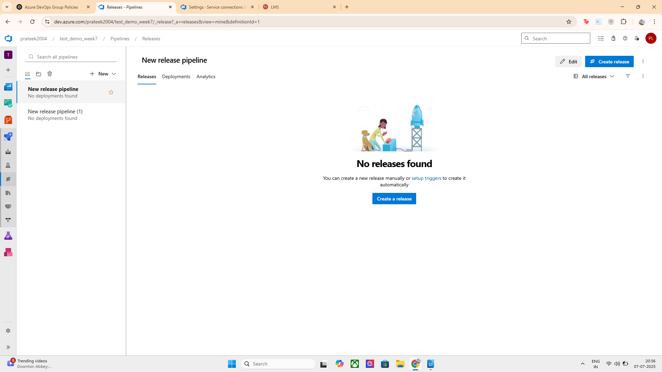

Step 2: Click "New Pipeline"
- Click the “+ New pipeline” button
- In the popup, click "Start with an Empty job"

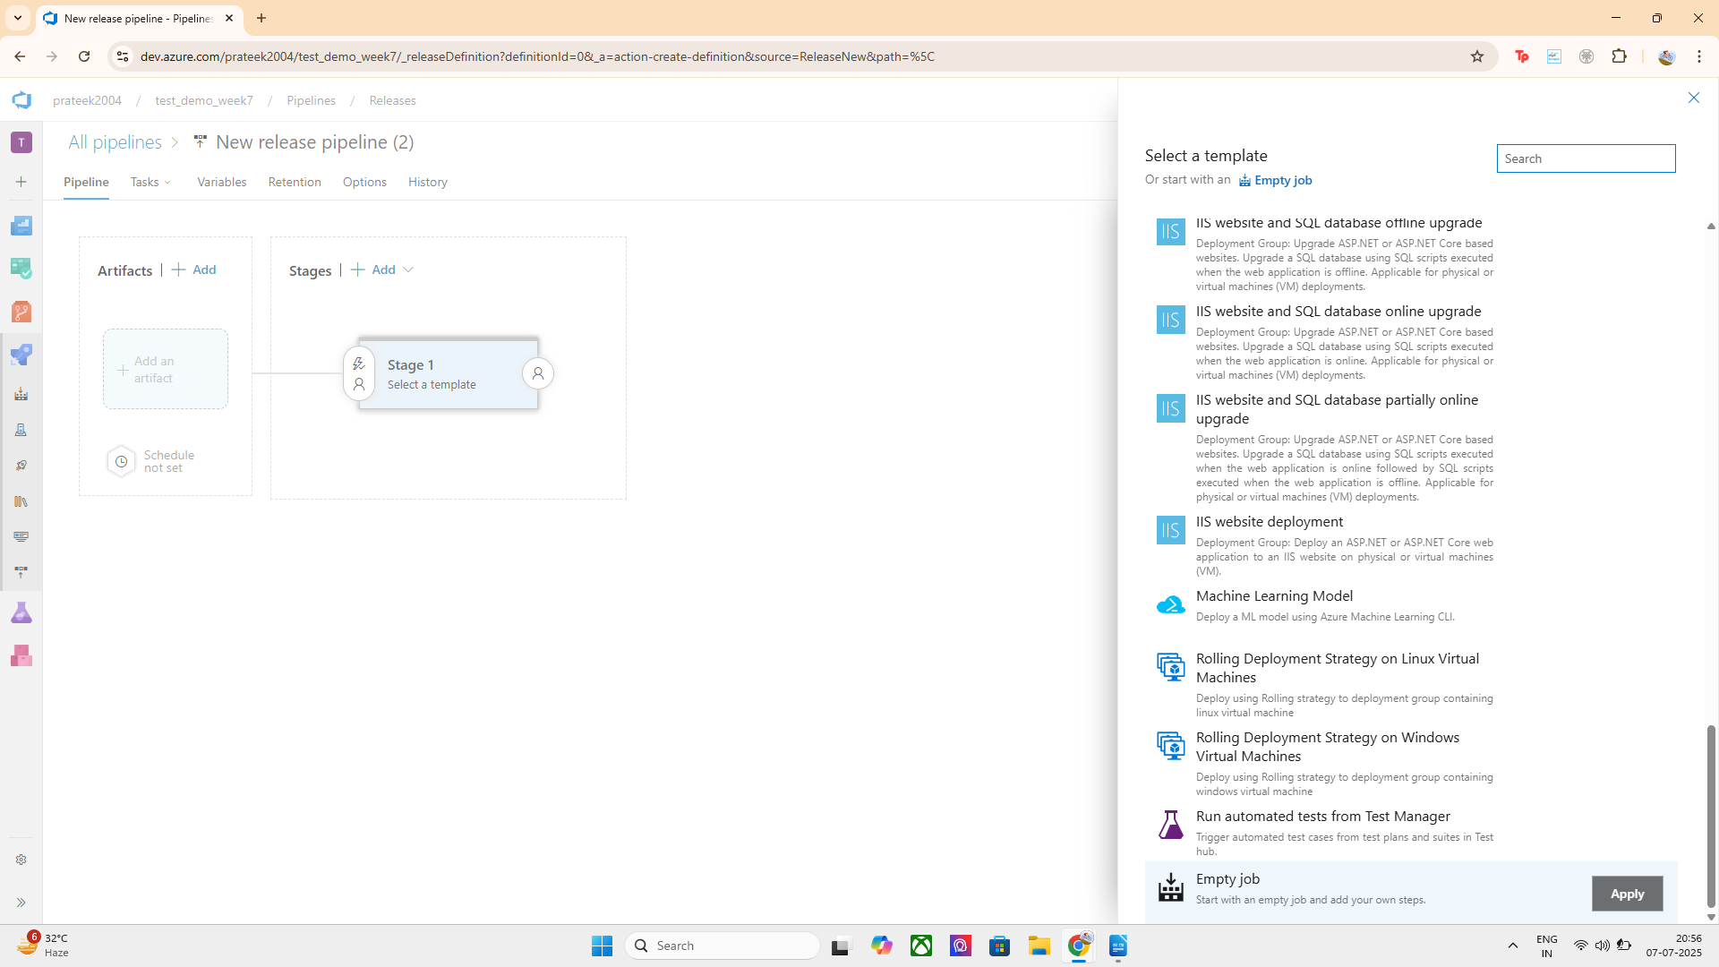
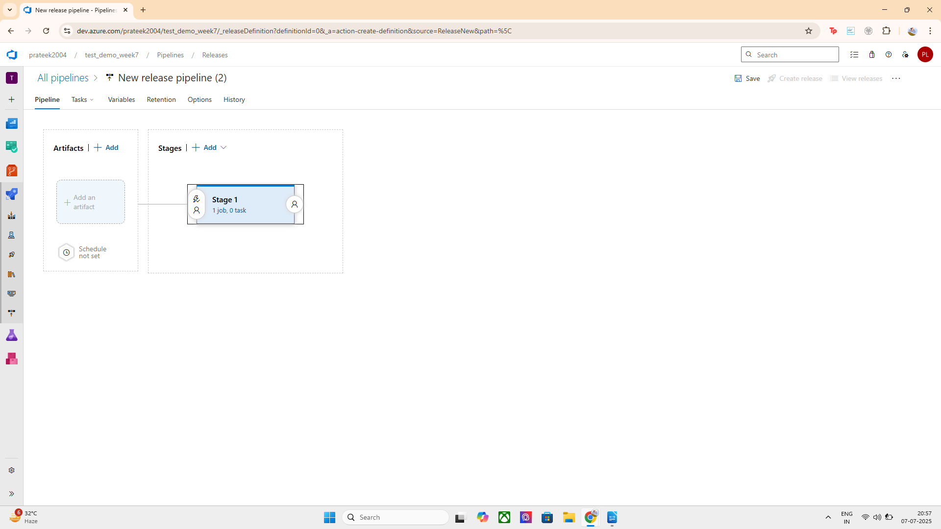

Step 3: Add Artifact (Your Build Output)
- Click “Add an artifact”
- Choose:
  - Source type → Build
  - Source (build pipeline) → Select your existing pipeline (e.g., test_demo_week7)
  - Click Add
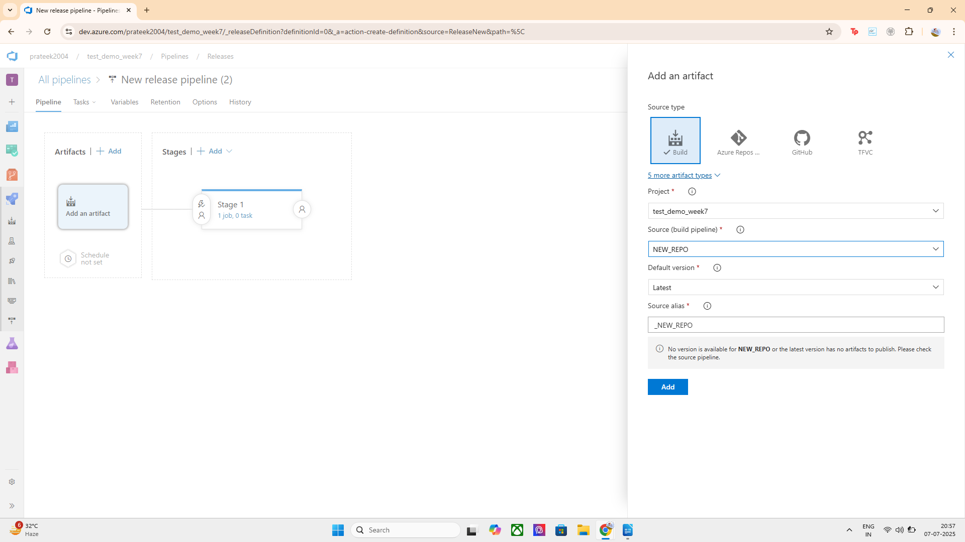
.
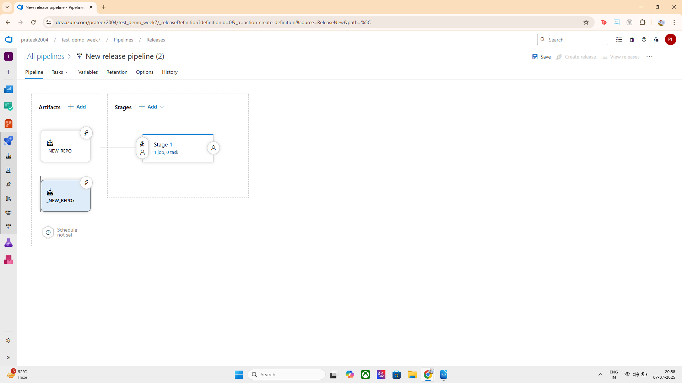

Step 4: Configure Stage
- Click on Stage 1 and rename it (e.g., DeployToTest)
- Click on the Tasks tab
- Add a task (e.g., “Command line script” with echo Deploying...)
- Save the pipeline

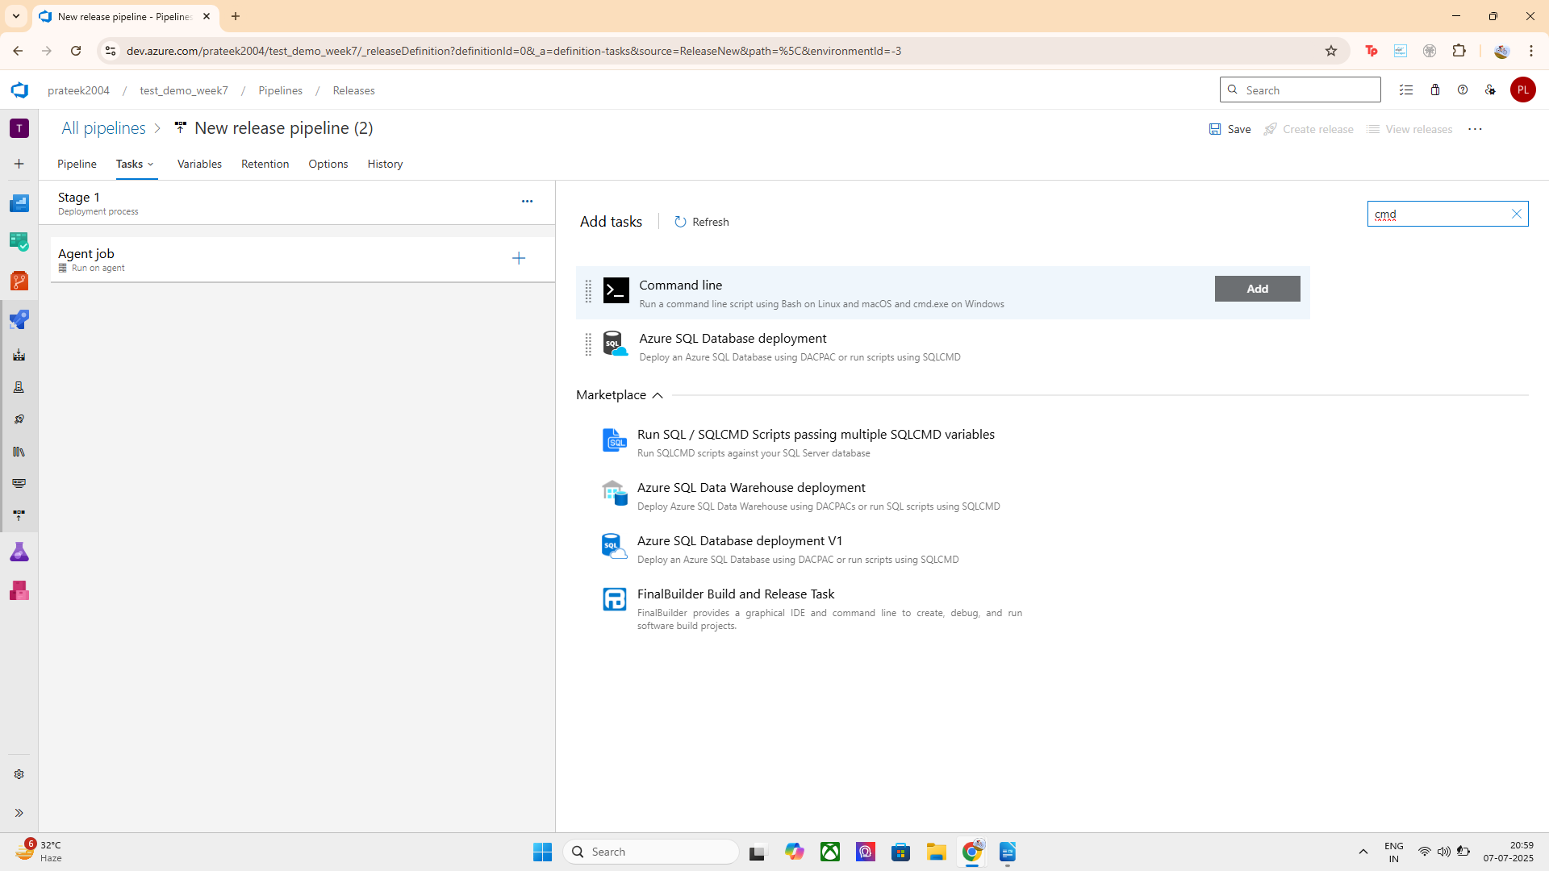

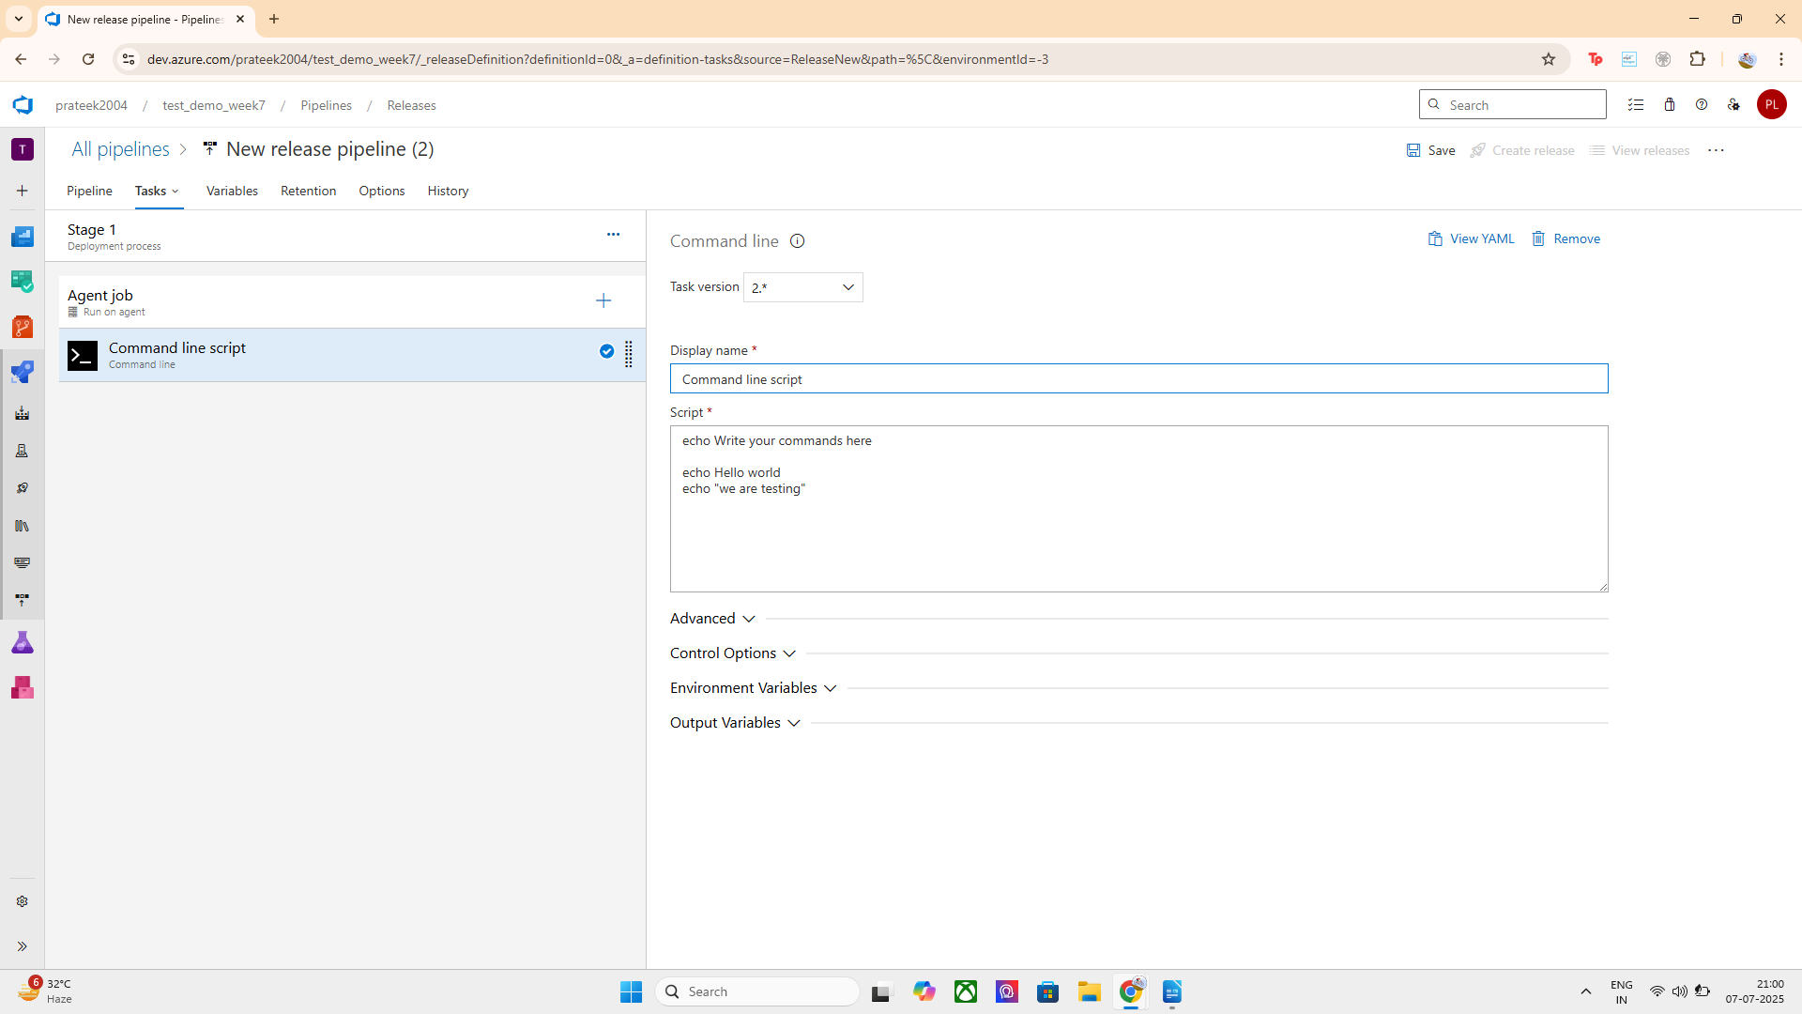

1 task successfully configured:
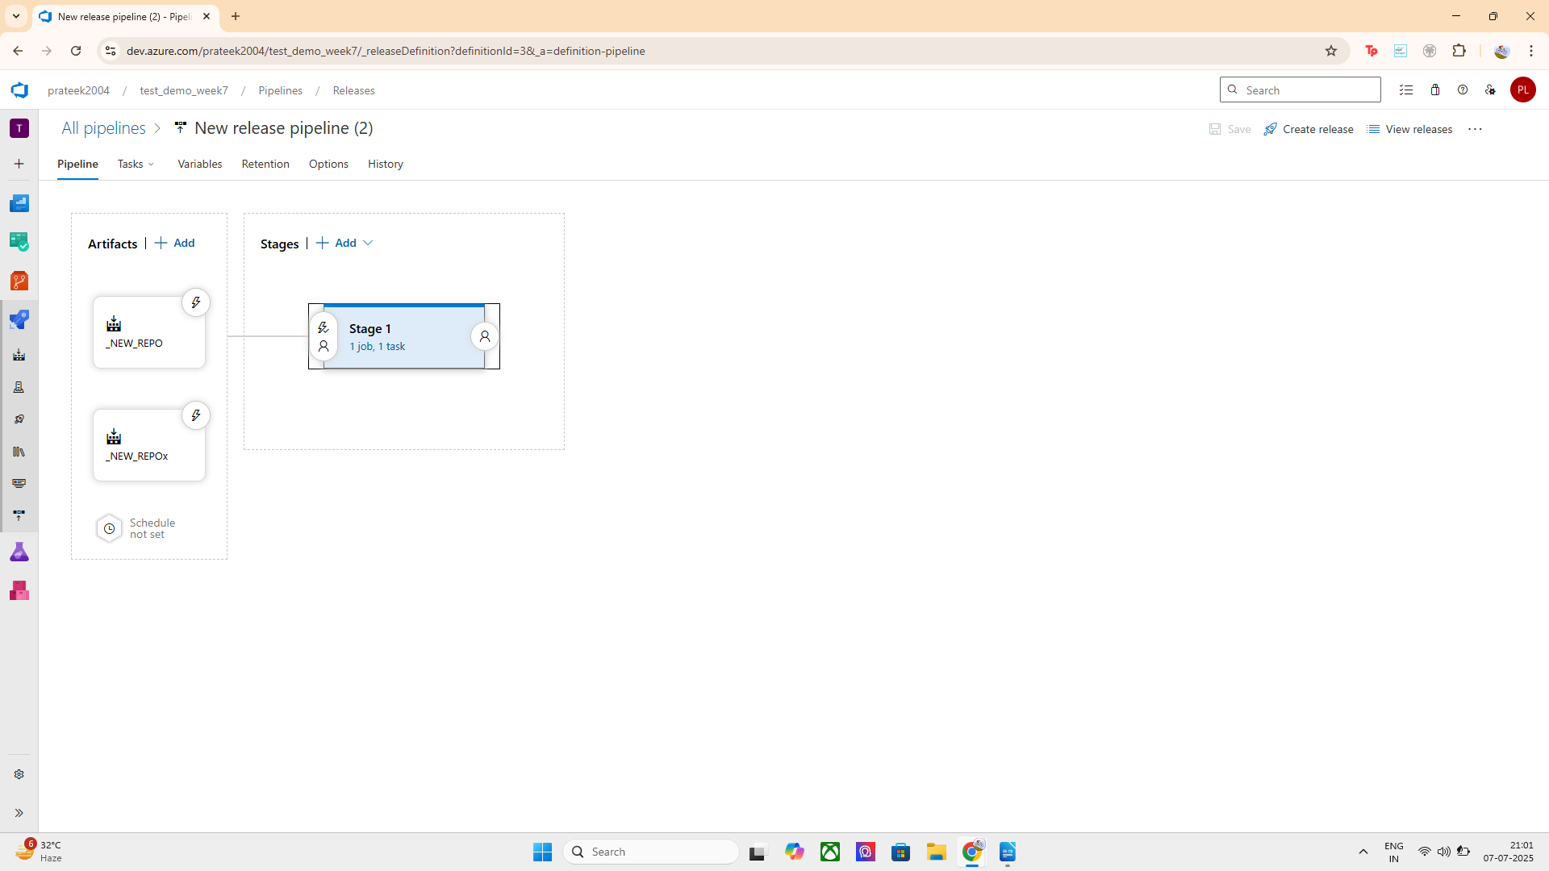

Step 5: Enable Pre-Deployment Gates
- Go back to the Pipeline view
- Under the stage (e.g., DeployToTest), click the ⚡ icon (Pre-deployment conditions)
- Enable the "Gates" toggle
- Click + Add gate and choose any of the following:
  - ✅ Delay before deployment (easiest to demo)
  - ✅ Manual approval
  - 🛠️ Invoke REST API, Query Work Items, etc.

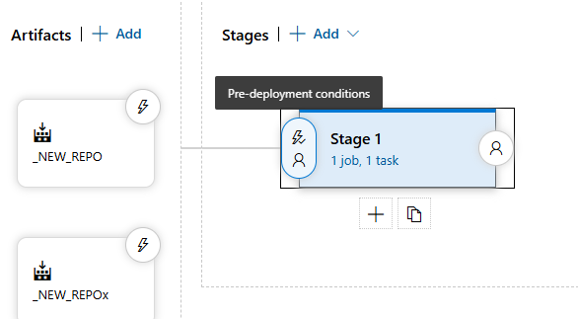

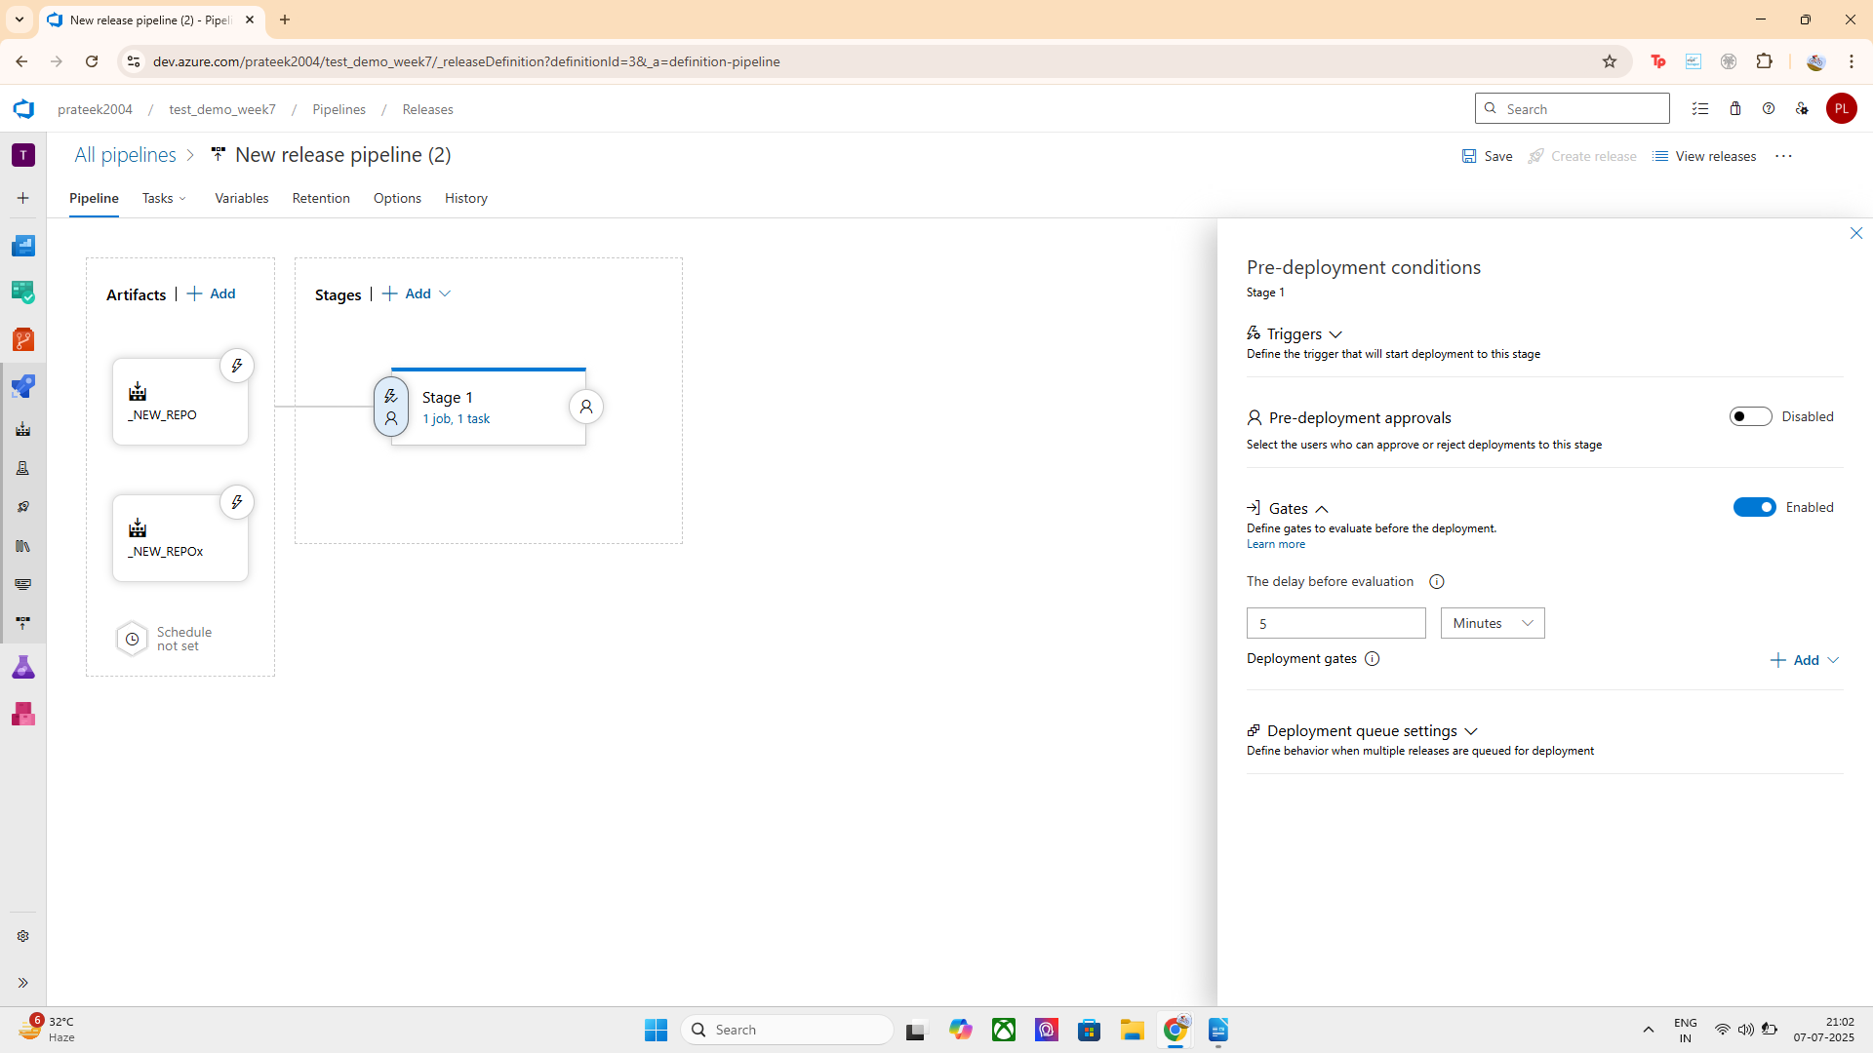
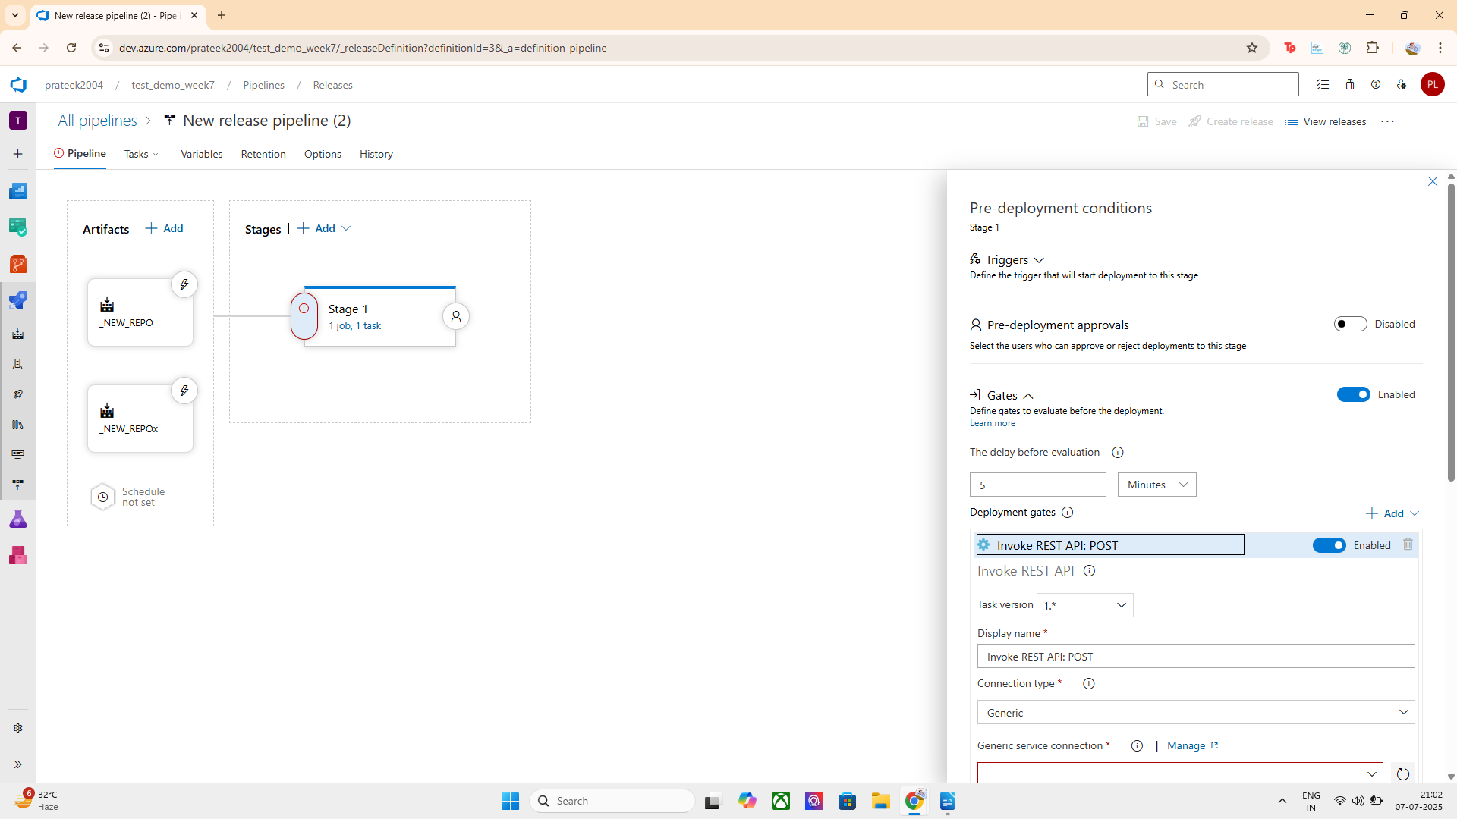

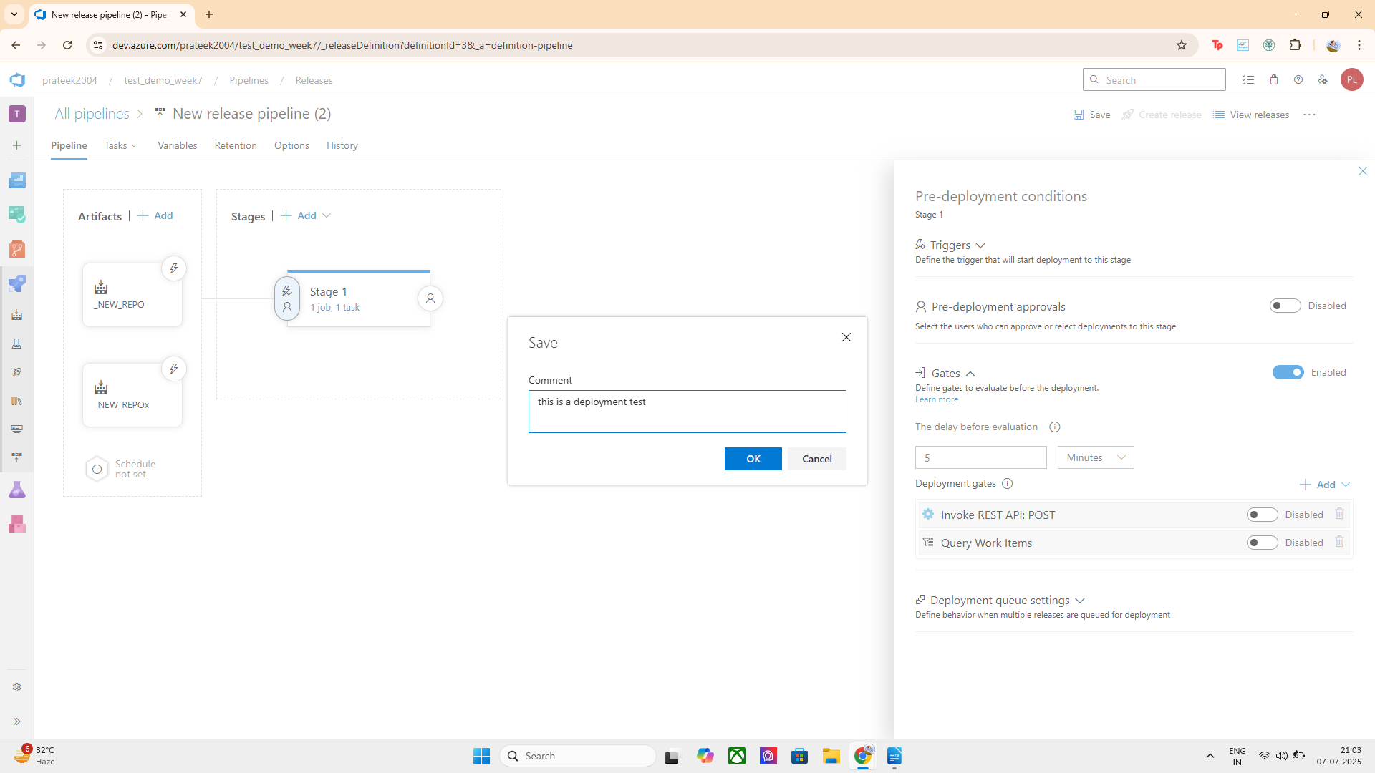

Step 6: Save and Create a Release
- Click Save
- Click Create Release
- Choose the latest artifact version
- Click Create
A build must exist before using it as an artifact source in a release pipeline. I ran the build manually once to generate the required version, which allowed the release pipeline to access and deploy the artifact successfully.
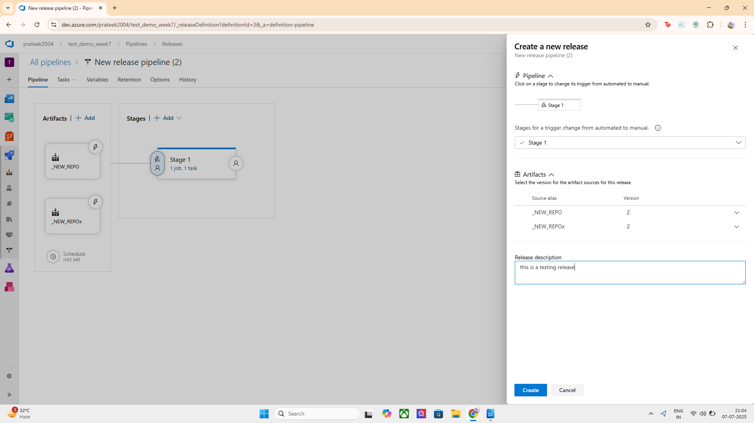
Implementation:
- Created a new release pipeline with a stage named DeployToTest.
- Added a build artifact from the _NEW_REPO build pipeline.
- Configured a task that prints a message using a Command Line Script.
- Enabled pre-deployment gates and added a 2-minute delay gate.
- Ran a build to generate a valid artifact version.
- Created a release to test gate behavior — deployment paused for 2 minutes before proceeding.

