Question: Apply security on branches so that contributors can create a pull request but cannot directly merge code to master

Soln:

This task involves using branch security and policies in Azure DevOps to enforce that only pull requests (PRs) can modify protected branches like master (or main). Direct pushes by contributors are denied to protect the branch integrity.

Real-World Use Case :
In a real development team, you don’t want contributors directly pushing risky or unreviewed code to the main branch. Instead, they must open a pull request that a maintainer or admin can review and approve.
This enforces peer review, catches bugs early, and keeps the production branch clean.

Steps to be implemented:

A. Set Branch Security

- Go to Repos > Branches
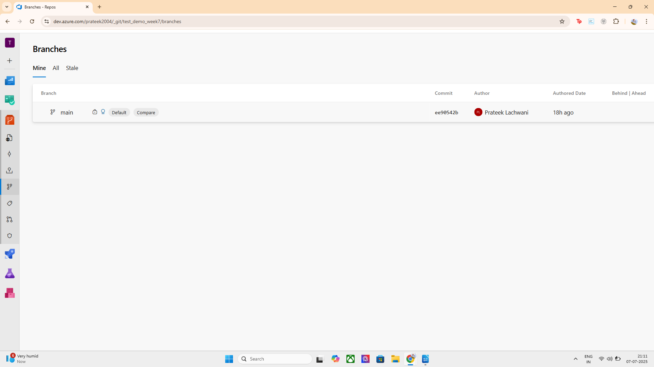
- Click the 3 dots ⋯ next to main or master → Click Branch security
- In the Contributors section:
  - Deny Contribute and Force Push
  - Allow Create branch and Create pull request

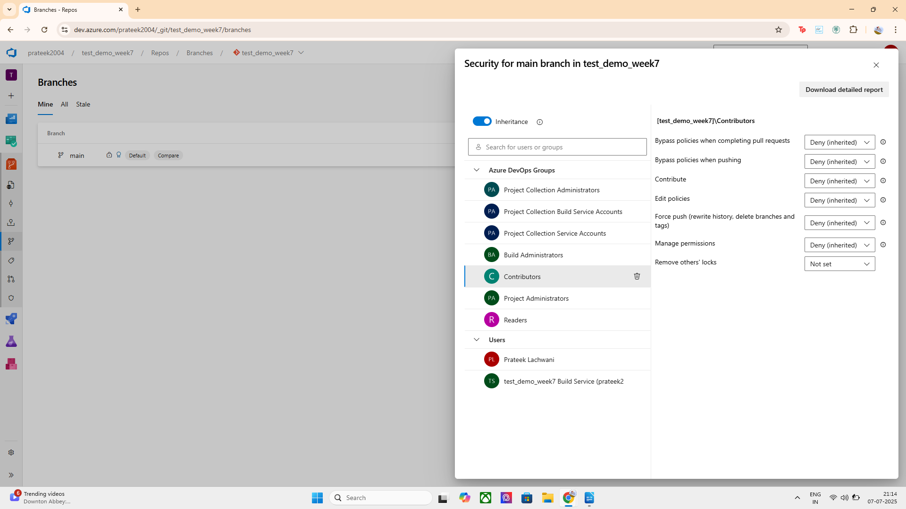
This prevents contributors from pushing directly but lets them create PRs

B. Apply a Branch Policy to Enforce Pull Requests

Go to Repos > Branches
- Click on the Policies button next to main or master

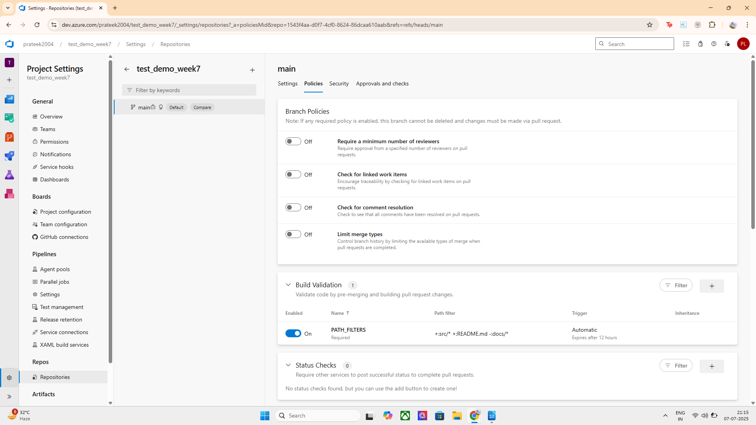
- Under Pull Request Policies, enable:
  - "Require a minimum number of reviewers" (set to 1)
  - "Limit merge types" (optional)
  - "Require a linked work item" (optional but good)
  - "Check for comment resolution" (optional)
This ensures that merging to master is only possible through PR review.

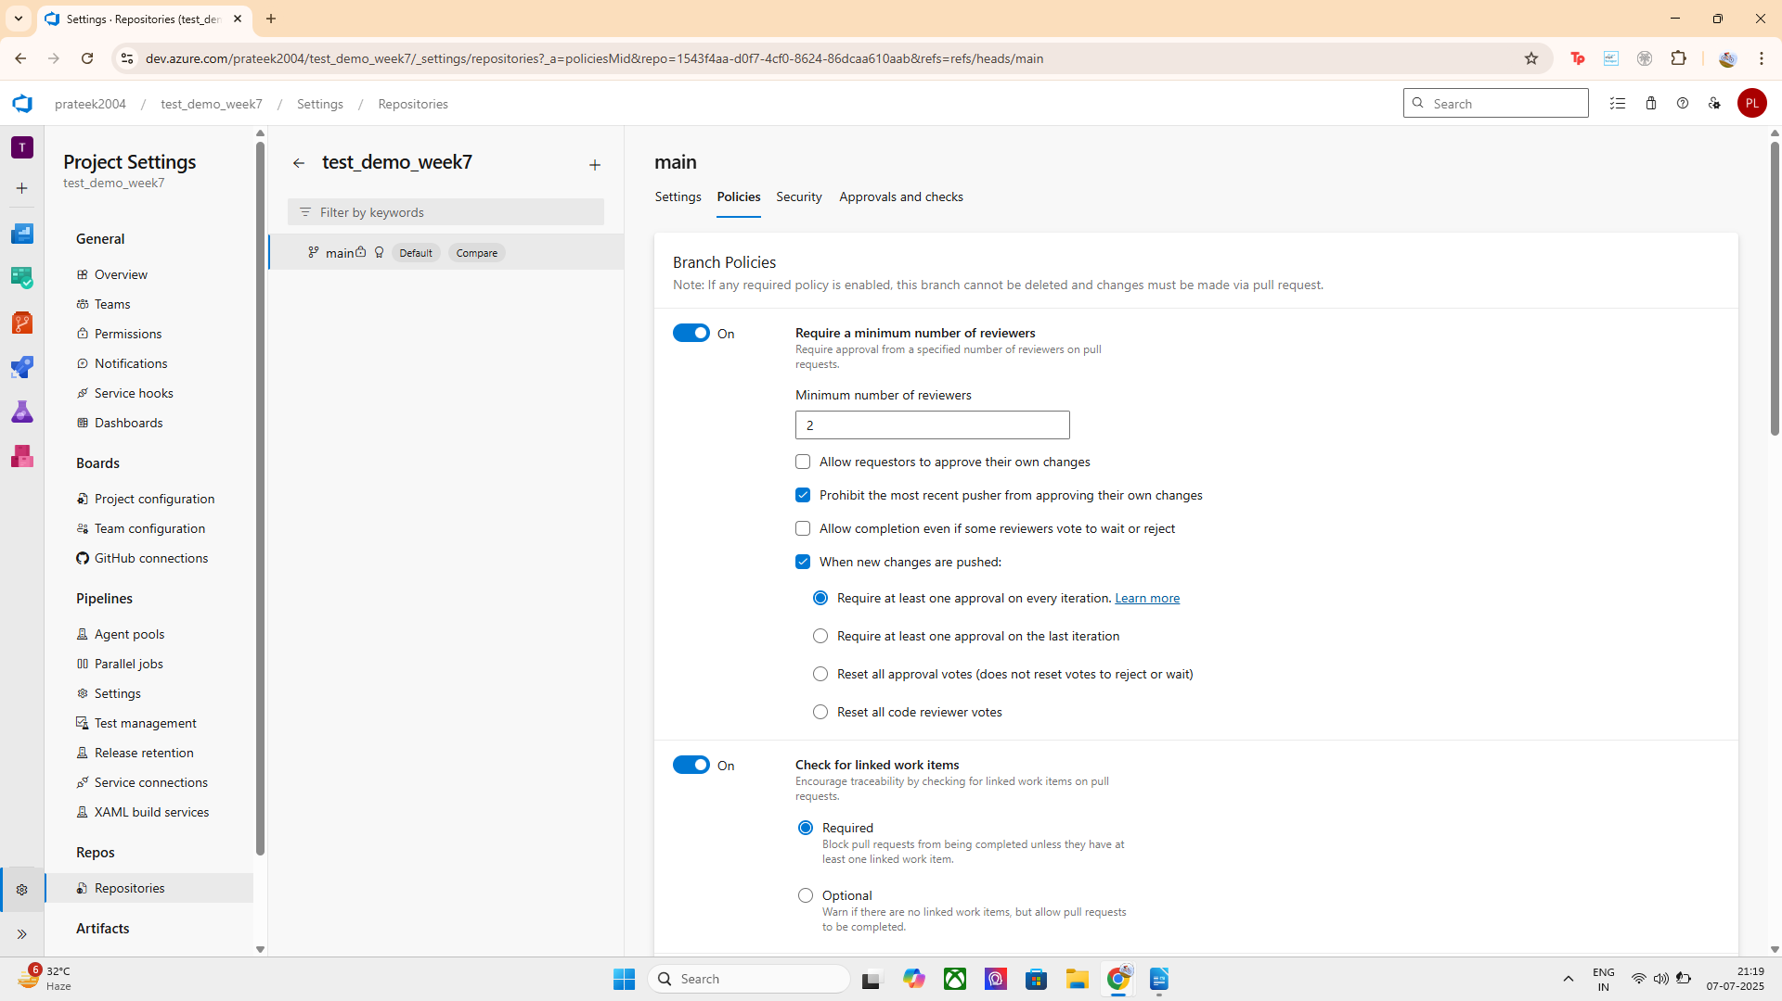
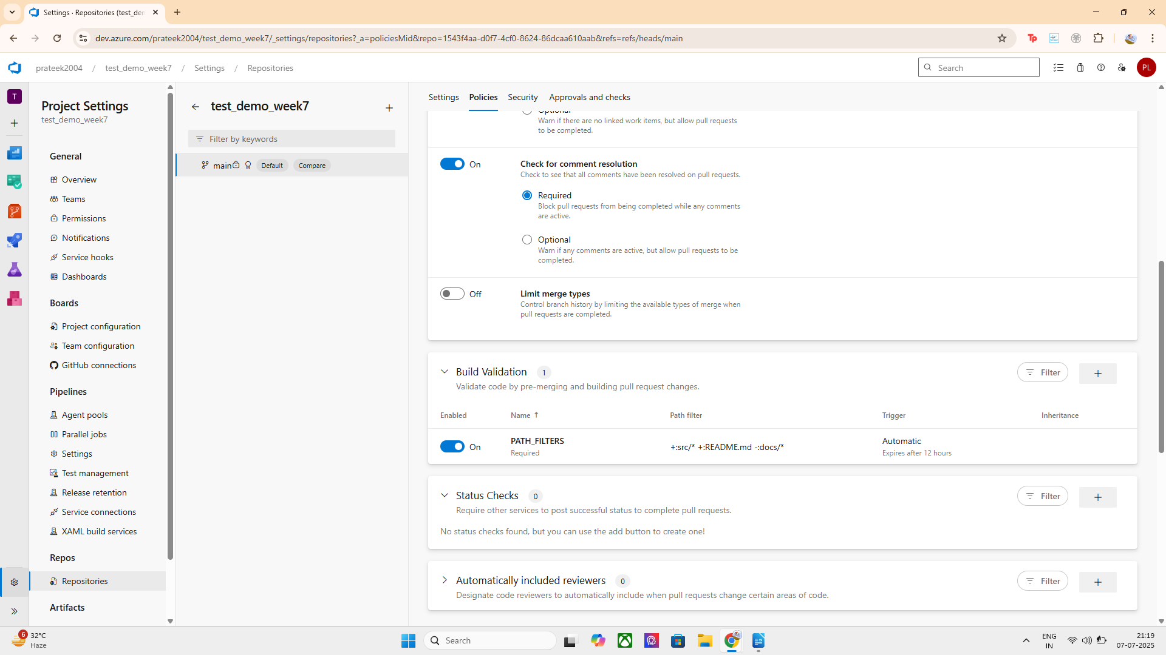
Implementation:
- Applied Branch Security: Denied Contribute and Force Push to the Contributors group for the main branch.
- Allowed contributors to create Pull Requests.
- Configured Branch Policies: Enabled pull request validation with at least one required reviewer.
- This ensures contributors cannot directly merge but can only make changes via PRs.

