PAYROLL ACCOUNTING SYSTEM

**(SUBMITTED TOWARDS FULFILLMENT OF 4th SEMESTER SOFTWARE TOOL PROJECT )**

INSTITUTE OF ENGINEERING AND MANAGEMENT  
 SALTLAKE,SECTOR-V,KOLKATA

**SUBMITTED TO:**

**PROF. SUBHABRATA SENGUPTA**

**SUBMITTED BY:**

NAME:PRINCE KUMAR

ROLL NO: **63**



ACKNOWLEDGEMENT

With Candor and Pleasure I take opportunity to express my sincere thanks and obligation to my esteemed guide . It is because of his able and mature guidance and co-operation without which it would not have been possible for me to complete my project.

It is my pleasant duty to thank all the teacher of our IT department who never hesitated me from time during the project.

Finally, I gratefully acknowledge the support, encouragement & patience of my freind, And as always, nothing in my life would be possible without God, Thank You!

TABLE OF CONTENT

1.1Acknowledgment

1.2preface

2. Data flow diagram

3.Graphical user interface(G.U.I)

4. Source code

5. Bibliography

PROBLEM DEFINATION

* 1. **INTRODUCTION TO THE PROBLEM:**

This is a Project work undertaken in context of partial fulfillment of the FOURTH SEMESTER PROJECT WORK. Since PAYROLL is associated with the lives of common people and their day to day routines so I decided to work on this project. The manual handling of the record is time consuming and highly prone to error. The user can inputs codes of Employee he wants to see Pay Slip. The activities like see Employee Record , add Record, modify records, delete Record and finally receiving Pay Slip can be performed easily. .

I found two main key-points to design and programmed my project using VISUAL BASIC 6.0 and its FILES facility as database storage. First, Because VISUAL BASIC 6.0 compiler has the ability to debug the project at run time and gives appropriate error messages if it found in the project at run time.

I have tried my best to make the complicated process of PAYROLL ACCOUNTING System as simple as possible using Structured & Modular technique & Menu oriented interface. I have tried to design the software in such a way that user may not have any difficulty in using this package & further expansion is possible without much effort. Even though I cannot claim that this work to be entirely exhaustive, the main purpose of my exercise is perform each PayRoll’s activity in computerized way rather than manually which is time consuming.

I am confident that this software package can be readily used by non-programming personal avoiding human handled chance of error.

* 1. **NEED:**

I have designed the given proposed system in the VISUAL BASIC 6.0 to automate the process of Payroll system.The complete set of rules & procedures related to PayRoll and generating report is called “PAYROLL ACCOUNTING SYSTEM”. My project gives a brief idea regarding automated Payroll activities.

The following steps that gives the detailed information of the need of proposed system are:

**Performance:** During past several decades, the Payroll is supposed to maintain manual handling of all the Payroll activities. The manual handling of the record is time consuming and highly prone to error. To improve the performance of the payroll system, the computerized payroll system is to be undertaken. The computerized project is fully computerized and user friendly even that any of the members can see the report and status of the pay.

**Efficiency:** The basic need of the project is accuracy and efficiency . The project should be efficient so that whenever a Employee is added,add his Record , delete his record, display and generate his payslip.

**Control:** The complete control of the project is under the hands of authorized person who has the password to access this project and illegal access is not supposed to deal with. All the control is under the administrator and the other members have the rights to just see the records not to change any transaction or entry.

**Security:** Security is the main criteria for the proposed system. Since illegal access may corrupt the database. So security has to be given in this project.

**Software:** Software includes the platform where the Payroll project is being prepared. I have done my project using DATABASE CONNECTED WITH VISUAL BASIC 6.0 platform But it is necessary that we have to first install VISUAL BASIC 6.0 to run this project

OBJECTIVE

During the past several decades personnel function has been transformed from a relatively obscure record keeping staff to central and top level management function. There are many factors that have influenced this transformation like technological advances, professionalism, and general recognition of human beings as most important resources.

A computer based management system is designed to handle all the primary information required to calculate monthly statements of Employees Record which include monthly statement of any month. Separate database is maintained to handle all the details required for the correct statement calculation and generation.

This project intends to introduce more user friendliness in the various activities such as record updation, maintenance, and searching. The searching of record has been made quite simple as all the details of the Employee can be obtained by simply keying in the identification of that Employee. Similarly, record maintenance and updation can also be accomplished by using the identification of Employee with all the details being automatically generated. These details are also being promptly automatically updated in the master file thus keeping the record absolutely up-to-date.

The entire information has maintained in the database or Files and whoever wants to retrieve can’t retrieve, only authorization user can retrieve the necessary information which can be easily be accessible from the file.

DATA FLOW DIAGRAM

**CONTEXT LEVEL DFD PAYROLL MANAGEMENT SYSTEM:-**

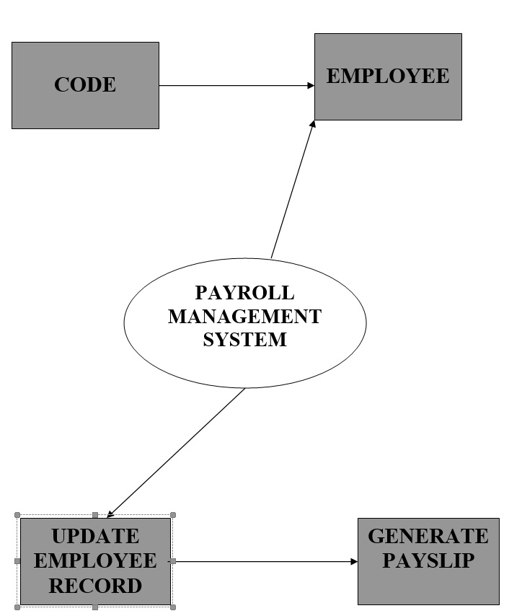

**DATA FLOW DIAGRAM OPENING A EMPLOYEE RECORD:-**

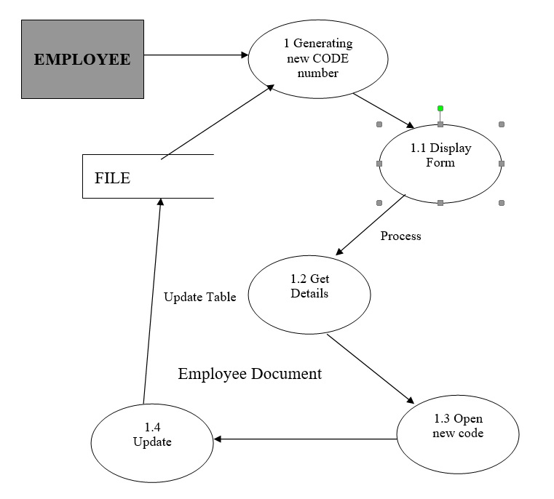

**DATA FLOW DIAGRAM ADDING A NEW EMPLOYEE RECORD:-**

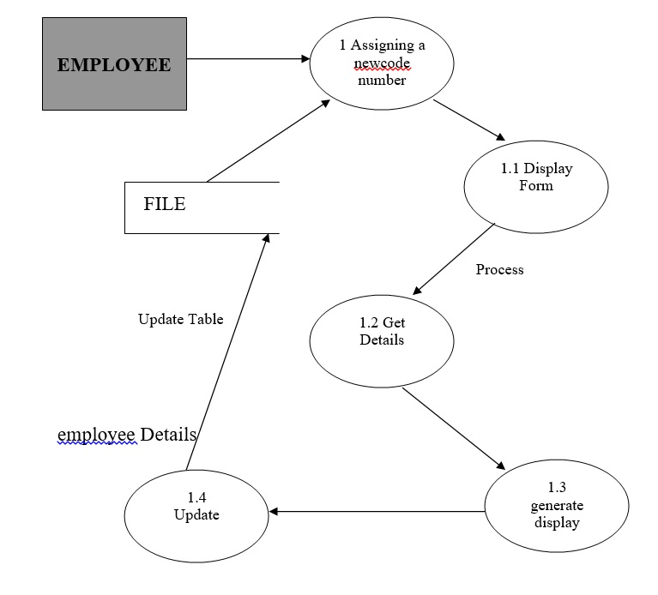

**DATA FLOW DIAGRAM UPDATING A EMPLOYEE RECORD:-**

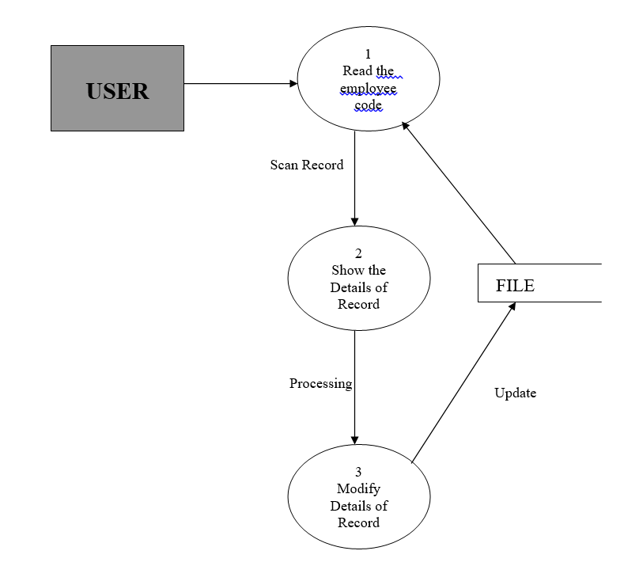

G.U.I

**Splash sreen:-**

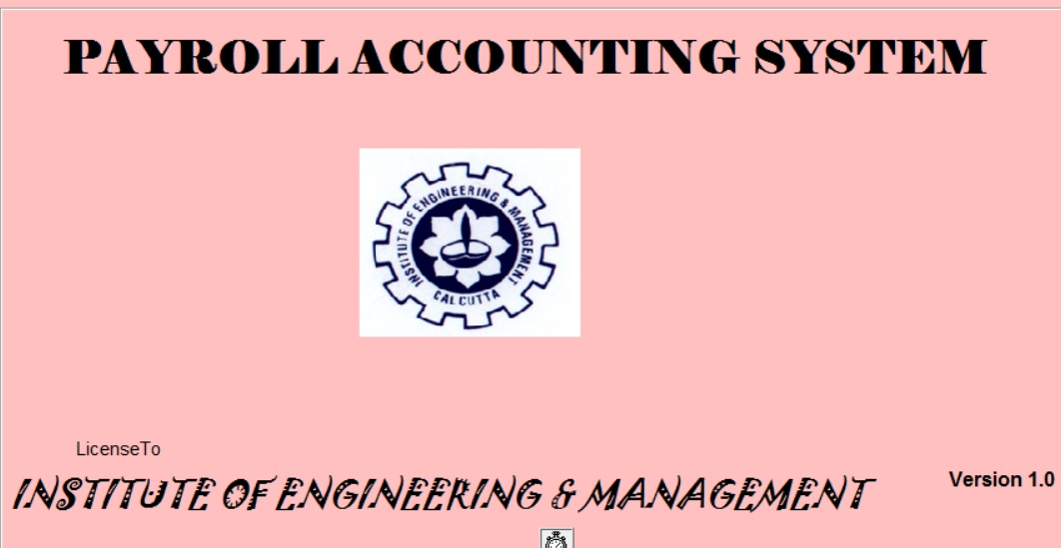

**Login:-**

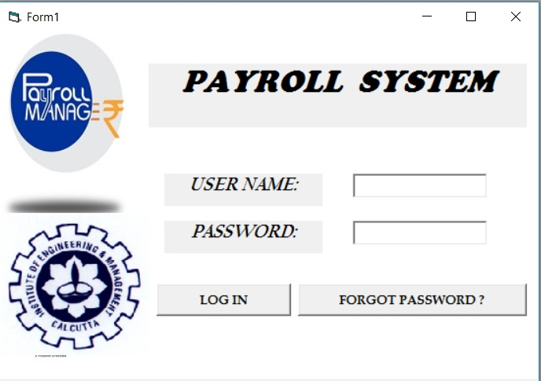

**Forgot password:-**

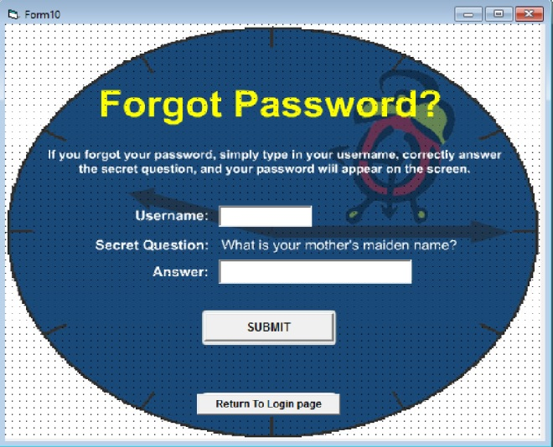

**Menu:-**

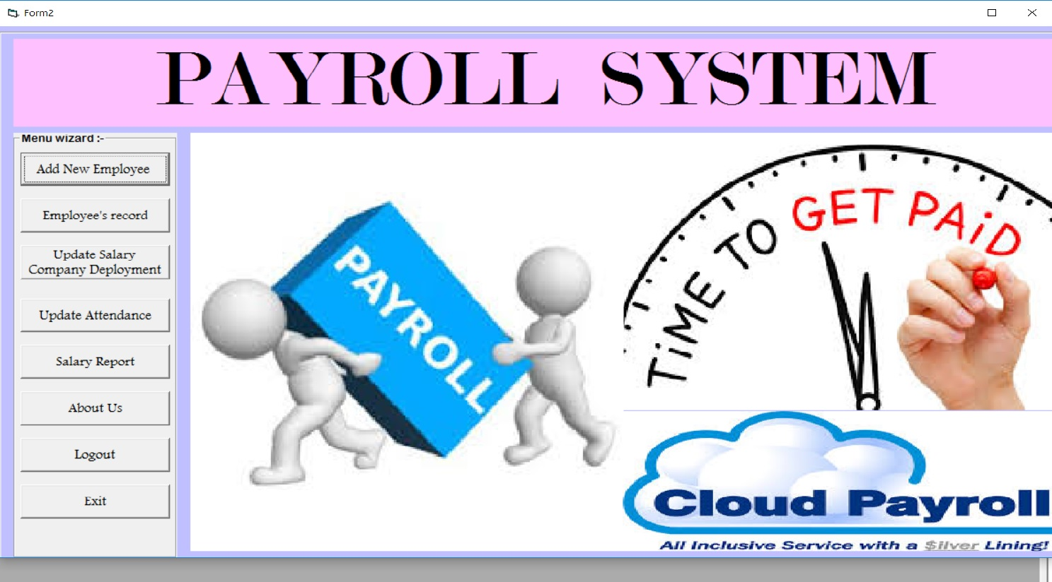

**Add new employee:-**

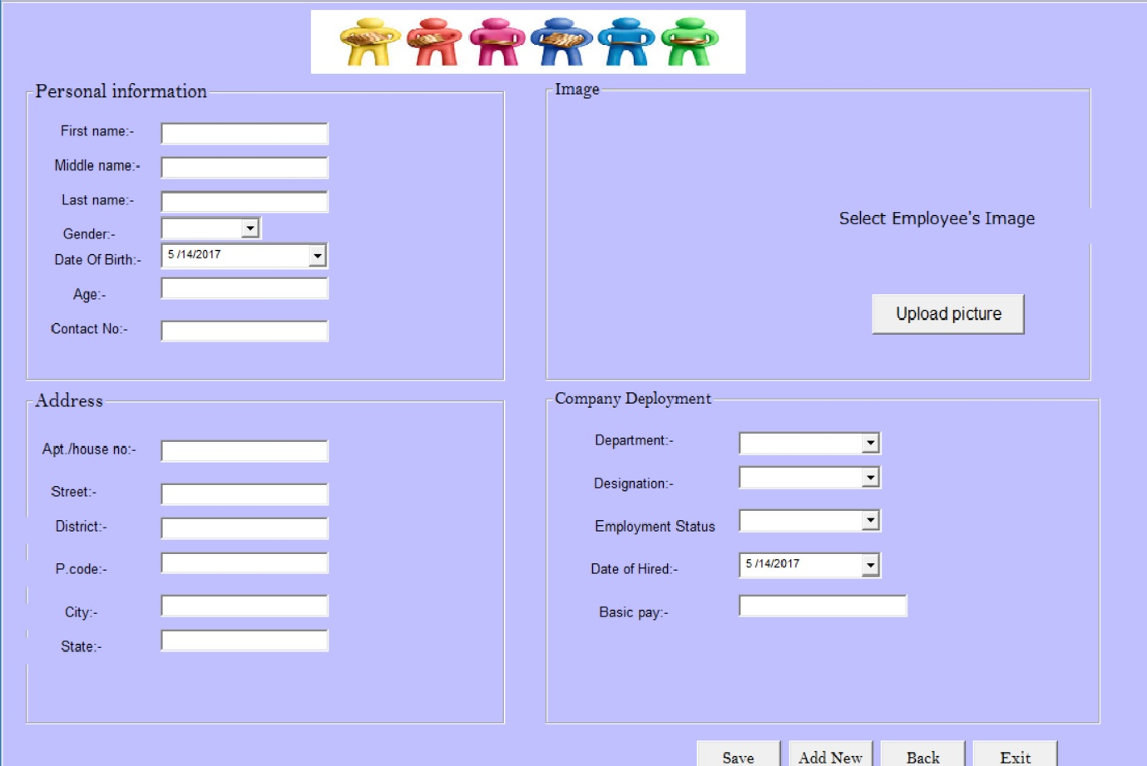

**Employee record:-**

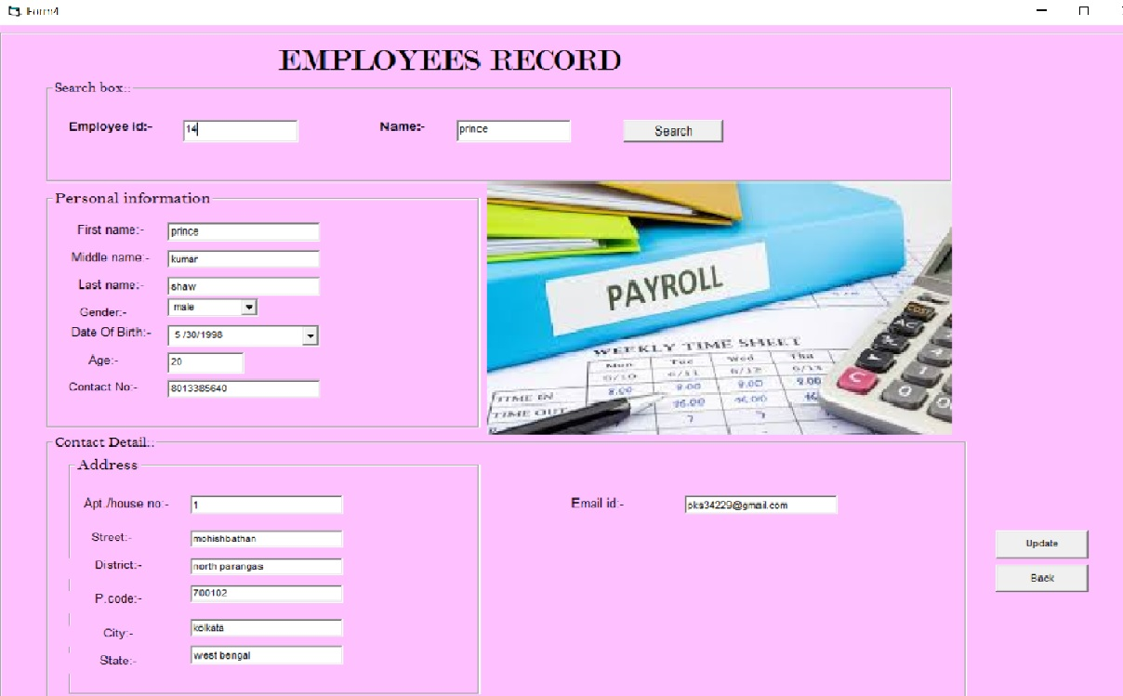

**Update salary:-**

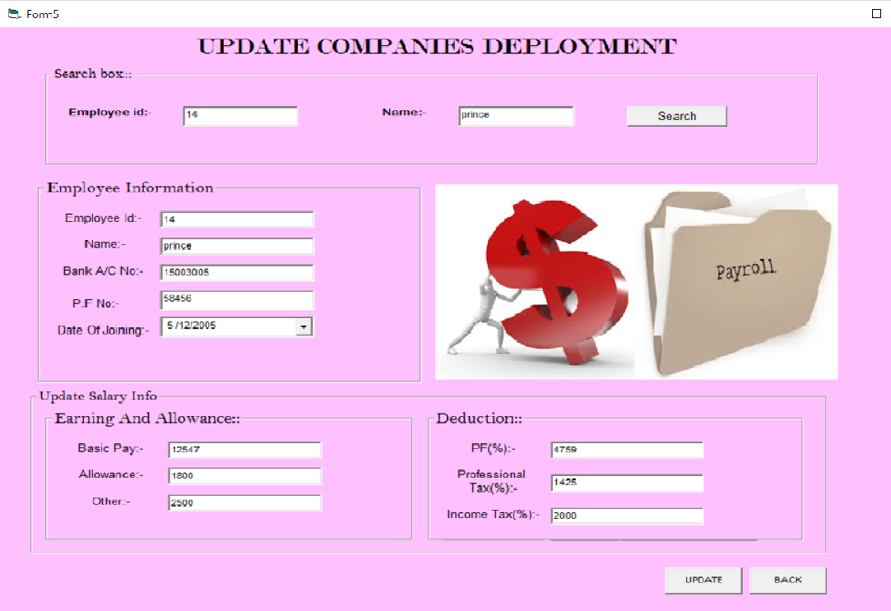

**Update attendance:-**

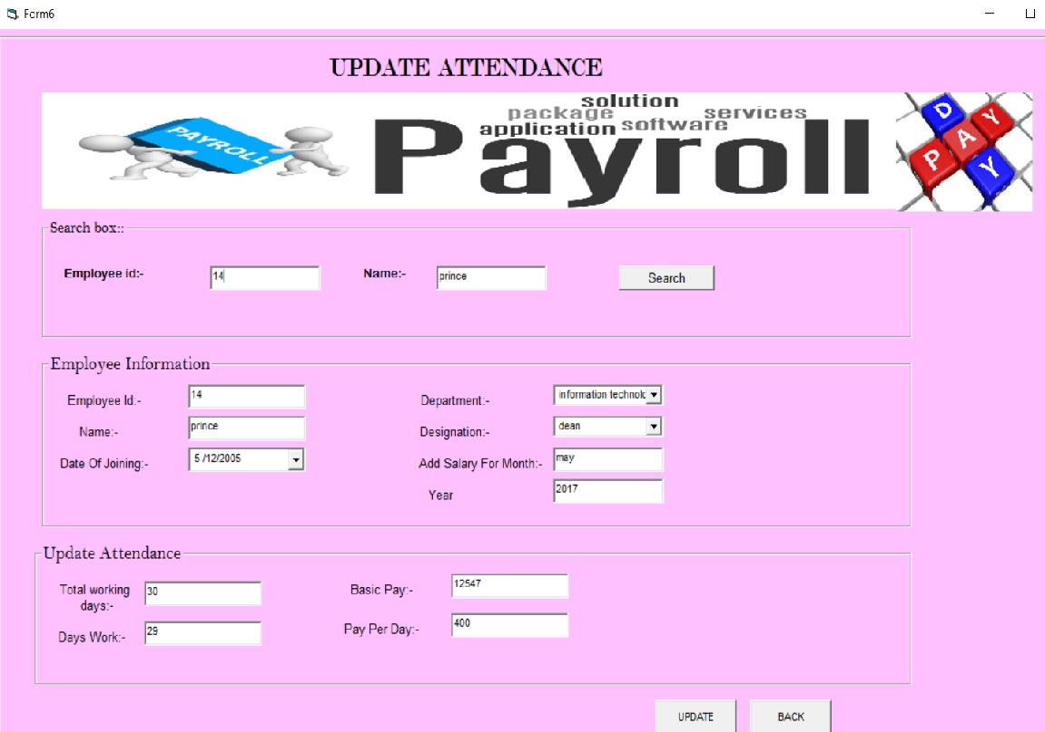

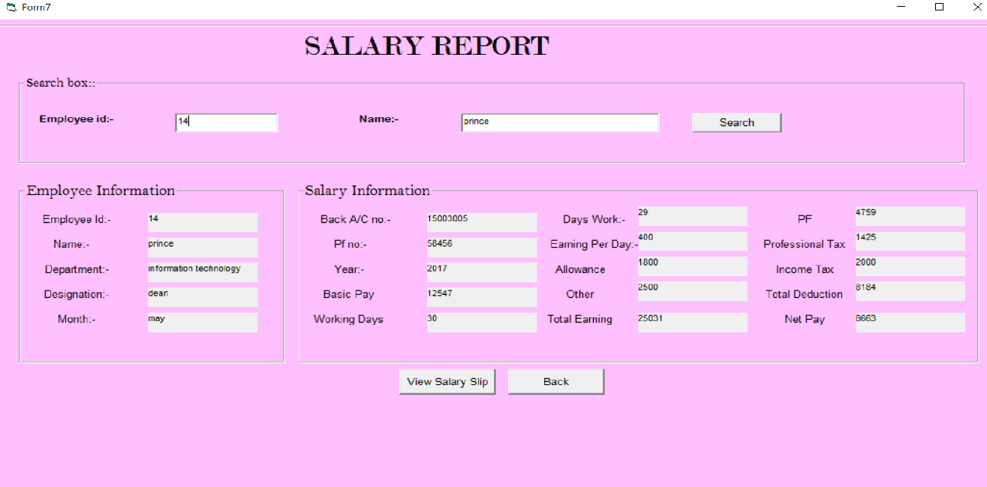**Salary report:-**

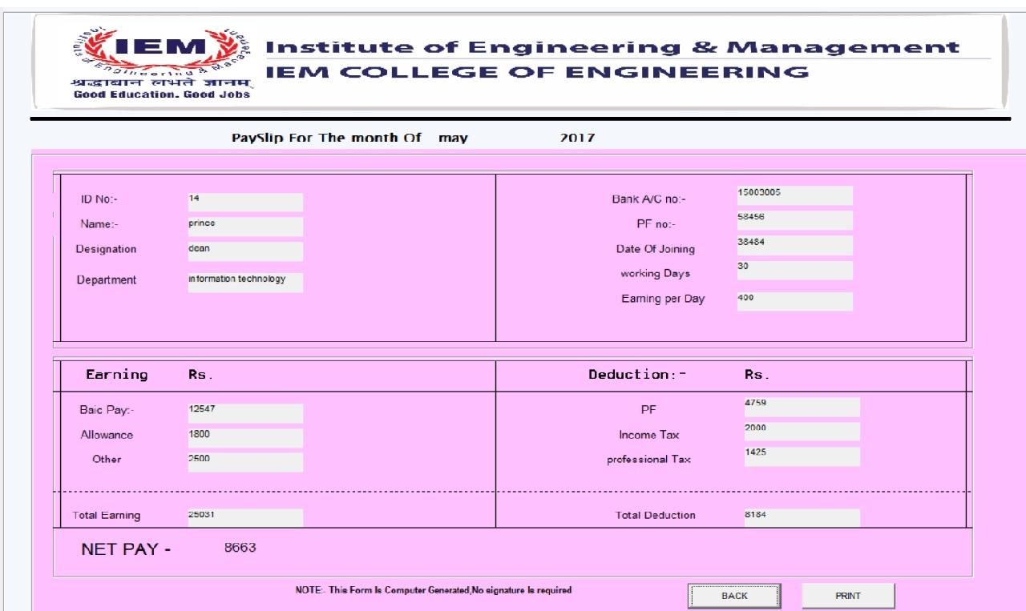**Salary slip:-**

**About us:-**

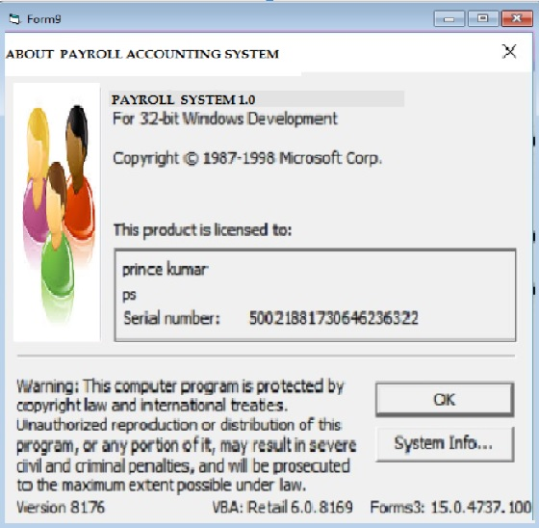

SOURCE CODE



**Splash screen:-**

Private Sub Timer1_Timer()

Unload Me

Form1.Show

End Sub

**Login:-**

Private Sub Command1_Click()

Dim user As String

Dim pass As Integer

user = "admin"

pass = 12345

a = Text1.Text

b = Val(Text2.Text)

If ((a = user) And (b = pass)) Then

Y = MsgBox("well Done....Login Successful", vbInformation, Login)

Form2.Show

Unload Me

Else

Y = MsgBox("Login Failed...Please Login With Correct Credential", vbInformation, Login)

End If

End Sub

Private Sub Command2_Click()

Form10.Show

Unload Me

End Sub

**Menu:-**

Private Sub Command1_Click()

Form3.Show

End Sub

Private Sub Command2_Click()

Form4.Show

End Sub

Private Sub Command3_Click()

Form5.Show

End Sub

Private Sub Command4_Click()

Form6.Show

End Sub

Private Sub Command5_Click()

Form7.Show

End Sub

Private Sub Command6_Click()

Form9.Show

End Sub

Private Sub Command7_Click()

Form1.Show

Form2.Visible = False

Form3.Visible = False

Form4.Visible = False

Form5.Visible = False

Form6.Visible = False

Form2.Visible = False

Form2.Visible = False

End Sub

Private Sub Command8_Click()

Y = MsgBox("Are You Sure You Want to Exit...! ?", vbOKCancel, " payroll")

If (Y = 1) Then

Form1.Visible = False

Form2.Visible = False

Form3.Visible = False

Form4.Visible = False

Form5.Visible = False

Form6.Visible = False

Form7.Visible = False

Form8.Visible = False

Else

Form2.Visible = True

End If

End Sub

**Add new employee:-**

Dim con As New ADODB.Connection

Dim rs As New ADODB.Recordset

Dim str As String

Private Sub Command2_Click()

CommonDialog1.ShowOpen

CommonDialog1.Filter = "jpeg|*.jpg"

str = CommonDialog1.FileName

Image1.Picture = LoadPicture(str)

End Sub

Private Sub Command4_Click()

rs.AddNew

clear

End Sub

Private Sub Command5_Click()

Form2.Show

End Sub

Private Sub Command6_Click()

Unload Me

Form2.Show

End Sub

Private Sub Command7_Click()

rs.Fields("first").Value = Text1.Text

rs.Fields("middle").Value = Text2.Text

rs.Fields("last").Value = Text3.Text

rs.Fields("gender").Value = Combo1.Text

rs.Fields("dob").Value = DTPicker1.Value

rs.Fields("age").Value = Text4.Text

rs.Fields("contact").Value = Text5.Text

rs.Fields("house").Value = Text6.Text

rs.Fields("street").Value = Text7.Text

rs.Fields("district").Value = Text8.Text

rs.Fields("pin").Value = Text9.Text

rs.Fields("city").Value = Text10.Text

rs.Fields("state").Value = Text11.Text

rs.Fields("image").Value = str

rs.Fields("department").Value = Combo5.Text

rs.Fields("designation").Value = Combo6.Text

rs.Fields("employment").Value = Combo7.Text

rs.Fields("doh").Value = DTPicker2.Value

rs.Fields("basicpay").Value = Text12.Text

MsgBox "Data is saved successfully ..!!!", vbInformation

rs.Update

End Sub

Sub clear()

Text1.Text = ""

Text2.Text = ""

Text3.Text = ""

Text4.Text = ""

Text5.Text = ""

Text6.Text = ""

Text7.Text = ""

Text8.Text = ""

Text9.Text = ""

Text10.Text = ""

Text11.Text = ""

Text12.Text = ""

Combo1.Text = ""

Combo5.Text = ""

Combo6.Text = ""

Combo7.Text = ""

Image1.Picture = LoadPicture("")

DTPicker1.Value = "5/14/2017"

DTPicker2.Value = "5/14/2017"

End Sub

Private Sub Form_Load()

con.Open "provider=microsoft.jet.oledb.4.0;data source=F:\PAYROLL\payroll1.mdb; persist security info=false"

rs.Open "select *from pay", con, adOpenDynamic, adLockPessimistic

Combo5.AddItem "computer science"

Combo5.AddItem "information technology"

Combo5.AddItem "electronics & communication"

Combo5.AddItem "mechanical"

Combo5.AddItem "electrical"

Combo1.AddItem "male"

Combo1.AddItem "female"

Combo1.AddItem "other"

Combo6.AddItem "dean"

Combo6.AddItem "accountant"

Combo6.AddItem "principal"

Combo6.AddItem "professor"

Combo6.AddItem "associate professor"

Combo6.AddItem "staff"

Combo6.AddItem "other"

Combo7.AddItem "fresher"

Combo7.AddItem "experienced"

End Sub

Private Sub Frame2_DragDrop(Source As Control, X As Single, Y As Single)

End Sub

**Employee record:-**

Dim con As New ADODB.Connection

Dim rs As New ADODB.Recordset

Private Sub Command1_Click()

rs.Close

rs.Open "Select * from Pay where first='" + Text2.Text + "'", con, adOpenDynamic, adLockPessimistic

'rs.Open "Select * from Pay where Eid='" + Text1.Text + "'", con, adOpenDynamic, adLockPessimistic

If Not rs.EOF Then

display

Else

MsgBox "Record Profile not found ..!!", vbInformation

End If

End Sub

Private Sub Command2_Click()

rs.Fields("first").Value = Text6.Text

rs.Fields("middle").Value = Text4.Text

rs.Fields("last").Value = Text3.Text

rs.Fields("gender").Value = Combo1.Text

rs.Fields("dob").Value = DTPicker1.Value

rs.Fields("age").Value = Text7.Text

rs.Fields("contact").Value = Text5.Text

rs.Fields("house").Value = Text13.Text

rs.Fields("street").Value = Text12.Text

rs.Fields("district").Value = Text8.Text

rs.Fields("pin").Value = Text9.Text

rs.Fields("city").Value = Text10.Text

rs.Fields("state").Value = Text11.Text

rs.Fields("email").Value = Text15.Text

MsgBox "Data is updated successfully ..!!!", vbInformation

rs.Update

End Sub

Private Sub Command3_Click()

Form2.Show

End Sub

Private Sub Form_Load()

con.Open "provider=microsoft.jet.oledb.4.0;data source=F:\PAYROLL\payroll1.mdb; persist security info=false"

rs.Open "select *from pay", con, adOpenDynamic, adLockPessimistic

End Sub

Sub display()

Text6.Text = rs!First

Text4.Text = rs!middle

Text3.Text = rs!Last

Text7.Text = rs!age

Combo1.Text = rs!gender

DTPicker1.Value = rs!DOB

Text5.Text = rs!contact

Text13.Text = rs!house

Text12.Text = rs!street

Text8.Text = rs!district

Text9.Text = rs!pin

Text10.Text = rs!city

Text11.Text = rs!State

Text15.Text = rs!email

End Sub

Private Sub Frame2_DragDrop(Source As Control, X As Single, Y As Single)

End Sub

**Update salary:-**

Dim con As New ADODB.Connection

Dim rs As New ADODB.Recordset

Private Sub Command1_Click()

rs.Close

rs.Open "Select * from Pay where first='" + Text2.Text + "'", con, adOpenDynamic, adLockPessimistic

If Not rs.EOF Then

display

Else

MsgBox "Record Profile not found ..!!", vbInformation

End If

End Sub

Private Sub Command2_Click()

'rs.Fields("Eid").Value = Text6.Text

rs.Fields("first").Value = Text4.Text

rs.Fields("bank").Value = Text3.Text

rs.Fields("pfno").Value = Text7.Text

rs.Fields("doh").Value = DTPicker1.Value

rs.Fields("basicpay").Value = Text15.Text

rs.Fields("allowance").Value = Text14.Text

rs.Fields("other").Value = Text13.Text

rs.Fields("pf").Value = Text18.Text

rs.Fields("professionaltax").Value = Text17.Text

rs.Fields("incometax").Value = Text16.Text

MsgBox "Data is updated successfully ..!!!", vbInformation

rs.Update

End Sub

Private Sub Command3_Click()

Form2.Show

End Sub

Private Sub Form_Load()

con.Open "provider=microsoft.jet.oledb.4.0;data source=F:\PAYROLL\payroll1.mdb; persist security info=false"

rs.Open "select *from pay", con, adOpenDynamic, adLockPessimistic

End Sub

Sub display()

Text6.Text = rs!Eid

Text4.Text = rs!First

Text3.Text = rs!bank

Text7.Text = rs!pfno

Text15.Text = rs!basicpay

Text14.Text = rs!allowance

Text13.Text = rs!other

Text18.Text = rs!pf

Text17.Text = rs!professionaltax

Text16.Text = rs!incometax

DTPicker1.Value = rs!doh

End Sub

**Update attendance:-**

Dim con As New ADODB.Connection

Dim rs As New ADODB.Recordset

Private Sub Command1_Click()

rs.Close

rs.Open "Select * from Pay where first='" + Text2.Text + "'", con, adOpenDynamic, adLockPessimistic

If Not rs.EOF Then

display

Else

MsgBox "Record Profile not found ..!!", vbInformation

End If

End Sub

Private Sub Command2_Click()

rs.Fields("Eid").Value = Text6.Text

rs.Fields("first").Value = Text5.Text

rs.Fields("month").Value = Text8.Text

rs.Fields("year").Value = Text7.Text

rs.Fields("workingdays").Value = Text11.Text

rs.Fields("basicpay").Value = Text14.Text

rs.Fields("dayswork").Value = Text12.Text

rs.Fields("payperday").Value = Text13.Text

rs.Fields("department").Value = Combo3.Text

rs.Fields("designation").Value = Combo2.Text

rs.Fields("doh").Value = DTPicker1.Value

MsgBox "Data is updated successfully ..!!!", vbInformation

rs.Update

End Sub

Private Sub Command3_Click()

Form2.Show

End Sub

Private Sub Form_Load()

con.Open "provider=microsoft.jet.oledb.4.0;data source=F:\PAYROLL\payroll1.mdb; persist security info=false"

rs.Open "select *from pay", con, adOpenDynamic, adLockPessimistic

Combo3.AddItem "computer science"

Combo3.AddItem "information technology"

Combo3.AddItem "electronics & communication"

Combo3.AddItem "mechanical"

Combo3.AddItem "electrical"

Combo2.AddItem "dean"

Combo2.AddItem "accountant"

Combo2.AddItem "principal"

Combo2.AddItem "professor"

Combo2.AddItem "associate professor"

Combo2.AddItem "staff"

Combo2.AddItem "other"

End Sub

Sub display()

Text6.Text = rs!Eid

Text5.Text = rs!First

Text7.Text = rs!year

Text8.Text = rs!Month

Text11.Text = rs!workingdays

Text12.Text = rs!dayswork

Text13.Text = rs!payperday

Text14.Text = rs!basicpay

Combo3.Text = rs!department

Combo2.Text = rs!designation

DTPicker1.Value = rs!doh

End Sub

Private Sub Frame2_DragDrop(Source As Control, X As Single, Y As Single)

End Sub

**Salary report:-**

Private Sub Form_Load()

con.Open "provider=microsoft.jet.oledb.4.0;data source=F:\PAYROLL\payroll1.mdb; persist security info=false"

rs.Open "select *from pay", con, adOpenDynamic, adLockPessimistic

End Sub

Sub display()

Label6.Caption = rs!Eid

Label10.Caption = rs!First

Label14.Caption = rs!department

Label15.Caption = rs!designation

Label47.Caption = rs!Month

Label46.Caption = rs!year

Label20.Caption = rs!bank

Label19.Caption = rs!pfno

Label43.Caption = rs!basicpay

Label42.Caption = rs!workingdays

Label11.Caption = rs!dayswork

Label9.Caption = rs!payperday

Label39.Caption = rs!allowance

Label38.Caption = rs!other

Label41.Caption = rs!pf

Label40.Caption = rs!professionaltax

Label36.Caption = rs!incometax

pf = rs!pf

pt = rs!professionaltax

it = rs!incometa

td = (pf + pt + it)

Label35.Caption = td

bp = rs!basicpay

al = rs!allowance

o = rs!other

te = (bp + al + o + pf + pt + it)

Label37.Caption = te

net = (bp + al + o) - (td)

Label34.Caption = net

End Sub

Private Sub Frame2_DragDrop(Source As Control, X As Single, Y As Single)

End Sub

**Salary slip:-**

Private Sub Command1_Click()

Form2.Show

End Sub

Private Sub Command2_Click()

CommonDialog1.ShowPrinter

End Sub

BIBLIOGRAPHY

1. <https://www.youtube.com/results?search_query=database+vb+6.0>
2. <https://www.youtube.com/watch?v=bL03PrGt8WY>
3. <https://www.youtube.com/watch?v=55yNzPgSprc>
4. <https://www.youtube.com/watch?v=dAeyV83jU84>
5. <https://squareup.com/townsquare/the-payroll-basics-every-employer-should-know/>
6. Visual basic 6.0 from the ground up by gary cornwell