TOOL DOCTOR
Clear Concept, Architecture & Implementation Plan
A provider-neutral platform for diagnosing open-source project health and maintenance risks.
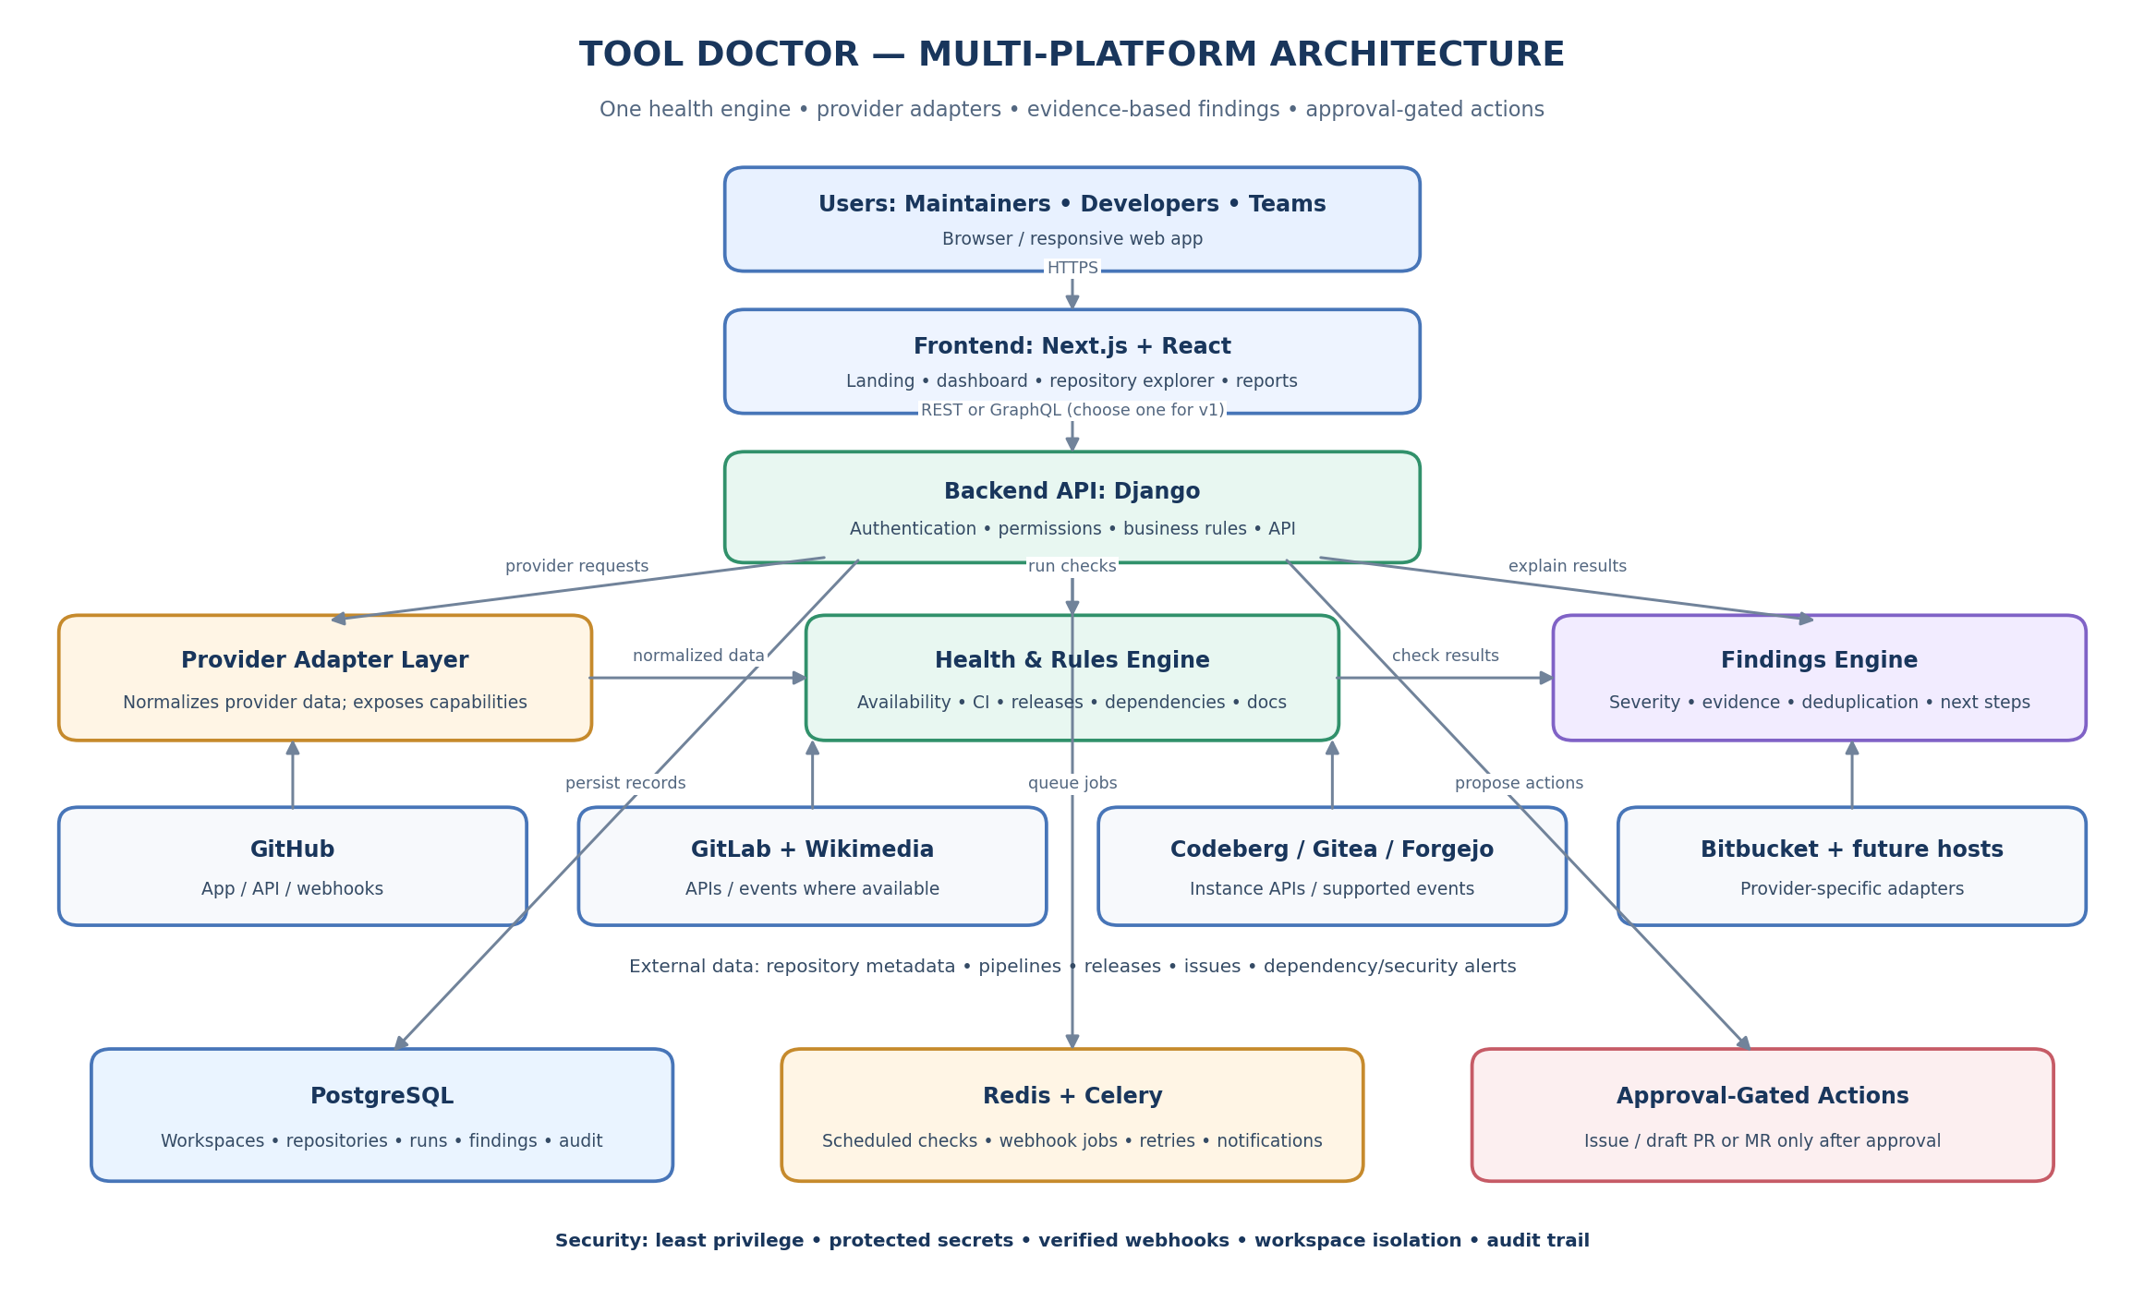
Conceptual architecture. Actual provider capabilities vary by API, instance, and permissions.

1. Concept in simple words
Tool Doctor helps open-source maintainers understand the health of repositories and tools, detect possible problems, see the evidence, and organize maintenance work. It connects to supported code-hosting platforms, runs configured checks, explains findings, and tracks whether issues are resolved.
It is not limited to Wikimedia or GitHub. A provider-adapter design lets the same health engine work across GitHub, GitLab, Wikimedia-related services, Codeberg, Gitea, Forgejo, Bitbucket, and future platforms where APIs and permissions permit.
Problem | Tool Doctor response | User benefit
A repository or endpoint may be unavailable. | Run supported availability checks and record evidence. | Clear status, timestamp, and verification detail.
CI or dependencies may be unhealthy. | Inspect available pipeline status and dependency signals. | Prioritized findings with sources and next steps.
Maintenance status is unclear. | Summarize releases, activity, and repository metadata. | Risk signals without falsely declaring a project abandoned.
Many projects need attention. | Deduplicate findings and support assignment and tracking. | A single maintenance queue across repositories.

2. Who is it for?
- Individual open-source maintainers managing several repositories.
- Contributors looking for useful maintenance tasks.
- Organizations and teams responsible for software projects.
- Community coordinators who need transparent, evidence-based project health information.

3. Core workflow
- Create a workspace and set access roles.
- Connect a provider or import a public repository where supported.
- Select repositories and enable checks.
- Collect permitted metadata through APIs, webhooks, or scheduled polling.
- Run checks and normalize provider-specific data.
- Display health summaries and findings with evidence.
- Assign follow-up work, approve supported actions, and rerun checks to verify fixes.

4. Architecture layers
Layer | Responsibility | Examples
Frontend | Public landing page and workspace interface. | Landing page, dashboard, repository explorer, health report.
Application API | Authentication, permissions, business logic, normalized data. | Django API; use REST or GraphQL consistently in v1.
Provider adapters | Translate each provider’s APIs/events into a common format. | GitHub, GitLab, Wikimedia sources, Forgejo/Gitea, Bitbucket.
Health engine | Run checks and evaluate observations. | Availability, CI, release recency, dependency and documentation signals.
Findings engine | Deduplicate results and explain risk. | Severity, evidence, uncertainty, recommendations, history.
Background workers | Execute scheduled and long-running jobs. | Celery, Redis, scheduler, retries, notifications.
Database | Persist app state and history. | PostgreSQL for workspaces, repositories, check runs, findings, audit.
External systems | Provide repository data and approved actions. | Provider APIs, webhooks, issue and PR/MR endpoints.

5. How a health check runs
Trigger → Select provider adapter → Fetch permitted data → Normalize results → Run checks → Create/update findings → Show evidence → Recheck after maintenance

Every finding should show what was observed, when it was observed, the source/evidence, severity, confidence or uncertainty, and the recommended next step. “Unknown” or “Not checked” is preferable to treating missing data as a failure.

6. Provider strategy
Provider | Integration approach | Notes
GitHub | GitHub App/API/webhooks where appropriate. | Use selected-repository and least-privilege permissions.
GitLab | OAuth/token, APIs and webhooks where supported. | SaaS and self-managed versions may differ.
Wikimedia ecosystem | Relevant Wikimedia APIs plus repository-host adapters. | Wikimedia projects can use different hosts/services; no single connector covers all tools.
Codeberg / Gitea / Forgejo | Instance APIs and supported events. | Capabilities depend on host/version/configuration.
Bitbucket | Cloud or Data Center API integration. | Treat Cloud and Data Center as distinct targets.
Other hosts | New adapter implementing the shared interface. | Generic public URL import may support fewer checks.

Recommended sequence: create the provider-neutral interface first, then complete one integration end-to-end (GitHub is a reasonable first option), add GitLab next, and prioritize further adapters based on actual user demand and API feasibility.

7. Adapter interface idea
ProviderAdapter\n ├─ validate_connection()\n ├─ list_repositories()\n ├─ get_repository_metadata()\n ├─ get_ci_status() [optional]\n ├─ get_releases() [optional]\n ├─ get_dependency_alerts() [optional]\n ├─ process_events() [optional]\n └─ create_approved_action() [optional; write permission required]

8. Main frontend pages
Page | Purpose
Landing page | Explain the multi-platform mission, supported providers, workflow, transparency, and contribution path.
Workspace dashboard | Health summary, open findings, critical items, recent checks, next actions.
Repository explorer | Search/filter by provider, workspace, language, owner, health, and last check.
Repository health report | Check breakdown, evidence, findings, history, and recommendations.
Findings center | Prioritized work queue, severity, status, owner, recurrence, and verification.
Connections/settings | Provider scopes, selected repositories, schedules, notification preferences, retention, audit.

9. Core data model
Entity | Stores
Workspace / Membership | Users, roles, workspace settings, access rules.
ProviderConnection | Provider, external account/instance, scopes, status, encrypted credential reference.
Repository | Provider, immutable external ID, namespace/path, URL, visibility, default branch.
CheckDefinition / CheckRun | Check rules and each execution’s result, timestamp, version, and evidence.
Finding | Severity, lifecycle status, evidence, confidence, timestamps, deduplication key.
Recommendation | Next step, explanation, source links, confidence, verification state.
ExternalAction / Approval | Proposed issue/comment/PR/MR, approval decision, execution state.
WebhookEvent / AuditEvent | Event processing state and traceable record of consequential actions.

10. Recommended technology stack
Area | Choice | Purpose
Frontend | Next.js + React | Landing page and interactive application.
Backend | Django + Django REST Framework or Django GraphQL | Authentication, provider logic, business rules, API.
Database | PostgreSQL | Durable records, relationships, constraints, history.
Background jobs | Celery + Redis | Scheduled checks, async processing, retries, notifications.
Secrets | Managed secret store or encrypted credential store | Protect provider credentials and refresh tokens.
Testing | Unit, integration, frontend, adapter contract tests | Ensure each adapter and shared engine behave predictably.

11. Security and trust
- Read-only access by default; request write access only for enabled features.
- Verify webhook authenticity and deduplicate incoming events.
- Enforce workspace and repository permissions on every request and background task.
- Never log access tokens; support disconnect, revocation, and data-retention controls.
- Do not infer abandonment from inactivity alone.
- Show sources, timestamps, limitations, and uncertainty for findings.
- Require explicit approval for external write actions and record them in an audit trail.
- Respect provider rate limits, terms, privacy rules, and instance-specific capabilities.

12. Implementation roadmap
Phase | Deliverable | Acceptance checkpoint
1. Foundation | Auth, workspace, database, basic web app. | User can sign in and create a workspace.
2. Adapter framework | Common interface, capability model, mock adapter. | Core works with fixtures without provider-specific assumptions.
3. First provider | Connect repositories and retrieve real metadata. | Selected repositories appear with correct access controls.
4. First checks | Availability, CI where available, release recency, basic dependency/docs signals. | Each check has timestamped evidence and tests.
5. Findings UI | Health reports, filters, deduplication, history. | Users can understand and track findings.
6. Second provider | Add GitLab or another priority provider through adapter. | Existing dashboard and health engine are reused.
7. More providers | Wikimedia-related sources and additional hosts. | Capabilities and unsupported checks are explicit.
8. Maintenance workflow | Assignments, notifications, approved issue/PR/MR actions. | No external write occurs without approval and audit.

13. Version-one scope
Keep the first release focused: one complete provider integration, a small set of reliable checks, and a strong findings workflow. Add providers incrementally. Do not promise universal coverage or automatic fixes before permissions, provider-specific behavior, and evidence quality are tested.

Product statement
Tool Doctor helps open-source maintainers discover repository health issues, understand evidence-backed risks, and coordinate fixes across multiple code-hosting platforms.

