Big Data Analysis

Practical 3: Single node Hadoop cluster

Objective :

Setup single node Hadoop cluster and apply HDFS commands on single node Hadoop Cluster.

Roll No. & Name : 18bce183 & Prince Prajapati

Submitted to: Prof. Jaiprakash Verma

1. Initialise HDFS

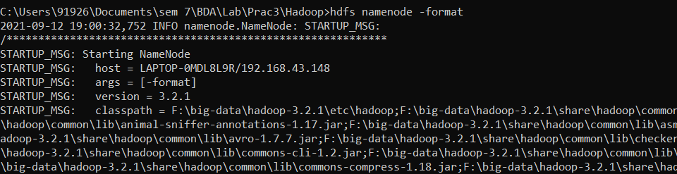

1. Start HDFS daemons

%HADOOP_HOME%\sbin\start-dfs.cmd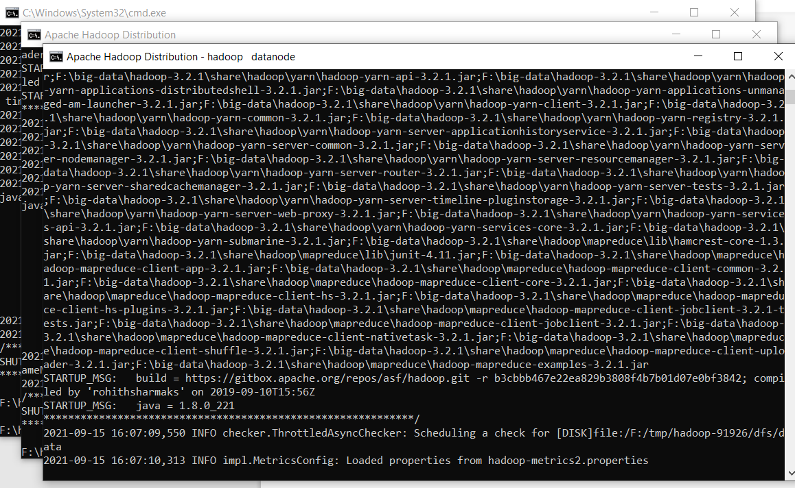

1. Start YARN daemons

%HADOOP_HOME%\sbin\start-yarn.cmd

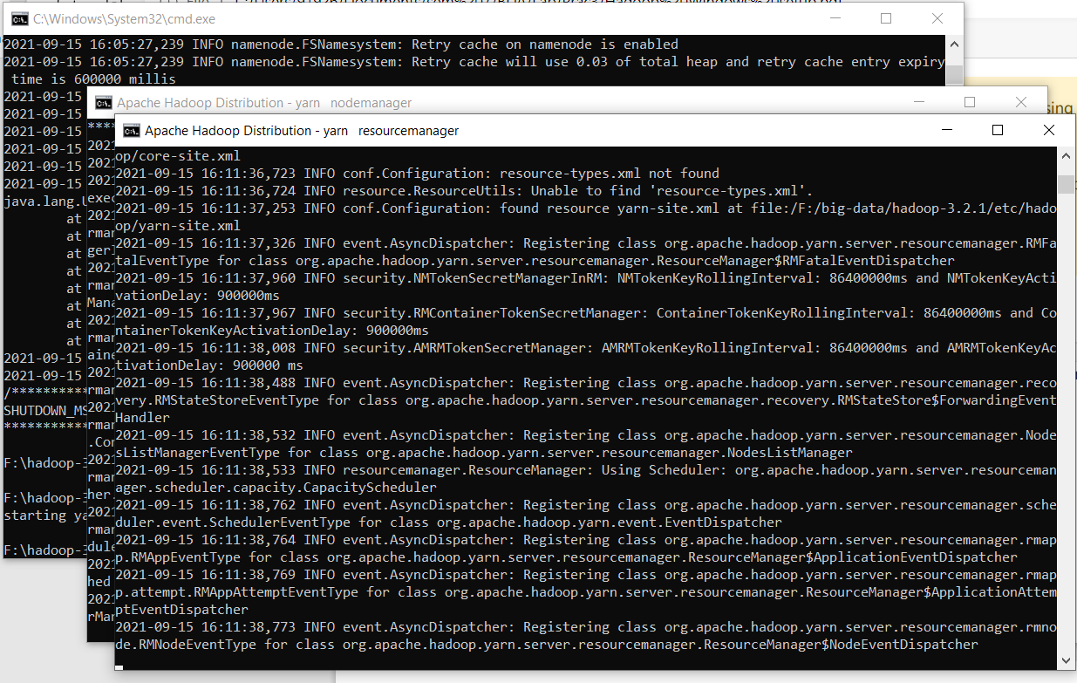

1. Print the Hadoop version
   * hadoop version

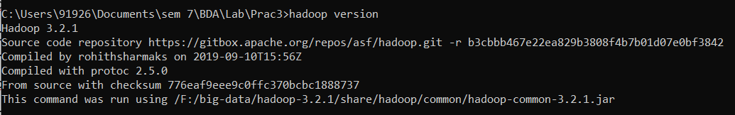

1. jps : Java Virtual Machine Process Status tool.

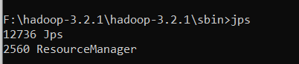

1. make direcory
2. List the contents of the root directory in HDFS
   * hadoop fs -ls /
   * Hadoop fs -mkdir /directory

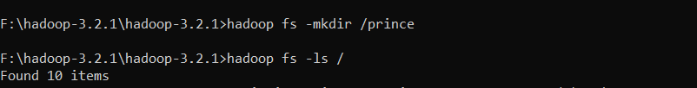

...

1. Report the amount of space used and available on currently mounted files system
   * hadoop fs -du hdfs:/

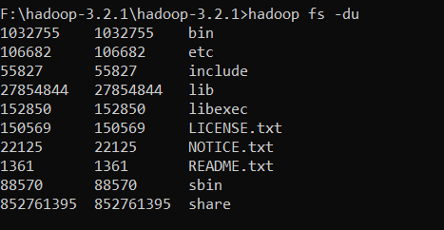

1. Count the number of directories, files and bytes under the paths that match the specified file pattern
   * hadoop fs -count hdfs:/



1. Run a DFS file system checking utility
   * hadoop fsck – /

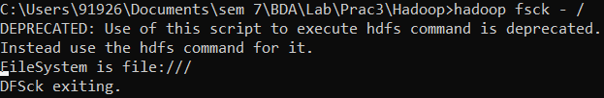

1. Run a cluster balancing utility
   * hadoop balancer

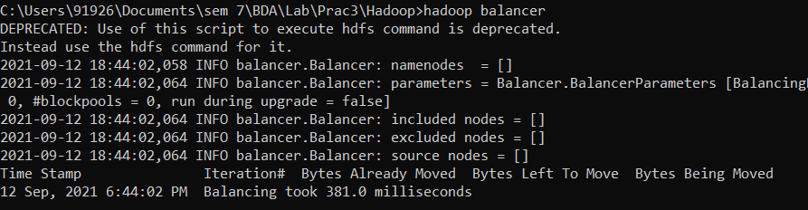

1. hadoop fs -put F:/sample.txt /prince : add local directory file to hdfs directory

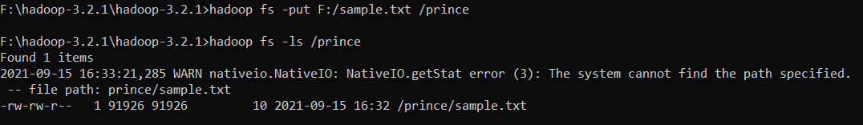

1. hadoop fs -put C:/Users/Hp/retail /hadoop : add local directory folder to hdfs directory

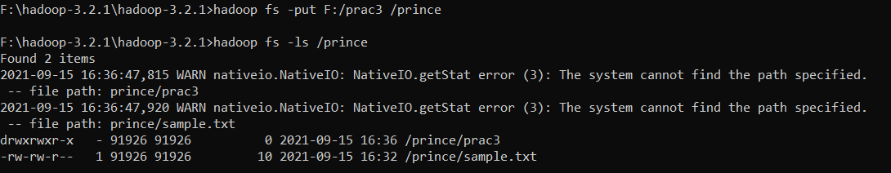

1. hadoop fs -du -s -h /prince : See how much space directory occupies in HDFS.



1. hadoop fs -rm /prince/sample.txt : deleting a file from directory in hdfs



1. hadoop fs -rm /prince/prac3/* : deleting all the files from directory in hdfs



1. hadoop fs –expunge : to empty the trash



1. hadoop fs -rmr /prince/prac3 : remove entire directory and all its content in hdfs



1. hadoop fs -copyFromLocal C:/Users/Hp/purchases.txt /hadoop : add local directory file to hadoop directory in hdfs



1. hadoop fs -cat /prince/PP2.java : view the content of file which is present in hdfs directory

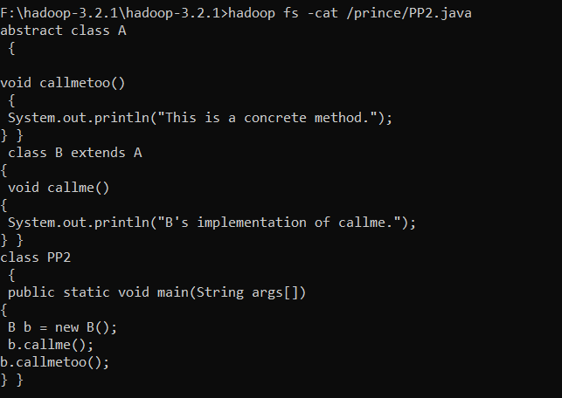

1. hadoop fs -copyToLocal /prince/PP2.java F:\tmp: add file which is present in hdfs directory to local directory

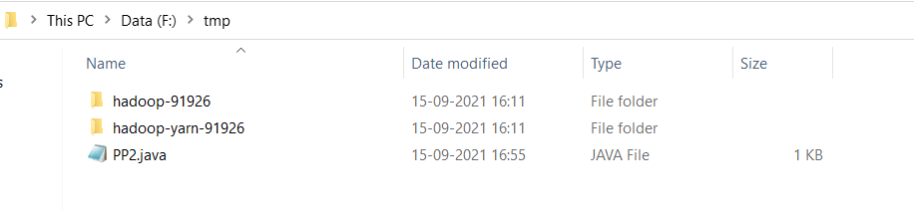

Conclusion : After implementing this practical now I have good practice in working with Hadoop and its commands.