Big Data Analysis

Practical 6: MapReduce

Objective :

Analyse impact of different number of mapper and reducer on same definition as practical 4.

• Prepare a conclusive report on analysis.

Roll No. & Name : 18bce183 & Prince Prajapati

Submitted to: Prof. Jaiprakash Verma

Table:

|  |  |  |  |  |
| --- | --- | --- | --- | --- |
| NO. | Mapper | Reducer | Time (Second) | File Size(Lines) |
| 1 | 1 | 1 | 47 | 7 |
| 2 | 2 | 1 | 35 | 7 |
| 3 | 1 | 2 | 31 | 7 |
| 4 | 2 | 2 | 40 | 7 |
| 5 | 5 | 1 | 51 | 7 |
| 6 | 1 | 5 | 41 | 7 |
| 7 | 5 | 5 | 92 | 7 |
| 1 | 1 | 1 | 45 | 100 |
| 2 | 1 | 2 | 32 | 100 |
| 3 | 2 | 1 | 30 | 100 |
| 4 | 2 | 2 | 30 | 100 |
| 5 | 5 | 1 | 34 | 100 |
| 6 | 1 | 5 | 37 | 100 |
| 7 | 5 | 5 | 42 | 100 |
| 8 | 10 | 1 | 43 | 100 |

Mapper:1 ,Reducer:1 ,Lines:7 Mapper: 2, Reducer: 1 , Lines: 7

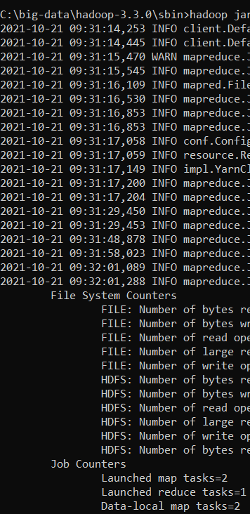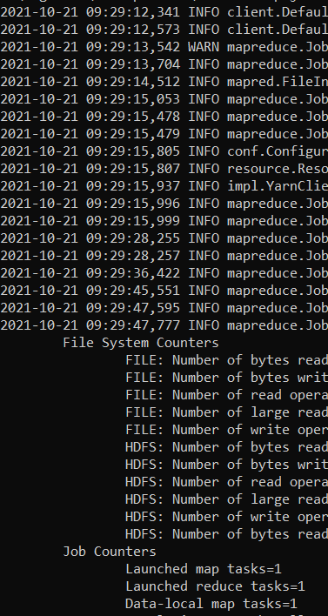time :35 time:47

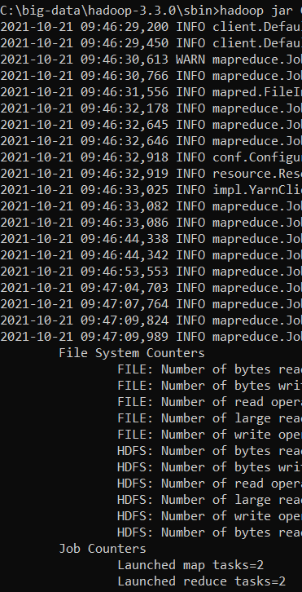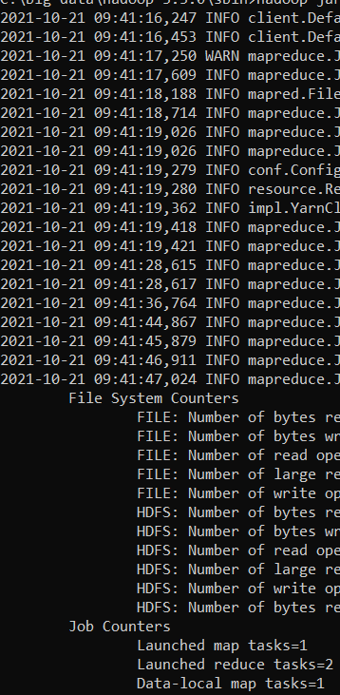Mapper:1 Reducer:2 Lines:7 Mapper:2 Reducer:2 Lines:7  
time:31 time:40

Mapper:5,Reducer:1,Lines:7 Mapper:1,Reducer:5 Mapper:5,Reducer:5

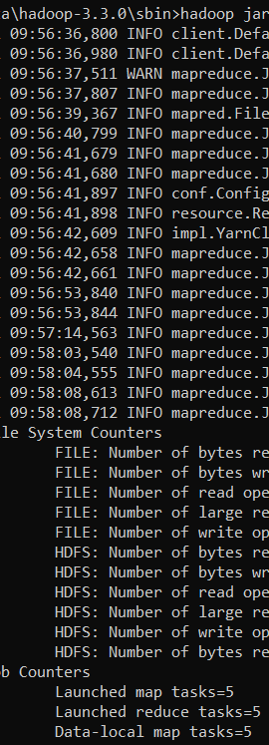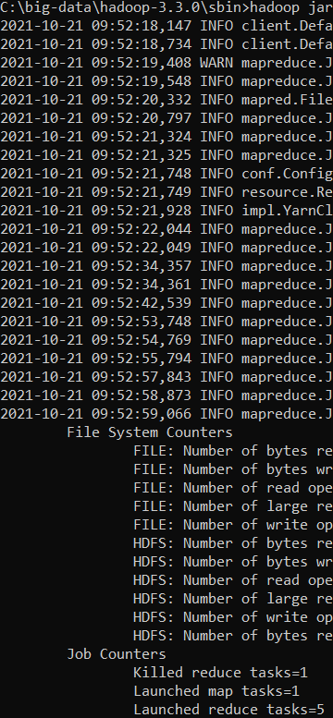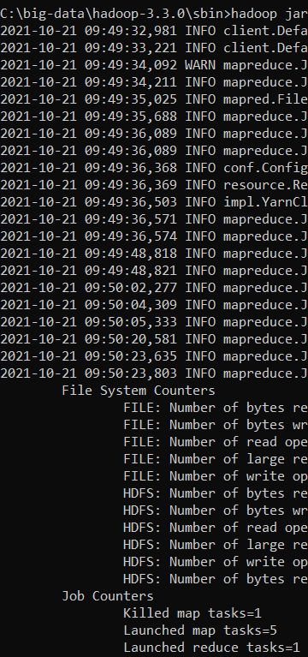time:51 time:41 tim:92

Mapper:1, Reducer:1, Lines:100 ,time:45 Mapper:1 ,Reducer:1 ,Lines:100, time:31

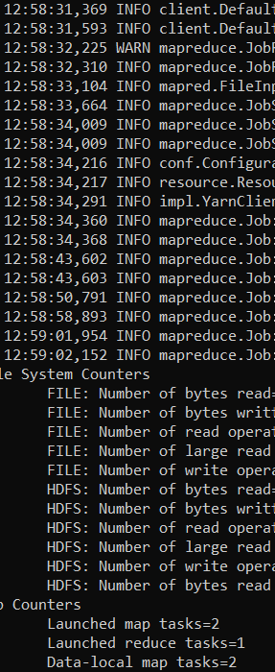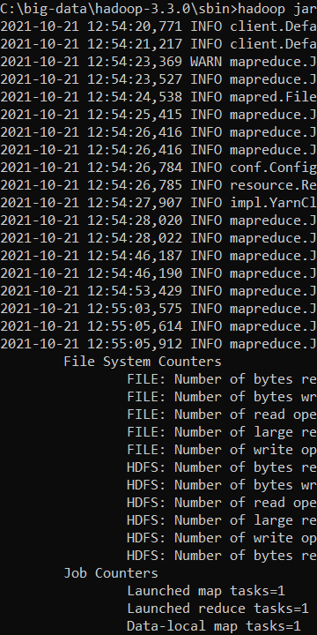

Mapper:1,Reducer:2,Lines:100, Mapper:2,Reducer:1,Lines:100 Mapper:2,Reducer:2,Lines:100

Time:32 Time:30 Time:30

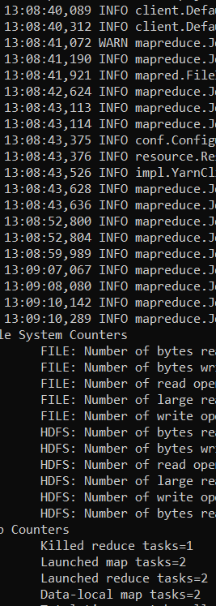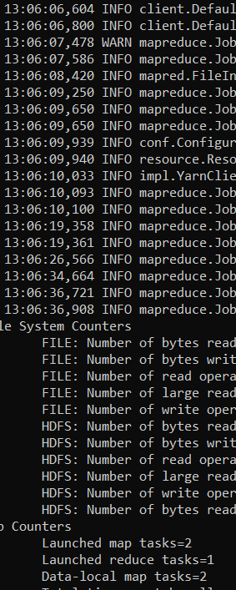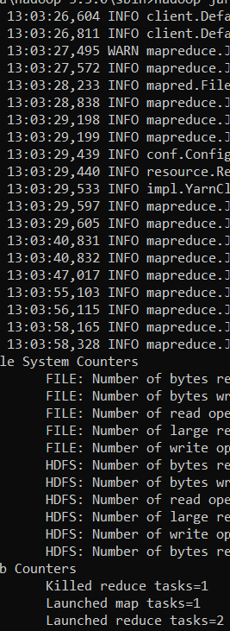

Mapper:5,reduce:1,line:100 Mapper:1,Reducer:5, line:100 Mapper:5,Reducer:5,line:100

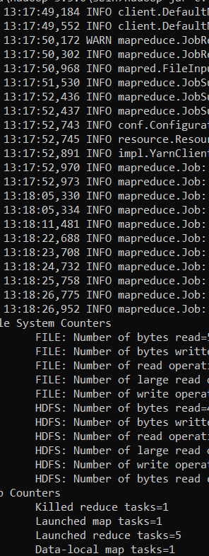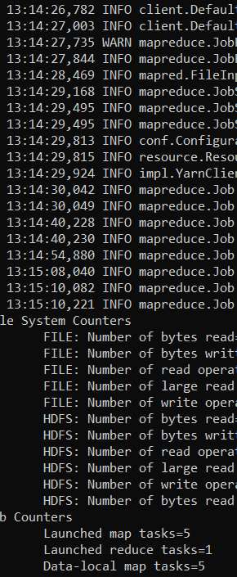 Time:34 Time:37 Time:42

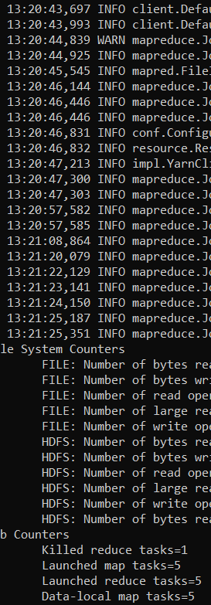

Mapper:10,Reducer:1, size:100

Time:43

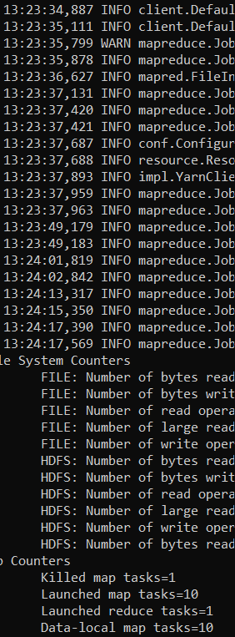

**Conclusion:**

Mapper and Reducer sizes are depends on input size and types of data.

If input size is greater then mappers requirement is more.

Reducer size depends in quality of data.