Big Data Analysis

Practical 9

Objective :

Setup Cassandra environment in your system and apply Create, Update, Read and Delete operations.

Roll No. & Name : 18bce183 & Prince Prajapati

Submitted to: Prof. Jaiprakash Verma

What is Apache Cassandra?

Apache Cassandra is a highly scalable, high-performance distributed database designed to handle large amounts of data across many commodity servers, providing high availability with no single point of failure. It is a type of NoSQL database

**Download Cassandra:**

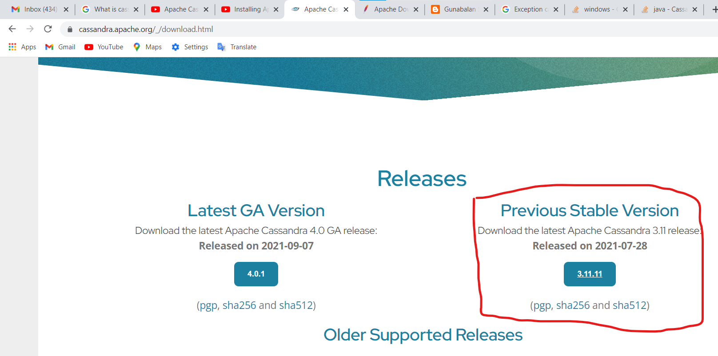

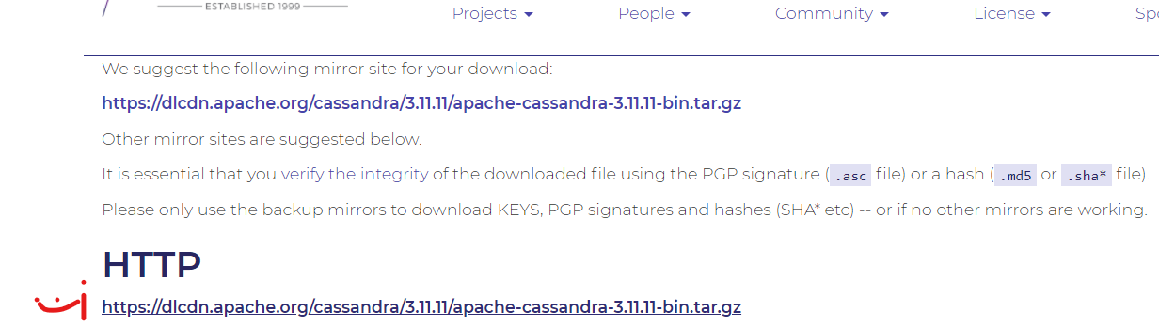

**Set PATH:**





**SET ExecutionPolicy:**

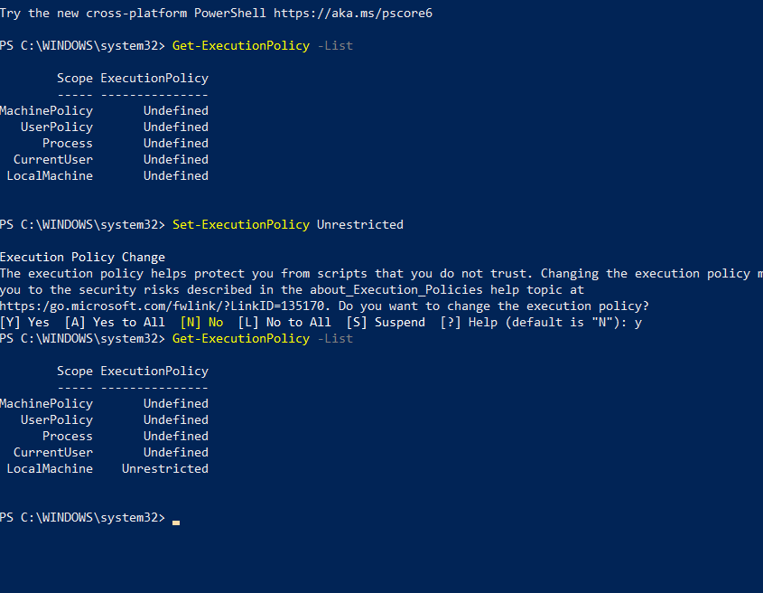

**Now Check Cassandra running :**

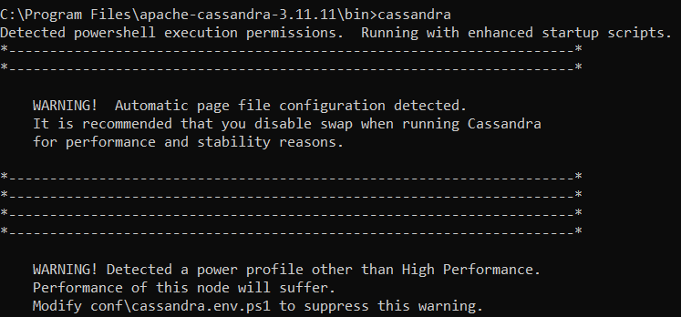

**CREATE KEYSPACE:**

|  |
| --- |
| CREATE KEYSPACE PRAC9 WITH replication  = {'class': 'SimpleStrategy', 'replication_factor': 3}; |

1. Strategy: There are two types of strategy declaration in Cassandra syntax:

Simple Strategy: Simple strategy is used in the case of one data center. In this strategy, the first replica is placed on the selected node and the remaining nodes are placed in clockwise direction in the ring without considering rack or node location.

Network Topology Strategy: This strategy is used in the case of more than one data centers. In this strategy, you have to provide replication factor for each data center separately.

1. Replication Factor: Replication factor is the number of replicas of data placed on different nodes. More than two replication factor are good to attain no single point of failure. So, 3 is good replication factor.

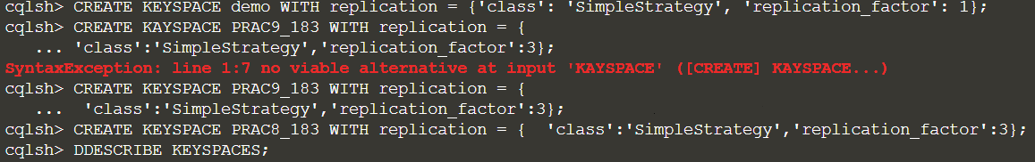

**VIEW ALL KEYSPACES:**

|  |
| --- |
| DESCRIBE KEYSPACES; |

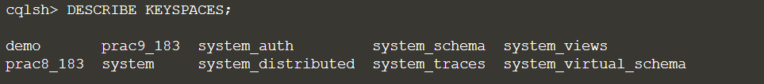

**ALTER KEYSPACE:**

|  |
| --- |
| ALTER KEYSPACE PRAC8 WITH replication = {'class':'NetworkTopologyStrategy', 'replication_factor' : 1}; |

**DROP KEYSPACE:**

|  |
| --- |
| DROP KEYSPACE PRAC8 ; |

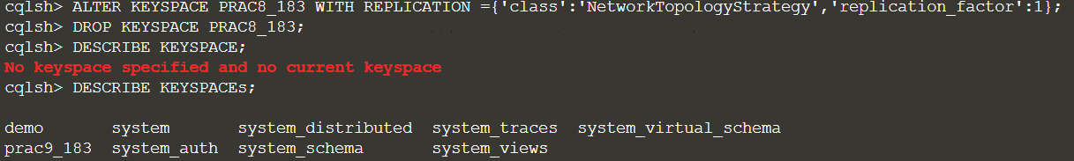

**CREATE TABLE:**

|  |
| --- |
| CREATE TABLE PRAC9_183.users  (firstname text PRIMARY KEY,  lastname text,  email text); |



**INSERT VALUES INTO TABLE(CREATE):**

|  |
| --- |
| USE PRAC9_183;  INSERT INTO users(lastname,firstname,email)  VALUES(‘Round’, ‘Creaig’, ‘craig@gmail.com’); |

**SELECT (READ):**

WHERE clause can be used only on the columns that are a part of primary key or have a secondary index on them.

|  |
| --- |
| SELECT * from users;  SELECT * FROM users WHERE firstname = 'Cassi'; |

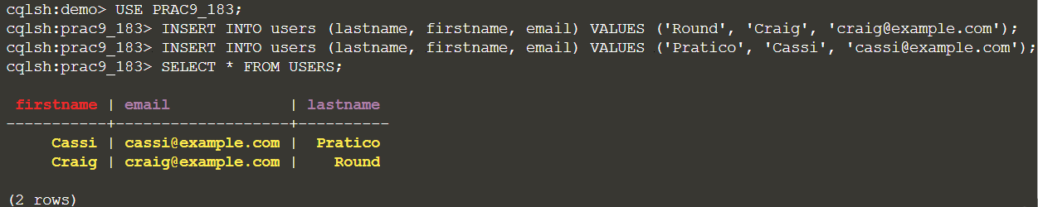

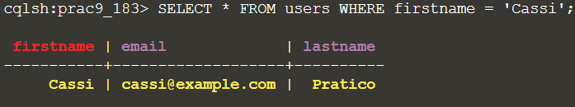

**SET (UPDATE):**

|  |
| --- |
| UPDATE users SET email = '18bce183@nirmauni.ac.in'  WHERE firstname = 'Cassi'; |

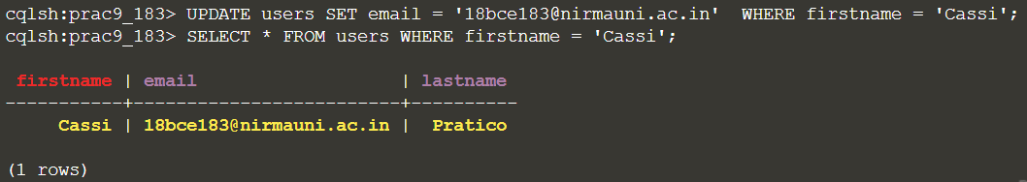

**DELETE :**

|  |
| --- |
| DELETE FROM users WHERE firstname='Cassi'; |

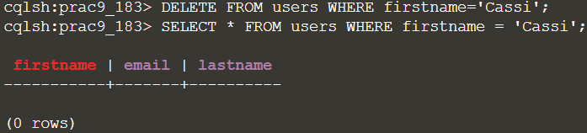

**Conclusion:**

**After implementing this practical now I have complete understanding of how Cassandra works and how to use it operations.**