Choose the Right Hardware

*Proposal Template*

# Scenario 1: Manufacturing

Client Requirements and Potential Hardware Solution

Look through the scenario and find any relevant client requirements. Then, suggest a potential hardware type and explain how this hardware would satisfy each of the requirements.

|  |
| --- |
| **Which hardware might be most appropriate for this scenario?**  **(CPU / IGPU / VPU / FPGA)** |
| *gpu* |

|  |  |
| --- | --- |
| **Requirement Observed (Include at least two.)** | **How does the chosen hardware meet this requirement?** |
| *Example requirement:*  The client requires a tiny device to be connected to their  CPU—and their budget is only about $100 for each device. | *Example explanation:*  VPU or NCS2 is only about 27.40 mm in size and would fit in the price range. |
| *Noticed that work stuck at a single point at unit 7* | *Means they need to monitor a particular facility and GPU is better in this case* |
| *Already camera installed working on 30-35 fps* | *We need to increase fps that can be done by GPU* |
| need to be able to run inference on the video stream very quickly | *At low cost gpu is the best solution to increse fps* |

Queue Monitoring Requirements

|  |  |
| --- | --- |
| **Maximum number of people in the queue** | *5* |
|  | *FP16* |
| **Model precision chosen (FP32, FP16, or Int8)** |

Test Results

After you've tested your application on all four hardware types (CPU, IGPU, VPU, and FPGA), copy the matplotlib output showing the comparison into the spaces below. You should have three graphs (for model load time, inference time, and FPS).

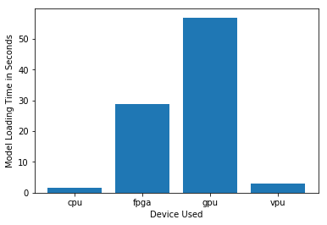

## Model Load Time

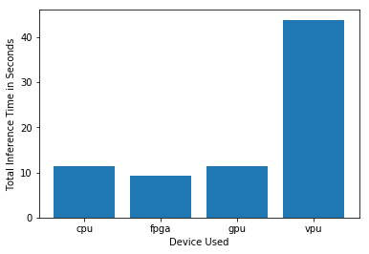

## Inference Time

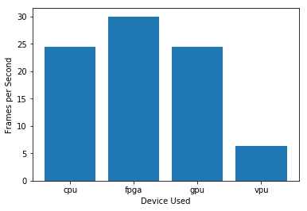

***FPS***

Final Hardware Recommendation

Now synthesize your points from above and provide a brief write-up describing why the chosen hardware is the best choice for this scenario. Be sure to discuss the client's requirements, the test results, and how these relate to one another (e.g., perhaps one of the devices performed better than the rest, but does not meet one of the client's requirements).

|  |
| --- |
| **Write-up: Final Hardware Recommendation** |
| ***FPGA*** |

# Scenario 2: Retail

Client Requirements and Potential Hardware Solution

Look through the scenario and find any relevant client requirements. Then, suggest a potential hardware type and explain how this hardware would satisfy each of the requirements.

|  |
| --- |
| **Which hardware might be most appropriate for this scenario?**  **(CPU / IGPU / VPU / FPGA)** |
| *CPU* |

|  |  |
| --- | --- |
| **Requirement Observed (Include at least two.)** | **How does the chosen hardware meet this requirement?** |
| *Example requirement:*  The client requires a tiny device to be connected to their  CPU—and their budget is only about $100 for each device. | *Example explanation:*  VPU or NCS2 is only about 27.40 mm in size and would fit in the price range. |
| save as much as possible on his electric bill. | *Low power consumption devices could be CPU or NCS2* |
| *Already has intel i7 processor* | *Already have pretty powerful computer so cpu alone will be enough* |
| *Waiting time is 200-300 ms* | *Means we did not need a super computer kind of stuff* |

Queue Monitoring Requirements

|  |  |
| --- | --- |
| **Maximum number of people in the queue** | *5* |
| **Model precision chosen (FP32, FP16, or Int8)** | *FP16* |

Test Results

After you've tested your application on all four hardware types (CPU, IGPU, VPU, and FPGA), copy the matplotlib output showing the comparison into the spaces below. You should have three graphs (for model load time, inference time, and FPS).

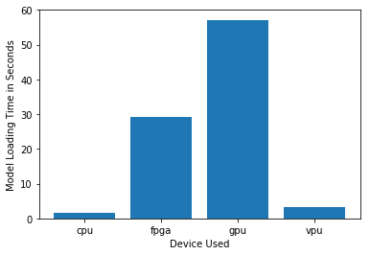

***Model Load Time***

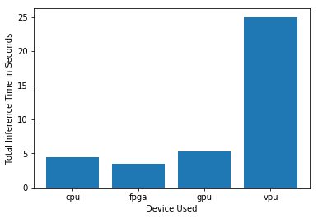

***Inference Time***

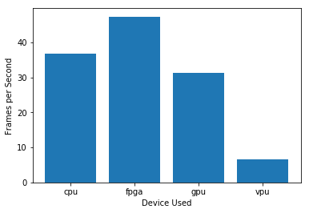

***FPS***

Final Hardware Recommendation

Now synthesize your points from above and provide a brief write-up describing why the chosen hardware is the best choice for this scenario. Be sure to discuss the client's requirements, the test results, and how these relate to one another (e.g., perhaps one of the devices performed better than the rest, but does not meet one of the client's requirements).

**Write-up: Final Hardware Recommendation**

*IGPU*

# Scenario 3: Transportation

Client Requirements and Potential Hardware Solution

Look through the scenario and find any relevant client requirements. Then, suggest a potential hardware type and explain how this hardware would satisfy each of the requirements.

|  |
| --- |
| **Which hardware might be most appropriate for this scenario?**  **(CPU / IGPU / VPU / FPGA)** |
| *FPGA* |

|  |  |
| --- | --- |
| **Requirement Observed (Include at least two.)** | **How does the chosen hardware meet this requirement?** |
| *Example requirement:*  The client requires a tiny device to be connected to their  CPU—and their budget is only about $100 for each device. | *Example explanation:*  VPU or NCS2 is only about 27.40 mm in size and would fit in the price range. |
| Delhi Metro makes 2,700 trips every day and is one of the busiest metros in India. | *Very crowded hence need a high speed processor and FPGA and VPU is useful* |
| 7 CCTV cameras on the platform. | *Means have to distribute the computation FPGA is useful* |
| Ms. Leah's budget allows for a maximum of $300 per machine, and she would like to save as much as possible both on hardware and future power requirements. | *Costly and diverse system required* |

Queue Monitoring Requirements

|  |  |
| --- | --- |
| **Maximum number of people in the queue** | *15* |
| **Model precision chosen (FP32, FP16, or Int8)** | *FP16* |

Test Results

After you've tested your application on all four hardware types (CPU, IGPU, VPU, and FPGA), copy the matplotlib output showing the comparison into the spaces below. You should have three graphs (for model load time, inference time, and FPS).

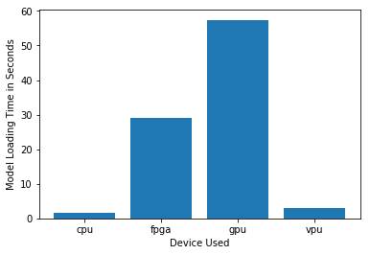

## Model Load Time

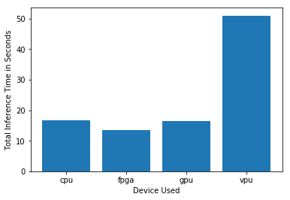

## Inference Time

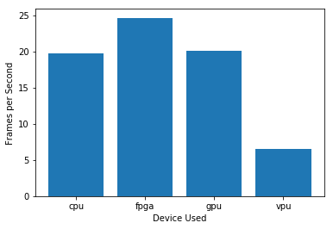

***FPS***

Final Hardware Recommendation

Now synthesize your points from above and provide a brief write-up describing why the chosen hardware is the best choice for this scenario. Be sure to discuss the client's requirements, the test results, and how these relate to one another (e.g., perhaps one of the devices performed better than the rest, but does not meet one of the client's requirements).

|  |
| --- |
| **Write-up: Final Hardware Recommendation** |
| ***VPU*** |