# Chapter-3

Analysis & Design

## 

## Use-case Diagrams

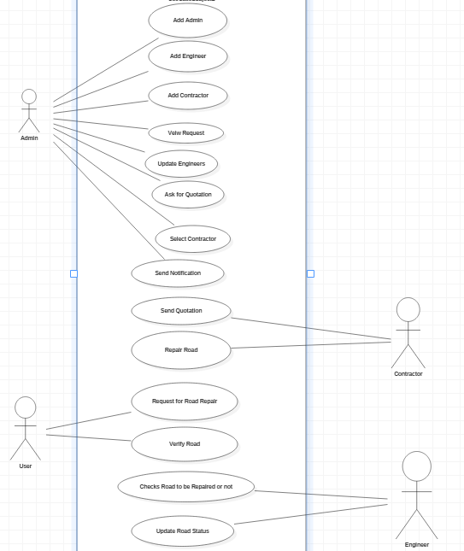

**Figure 3.1: Use-case Diagram of Road Repair Request System**

## Activity Diagrams

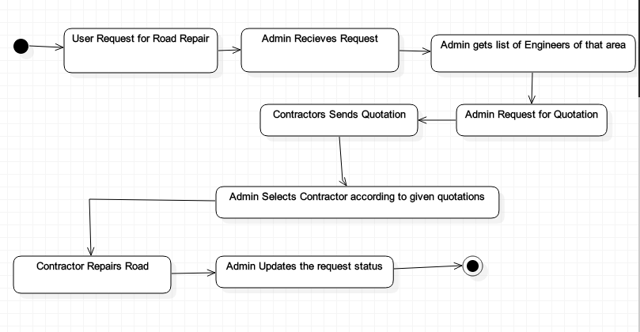

**3.2: Activity Diagram of Road Repair Request System**

## Sequence Diagrams

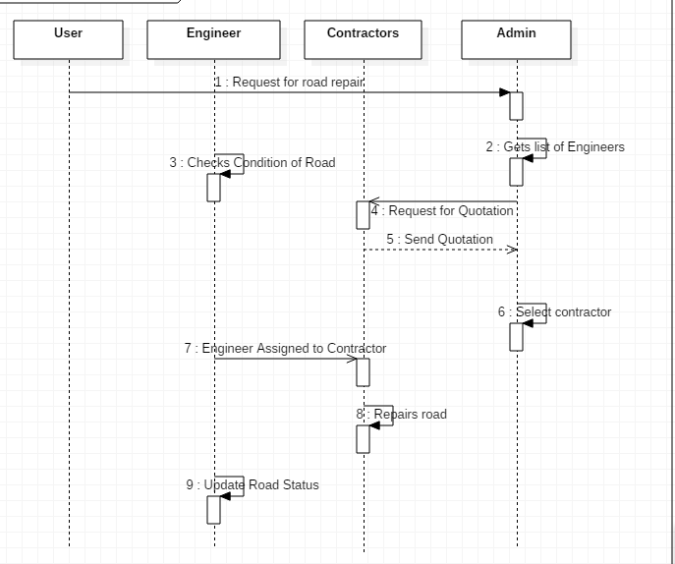

**3.3: Sequence Diagram of Road Repair Request System**

## 3.4 Class Diagrams

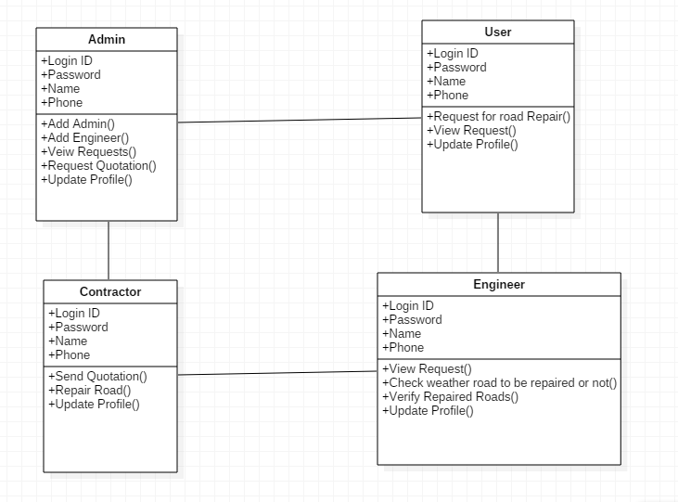

**3.4: Class Diagram of Road Repair Request System**