# Chapter-5

Conclusion & Future Works

Appendix A

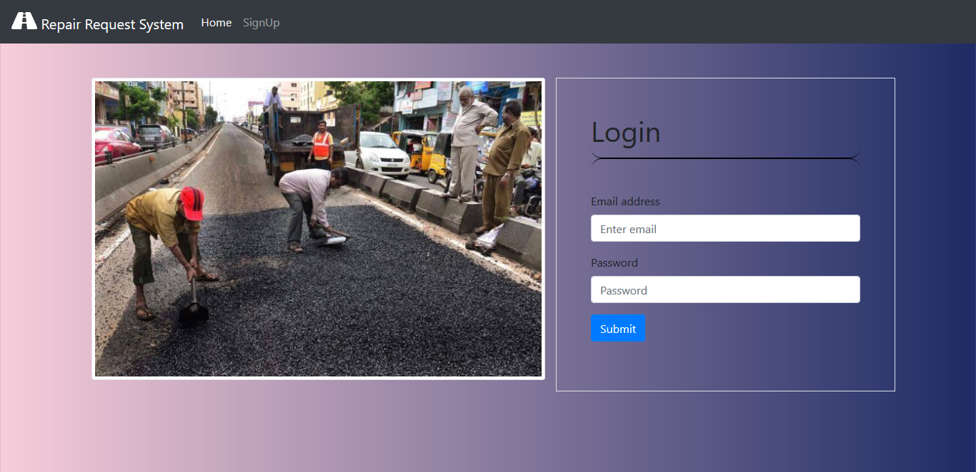Fig. 5.1: Login Page

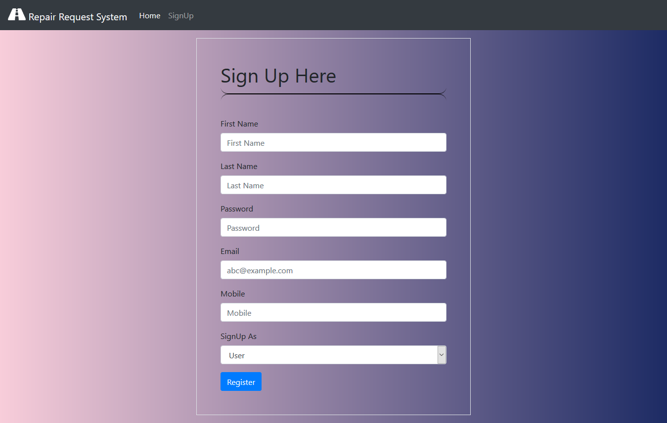Fig 5.2: Signup Page

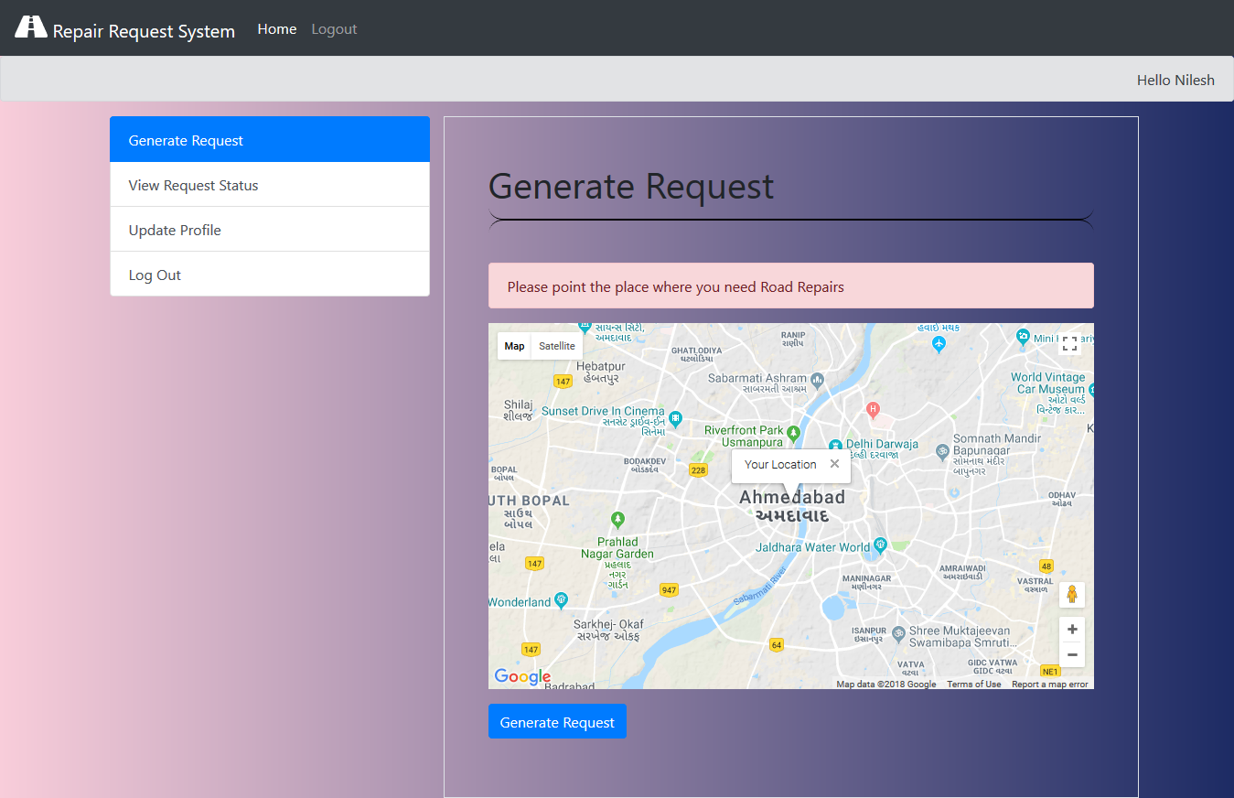Fig 5.3: Generate Request Page (User)

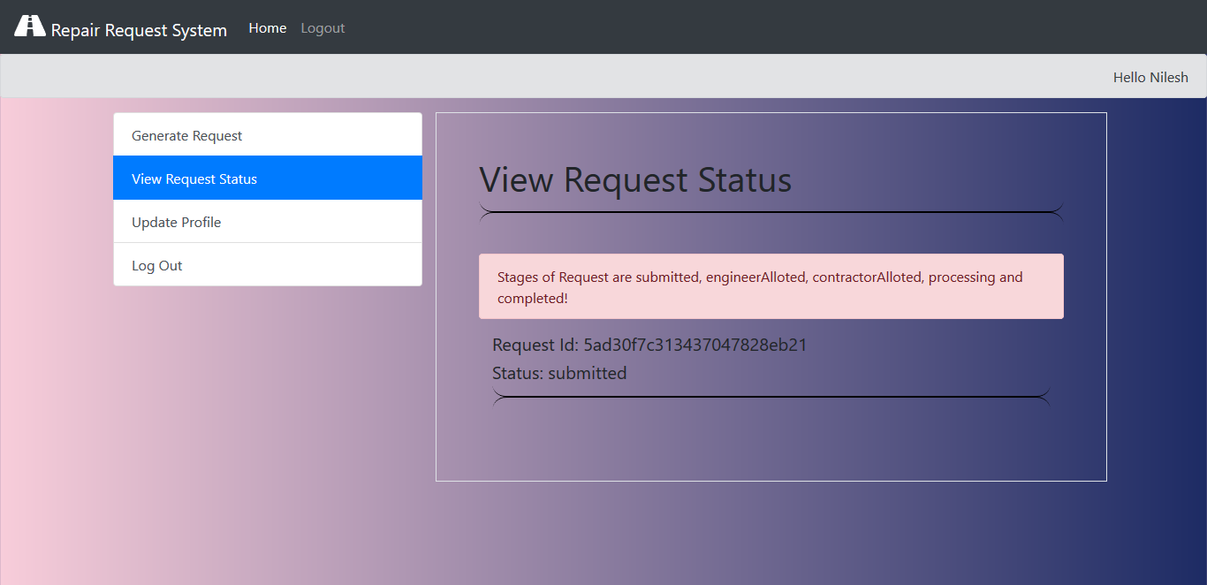Fig 5.4: View Request Status Page (User)

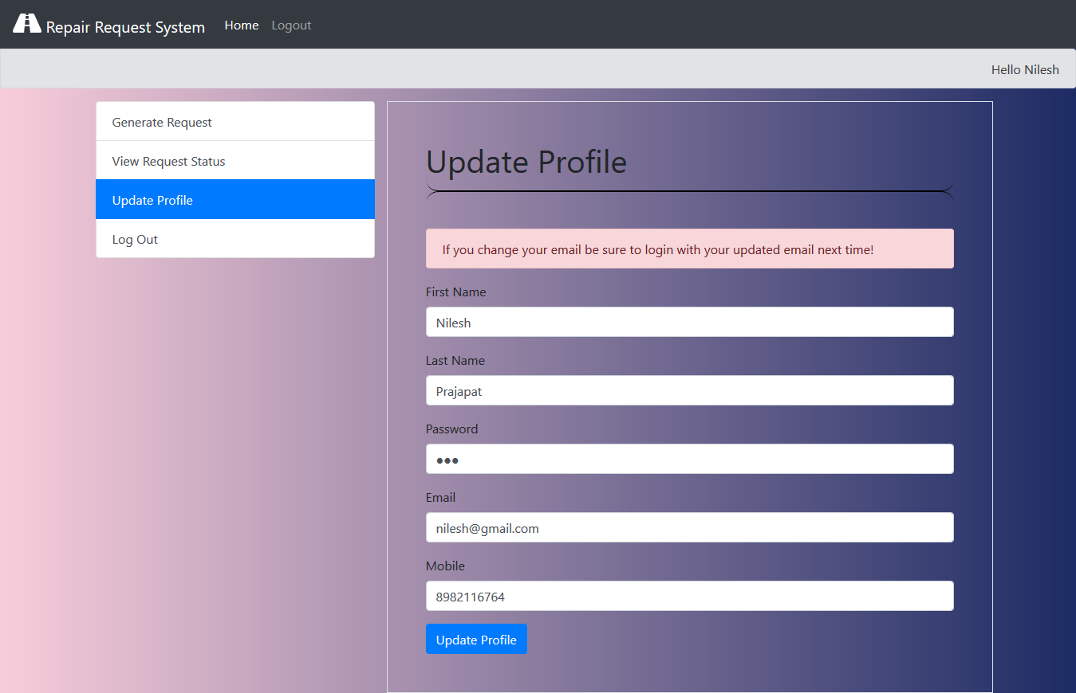Fig 5.5: Update Profile Page (User)

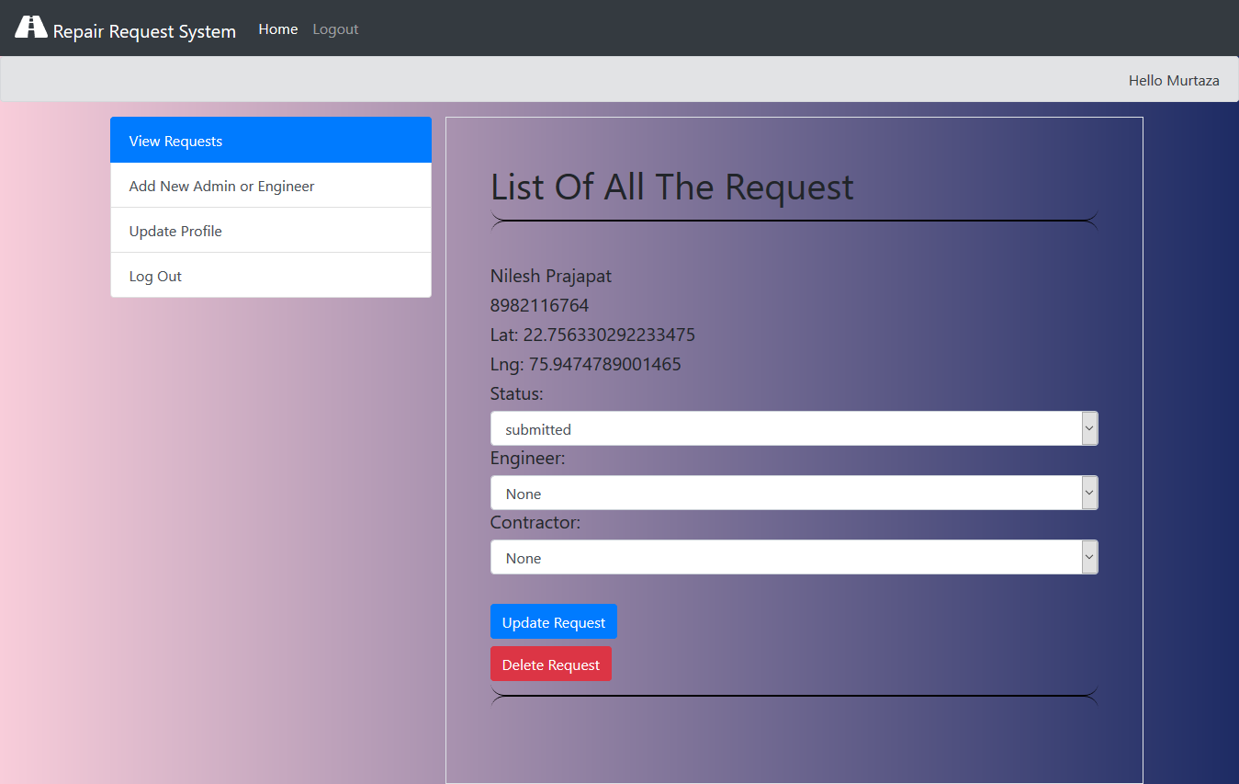Fig 5.6: View Request List Page (Admin)

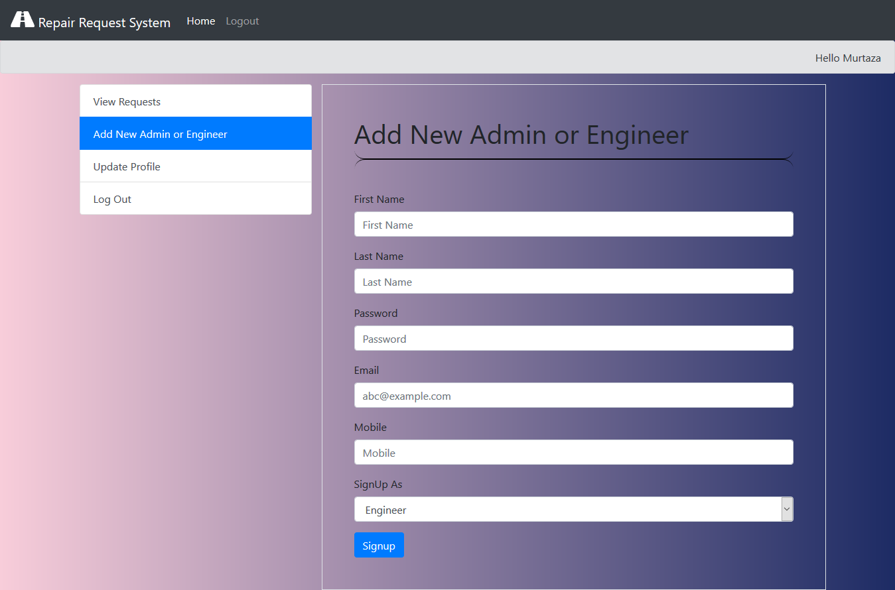Fig 5.7: Add New Admin or Engineer (Admin)

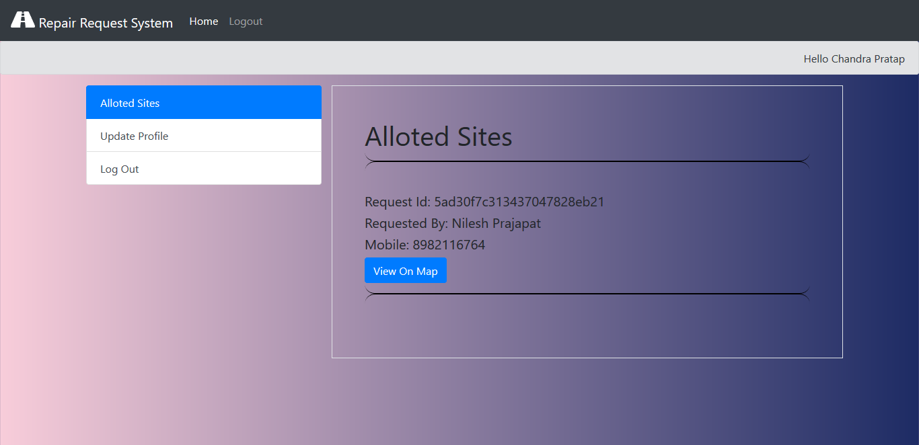Fig 5.8: Allotted Sites Page (Engineer)

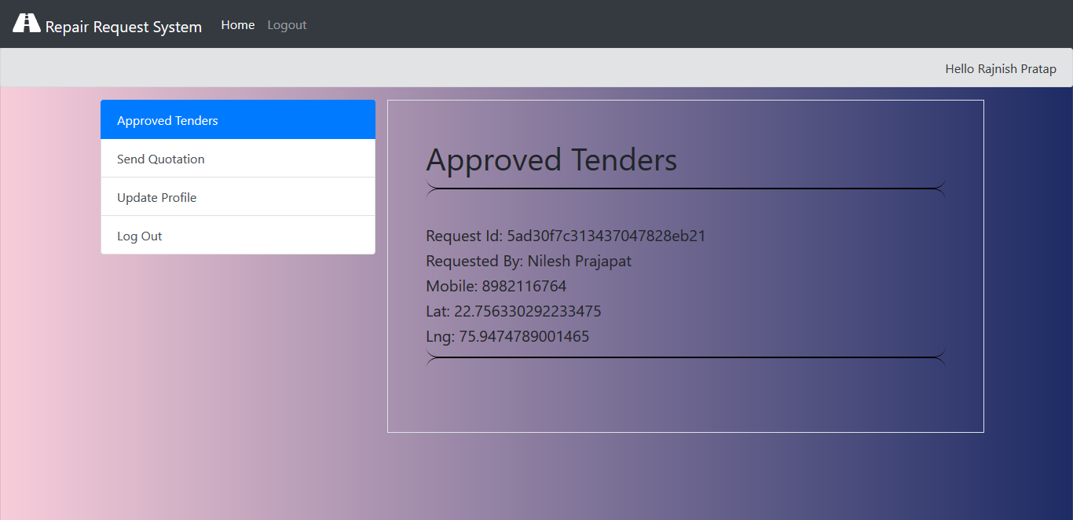Fig 5.9: Approved Tenders Page (Contractor)

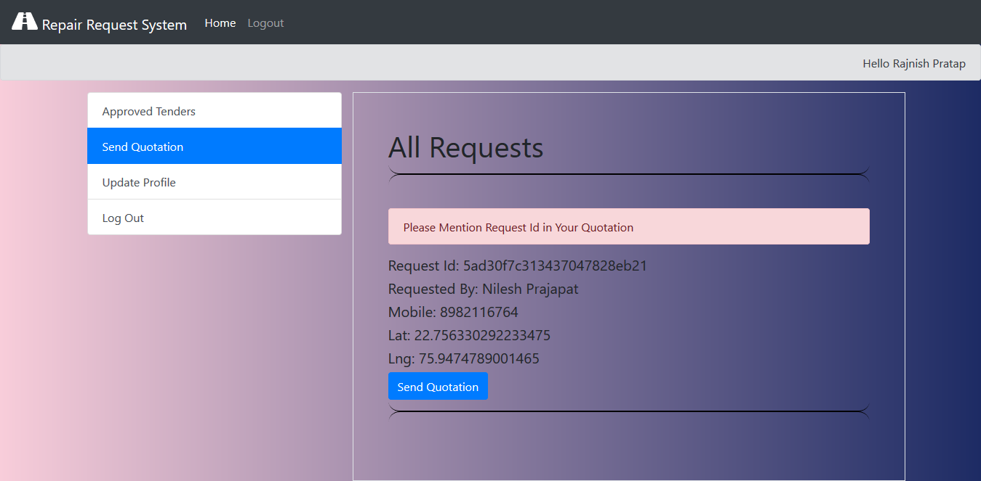Fig 5.10: Send Quotation Page (Contractor)