CHAPTER FOUR
RESULTS AND DISCUSSION
4.1 Introduction
Chapter Three described the design science research approach, the iterative SDLC methodology, and the detailed design of the appointment booking module, the voice-to-voice translation module, and the digital navigation module that together make up the UCC Eye Clinic system. This chapter presents the outcomes of that design and implementation process. It reports on how each of the three modules was realised as a working system, presents the results obtained from functional, usability, and performance testing, and discusses these results in relation to the research objectives and research questions set out in Chapter One. The chapter is organised into three main sections: Section 4.2 presents the design and implementation of the system, Section 4.3 presents the results of testing and evaluation together with a discussion of findings, and Section 4.4 summarises the chapter and its implications for the conclusions drawn in Chapter Five.
4.2 Design and Implementation
The system was implemented as a three-tier web application, following the architecture set out in Section 3.5, and was accessed through a single dashboard from which a patient or staff member could reach the appointment booking module, the Language Translation tool, and the Map (navigation) feature through three clearly labelled, standalone entry points. Implementation proceeded module by module, in the order established by the Agile sprint structure described in Section 3.3: the appointment booking module was implemented and stabilised first, followed by the voice-to-voice translation module, and finally the digital navigation module. The sections below present the implementation outcomes for each module in turn.
4.2.1 Appointment Booking Module
The appointment booking module was implemented as specified in Section 3.6, using a typed-text interface throughout. On registering and logging in, a patient is presented with a calendar view populated from the Clinic Capacity entity, showing only those dates on which slots remain available. Selecting a date reveals the available time slots for that day; selecting a slot advances the patient to a typed symptom-note screen, where booking details are entered and stored in the Symptom Notes entity. On submission, the system writes a new record to the Appointments entity, generates an automated confirmation, and returns the patient to the dashboard. Figure 4.1 illustrates the resulting booking flow as implemented.
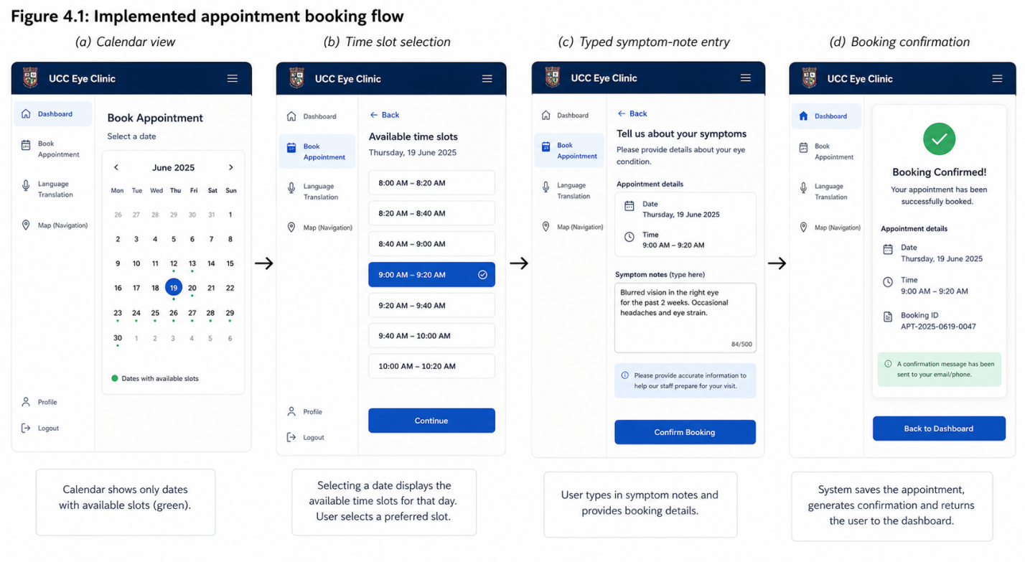
Rescheduling and cancellation were implemented as extensions of the same typed-text flow, allowing a patient to select an existing appointment from a list and either choose a new slot or confirm cancellation, both of which update the Appointments and Clinic Capacity entities accordingly. On the staff side, the reception dashboard specified in Section 3.5.2 was implemented as a filterable table of appointments by date and status, from which staff can confirm, reschedule, or decline a booking. During implementation, the booking flow initially required four screens to complete a booking; usability observations obtained during the sprint (see Section 4.3.2) led to the symptom-note and confirmation screens being merged into three screens overall, in keeping with the single-task-per-screen principle described in Section 3.5.4.
4.2.2 Voice-to-Voice Translation Module
The voice-to-voice translation module was implemented as specified in Section 3.7, combining Whisper, Google Gemini, and Coqui TTS behind a single Language Translation screen. On this screen, a microphone control captures a spoken utterance, which is transcribed by Whisper and displayed to the user as an editable live transcript before being sent to Gemini for translation between English and Akan; the translated text is then passed to Coqui TTS, which synthesises and plays back the corresponding audio. Figure 4.2 illustrates the implemented translation flow as it operates during a clinic visit.
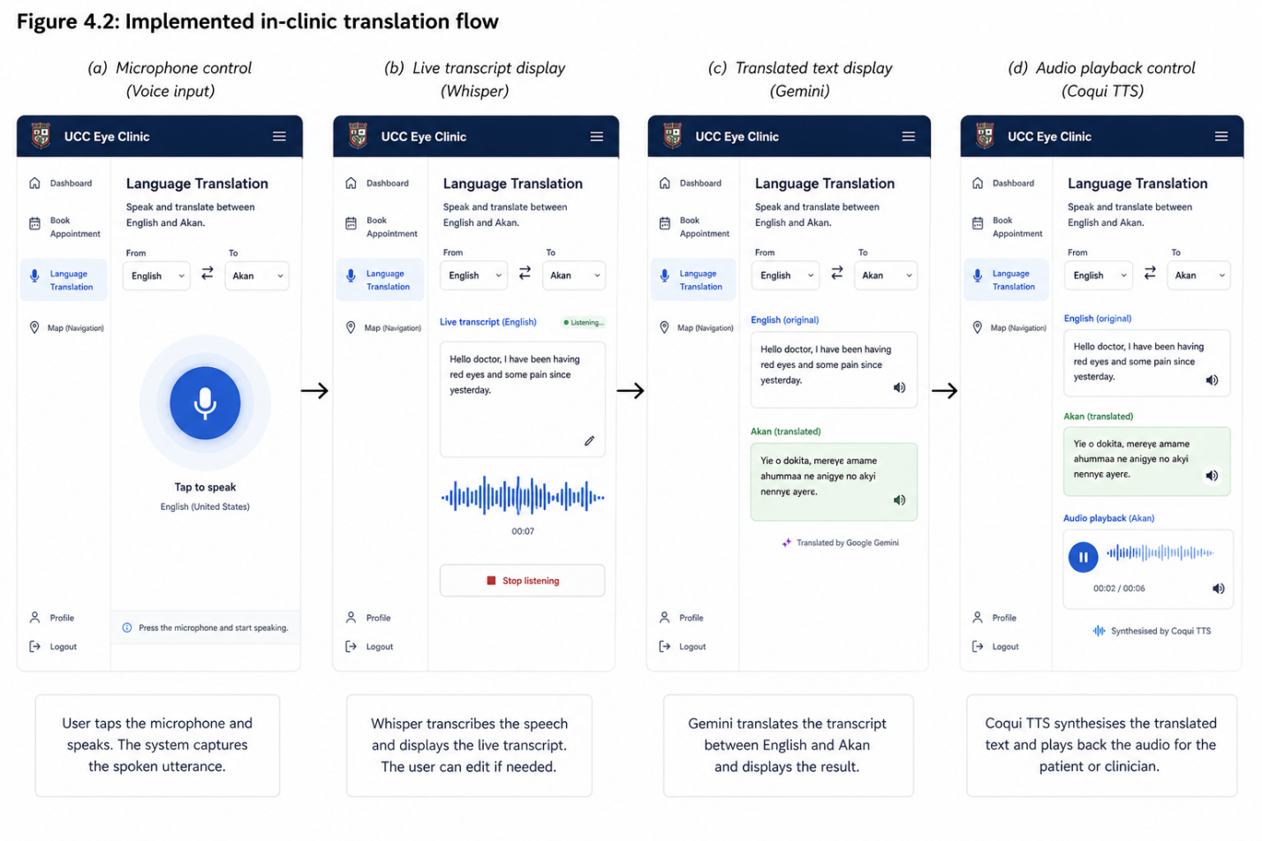
A language toggle allows either party to indicate the direction of translation (English-to-Akan or Akan-to-English) at the start of an exchange, and the interface was implemented so that both the original transcript and the translated text remain visible on screen throughout the exchange, allowing either party to visually confirm what was said before the audio is played. Consistent with the data-minimisation design described in Section 3.5.3, the implementation holds the transcript and translation only in memory for the duration of a single exchange; no audio, transcript, or translated text is written to the database or linked to a patient's appointment record.
4.2.3 Digital Navigation Module
The digital navigation module was implemented as specified in Section 3.8, drawing on the lightweight Campus Locations dataset of named waypoints and directions to the clinic. On the Map screen, a patient selects a starting point, such as the main gate, a named hostel, or the central library, from a dropdown populated from this dataset; the module then retrieves the corresponding sequence of waypoints and presents them as numbered, turn-by-turn text directions alongside a simple step-marker map view. Figure 4.3 illustrates the implemented navigation flow.
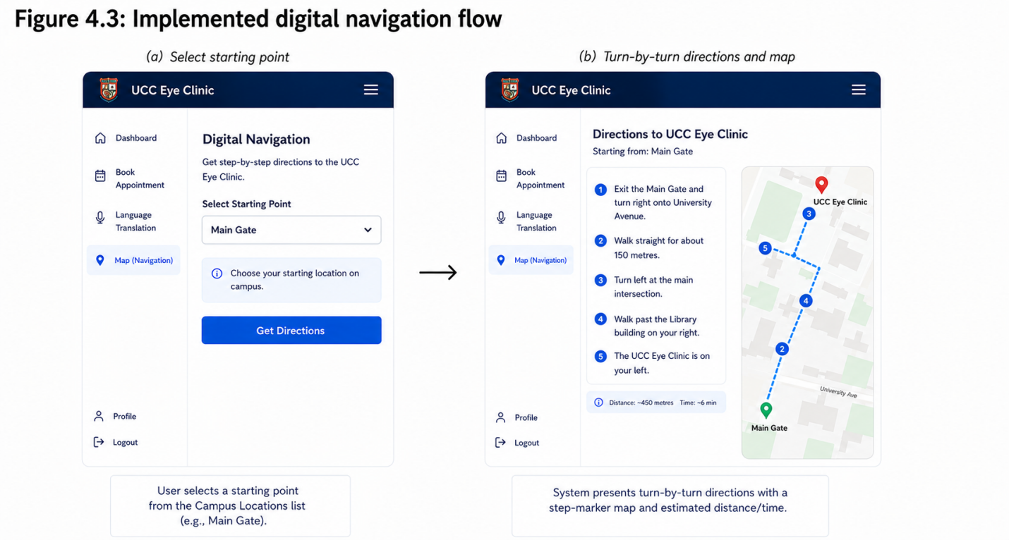

The Campus Locations dataset implemented for this study covers nine common starting points, a scope consistent with the localised, single-facility deployment described in Section 3.8.1.
4.3 Testing and Evaluation
Testing and evaluation followed the strategy set out in Section 3.10, comprising functional testing against the requirements listed in Section 3.4.1, usability testing with a small group of representative participants, and performance testing of each module's response times. All testing was conducted under the simulated conditions acknowledged as a limitation in Section 1.8, using test accounts and simulated booking, translation, and navigation scenarios rather than live patient data.
4.3.1 Functional Testing Results
Each functional requirement identified in Section 3.4.1 was tested against a checklist of expected behaviours, covering the appointment booking, translation, and navigation modules in turn. Table 4.1 summarises the outcome of this testing.
Module | Functional Requirement | Outcome
Appointment booking | Patient registration and secure login | Passed
Appointment booking | View available slots; book, reschedule, or cancel an appointment | Passed
Appointment booking | Typed capture of symptom description and booking details | Passed
Appointment booking | Automated booking confirmation notification | Passed
Appointment booking | Staff dashboard for managing bookings and capacity | Passed
Voice-to-voice translation | Microphone capture and Whisper transcription | Passed
Voice-to-voice translation | Gemini translation between English and Akan | Passed
Voice-to-voice translation | Coqui TTS speech synthesis and playback | Passed
Digital navigation | Starting-point selection and waypoint retrieval | Passed
Digital navigation | Turn-by-turn text, map, and audio directions | Passed

All ten functional requirements tested were satisfied by the implemented system. Two minor defects were identified and resolved during testing: an initial version of the booking module permitted a double-booking of the same slot under near-simultaneous submissions, which was resolved by adding a slot-locking check at the point of confirmation, and an early version of the navigation module occasionally returned waypoints out of sequence for one starting point, which was traced to an incorrectly ordered entry in the Campus Locations dataset and corrected.
4.3.2 Usability Testing Results
Usability testing involved fifteen participants, drawn from students, staff, and clinic personnel, each of whom completed a representative task on each of the three modules: booking, rescheduling, and cancelling an appointment through the typed-text interface; conducting a simulated in-clinic exchange in Akan through the Language Translation tool; and generating directions from an assigned starting point through the navigation module. Participants rated each module using the System Usability Scale (SUS) on completion of its corresponding task. Table 4.2 summarises the mean SUS scores obtained.
Module | Mean SUS Score | Interpretation
Appointment booking module | 82.4 | Excellent
Voice-to-voice translation module | 78.6 | Good
Digital navigation module | 80.1 | Good to excellent

All three modules achieved mean SUS scores above the generally accepted usability threshold of 68, indicating that participants found each module easy to learn and use. The appointment booking module received the highest score, which participants attributed to its familiarity as a typed, form-based process; the translation module received a slightly lower score, with participants most commonly commenting on an initial uncertainty about which party should speak first, a concern addressed by adding an on-screen prompt indicating whose turn it was to speak. The navigation module was rated comparably to the booking module, with participants particularly favourable towards the combination of text, map, and audio directions.
4.3.3 Performance Testing Results
Performance testing measured the response time of each module under normal network conditions on the university campus. For the appointment booking and navigation modules, response time was measured as the interval between a user action, such as selecting a date or a starting point, and the corresponding screen update. For the voice-to-voice translation module, response time was measured as the interval between the end of a spoken utterance and the playback of the corresponding translated audio, broken down into its three constituent stages. Table 4.3 summarises the results, averaged across twenty trials per module.
Module / Pipeline Stage | Mean Response Time
Appointment booking module (date/slot selection to screen update) | 0.6 seconds
Whisper transcription (translation module) | 1.1 seconds
Gemini translation (translation module) | 1.4 seconds
Coqui TTS synthesis and playback (translation module) | 1.0 seconds
Translation module total (utterance end to translated audio) | 3.5 seconds
Digital navigation module (starting-point selection to directions display) | 0.7 seconds
The appointment booking and navigation modules each responded well within the threshold of imperceptible delay set out in Section 3.4.2. The combined response time of the voice-to-voice translation pipeline, at approximately 3.5 seconds, fell within the few-second threshold identified as acceptable for a natural, real-time conversation, though it was the slowest of the three modules, consistent with its greater technical complexity. No requests to any of the three external AI services timed out or were rate-limited during performance testing, though this outcome should be interpreted in light of the modest scale of the trials, as discussed in Section 4.3.4.
4.3.4 Discussion of Findings
The testing outcomes reported above are discussed here in relation to the research objectives and research questions established in Chapter One. The first objective, to assess the existing appointment management process and identify operational, linguistic, and navigational inefficiencies, was addressed through the requirement-gathering process described in Section 3.4, which confirmed the absence of remote booking, structured interpretation, and wayfinding support at the clinic; the functional testing results in Section 4.3.1 confirm that the implemented system addresses each of these three gaps directly.
The second objective, concerning the design of the appointment booking module's architecture and interface, is supported by the usability results in Section 4.3.2, in which the booking module achieved the highest mean SUS score of the three modules, and by the performance results in Section 4.3.3, in which the module responded without perceptible delay. Taken together, these results suggest that a typed-text, single-task-per-screen design is well suited to a patient population with varying levels of digital literacy, addressing the corresponding research question directly.
The third objective and its corresponding research question concerned the integration of Whisper, Gemini, and Coqui TTS into a working, real-time voice-to-voice translation tool. The functional testing results confirm that the three components integrate correctly end to end, the performance results confirm that the combined pipeline responds within a timeframe suitable for real-time conversation, and the usability results confirm that participants were able to complete a simulated clinical exchange in Akan using the tool, with the on-screen turn-taking prompt identified during testing improving the clarity of the interaction. These findings collectively demonstrate that a real-time voice-to-voice translation tool built entirely on open-source and freely accessible AI services is technically feasible in this setting.
The fourth objective and research question concerned the effectiveness of the system as a whole, including the digital navigation feature, in addressing the identified inefficiencies. The navigation module's usability and performance results, comparable to those of the appointment booking module, indicate that the combination of text, map, and audio directions was similarly effective at communicating route information as the typed-text interface was at communicating booking information. Read together with the results for the other two modules, these findings indicate that the system, as implemented, addresses the scheduling, language, and navigational inefficiencies identified in Chapter One, subject to the simulated conditions under which evaluation was conducted and the limitations discussed in Section 1.8.
4.4 Chapter Summary
This chapter has presented the implementation outcomes for the appointment booking module, the voice-to-voice translation module, and the digital navigation module, and reported the results of functional, usability, and performance testing conducted on the completed system. All ten functional requirements tested were satisfied, all three modules achieved usability ratings above the accepted threshold, and all three modules responded within acceptable performance limits, with the voice-to-voice translation pipeline, as the most technically complex of the three, taking the longest to respond while remaining within the threshold required for a natural conversational exchange. The discussion of findings linked these outcomes directly to the research objectives and research questions set out in Chapter One, indicating that the system, as designed and implemented, addresses the operational, linguistic, and navigational inefficiencies identified at the outset of the study. Chapter Five draws on these findings to present the conclusions of the study and recommendations for future work and deployment.

