

REGIONS BANK XML Converter Internal Tool

**How to Deploy**

Copy the file to XMLConverterTool.html in your system – This single .html file contain css styles and plan JavaScript without any third party libraries like jQuery or Bootstrap

**How to use the Tool**

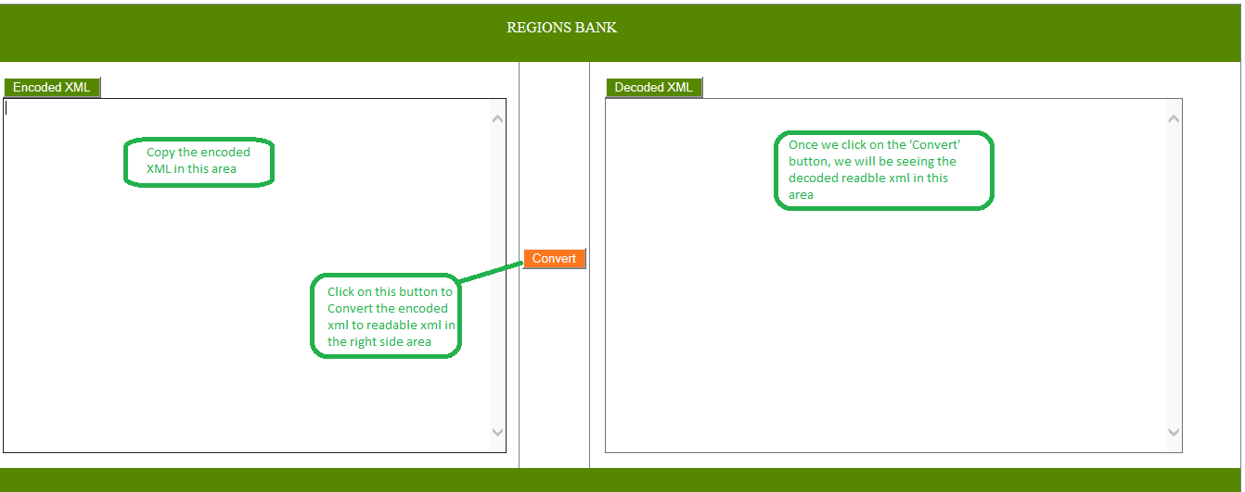

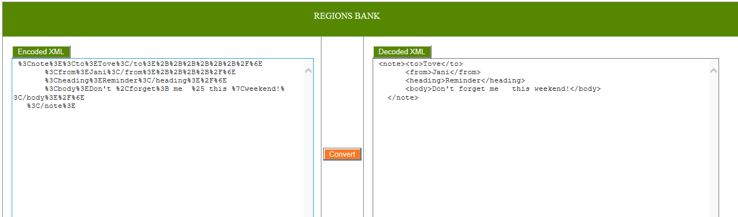

**How to maintain this tool**

Since it a single .html page without any db, file system or any other data storage machanisum, we need to edit the code if you find any new encode character. Here below are the steps you need to follow to get the accurate output.

1. Open the file in notepad or any other editor
2. Update the code as below screen
3. Make sure each hexCodes in the list must have a corresponding symbolText for the replacement
4. Values should be in the double quotes ( “”)

