PES UNIVERSITY

100 feet Ring Road, BSK 3rd Stage, Bengaluru 560085



Department of Computer Science and Engineering

B. Tech. CSE - 7th Semester

Aug – Dec 2020

UE17CS424

Human computer Interaction

Need finding report

Topic: Creating a website for the use of visually impaired people

PES1201701507: Abhishek Patil

PES1201701611: Naveen Karthik M J

PES1201701498: Manthan B Y

**Why is it required?**

According to Prevent Blindness America, 53.2 million Americans aged 45 or older have some form of visual impairment, from mild to severe, and about 18% of those affected are "legally blind."

As of 2014, there are around 360,000 people registered as blind or partially sighted in the UK.

Despite their visual impairments, many of those people use the Internet every day, just like us.

Further, as more and more people over the age of 50 become comfortable with technology, Internet usage among this demographic will only increase in coming years.

**From a business perspective**

The business benefits of making your website accessible to the visually impaired user base are:

* If you’re a business, you’ll expand your customer base.
* It’s the right thing to do. The visually impaired will appreciate it and their friends and family will certainly take notice of your efforts. It might even generate positive publicity for your company.

**Problems with existing website designs**

1.Colour Contrast

Eye diseases like Retinitis Pigmentosa, Glaucoma, Retinopathy and cataracts (some of the most common eye disorders out there) all lead to a significant decrease in contrast sensitivity — that is, the eye's ability to differentiate between similar shades and levels of brightness.

But today's layouts are detailed-oriented, often utilizing subtle gradients and slight shifts in value to create clean, modern, unobtrusive interfaces.

For a user with normal eyesight, this makes for a very pleasing visual experience. To a user who struggles with contrast sensitivity, however, it can be a literal headache.

2. Font Size and Spacing

Font sizes used in regular websites are too small to be recognized or perceived by the visually impaired user group, to read the text, they have to zoom in, but when they zoom in, they can only read a part of a sentence, to read the next part of a sentence, they need to scroll sideways frequently.

This reduces the appeal of the website to the user group.

3.Use of Images

The particular user group can not completely see the images, and thus it is of little to no use to the particular user group.

4.No screen reading capability

If a user wants the website to read out the word or a sentence he/she has difficulty in reading in, most of the websites don’t offer this feature as they are designed keeping the general populace in the mind.

5. Content Separability

Due to the use of a consistent colour choice, usually lesser space between different contents, the different parts of a page (for example: different paragraphs, options, buttons, fields in a form) are difficult to differentiate.

**Making the websites accessible to the visually impaired**

Some of the ways using which the websites can be made accessible to the visually impaired user group are:

1.Make the fonts larger, and use fonts of strokes such that the alphabets are clearly distinguishable

Sometimes, simply making text larger is all that a user requires. We can offer alternate stylesheets with larger font sizes and make sure our layout doesn't break when text-only zoom is enabled in the browser.

Many visually impaired users will want to zoom in on the text without changing the scale of the entire site layout, which can lead to difficulties scrolling and tracking text over long lines.

2.Contrast is key

We can offer a second version of our site with more contrast between elements.

Make use of bold text for added readability on low-contrast items and avoid very thin fonts.

We should avoid using JavaScript or CSS techniques that would prevent users from highlighting elements of the page with their mouse or change the default highlight behaviour.

Many visually impaired users make use of highlighting as a quick trick to increase contrast and to aid visual focus.

3.Images not required

Many of the times, images are of no use when designing websites for such special cases. This would remove the simple distraction of image on the page and would make the users to focus on the actual content which is comprehendible.

Removal of images also saves network bandwidth, which would lead to significant savings if the website is being accessed by a large number of users.

Removal of images also reduces the load time of the websites, and thereby, increasing its appeal.

4. Screen reading capability

Allow users to invoke the screen reading capability when they can not read a sentence or a word. Such a capability will help the users immensely.

5.Content separability

By use of the right colour combination and spacing between contents, the website can be made more readable to the user group.

**Proposed Solution**

The proposed solution is completely based on idea of RSS which is published by the leading news websites in the world.

RSS is an XML document which contains the latest headlines and links to the particular news articles.

We can subscribe to RSS documents of a news website to get the information and use that information in our own website by making use of XML parsing tools to get the information from the document.

The major advantage of RSS is that it is a known format. All the websites which publish RSS documents have to follow a particular template, and should structure the content within the specified tags.

This makes RSS some sort of a universal format to publish latest news articles.

Our idea is based on similar lines.

We create a website using the above-mentioned principles of website design for the visually impaired users.

The website can be designed in such a way that, if a website wants to make its content accessible to the visually impaired user group, they need to only deliver the content to us/our website in a specified format which can be designed.

Using the content delivered in the specified format, we can parse the content and make it available to the visually impaired user group.

From the website perspective, this is a sort of plug and play interface or some sort of design translation.

**Screenshots from the website**

Screenshot 1

Home page

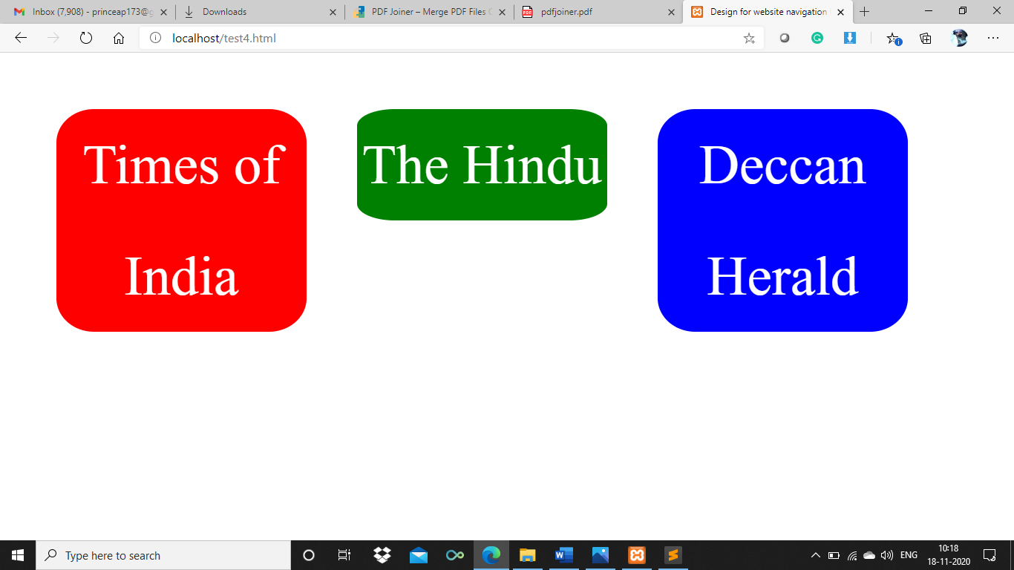

Screenshot 2

Categories from various newspapers

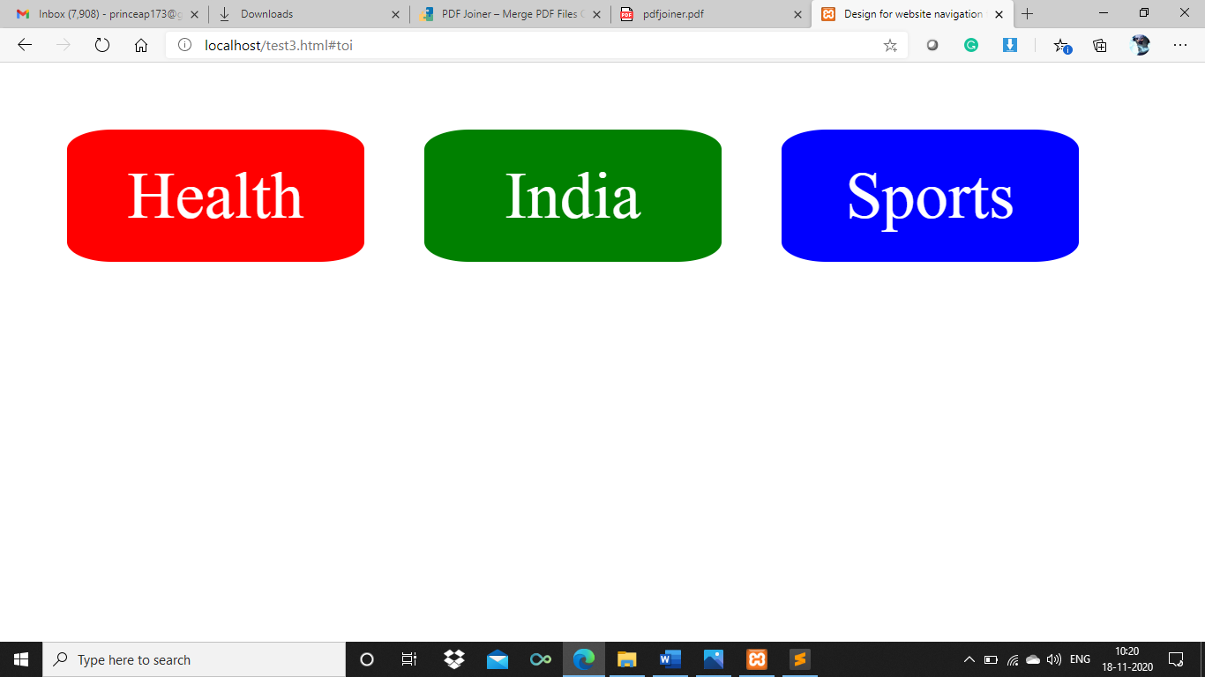

3.Screenshot 3

Ability to highlight the current line of text

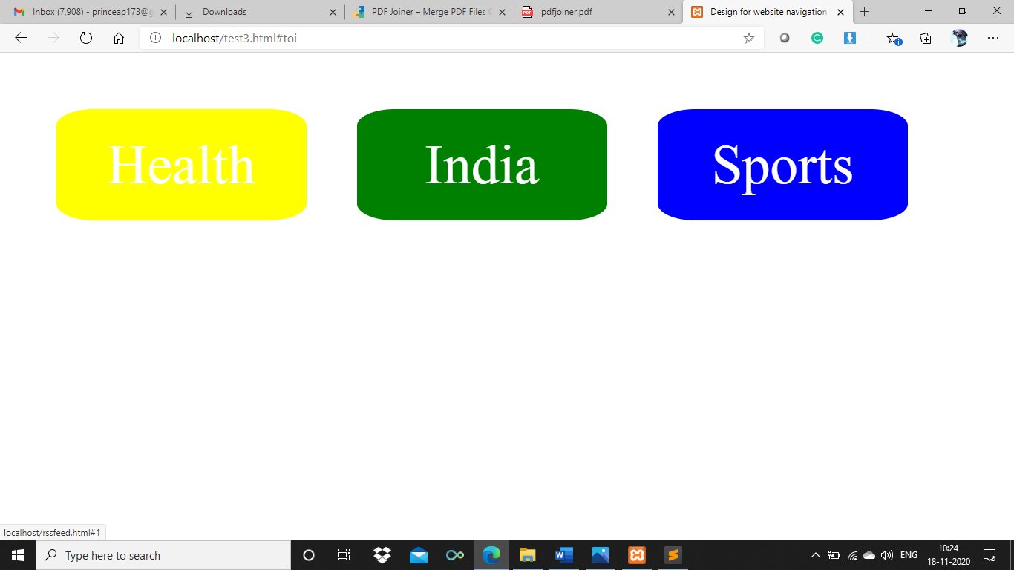

4.Screenshot 4

News from India category – Times of India Newspaper

